The Maze

Major Programming Topics Island Files

- Jeroo methods Maze_1.jev
- Recursion opportunity

Statement of the Problem
A Jeroo just returned home from visiting a neighboring island only to discover that heavy rains had turned the island into a veritable maze. There is a single flower growing somewhere on the island. The purpose of this program is to have the Jeroo find and pick the flower. The Jeroo is starting somewhere along the edge of the ocean, facing inland. There is a unique path to the flower, but there are also many dead ends. Help the Jeroo find the flower.
A representative starting layout is shown in figure 1.
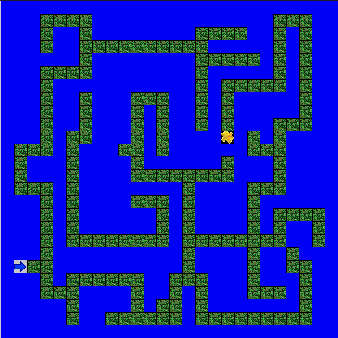

Figure 1 – A Possible Island Layout

