Two Friends Meet

Major Programming Topics Island Files

- Jeroo methods Start with an empty island
- while structures
- if structures
- nested structures

Statement of the Problem
One Saturday morning, two friends, Bugs and Daffy, decide to meet and plant flowers to beautify Santong island. Daffy starts in the Northwest corner facing East with 90 flowers in his pouch. Bugs starts in the Northeast corner facing West with 90 flowers in his pouch. Bugs and Daffy begin hopping toward one another. As they hop, each plants exactly one flower at every location it enters, including its starting location. They meet, facing each other, roughly in the middle of row 0. After a handshake and a little small talk, Bugs and Daffy both turn toward the south and continue planting flowers all the way to the southern edge of the island. When both reach the South Sea they say goodbye and part. Daffy turns west and plants flowers all the way to the Western Ocean. Bugs turns east and plants flowers all the way to the Eastern Ocean. This is where our story ends. Your task is to write a Jeroo program that will illustrate this story.

Figure 1 shows a possible ending view of the island.
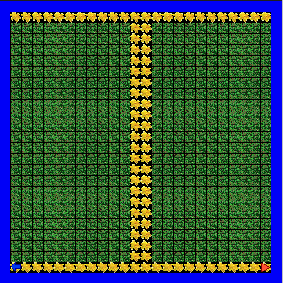

Figure 1 – The Ending View For This Program

