Is this technically a printer jam or a mouse problem?

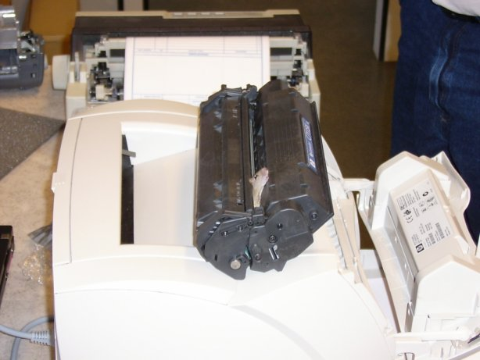

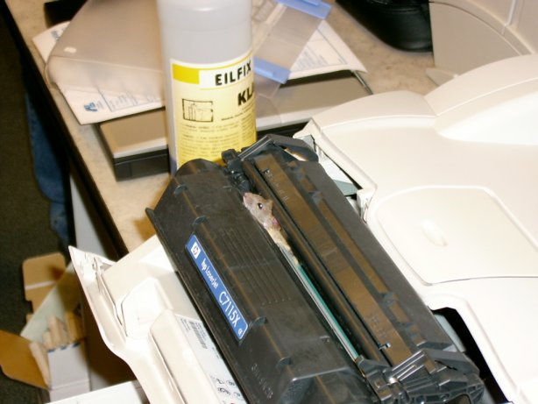

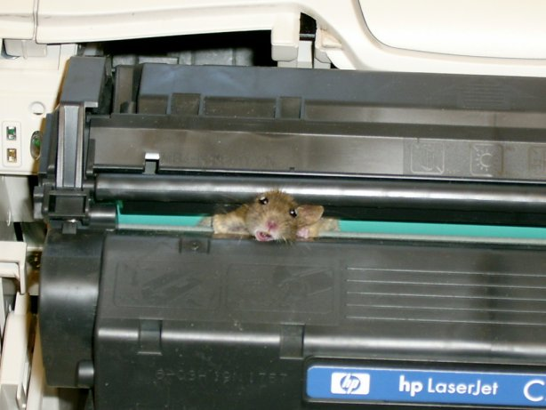

He's not dead but he's sure stuck. They do end up getting him out and letting him loose for those of you that are mouse lovers. How'd you like to get to work and find this problem? LOL .. hilarious!

Urban legend or real? Check out http://urbanlegends.about.com/library/bl_mouse_printer_jam.htm

