PEANUT BUTTER & JELLY – Communications for Business

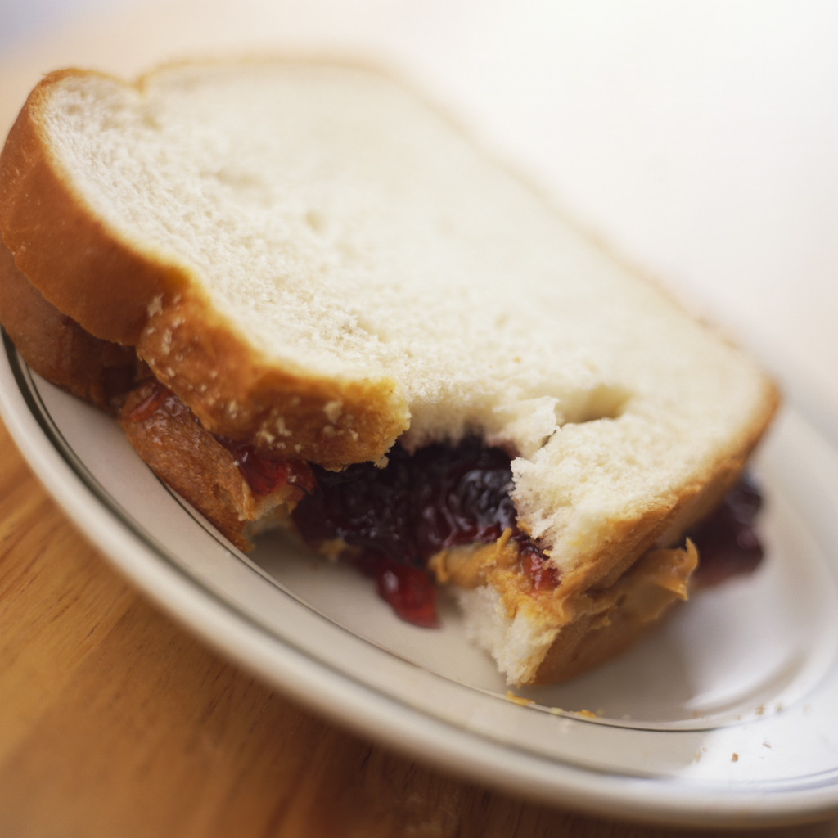

Activity Directions –

Teams will write directions on how to prepare a peanut butter and jelly sandwich. Directions should be as clear and accurate as possible.
- The written directions should then be traded with another team who will read the directions out loud to the team who wrote it.
- Team members will assemble a peanut butter and jelly sandwich based on their own team’s written directions. Team members will alternate steps so that both participate.

Example: Team A writes their directions and gives to Team B to read aloud. Team A will then prepare the sandwich based on their own directions.

Teams must follow the directions EXACTLY as written. No changes, no “we meant to write”, etc.

