Module 8  Activity 8  COMMUNICATION

Telephone Etiquette Checklist

- Whenever possible, try to answer your phone by the second ring. Do not let the phone ring endlessly—doing so will most certainly annoy your caller. Answering calls quickly is good business.

- Show respect for your listener's time.

- Do not put someone on "hold" for more than a minute or so. If for some important reason you feel you must take another call or do some other work, offer to call the listener back later rather than keeping him or her on "hold."

- Control the overall length of a call, and limit the nonbusiness part of the call to a minimum.

- Identify yourself immediately when you place a call.

- Identify yourself immediately when you answer a call.

- Identify yourself immediately when you answer someone else's phone.

- Show a willingness to take a message for another person.

- Be sure not to reveal personal or confidential information when answering someone else's phone.

- Always be polite. Remember to say "please" and "thank you" whenever appropriate. Don't be rude and read documents or do other work while on the telephone. Give your listener your full attention.

- Adjust your voice quality to your telephone equipment. Make sure that your volume is clear, your rate of speed not too fast, your pitch and emphasis appropriate, and your enunciation and pronunciation correct.

- Don't shout at or snap at people or give others the impression that you feel superior or are being disturbed unnecessarily. Try to control any negative feelings you might have.

- Respect each person with whom you work, regardless of his or her rank or position.

- Treat your job—and every business caller—seriously and professionally.

Module 8  Activity 8  COMMUNICATION

- Do not say negative things about the company or any of its employees.

- Be helpful. Is there something you can do to help the caller—for example, send her a catalog, put her name on a mailing list, or find out a price? The "true professional" always tries to be as cooperative as possible.

- Do not argue or become defensive with a "problem caller."

BASIC POINTS TO KNOW

- Know your telephone system and what all the features are.
- Answer promptly (2-3 rings).
- Identify yourself clearly.
- Use your friendliest (not sicky sweetest) voice and enunciate your words.
- Offer help to caller (within reason).
- Never lose your temper no matter how angry the caller may make you.
- Take messages carefully—Get necessary information tactfully.
- Spell and/or pronounce caller's name correctly.
- Avoid asking caller his/her name if the person being called is not in. Instead, ask if you can help or if you may take a message.
- Never keep caller waiting for one minute without going back and checking with the caller.

Module 8  Activity 8  COMMUNICATION
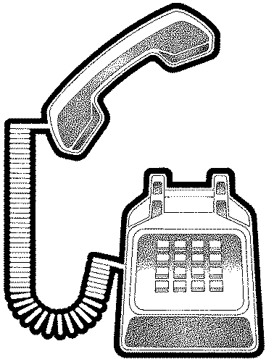

Answering the Telephone
With an Attitude

- Be prepared to answer calls. Keep pad and pen near
phone.

- Answer on first or second ring.

- Do not be in conversation with someone else with picking up
the receiver.

- Do not put caller on hold before asking permission and waiting for a response.

- Speak distinctly and slowly.

- Vary the tone of your voice.

- Identify yourself properly.

- Take messages carefully.

- Ask for verification of numbers and spelling of names and addresses.

- Repeat the message.

- Be tactful if you must screen calls, but avoid screening if at all possible.

- Be a good listener.

- Do not react to irate callers. Offer to help resolve the situation.

- Transfer calls properly and only when necessary.

- If a caller has been put on hold, do not leave caller dangling forever. Check with caller at least every 30 seconds or so. Offer to call him/her back if necessary.
Module 8  Activity 8  COMMUNICATION



On the phone

- Use variety in tone of voice

- Smile

- Answer in three rings

- Ask how you can help

- Be courteous

Life Skills: Job Skills – Lesson 9 – Customer Service
- The University of Georgia Cooperative Extension Service
Module 8  Activity 8  COMMUNICATION

On The Telephone with Customers
Always smile when you are talking on the phone. The customer needs to feel understanding in your voice.

Answer the phone within the first three rings. This will give the customer a feeling that you are efficient and there to help him/her.

Ask what you can do to help him/her. Doing so will let the customer know that you are willing to help in any way you can.

Always be courteous when putting someone on hold or transferring calls. Ask if you may put them on hold or transfer their call before you do it.







How Do You Calm Down an Upset Customer?

- Make sure you see the problem from his/her side.

- Stay calm yourself.

- Let the customer talk. Don't interrupt!

- Write down what is said.

- Echo what they said and restate the prob-lem, and this shows that you are listening.

- Try to find something on which the two of you can agree.
- Avoid emotional trigger words such as "prob-lem" and "can't."

- Tell him/her what you can do for him/her, instead of what you can't do.

- Don't ever say "It's not my job!" Instead say, "Let me put you in touch with . . . She can help you with your situation."

- Don't ever say "What do you expect from me?" or "What do you want?" or "What else can I tell you?"

