Name __________________________________________________________ Date ________________

Chapter 1
Reading Organizer
Answer Key
1.1

1. List and explain the three things that have to work together in order for most computers to perform useful functions.

Hardware - the physical components, both internal and external, that make up a computer.

Operating System - a set of computer programs that manages the hardware of a computer. An operating system controls the resources on a computer, including memory and disk storage. An example of an operating system is Windows XP.

Application Software - programs loaded on the computer to perform a specific function using the capabilities of the computer. An example of application software is a word processor or a computer game.

2. List and explain the two general categories of application software.

Business/Industry Software - Software designed for use by a specific industry or market. Examples include: medical practice management tools, educational tools and legal software.

General Use Software - Software used by a wide range of organizations and home users for various purposes. These applications can be used by any business or individual.

3. Explain the difference between local and network application software.

Local application - A local application is a program, such as a word processor, that is stored on the hard disk of the computer. The application runs only on that computer.

Network application - A network application is one that is designed to run over a network, such as the Internet. A network application has two components, one that runs on the local computer and one that runs on a remote computer. Email is an example of a network application.

4. 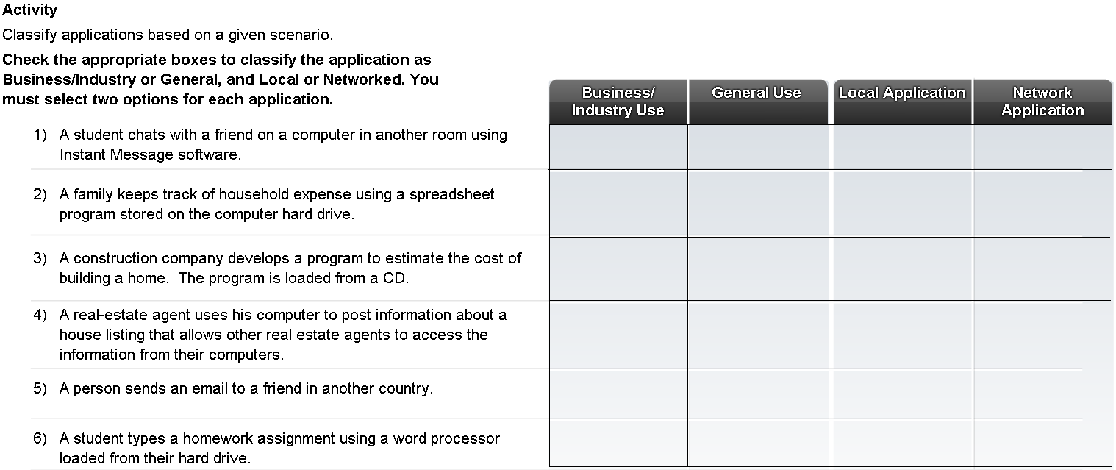

1.2

5. List the six common types of computers available.

- Mainframes
- Servers
- Desktops
- Workstations
- Laptops
f. Hand-held portable devices

6. Explain what servers are and what they are used for.

Servers are high performance computers used in businesses and other organizations.
Servers provide services to many end users or clients.

7. Why do servers often contain duplicate or redundant parts?

The services provided by a server are often important and may need to be available to users at all times. Servers, therefore, often contain duplicate, or redundant, parts to prevent them from failing.

8. How do workstations differ from desktop computers?

Desktops are commonly used to run applications such as word processing, spreadsheets and networked applications such as email and web browsing.

Workstations are high-powered business computers. They are designed for specialized, high-end applications like engineering programs such as CAD (Computer Aided Design).

9. 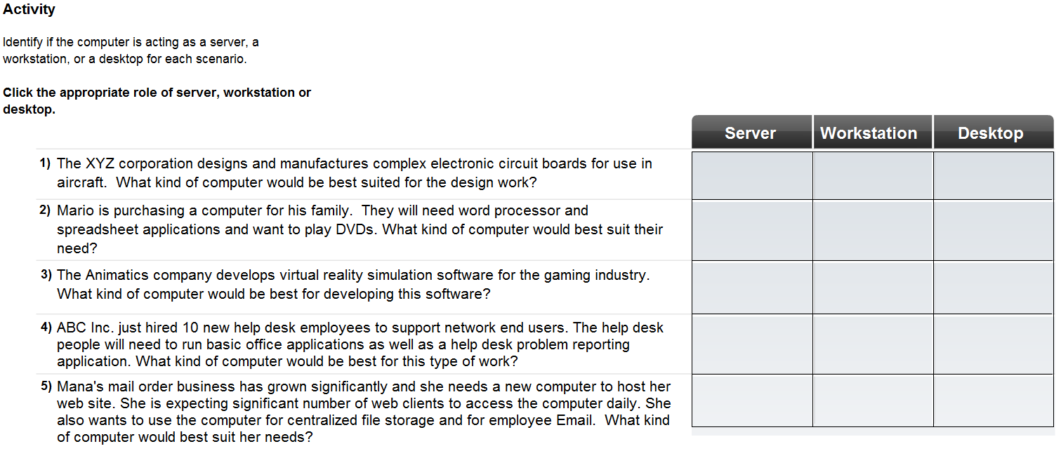

10. How do laptops differ from desktops?

They are portable devices built to be lightweight and use less power, with a built-in mouse, monitor and keyboard.

11. What are the advantages of using a docking station with a laptop computer?

It allows the user to utilize a larger monitor, mouse, full-sized keyboard and have more connection options.

1.3

12. How many values are in a single binary digit (or bit)?

Two

13. What is ASCII and how does a computer use it?

Computers use binary codes to represent and interpret letters, numbers and special characters with bits. A commonly used code is the American Standard Code for Information Interchange (ASCII). With ASCII, each character is represented by a string of bits

14. Explain the following terms:

Byte -

While a bit is the smallest representation of data, the most basic unit of digital storage is the byte. A byte is 8 bits and is the smallest unit of measure (UOM) used to represent data storage capacity.

Kilobyte –

One kilobyte is a little more than one thousand bytes, specifically 1,024.

Megabyte –

A megabyte represents more than a million bytes or 1,048,576.

Gigabyte –

A gigabyte is 1,073,741,824 bytes.

15. What are bytes, megabytes, and gigabytes typically used to measure?

Kilobytes, megabytes, gigabytes, and terabytes are typically used to measure the size or storage capacity of a device. Examples of components and devices that use byte storage include: random access memory (RAM), hard disk drive space, CDs, DVDs, and MP3 players.

Complete Lab 1.3.2

16. List and explain three types of commonly used media.

a. Cables, which use pulses of electricity through copper wires
b. Fiber optics, which use pulses of light over fibers made from glass or plastic
c. Wireless, which uses pulses of low-power radio waves.

17. How are data rates measured?

Data transfer rates are measured in thousands of bits per second (kbps) or millions of bits per second (Mbps).

18. Graphics resolution is measured by what unit of measurement?

Graphics resolution is measured in pixels.

19. What unit of measurement is used to measure the speed of a computer processor?

Hertz is a measurement of how fast something cycles or refreshes. One hertz represents one cycle per second. In computers, the speed of the computer processor is measured by how fast it can cycle in order to execute instructions, measured in hertz.

Complete Lab 1.3.3

1.4

20. What are the advantages of purchasing a preassembled computer?

a. Lower cost
b. Adequate to perform most applications
c. No waiting period for assembly

21. What are the advantages of purchasing a custom built computer?

a. The end-user can specify exact components that meet user needs
b. Generally support higher performance applications such as graphics, gaming, and server applications

22. What are some issues to consider when selecting a motherboard?

a. Support the selected CPU type and speed
b. Support the amount and type of system RAM required by the applications
c. Have sufficient slots of the correct type to accept all required interface cards
d. Have sufficient interfaces of the correct type

23. Explain what the Central Processing Unit (CPU) is and what it does.

The CPU, or processor, is the nerve center of the computer system. It is the component that processes all of the data within the machine.

24. If a computer is running multiple applications simultaneously what component is essential to accomplish this?

Most computers are capable of running multiple applications simultaneously, or multi-tasking. The more applications that need to run simultaneously, the more RAM required.

25. Explain in detail the function of the following adapter cards.

Video Cards –
Video cards accept information from computers and translate it into a format that can be displayed on a monitor screen. Video cards often contain large amounts of RAM and dedicated processor chips for manipulating video content. The choice of video cards is made based on video speed and higher resolution cards. Video cards must match the capabilities of the connected monitors.

Sound Cards –
Sound cards accept digital information from the system and convert them into a signal that is transmitted to a speaker that outputs an audio signal. High-end sound cards can produce an audio output that rivals some do the best stereo equipment available.

Network Interface Cards –
Network interface cards (NICs) enable a computer system to exchange information with other systems in a local network. The speed of the network and the type of technology help determine what NIC is required. The most common networking technology is currently Ethernet.

26. What is the main storage medium found in almost all computers including: servers, desktops, and laptops?

Hard disk drives

27. What is another name for static memory and memory sticks?

USB memory keys or flash drives

28. List several input devices.

Trackball, joystick, scanner, digital camera, digitizer, barcode reader, microphone

29. List several output devices.

Printer, plotter, speakers, headphones

30. Explain the purpose of a surge suppressor?

A surge suppressor is designed to remove voltage spikes and surges from the power line and prevent them from damaging a computer system.

31. Explain in detail the function and process of an uninterruptible power supply.
(In other words explain what it does and how it works.)

A UPS is a device that continually monitors the power to a computer system and maintains the charge on an internal battery. If the power is interrupted, the UPS provides backup power to the system without interruption. The backup power comes from a battery inside the UPS and can only power the computer system for a short period of time. UPSs are designed to provide the end-user with sufficient time to properly shut down a computer system should the main power fail. A UPS can also provide an even flow of power to the computer and prevent damage caused by voltage surges.

1.5

32. What is the reason for technicians to wear special wrist grounding straps?

A special wrist grounding strap is used to connect the technician to the computer case. Grounding ensures that they both reach the same voltage potential and ESD is prevented.

33. After installing a new computer component why is it important to obtain the most current driver for it?

Drivers are continually updated to improve efficiency and functionality. The most current driver can be obtained from the manufacturer's web site and should normally be used.

34. Computer components are designed to make use of specific sets of system resources. When dealing with newer components how are these resources assigned?

Newer components and operating systems are able to dynamically assign system resources.

35. What are the steps required to install a peripheral device?

a. Connect the peripheral to the host using the appropriate cable or wireless connection
b. Connect the peripheral to a power source
c. Install the appropriate driver

36. If a newly installed peripheral device does not function properly what steps can be taken to correct the problem?

a. Verify that all cables have been properly connected and that the device is powered up.

b. Many devices, such as printers, offer a testing functionality on the device directly, and not through the computer. Use this feature to verify that the device itself is functioning properly. If the device is operational, but not connecting to the computer system, the problem could be with the cable connection.

c. Swap the suspect cable with a known good one. If this fails to solve the problem the next step is to verify that the connection port the peripheral device is connected to is recognized by the operating system.

Complete Lab 1.3.3

