Name __________________________________________________________ Date ________________

Chapter 1
Reading Organizer

1.1

1. List and explain the three things that have to work together in order for most computers to perform useful functions.

____________________________ -

____________________________ -

____________________________ -

2. List and explain the two general categories of application software.

____________________________ -

____________________________ -

3. Explain the difference between local and network application software.

4. 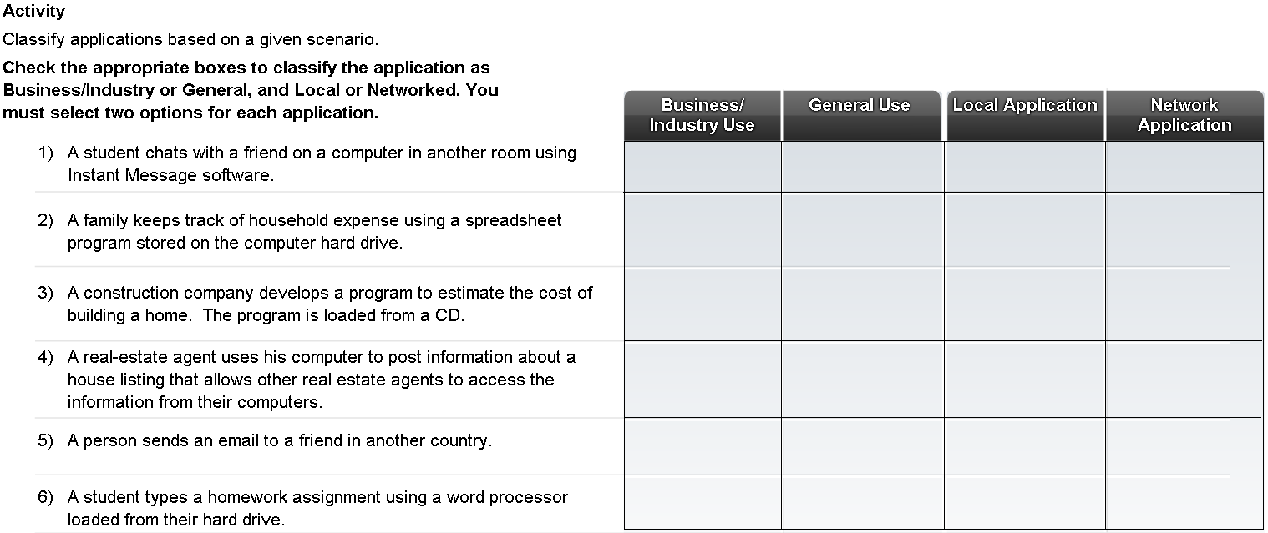

1.2

5. List the six common types of computers available.

a.

b.

c.

d.

e.

e.

6. Explain what servers are and what they are used for.

7. Why do servers often contain duplicate or redundant parts?

8. How do workstations differ from desktop computers?

9. 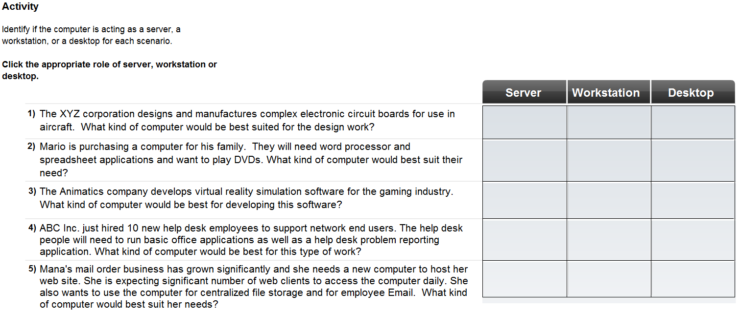

10. How do laptops differ from desktops?

11. What are the advantages of using a docking station with a laptop computer?

1.3

12. How many values are in a single binary digit (or bit)?

13. What is ASCII and how does a computer use it?

14. Explain the following terms:

Byte -

Kilobyte –

Megabyte –

Gigabyte –

15. What are bytes, megabytes, and gigabytes typically used to measure?

Complete Lab 1.3.2
16. List and explain three types of commonly used media.

a. ____________________________ -

b. ____________________________ -

c. ____________________________ -

17. How are data rates measured?

18. Graphics resolution is measured by what unit of measurement?

19. What unit of measurement is used to measure the speed of a computer processor?

Complete Lab 1.3.3

1.4

20. What are the advantages of purchasing a preassembled computer?

a.

b.

c.

21. What are the advantages of purchasing a custom built computer?

a.

b.

22. What are some issues to consider when selecting a motherboard?

a.

b.

c.

d.

23. Explain what the Central Processing Unit (CPU) is and what it does.

24. If a computer is running multiple applications simultaneously what component is essential to accomplish this?

25. Explain in detail the function of the following adapter cards.

Video Cards –

Sound Cards –

Network Interface Cards –

26. What is the main storage medium found in almost all computers including: servers, desktops, and laptops?

27. What is another name for static memory and memory sticks?

28. List several input devices.

29. List several output devices.

30. Explain the purpose of a surge suppressor?

.

31. Explain in detail the function and process of an uninterruptible power supply.
(In other words explain what it does and how it works.)

1.5

32. What is the reason for technicians to wear special wrist grounding straps?

33. After installing a new computer component why is it important to obtain the most current driver for it?

34. Computer components are designed to make use of specific sets of system resources. When dealing with newer components how are these resources assigned?

35. What are the steps required to install a peripheral device?

a.

b.

c.

36. If a newly installed peripheral device does not function properly what steps can be taken to correct the problem?

a.

b.

c.

Complete Lab 1.3.3

