Name __________________________________________________________ Date ________________

Chapter 2
Reading Organizer
Answer Key
2.1

1. Explain what the OS is and its purpose.

The OS controls input and output functions. In addition, the entered data is manipulated inside of the computer, stored in RAM and processed by the CPU. This internal manipulation and processing is also controlled by the OS. All computerized devices, such as servers, desktops, laptops or handhelds, require an OS in order to function.

2. Explain in detail what application programs are designed for. List some examples.

Application programs are designed for a specific purpose, such as word processing, and know nothing of the underlying electronics. For example, the application is not concerned with how information is entered into the application from the keyboard. The operating system is responsible for the communication between the application and the hardware.

3. There are two ways for a computer user to interact with a computer. List and explain both.

CLI - When using the CLI, the user interacts directly with the system in a text-based environment by entering commands on the keyboard at a command prompt. The system executes the command, often providing textual output.

GUI - The GUI interface allows the user to interact with the system in an environment that uses graphical images, multimedia, and text. Actions are performed by interacting with the images on screen. GUI is more user friendly and requires less knowledge than CLI of the command structure to utilize the system.

4. Explain the following terms:

Shell – The user interface that allows users to request specific tasks from the computer. Theses requests can be made either through the CLI or GUI interfaces.

Kernel – Communications between the hardware and software of a computer and manages how hardware resources are used to meet software requirements.

Hardware – The physical part of a computer including underlying electronics.

5. Explain what a network operating system (NOS) does.

A NOS offers complex scheduling and user management software that allow a device to share resources between many users and treat networked resources as though they are directly connected.

6. List four characteristics of an operating system that falls under a commercial license.

a. Restrictive in nature and limits what the end user can do with the code.
b. Often very expensive depending on deployment.
c. Very structured development cycle and changes are not quickly available.
d. Structured support available for a fee.

7. List four characteristics of an operating system that falls under a GNU public license (GPL).

a. Ensures everyone has full access to the source cone and can participate in enhancements on the product.
b. Often released free-of-charge.
c. Development cycle is usually less structured and changes are more quickly implemented.
d. Less of a structured support arrangement often relying on community.

8. Operating systems require a certain amount of hardware resources, these resources include such things as:

a. Amount of RAM
b. Hard disk space required
c. Processor type and speed
d. Video resolution

9. 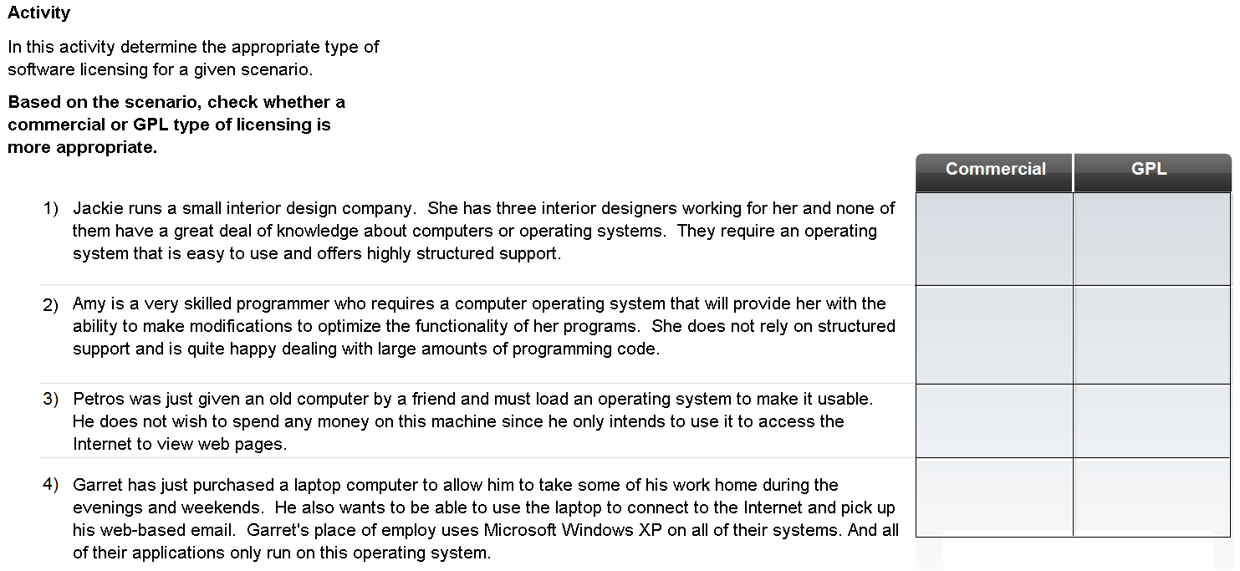

10. What factors need to be considered when selecting an operation system?

a. Ensure that the OS being considered fully supports the requirements of the end user.
b. Make sure that sufficient hardware resources are available to support the OS.
c. The level of human resources needed to support the OS.

2.2

11. List and explain two instances when a clean install of an OS could be done.

a. A clean install is done on a new system or in cases where no upgrade path exists between the current OS and the one being installed.
b. A clean install is also performed when the existing OS installation has become damaged in some way.

12. What happens to the existing data on a hard drive during a clean install?

It deletes all data on the partition where the OS is installed and requires application software to be reinstalled.

13. How many partitions are required for a multiple OS’s in a multi-boot environment?

Each OS is contained within its own partition and can have its own files and configuration settings.

14. 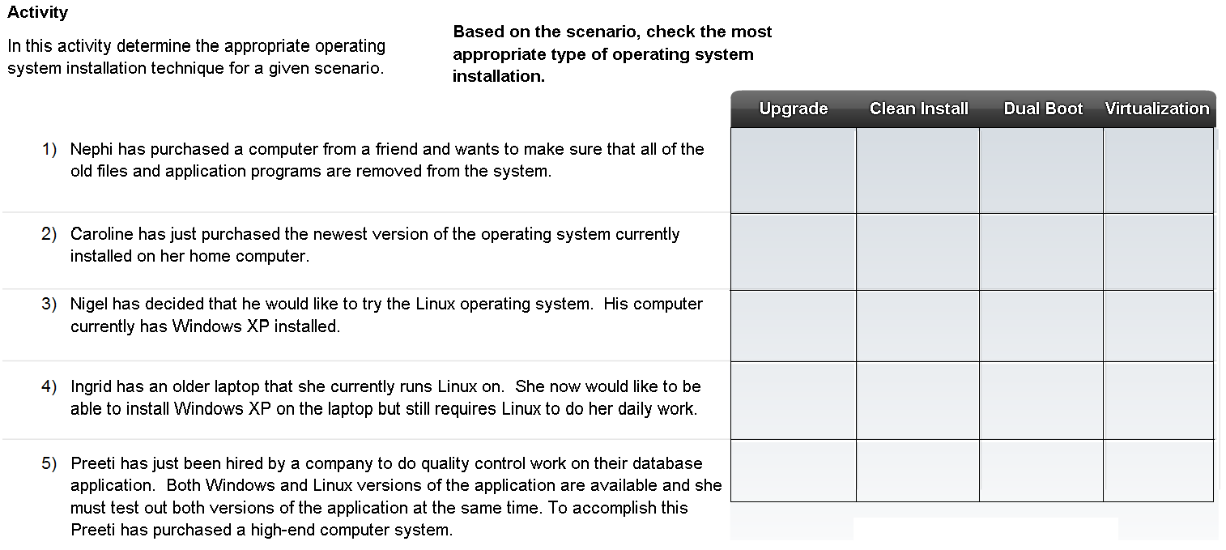

15. List and explain what things a technician can check prior to installing a new OS to ensure that the installation will work correctly?

a. Verify that all hardware is certified to work with the selected OS.

b. Verify that the hardware resources meet or exceed the published minimum requirements.

c. Confirm that the appropriate installation medium is available. Due to the file size of current operating systems, they are usually available on both CD and DVD medium.

d. If the OS is to be installed on a system that already contains data: (a) Use system diagnostic tools and utilities to ensure the current OS installation is in good condition, free of malicious or damaging files and codes; (b) Complete a full backup of all important files.

e. If performing a clean-install, verify that all application software is available for installation.

16. Explain the technique that can be used to help protect data on a hard drive when doing a clean install?

One of the techniques available to help protect data is to divide the hard drive into multiple partitions. With a clean install, many technicians prefer to create one partition for data and a separate partition for the OS. This enables an OS to be upgraded without the risk of losing data. It also simplifies backup and recovery of data files.

17. There are three parts to the IP configuration, which must be correct for the computer to send and receive information on the network. List and explain these three parts.

a. IP address - identifies the computer on the network.
b. Subnet mask- is used to identify the network on which the computer is connected.
c. Default gateway- identifies the device that the computer uses to access the Internet or another network.

18. A computer IP address can be configured manually or assigned automatically by another device. List and explain both.

a. Manual IP Configuration –

With manual configuration, the required values are entered into the computer via the keyboard, typically by a network administrator. The IP address entered is referred to as a static address and is permanently assigned to that computer.

b. Dynamic IP Configuration –

Computers may be set up to receive network configuration dynamically. This allows a computer to request an address from a pool of addresses assigned by another device within the network. When the computer is finished with the address it is returned to the pool for assignment to another computer.

19. What two pieces of information must be unique to every computer and not duplicated on the local network.

a. Computer names must be unique
b. IP addresses must also be unique to each device.

2.3

20. Explain what a software patch is.

A patch is a piece of program code that can correct a problem or enhance the functionality of an application program or OS. They are usually provided by the manufacturer to repair a known vulnerability or reported problem.

21. List and explain the three different methods patches can be installed on a computer.

a. Automatic installation -
The OS can be configured to connect to the manufacturer's web site, download and install minor updates without any user intervention. Updates can be scheduled to occur during times when the computer is on, but not in use.

b. Prompt for Permission -

Some users wish to have control over which patches are applied. This is often the choice of users who understand what impact a patch may have on system performance. The system can be configured to notify the end-user when a patch is available. The user must then decide if the patch should be downloaded and installed.

c. Manual -

Updates that require major pieces of code to be replaced on a system should be run manually. These major updates are often called service packs and are designed to correct problems with an application or OS, and sometimes to add functionality. These service packs usually require the end user to manually connect to a web site, download and install the update. They may also be installed from a CD that can be obtained from the manufacturer.

22. Match the scenario to the correct installation method by drawing a line between them.

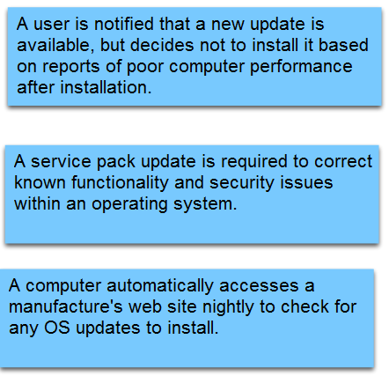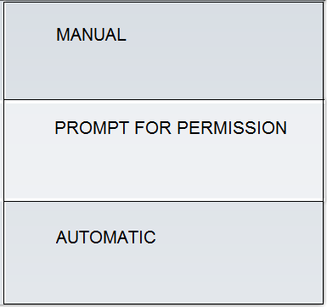

23. Why do browsers and office software such as word processors, spreadsheet and database applications need to be patched?

Browsers and office software such as word processors, spreadsheet and database applications are common targets for network attacks. These applications require updates to correct the code that may allow the attack to succeed. The manufacturer may also develop updates that can improve product functionality, at no additional cost.

Complete Lab 2.3.3

