Name __________________________________________________________ Date ________________

Chapter 2
Reading Organizer
2.1

1. Explain what the OS is and its purpose.

2. Explain in detail what application programs are designed for. List some examples.

3. There are two ways for a computer user to interact with a computer. List and explain both.

_________________________________ -

_________________________________ -

4. Explain the following terms:

_________________________________ -

_________________________________ -

_________________________________ -

5. Explain what a network operating system (NOS) does.

6. List four characteristics of an operating system that falls under a commercial license.

a.

b.

c.

d.

7. List four characteristics of an operating system that falls under a GNU public license (GPL).

a.

b.

c.

d.

8. Operating systems require a certain amount of hardware resources, these resources include such things as:

a.

b.

c.

d.

9. 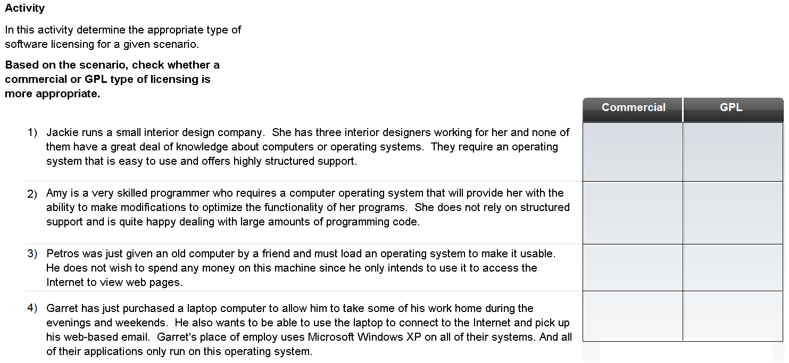

10. What factors need to be considered when selecting an operation system?

a.

b.

c.

2.2

11. List and explain two instances when a clean install of an OS could be done.

a.

b.

12. What happens to the existing data on a hard drive during a clean install?

13. How many partitions are required for a multiple OS’s in a multi-boot environment?

14. 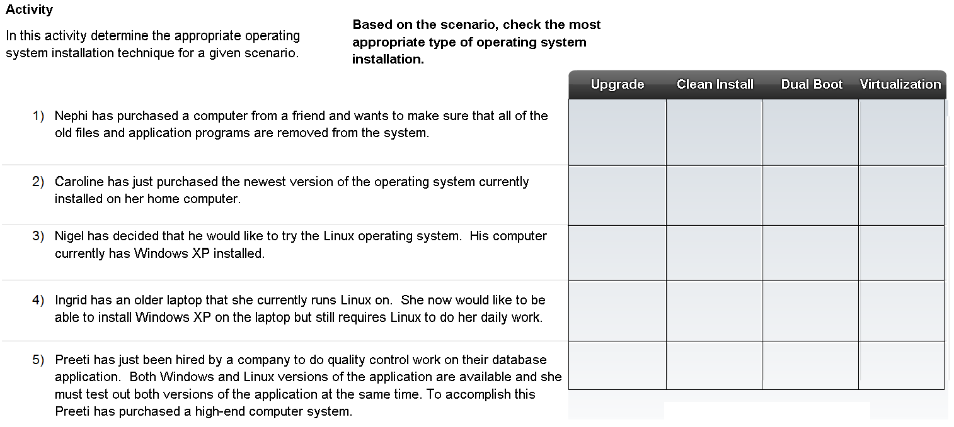

15. List and explain what things a technician can check prior to installing a new OS to ensure that the installation will work correctly?

a.

b.

c.

d.

e.

16. Explain the technique that can be used to help protect data on a hard drive when doing a clean install?

17. There are three parts to the IP configuration, which must be correct for the computer to send and receive information on the network. List and explain these three parts.

a. _________________________________ -

b. _________________________________ -

c. _________________________________ -

18. A computer IP address can be configured manually or assigned automatically by another device. List and explain both.

a. _________________________________ -

b. _________________________________ -

19. What two pieces of information must be unique to every computer and not duplicated on the local network.

a.

b.

2.3

20. Explain what a software patch is.

21. List and explain the three different methods patches can be installed on a computer.

a. _________________________________ -

b. _________________________________ -

c. _________________________________ -

22. Match the scenario to the correct installation method by drawing a line between them.

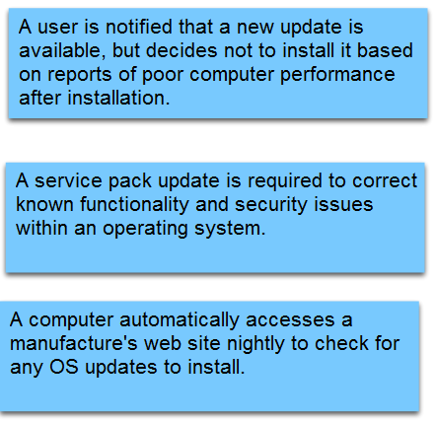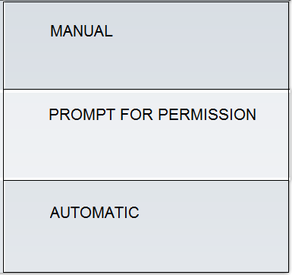

23. Why do browsers and office software such as word processors, spreadsheet and database applications need to be patched?

Complete Lab 2.3.3

