Name __________________________________________________________ Date ________________

Chapter 3
Reading Organizer
Answer Key
3.1

1. Explain the difference between a dedicated networks and converged networks.

Dedicated networks for voice, video and computer data communications required a different type of device in order to access the network. Telephones, televisions, and computers used specific technologies and different dedicated network structures, to communicate.

Converged networks are capable of delivering voice, video and data services over the same communication channel or network structure.

2. Why is the internet considered a "network of networks"?

Because it is literally made up of thousands of networks that are connected to each other.

3. Explain the four main categories of network components. List examples in each area.

Hosts –
Hosts send and receive user traffic. A host is a generic name for most end-user devices. A host has an IP network address. Examples of hosts are personal computers and network attached printers.

Shared peripherals –
Shared peripheral devices do not communicate directly on the network. Insteead, peripherals rely on their connected host to perform all network operations. Examples of shared peripherals are cameras, scanners, and locally attached printers.

Networking devices –
Networking devices connect other devices, mainly hosts. These devices move and control network traffic. Examples of network evices include hubs, switches, and routers.

Networking media –
Network media provides connections between hosts and network devices. Network media can be wired, such as copper and fiber optic or use wireless technologies.

4. Explain what the simplest form of peer-to-peer network is.

The simplest peer-to-peer network consists of two directly connected computers using a wired or wireless connection.

5. What are the advantages of a peer-to-peer network?

a. Easy to set up
b. Less complexity
c. Lower cost
d. Can be used for simple tasks such as transferring files and sharing printers

6. What are the disadvantages of a peer-to-peer network?

a. No centralized administration
b. Not as secure
c. Not scalable
c. All devices may act as both clients and servers which can slow their performance

7. 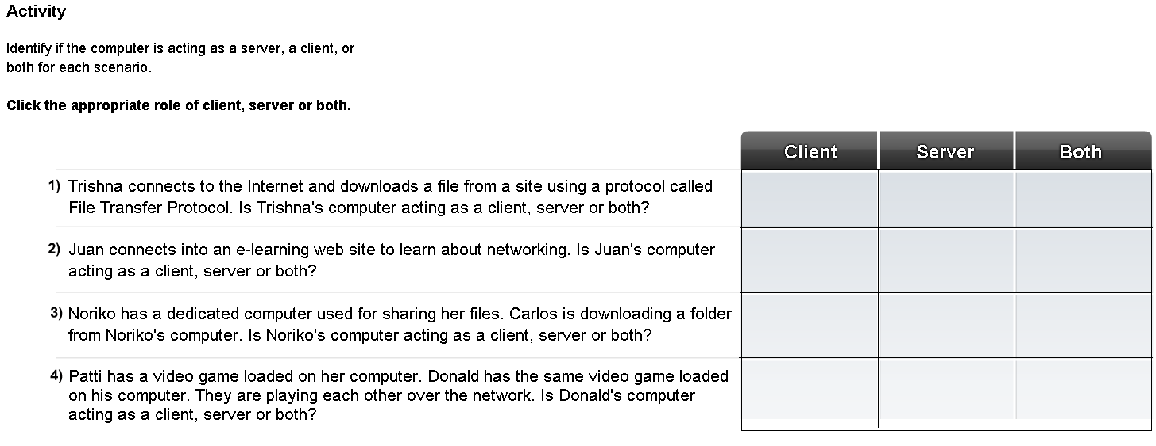

Complete Lab Activity 3.1.5

8. Explain the features of a physical topology.

A physical topology map is created to record where each host is located and how it is connected to the network. The physical topology map also shows where the wiring is installed and the locations of the networking devices that connect the hosts.

9. Explain the features of a logical topology.

A logical topology map groups hosts by how they use the network, no matter where they are physically located. Host names, addresses, group information and applications can be recorded on the logical topology map.

3.2

10. What issues do networking protocols help to manage?

a. Message format
b. Message size
c. Timing
d. Encapsulation
e. Encoding
f. Standard message pattern

11. What is encapsulation?

The process of placing one message format (the letter) inside another message format (the envelope) is called encapsulation.

12. Explain in detail the three rules of engagement with regard to timing.

Access Method -

Access Method determines when someone is able to send a message. These timing rules are based on the environment. For example, you may be able to speak whenever you have something to say. In this environment, a person must wait until no one else is talking before speaking. If two people talk at the same time, a collision of information occurs and it is necessary for the two to back off and start again. These rules ensure communication is successful. Likewise, it is necessary for computers to define an access method. Hosts on a network need an access method to know when to begin sending messages and how to respond when errors occur.

Flow Control -

Timing also effects how much information can be sent and the speed that it can be delivered. If one person speaks too quickly, it is difficult for the other person to hear and understand the message. The receiving person must ask the sender to slow down. In network communication, a sending host can transmit messages at a faster rate than the destination host can receive and process. Source and destination hosts use flow control to negotiate correct timing for successful communication.

Response Timeout -

If a person asks a question and does not hear a response within an acceptable amount of time, the person assumes that no answer is coming and reacts accordingly. The person may repeat the question, or may go on with the conversation. Hosts on the network also have rules that specify how long to wait for responses and what action to take if a response timeout occurs.

13. Explain the following types of network communication.

Uncast –
A one-to-one message pattern is referred to as a unicast, meaning that there is only a single destination for the message.

Multcast –
When a host needs to send messages using a one-to-many pattern, it is referred to as a multicast. Multicasting is the delivery of the same message to a group of host destinations simultaneously.

Broadcast -
If all hosts on the network need to receive the message at the same time, a broadcast is used. Broadcasting represents a one-to-all message pattern.

14.
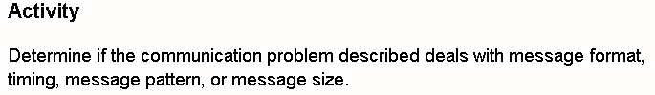

Draw a line between the communication characteristic producing the problem to the appropriate scenario.

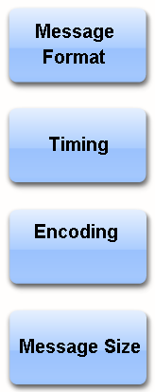
3.3

15. Explain what protocols allow networks to accomplish.

Protocols are especially important on a local network. In a wired environment, a local network is defined as an area where all hosts must "speak the same language" or in computer terms "share a common protocol".

16. What is the most common set of protocols used on local wired networks?

Ethernet

17. The above protocol defines many aspects of communication over the local networks, including:

a. message format
b. message size
c. timing
d. encoding
e. message patterns

18. Standards are beneficial to networking in many ways. These include:

a. Facilitate design
b. Simplify product development
c. Promote competition
d. Provide consistent interconnections
e. Facilitate training
f. Provide more vendor choices for customers

19. Breakdown and explain the term 100BASE-T.

100 - is the speed in Mbps
BASE - stands for baseband transmission
T - stands for the type of cable, in this case, twisted pair.

20. Explain in detail how Ethernet networks use Media Access Control (MAC) addresses when communicating and sending frames.

When a host on an Ethernet network communicates, it sends frames containing its own MAC address as the source and the MAC address of the intended recipient. Any hosts that receive the frame will decode the frame and read the destination MAC address. If the destination MAC address matches the address configured on the NIC, it will process the message and store it for the host application to use. If the destination MAC address does not match the host MAC address, the NIC will ignore the message.
21. Which specific address do NICs use when deciding whether or not to accept a frame?

Destination MAC address

Complete Lab Activity 3.3.3

22. Explain each part of the Ethernet frame below.

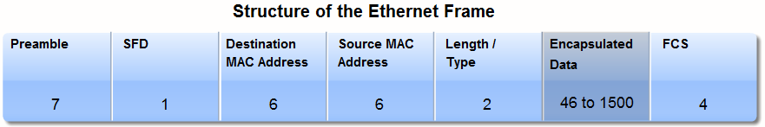

Preamble –
Defined pattern of alternating 1 and 0 bits used to synchronize timing

SFD –
Start of Frame Delimiter. Marks the end of the timing information and start of the frame.

Destination MAC Address –
The Destination MAC Address field contains the destination MAC address (receiver). The destination MAC address can be unicast (a specific host), multicast (a group of hosts), or broadcast (all hosts on the local network).

Source MAC Address –
The Source MAC Address field contains the source MAC address (sender). This is the unicast address of the Ethernet node that transmitted the frame.

Length / Type –
The Length/Type field supports two different uses. A type value indicates which protocol will receive the data. The length indicates the number of bytes of data that follows this field.

Encapsulated Data –
The Data field contains the packet of information being sent. Ethernet requires each frame to be between 64 and 1518 bytes.

FCS –
The FCS contains a 4-byte value that is created by the device that sends data and is recalculated by the destination device to check for damaged frames.

23. What does the format for Ethernet frames specify?

a. the location of the destination and source MAC addresses
b. Preamble for sequencing and timing
c. Start of frame delimiter
d. Length and type of frame
e. Frame check sequence to detect transmission errors

24. In networking, what is the hierarchical design used to do?

It is used to group devices into multiple networks that are organized in a layered approach. It consists of smaller, more manageable groups that allow local traffic to remain local. Only traffic that is destined for other networks is moved to a higher layer.

25. Explain the three basic layers of the hierarchical design model:

Access Layer - to provide connections to hosts in a local Ethernet network.
Distribution Layer - to interconnect the smaller local networks.
Core Layer - a high-speed connection between distribution layer devices.

26. Explain in detail the differences between physical and logical addresses.

On a host, the MAC address does not change; it is physically assigned to the host NIC and is known as the physical address. The physical address remains the same regardless of where the host is placed on the network.

The IP address is similar to the address of a person. It is known as a logical address because it is assigned logically based on where the host is located. The IP address, or network address, is assigned to each host by a network administrator based on the local network.

27. List and explain the two parts of an IP address.

IP addresses contain two parts. One part identifies the local network. The network portion of the IP address will be the same for all hosts connected to the same local network. The second part of the IP address identifies the individual host. Within the same local network, the host portion of the IP address is unique to each host.

Complete Lab Activity 3.3.6

28. Explain in detail the three layers of the hierarchical design model.

Access Layer -

The Access Layer provides a connection point for end user devices to the network and allows multiple hosts to connect to other hosts through a network device, usually a hub or switch. Typically, all devices within a single Access Layer will have the same network portion of the IP address.

If a message is destined for a local host, based on the network portion of the IP address, the message remains local. If it is destined for a different network, it is passed up to the Distribution Layer. Hubs and switches provide the connection to the Distribution Layer devices, usually a router.

Distribution Layer –

The Distribution Layer provides a connection point for separate networks and controls the flow of information between the networks. It typically contains more powerful switches than the Access Layer as well as routers for routing between networks. Distribution Layer devices control the type and amount of traffic that flows from the Access Layer to the Core Layer.

Core Layer –

The Core Layer is a high-speed backbone layer with redundant (backup) connections. It is responsible for transporting large amounts of data between multiple end networks. Core Layer devices typically include very powerful, high-speed switches and routers. The main goal of the Core Layer is to transport data quickly. Hubs, switches, and routers are discussed in more detail in the next two sections.

29. 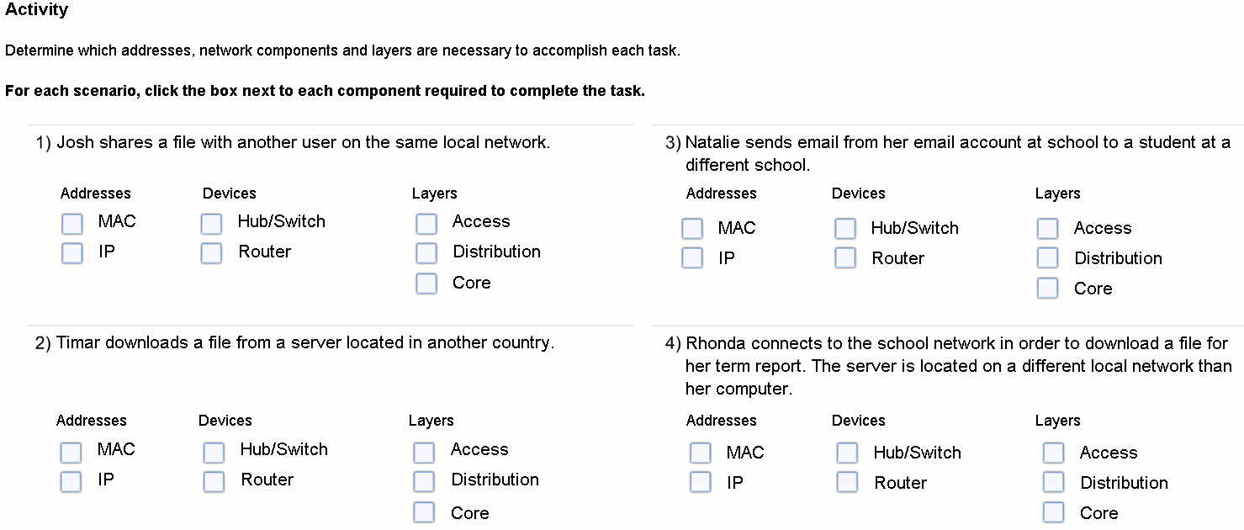

3.4

30. Within an Ethernet network, each host is able to connect directly to an Access Layer networking device using a point-to-point cable. What are these networking devices that each host connects to?

Hubs and switches

31. When a hub receives a message from a host for another host what does it do with it?

Hubs cannot determine which host should get any particular message. A hub simply accepts electronic signals from one port and regenerates (or repeats) the same message out all of the other ports.

32. What happens after a collision occurs in a collision domain?

A collision causes the messages to become garbled and unreadable by the hosts. A hub does not decode the messages; therefore it does not detect that the message is garbled and repeats it out all the ports. The area of the network where a host can receive a garbled message resulting from a collision is known as a collision domain.

Inside a collision domain, when a host receives a garbled message, it detects that a collision has occurred. Each sending host waits a short amount of time and then attempts to send, or retransmit, the message again. As the number of hosts connected to the hub increases, so does the chance of collisions. More collisions cause more retransmissions.

33. Why do you need to limit the size of collision domains?

More collisions cause more retransmissions. Excessive retransmissions can clog up the network and slow down network traffic. For this reason, it is necessary to limit the size of a collision domain.

34.
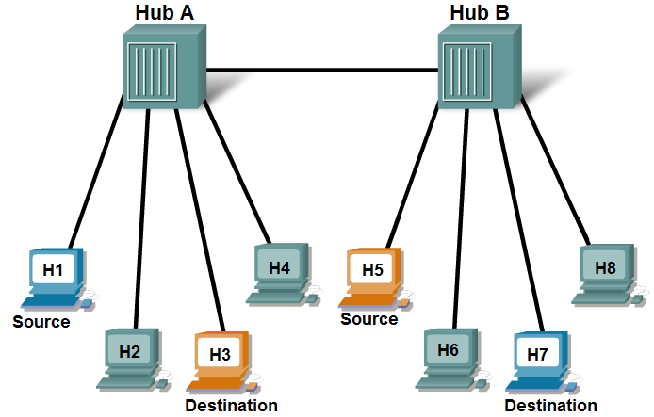
Based on the graphic above complete the following questions.

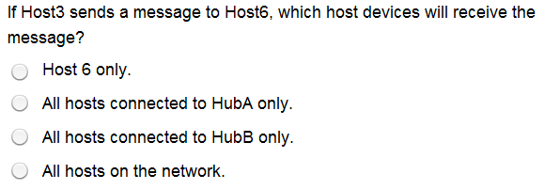

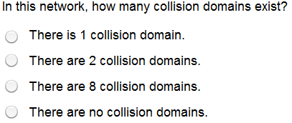

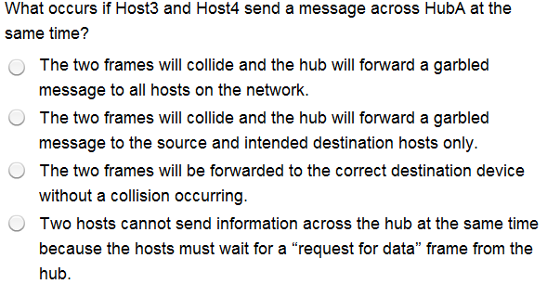

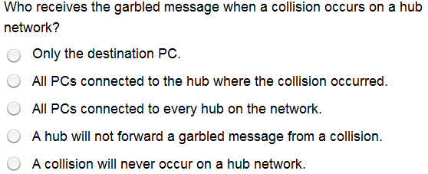
35. What advantage does a switch have over a hub when forwarding messages through the network?

Unlike a hub, a switch can forward a message to a specific host.

36. What is a MAC address table?

A table on the switch, called a MAC address table, contains a list of all of the active ports and the host MAC addresses that are attached to them.

37. What happens when the switch receives a frame addressed to a new host that is not yet in the MAC address table?

If the destination MAC address is not in the table, the switch does not have the necessary information to create an individual circuit. When the switch cannot determine where the destination host is located, it uses a process called flooding to forward the message out to all attached hosts. Each host compares the destination MAC address in the message to its own MAC address, but only the host with the correct destination address processes the message and responds to the sender.

38. How does the MAC address of a new host get into the MAC address table?

A switch builds the MAC address table by examining the source MAC address of each frame that is sent between hosts. When a new host sends a message or responds to a flooded message, the switch immediately learns its MAC address and the port to which it is connected. The table is dynamically updated each time a new source MAC address is read by the switch. In this way, a switch quickly learns the MAC addresses of all attached hosts.

39. How many collision domains are in the graphic?
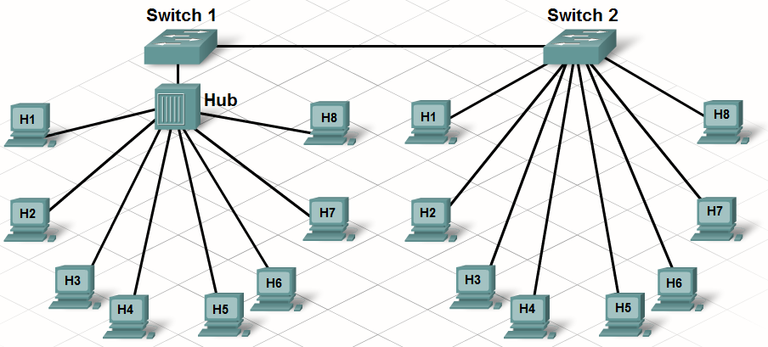

10 (ten) Every switch port creates a separate collision domain.

40.
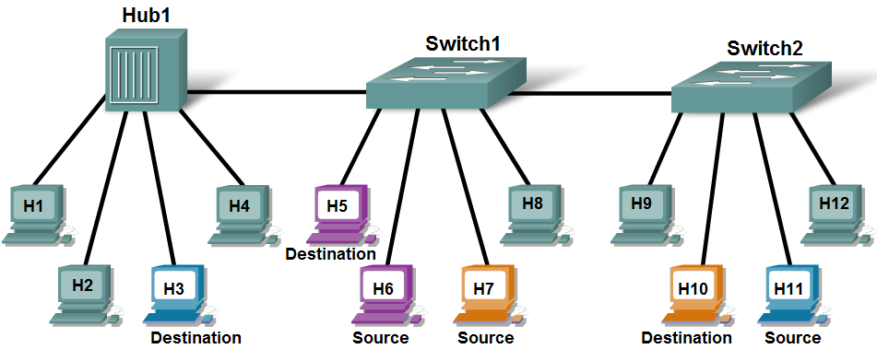
Based on the graphic above complete the following questions.

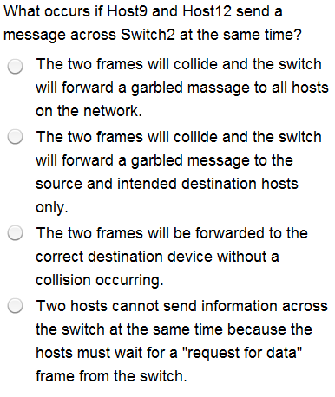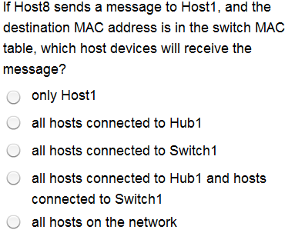

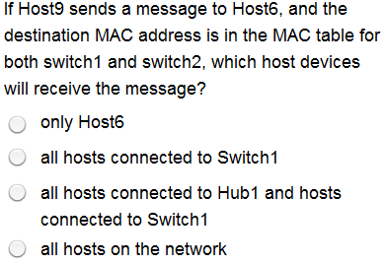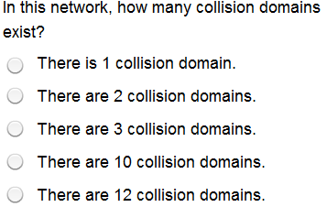
41. Explain what a network broadcast is?

Within the local network it is often necessary for one host to be able to send messages to all the other hosts at the same time. This can be done using a message known as a broadcast. Broadcasts are useful when a host needs to find information without knowing exactly what other host can supply it or when a host wants to provide information to all other hosts in the same network in a timely manner.

42. How is a Broadcast MAC address represented?

MAC addresses are usually represented in hexadecimal notation. The broadcast MAC address in hexadecimal notation is FFFF.FFFF.FFFF.

43. Explain the problem encountered with too many computers in a broadcast domain?

If too many hosts are connected to the same broadcast domain, broadcast traffic can become excessive. The number of hosts and the amount of network traffic that can be supported on the local network is limited by the capabilities of the hubs and switches used to connect them. As the network grows and more hosts are added, network traffic, including broadcast traffic, increases. It is often necessary to divide one local network, or broadcast domain, into multiple networks to improve performance.

44.
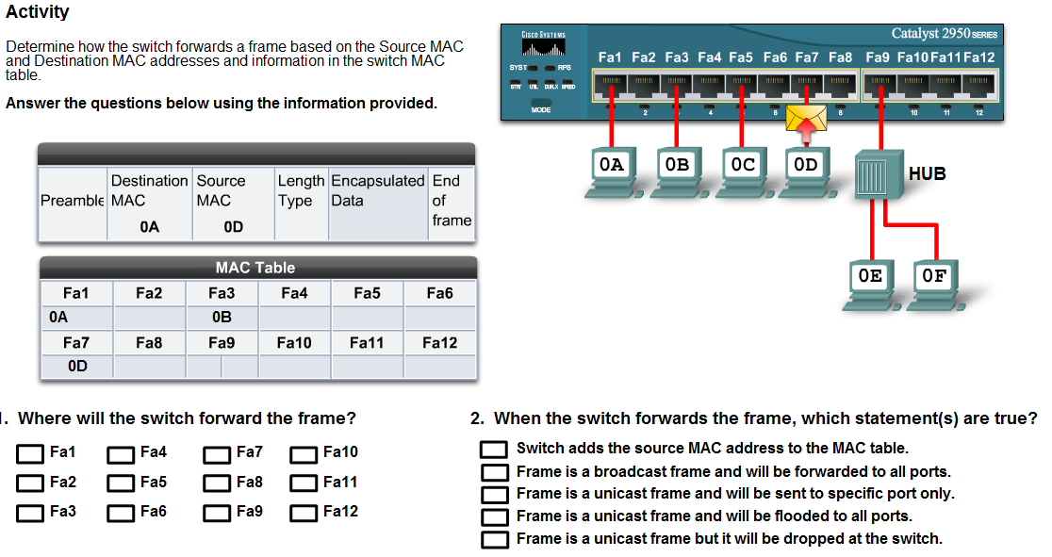

45.
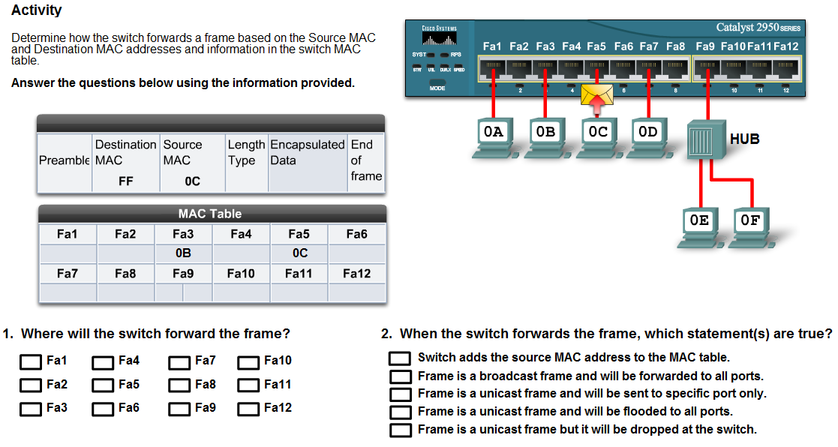

46.
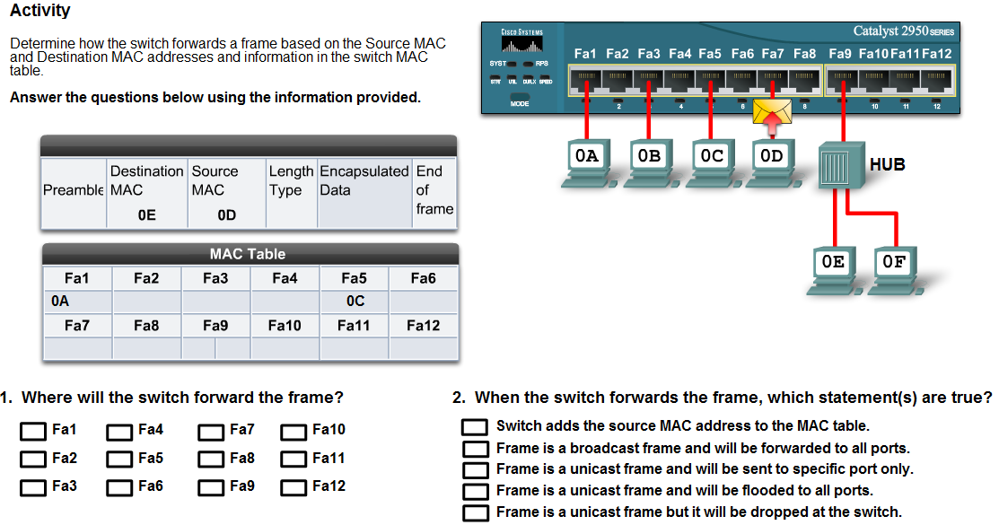

47. Explain the three step process that Address Resolution Protocol (ARP) uses to discover and store MAC addresses.

1. The sending host creates and sends a frame addressed to a broadcast MAC address. Contained in the frame is a message with the IP address of the intended destination host.

2. Each host on the network receives the broadcast frame and compares the IP address inside the message with its configured IP address. The host with the matching IP address sends its MAC address back to the original sending host.

3. The sending host receives the message and stores the MAC address and IP address information in a table called an ARP table.

3.5

48. In very general terms, what is the function of a router?

A router is a networking device that connects a local network to other local networks.

49. How do routers and switches differ?

Switches only decode (unencapsulate) the frame containing the MAC address information
Routers.
The router reads the network portion of the destination IP address and uses it to find which one of the attached networks is the best way to forward the message to the destination.

Complete Lab Activity 3.5.2

50. Explain how a router determines what path to send the message to get to the destination network?

When a router receives a frame, it decodes the frame to get to the packet containing the destination IP address. It matches the address of the destination to all of the networks that are contained in the routing table. If the destination network address is in the table, the router encapsulates the packet in a new frame in order to send it out. It forwards the new frame out of the interface associated with the path, to the destination network.

51. How do routers handle broadcasts messages using a MAC address?

Router interfaces do not forward messages that are addressed to the broadcast MAC address. As a result, local network broadcasts are not sent across routers to other local networks.

52. Which device is typically used as a hosts default gateway?

The default gateway address is the address of the router interface connected to the same local network as the source host.

53. Why are default gateways necessary to proper network functionality?

If no default gateway is configured in the host TCP/IP settings, or if the wrong default gateway is specified, messages addressed to hosts on remote networks cannot be delivered.

54.
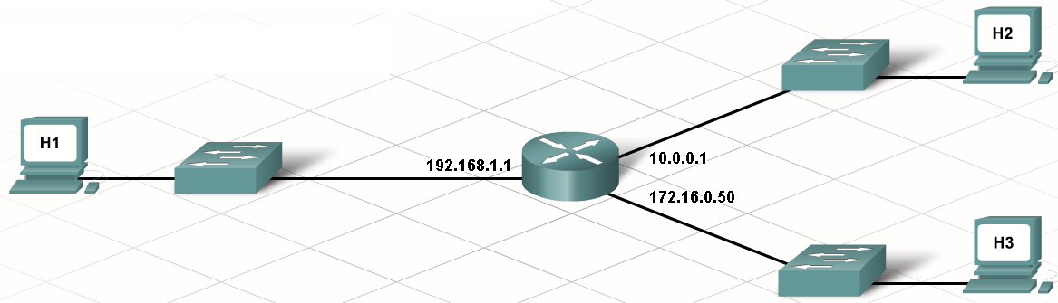
Based on the information included with the graphic, list the correct default gateway for each computer.

H1 ___________192.168.1.1__________________

H2 ___________10.0.0.1_____________________

H3 ___________172.16.0.50__________________

55. What do routers use routing tables to determine?

Routers use the routing tables to determine which interface to use to forward a message to its intended destination.

56. Explain the purpose of configuring a routing table with a default route.

If the router cannot determine where to forward a message, it will drop it. Network administrators configure a routing table with a default route to keep a packet from being dropped because the path to the destination network is not in the routing table. A default route is the interface through which the router forwards a packet containing an unknown destination IP network address.

57. When host A forwards a frame to host B in the same network which destination MAC address is used?

Host B

58. When host A forwards a frame to host F which is in a different network through router C which destination MAC address is used?

Router C

59.
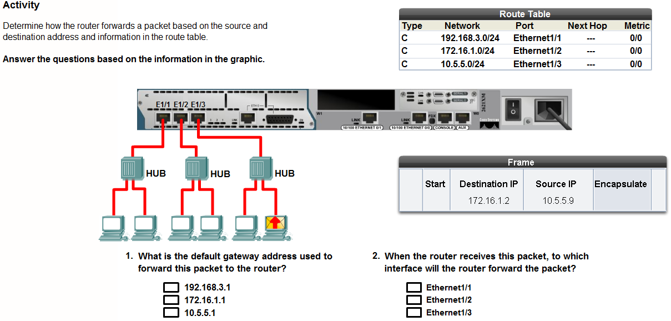
60.
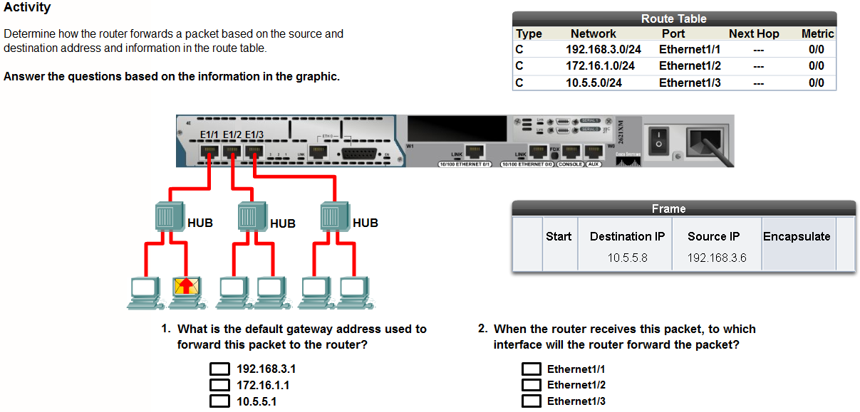
61. Explain the term Local Area Network (LAN).

The term Local Area Network (LAN) refers to a local network, or a group of interconnected local networks that are under the same administrative control. In the early days of networking,

Learn to Use Packet Tracer 3.5.7

3.6

62. A network plan starts with the gathering of information about how the network will be used. This information could include:

a. The number and type of hosts to be connected to network
b. The applications to be used
c. Sharing and Internet connectivity requirements
d. Security and privacy considerations
e. Reliability and uptime expectations
f. Connectivity requirements including, wired and wireless

63. Explain what should be included in a physical topology of the network:

a. Physical location of devices such as routers, switches, and hosts
b. How all devices are interconnected
c. Location and length of all cable runs
d. Hardware configuration of end devices such as hosts and servers

64. Explain what should be included in a logical topology of the network:

a. Location and size of broadcast and collision domains
b. IP addressing scheme
c. Naming scheme
d. Sharing configuration
e. Permissions

65. What is the purpose of prototyping?

A prototype allows a network administrator to test whether or not the planned network will operate as expected, before money is spent on equipment and installation. Documentation should be maintained on all aspects of the prototyping process.

Packet Tracer Activity 3.6.2

66. An integrated services router (ISR) can perform the functions of what devices?

Switch, Router, and Access Point

Complete Lab Activity 3.6.4

67. Why would you disable Simple File Sharing on your computer?

Simple File Sharing can be disabled so that more specific security access levels can be assigned.

Complete Lab Activity 3.6.5

