Name __________________________________________________________ Date ________________

Chapter 3
Reading Organizer

After completion of this chapter, you should be able to:
- Explain the concept of networking and the benefits of networks.
- Explain the concept of communication protocols.
- Explain how communication occurs across a local Ethernet network.
- Describe Access layer devices and communication methods on a local Ethernet network.
- Describe Distribution layer devices and communication methods across networks.
- Plan, implement, and verify a local network.

3.1

1. Explain the difference between a dedicated networks and converged networks.

2. Why is the internet considered a "network of networks"?

3. Explain the four main categories of network components. List examples in each area.

Hosts –

Shared peripherals –

Networking devices –

Networking media –

4. Explain what the simplest form of peer-to-peer network is.

5. What are the advantages of a peer-to-peer network?

a.

b.

c.

d.

6. What are the disadvantages of a peer-to-peer network?

a.

b.

c.

c.

7. 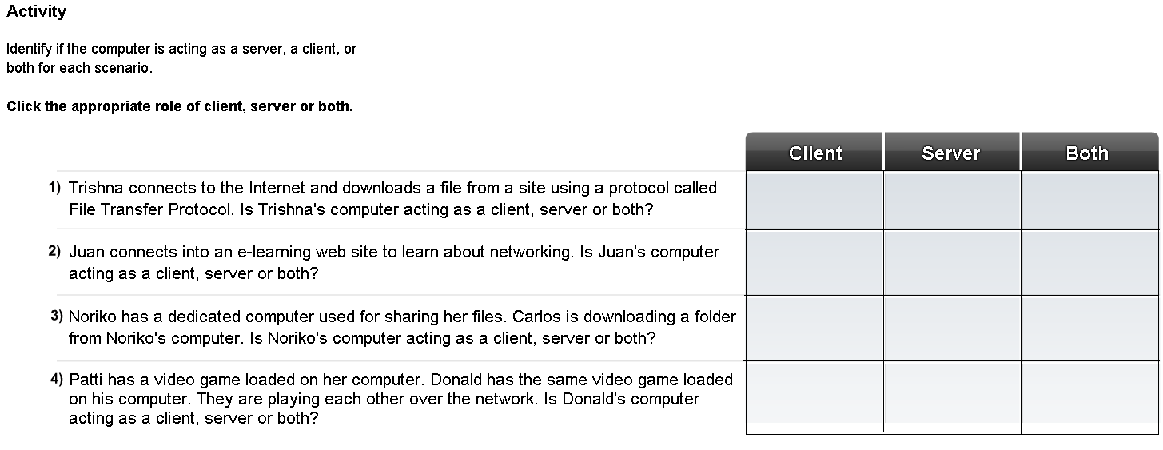

Complete Lab Activity 3.1.5

8. Explain the features of a physical topology.

9. Explain the features of a logical topology.

3.2

10. What issues do networking protocols help to manage?

a.

b.

c.

d.

e.

f.

11. What is encapsulation?

12. Explain in detail the three rules of engagement with regard to timing.

Access Method -

Flow Control -

Response Timeout -

13. Explain the following types of network communication.

Uncast –

Multcast –

Broadcast -

14.
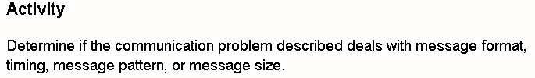

Draw a line between the communication characteristic producing the problem to the appropriate scenario.

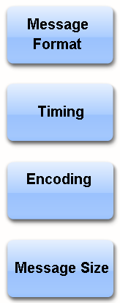
3.3

15. Explain what protocols allow networks to accomplish.

16. What is the most common set of protocols used on local wired networks?

17. The above protocol defines many aspects of communication over the local networks, including:

a.

b.

c.

d.

e.

18. Standards are beneficial to networking in many ways. These include:

a.

b.

c.

d.

e.

f.

19. Breakdown and explain the term 100BASE-T.

100 -

BASE -

T -

20. Explain in detail how Ethernet networks use Media Access Control (MAC) addresses when communicating and sending frames.

21. Which specific address do NICs use when deciding whether or not to accept a frame?

Complete Lab Activity 3.3.3

22. Explain each part of the Ethernet frame below.

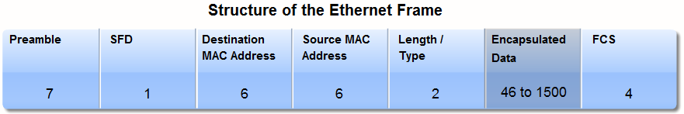

Preamble –

SFD –

Destination MAC Address –

Source MAC Address –

Length / Type –

Encapsulated Data –

FCS –

23. What does the format for Ethernet frames specify?

a.

b.

c.

d.

e.

24. In networking, what is the hierarchical design used to do?

25. Explain the three basic layers of the hierarchical design model:

26. Explain in detail the differences between physical and logical addresses.

27. List and explain the two parts of an IP address.

Complete Lab Activity 3.3.6

28. Explain in detail the three layers of the hierarchical design model.

Access Layer -

Distribution Layer –

Core Layer –

29. 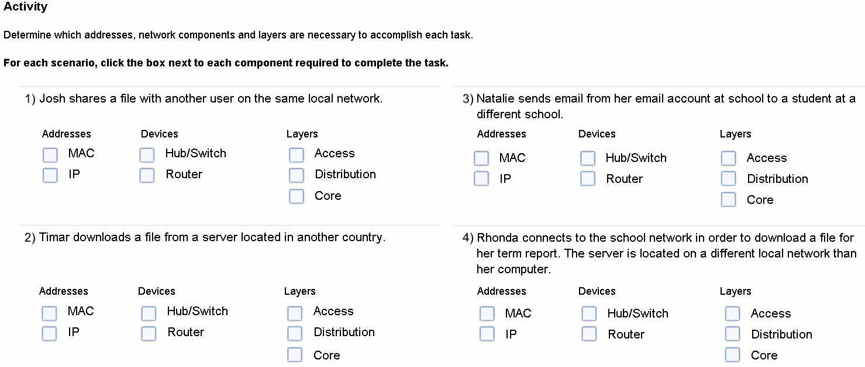
3.4

30. Within an Ethernet network, each host is able to connect directly to an Access Layer networking device using a point-to-point cable. What are these networking devices that each host connects to?

31. When a hub receives a message from a host for another host what does it do with it?

32. What happens after a collision occurs in a collision domain?

33. Why do you need to limit the size of collision domains?

34.
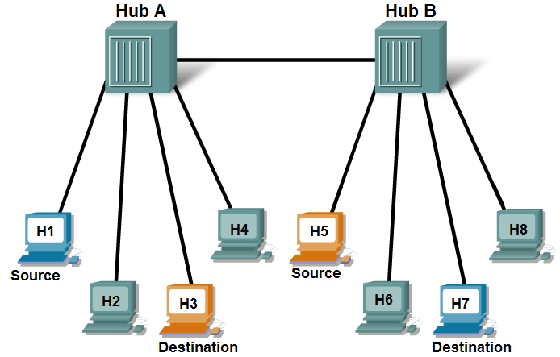
Based on the graphic above complete the following questions.

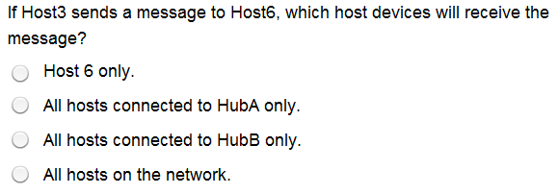

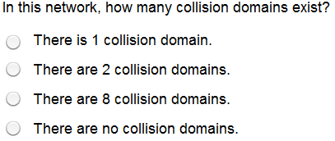

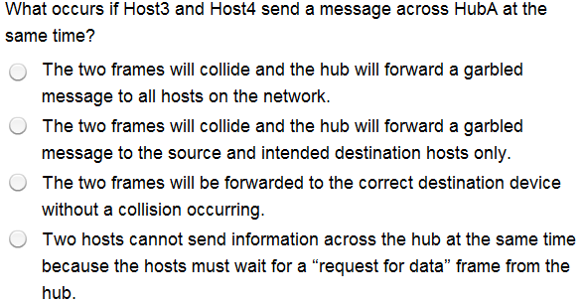

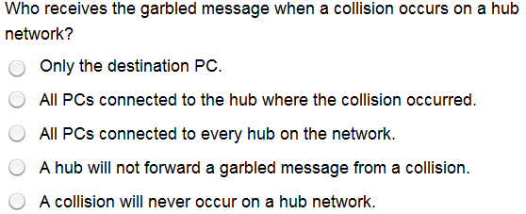
35. What advantage does a switch have over a hub when forwarding messages through the network?

36. What is a MAC address table?

37. What happens when the switch receives a frame addressed to a new host that is not yet in the MAC address table?

38. How does the MAC address of a new host get into the MAC address table?

39. How many collision domains are in the graphic?
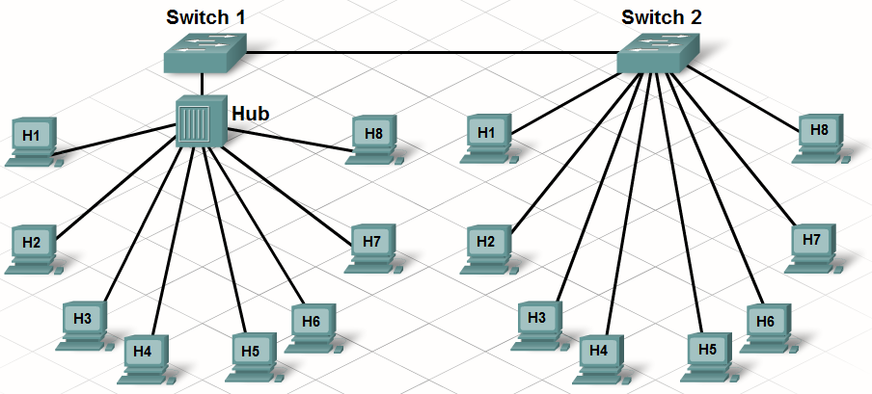

40.
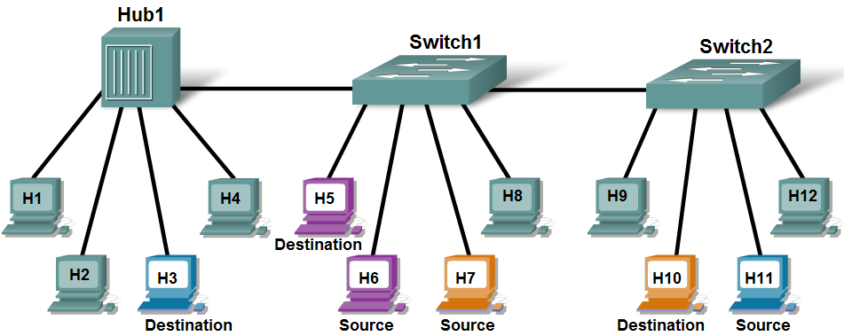
Based on the graphic above complete the following questions.

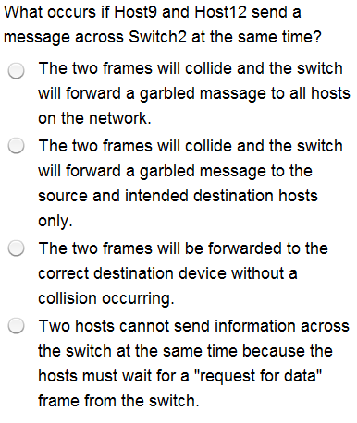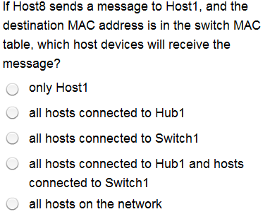

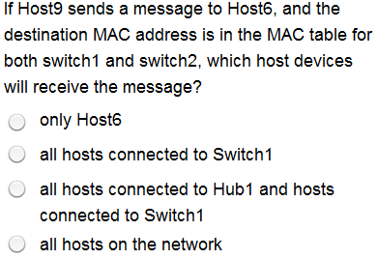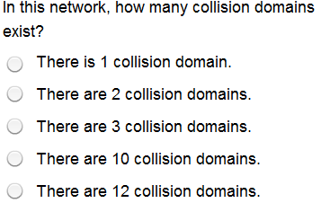
41. Explain what a network broadcast is?

42. How is a Broadcast MAC address represented?

43. Explain the problem encountered with too many computers in a broadcast domain?

44.
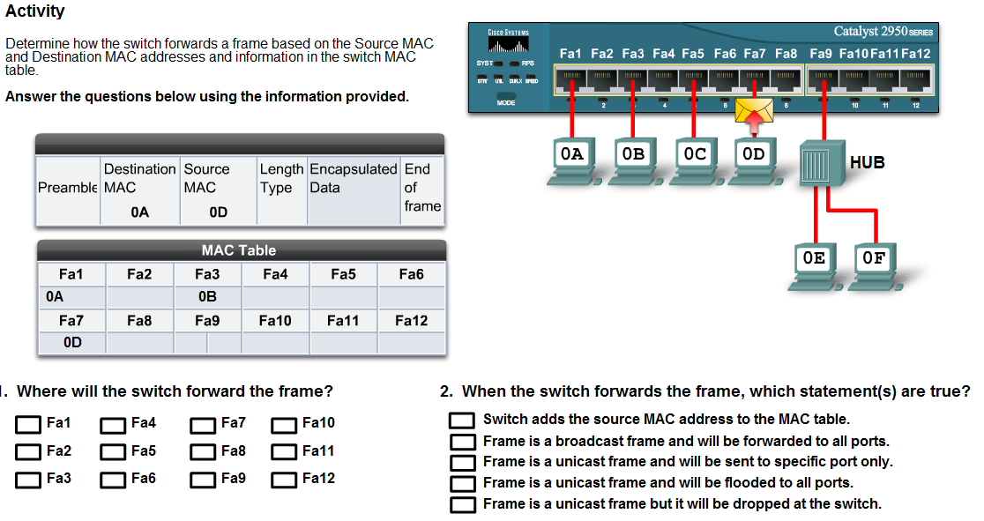
45.
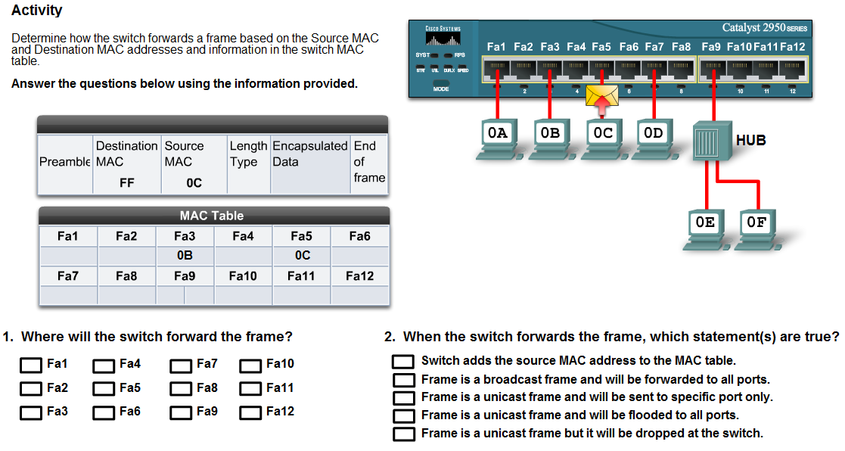

46.
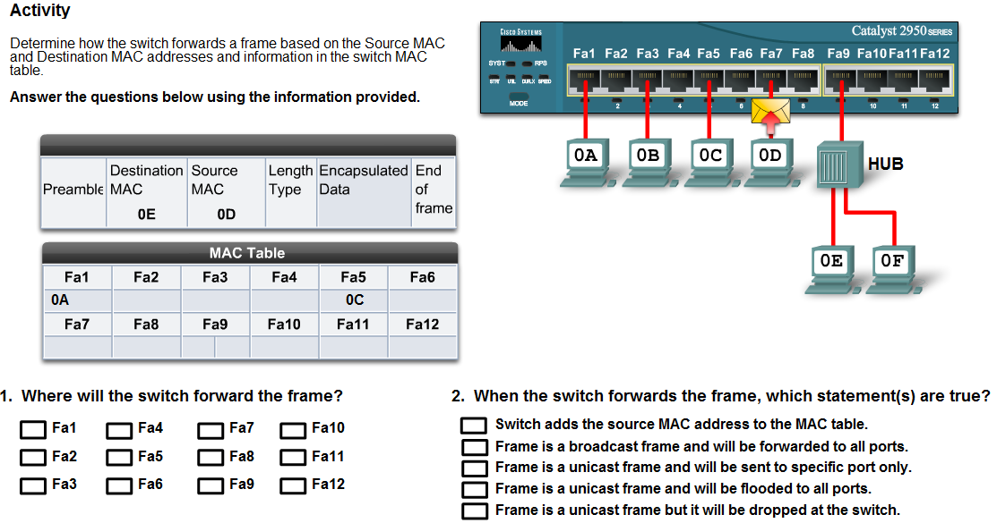

47. Explain the three step process that Address Resolution Protocol (ARP) uses to discover and store MAC addresses.

1.

2.

3.

3.5

48. In very general terms, what is the function of a router?

49. How do routers and switches differ?

Complete Lab Activity 3.5.2

50. Explain how a router determines what path to send the message to get to the destination network?

51. How do routers handle broadcasts messages using a MAC address?

52. Which device is typically used as a hosts default gateway?

53. Why are default gateways necessary to proper network functionality?

54.
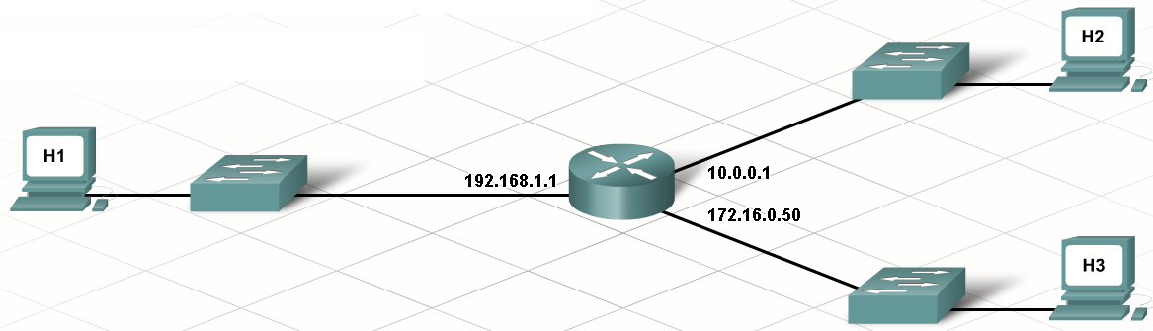
Based on the information included with the graphic, list the correct default gateway for each computer.

H1 ________________________________

H2 ________________________________

H3 ________________________________

55. What do routers use routing tables to determine?

56. Explain the purpose of configuring a routing table with a default route.

57. When host A forwards a frame to host B in the same network which destination MAC address is used?

58. When host A forwards a frame to host F which is in a different network through router C which destination MAC address is used?

59.
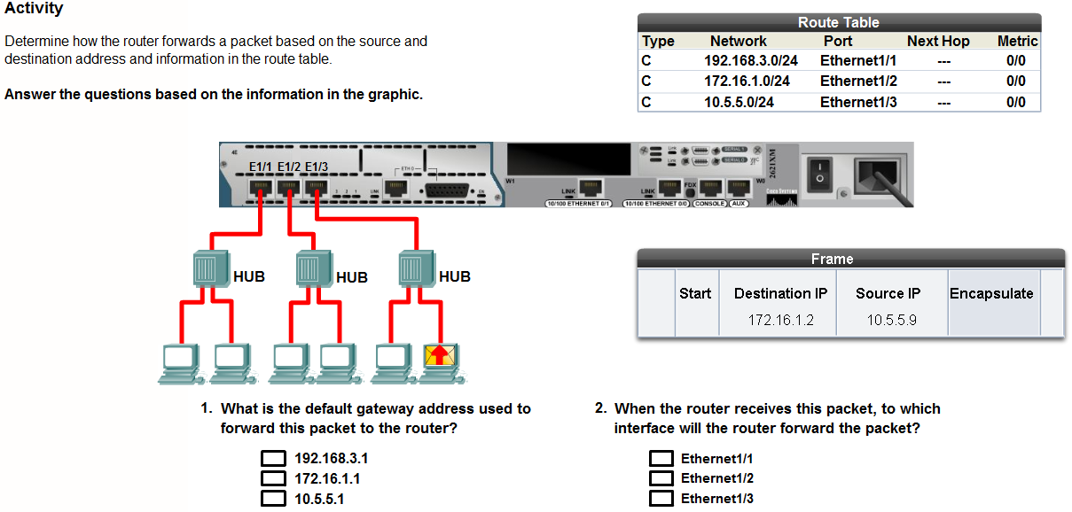
60.
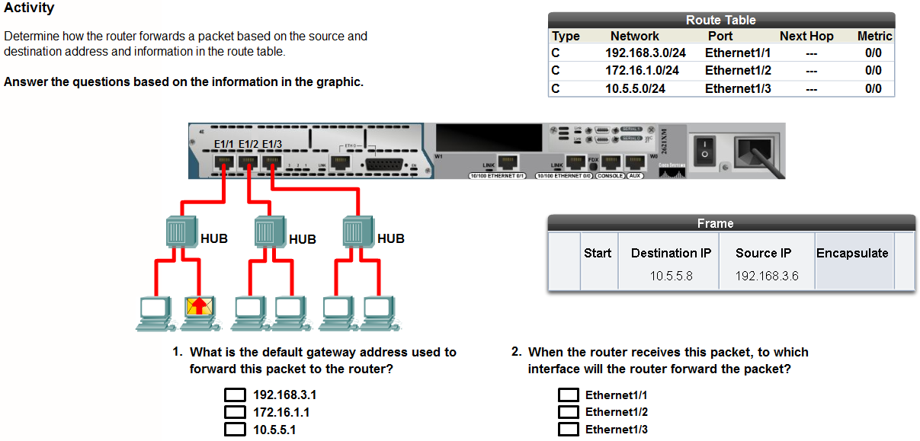
61. Explain the term Local Area Network (LAN).

Learn to Use Packet Tracer 3.5.7

3.6

62. A network plan starts with the gathering of information about how the network will be used. This information could include:

a.

b.

c.

d.

e.

f.

63. Explain what should be included in a physical topology of the network:

a.

b.

c.

d.

64. Explain what should be included in a logical topology of the network:

a.

b.

c.

d.

e.

65. What is the purpose of prototyping?

Packet Tracer Activity 3.6.2

66. An integrated services router (ISR) can perform the functions of what devices?

Complete Lab Activity 3.6.4

67. Why would you disable Simple File Sharing on your computer?

Complete Lab Activity 3.6.5

