Name _______________________________________________________ Date ________________

Chapter 4
Reading Organizer
Answer Key
4.1

- In simple terms what is the internet?

The Internet is a network of networks that connects users in every country in the world.

2. According to Cisco what two things are essential to gaining access to the internet?

a. ISPs are essential to gaining access to the Internet.
b. No one gets on the Internet without a host computer, and no one gets on the Internet without going through an ISP.

3. Explain in detail what a Point of Presence or (POP) is.

Individual computers and local networks connect to the ISP at a Point of Presence (POP). A POP is the connection point between the ISP's network and the particular geographical region that the POP is servicing.

4. Explain what an internet backbone is and what it does.

ISPs connect to other ISPs in order to send information beyond the boundaries of their own network. The Internet is made up of very high-speed data links that interconnect ISP POPs and ISPs to each other. These interconnections are part of the very large, high capacity network known as the Internet Backbone.

5. Explain what services an integrated router or integrated services router (ISR) provides?

If multiple computers connect through a single ISP connection, you will need additional networking devices. This includes a switch to connect multiple hosts on a local network, and a router to move packets from your local network to the ISP network. A home networking device, such as an integrated router, can provide these functions, as well as wireless capability, in a single package.

6. Most ISPs offer two different contract levels: home service and business class service. Explain the characteristics of each.

a. Home Service:
Home service is normally less expensive than business services, and generally provides scaled-down services such as slower connection speed, reduced web space storage, and fewer email accounts. A typical home account may include a minimum of five email addresses with additional addresses being available for a fee.

b. Business Class Service:
Business class service is more expensive but provides faster connection speeds and additional web space and email accounts. A business class service may include twenty, fifty or more email addresses. Business service also includes agreements between the ISP and the customer specifying items such as network availability and service response time. These are known as Service Level Agreements (SLAs).

7. List and explain the characteristics of asymmetric and symmetric data transfer.

a. Asymmetric:
Most commonly used for the home.
Download speeds are faster than upload speeds.
Necessary for users that download significantly more than upload.
Most Internet users, especially those who use graphics or multimedia intensive web data, need lots of download bandwidth.

b. Symmetric:
Most commonly used for business or individuals hosting servers on the Internet.
Used when necessary to upload large amounts of traffic such as intensive graphics, multimedia, or video.
It can carry large amounts of data in both directions at equal rates.

8.
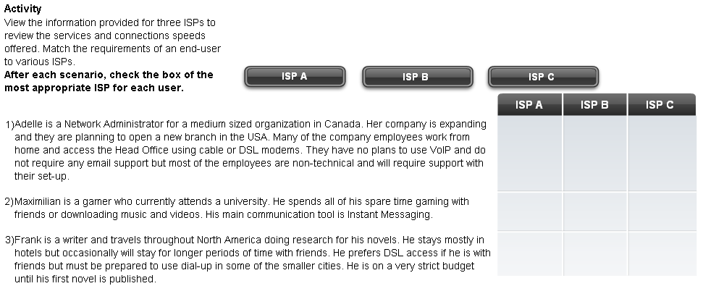

4.2

9. Explain in detail what the Ping utility does.

The ping utility tests end-to-end connectivity between source and destination. It measures the time that it takes test packets to make a round trip from the source to the destination and whether the transmission is successful.

10. Explain in detail what the Traceroute utility does.

The traceroute utility traces the route from source to destination. Each router through which the packets travel is referred to as a hop. Traceroute displays each hop along the way and the time it takes for each one. If a problem occurs, the display of the time and the route that the packet traveled can help to determine where the packet was lost or delayed.

Complete Packet Tracer Activity 4.2.3
Complete Lab Activity 4.2.3
4.3

11. Devices that provide connectivity to end-users must match the technology used by the end-user to connect to the ISP.

a. What type of device would be required for an end user using DSL technology?

If the end-user is using DSL technology to connect, the ISP must have a DSL Access Multiplexer (DSLAM) to accept these connections.

b. What type of device would be required for an end user connecting through cable?

For cable modems to connect, the ISP must have a Cable Modem Termination System (CMTS).

12. What are the advantages of an integrated router or integrated service router (ISR) for home use?

Integrated routers can perform several functions, including: Wireless LAN access point, switching, routing, firewalls and various address functions. An integrated router may support some or all of these functions.

13.
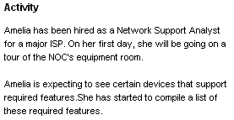

Draw a line between the correct device and the matching requirement.
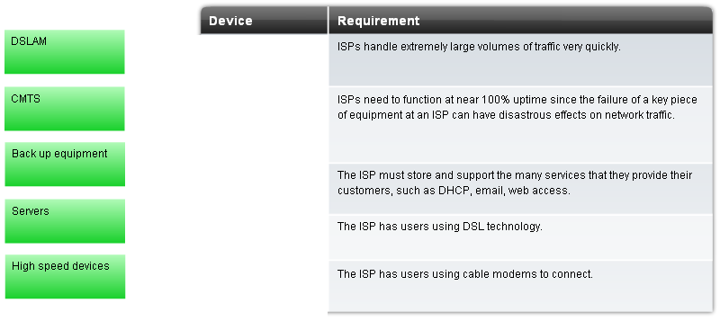

14. What are three physical and environmental factors which must be considered when setting up a home or small business network?

Environmental factors, such as heat and humidity.
Cable management is another area of concern.

4.4

15. Explain what networking media is.

A channel, or medium, provides a path over which the information is sent. In the networked world, the medium is usually some sort of physical cable. It may also be electromagnetic radiation, in the case of wireless networking. The connection between the source and destination may either be direct or indirect, and may span multiple media types.

16. Explain the following types of network cabling.

Twisted Pair -
Modern Ethernet technology generally uses a type of copper cable known as twisted pair (TP) to interconnect devices. Because Ethernet is the foundation for most local networks, TP is the most commonly encountered type of network cabling.

Coaxial Cable -
Coaxial cable is usually constructed of either copper or aluminum, and is used by cable television companies to provide service. It is also used for connecting the various components which make up satellite communication systems.

Fiber Optic -
Fiber optic cables are made of glass or plastic. They have a very high bandwidth, which enables them to carry very large amounts of data. Fiber is used in backbone networks, large enterprise environments and large data centers. It is also used extensively by telephone companies.

17. List and explain two types of interference commonly found with twisted pair cables.

a. A twisted pair cable is susceptible to electromagnetic interference (EMI), a type of noise.

b. A source of interference, known as crosstalk, occurs when cables are bundled together for long lengths. The signal from one cable can leak out and enter adjacent cables.

18. Three types of twisted pair cabling are?

a. unshielded twisted pair
b. shielded twisted pair
c. screened twisted pair

19. Explain what the following cables are used for, and common data speeds they can handle.

Category 3 –
- Used of Voice communication
- Most often used for phone lines

Category 5 and 5e –
- Used for Data transmission
- Cat 5 supports 100 Mbps and can support 1000 Mbps but it is not recommended
- Cat 5e can support 1000 Mbps

Category 6 –
- Used for Data transmission
- An added separator is between each pair of wires allowing it to function at higher speeds
- Supports 1000 Mbps – 10 Gbps, though 10 Gbps is not recommended

20. What terminator is commonly used with all UTP cabling?

All Categories of data grade UTP cable are traditionally terminated into an
RJ-45 connector.

21. Why is UTP cable more commonly used than coaxial cable in local networks?

Although coax has improved data carrying characteristics, most local area networking uses twisted pair because coax is physically harder to install and is more expensive.

22. Why is fiber optic cable preferred for use in areas where electricity or electrical components is an issue?

Fiber optic cable is constructed of either glass or plastic, neither of which conducts electricity. This means that it is immune to EMI and is suitable for installation in environments where interference is a problem.

23. Label the parts of a fiber optic cable.

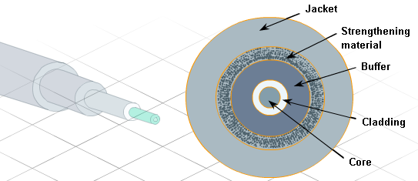

24. Explain in detail the two types of fiber optic cabling.

Multimode –
Of the two forms of fiber optic, multimode is the less expensive and more widely used. The light source that produces the pulses of light is usually an LED. It is referred to as multimode because there are multiple rays of light, each carrying data, being transmitted through the cable simultaneously. Each ray of light takes a separate path through the multimode core. Multimode fiber optical cables are generally suitable for links of up to 2000 meters. However, improvements in technology are continually improving this distance.

Single Mode –
Single mode fiber optic cables are constructed in such a way that light can follow only a single path through the fiber. The light source for single mode fiber optic cables is usually a LED laser, which is significantly more expensive and intense than ordinary LEDs. Due to the intensity of the LED laser, much higher data rates and longer ranges can be obtained. Single mode fibers can transmit data for approximately 3000 meters and is used for backbone cabling including the interconnection of various NOCs. Again, improvements in technology are continually improving this distance.

25.
Activity
Decide if fiber is the best solution to a cabling requirement. Put a check mark in the correct choice.
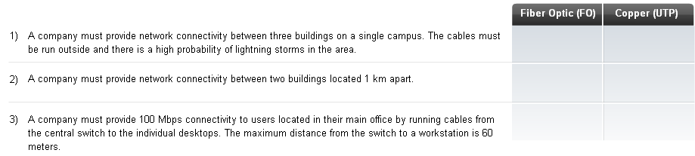

4.5

26. Why is it important to follow cabling standards, which have been developed by different organizations?

To ensure data networks operate to agreed levels of performance.

27. Fully explain what cabling standards are and what they specify.

Cabling standards are a set of specifications for the installation and testing of cables.
Standards specify types of cables to use in specific environments, conductor materials, pinouts, wire sizes, shielding, cable lengths, connector types and performance limits.

28. What is the difference between T568A and T568B pinouts.

The orange and green pairs of wires are reversed.

29. What type of cable is needed for “like devices”?

Crossover cable

30. What type of cable is needed for “unlike devices”?

Straight through cable

31. Identify if a crossover or straight through cable is necessary to connect the devices listed below.

Crossover Cable | Computer to Computer
Straight Through Cable | Switch to Computer
Crossover Cable | Router to Computer
Crossover Cable | Router to Router
Crossover Cable | Hub to Switch
Straight Through Cable | Switch to Router
Straight Through Cable | Hub to Computer
Crossover Cable | Hub to Hub

Complete Lab Activity 4.5.3

32. Explain in detail the characteristics of a patch panel.

The use of patch panels enables the physical cabling of the network to be quickly rearranged as equipment is added or replaced. These patch panels use RJ-45 jacks for quick connection on the front, but require the cables to be punched down on the reverse side of the RJ-45 jack.

33. Why is untwisting more cable than necessary to be avoided when terminating a female RJ-45 connector?

In all cases, untwisting more cable than is necessary will increase the amount of crosstalk and degrade overall network performance.

Complete Lab Activity 4.5.4

34. Explain the difference between a cable tester and a cable certifier.

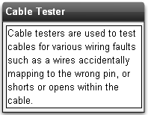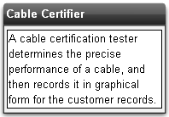

35. Explain in detail the following faults.

Short –
A short occurs when the copper conductors touch each other. As the electric pulse travels down the wire, it will cross onto the touching wire. This creates an unintended path in the flow of the signal to its destination.

Open –
An open circuit occurs when the wire is not properly pushed into the connector and there is no electrical contact. An open can also occur if there is a break in the wire.

Split Pair –
A split-pair fault occurs when one wire from one pair is switched with one wire from a different pair at both ends. A split pair creates two transmit or receive pairs each with two wires that are not twisted together. This mixing hampers the cross-cancellation process and makes the cable more susceptible to crosstalk and interference.

Reversed-Pair -
The reversed-pair fault occurs when a wire pair is correctly installed on one connector, but reversed on the other connector. For example if the white/green wire is terminated on pin 1 and the green wire is terminated on pin 2 at one end of a cable, but reversed at the other end, then the cable has a reversed-pair fault.

36. Identify the wire faults.

_____Reversed Pair_________________ 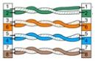

_____Open________________________ 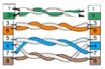
______Short________________________ 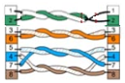
_______Split Pair____________________ 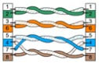

37. Explain attenuation in detail.

Attenuation, also commonly referred to as insertion loss, is a general term that refers to the reduction in the strength of a signal. Attenuation is a natural consequence of signal transmission over any medium. Attenuation limits the length of network cabling over which a message can be sent. A cable tester measures attenuation by injecting a signal in one end and then measuring its strength at the other end.

38. Explain the term near-end crosstalk (NEXT).

Crosstalk is the leakage of signals between pairs. If this is measured near the transmitting end it is termed near-end crosstalk (NEXT).

39. Explain the term far-end crosstalk (FEXT).

If measured at the receiving end of the cable it is termed far-end crosstalk (FEXT).

40. What is the cause and recommended solution to removing cross talk issues from a cable?

Both forms of crosstalk degrade network performance and are often caused by untwisting too much cable when terminating. If high crosstalk values are detected, the best thing to do is check the cable terminations and re-terminate as necessary.

Complete Lab Activity 4.5.5

41. Explain the six recommended steps, called best practices, to ensure that cable termination is successful.

1. It is important that the type of cables and components used on a network adhere to the standards required for that network. Modern converged networks carry voice, video and data traffic on the same wires; therefore the cables used on converged networks must be able to support all these applications.

2. Cable standards specify maximum lengths for different types of cables. Always adhere to the length restrictions for the type of cable being installed.

3. UTP, like all copper cable, is susceptible to EMI. It is important to install cable away from sources of interference such as high-voltage cables and fluorescent lighting. Televisions, computer monitors and microwaves are other possible sources of interference. In some environments it may be necessary to install data cables in conduit to protect them from EMI and RFI.

4. Improper termination and the use of low quality cables and connectors can degrade the signal carrying capacity of the cable. Always follow the rules for cable termination and test to verify that the termination has been done properly.

5. Test all cable installations to ensure proper connectivity and operation.

6. Label all cables as they are installed, and record the location of cables in network documentation.

42. What two purposes does cable management serve?

a. First, it presents a neat and organized system which aids in the isolation of cabling problems.

b. Second, by following cable management best practices, the cables are protected from physical damage which greatly reduces the number of problems experienced.

43.
