Name _______________________________________________________ Date ________________

Chapter 4
Reading Organizer

After completion of this chapter, you should be able to:

- Explain “what is the internet?” and how we connect to the internet using an Internet Service Provider (ISP).
- Explain how information is sent across the Internet through an ISP.
- Describe and identify the components of an ISP Network Operation Center.
- Identify the different types of cables and connectors for connecting the devices in a Network Operations Center.
- Construct and terminate twisted pair cables and determine type of cable needed.

4.1

- In simple terms what is the internet?

2. According to Cisco what two things are essential to gaining access to the internet?

a.

b.

3. Explain in detail what a Point of Presence or (POP) is.

4. Explain what an internet backbone is and what it does.

5. Explain what services an integrated router or integrated services router (ISR) provides?

6. Most ISPs offer two different contract levels: home service and business class service. Explain the characteristics of each.

a. Home Service:

b. Business Class Service:

7. List and explain the characteristics of asymmetric and symmetric data transfer.

a. Asymmetric:

b. Symmetric:

8.
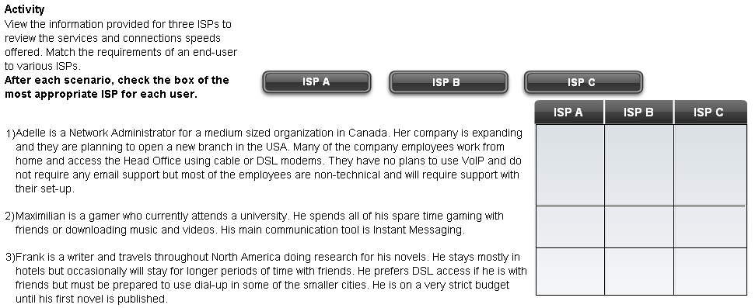

4.2

9. Explain in detail what the Ping utility does.

10. Explain in detail what the Traceroute utility does.

Complete Packet Tracer Activity 4.2.3
Complete Lab Activity 4.2.3
4.3

11. Devices that provide connectivity to end-users must match the technology used by the end-user to connect to the ISP.

a. What type of device would be required for an end user using DSL technology?

b. What type of device would be required for an end user connecting through cable?

12. What are the advantages of an integrated router or integrated service router (ISR) for home use?

13.
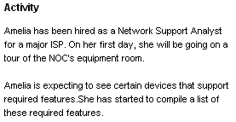

Draw a line between the correct device and the matching requirement.
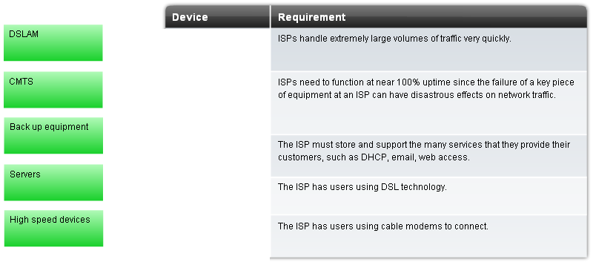

14. What are three physical and environmental factors which must be considered when setting up a home or small business network?

4.4

15. Explain what networking media is.

16. Explain the following types of network cabling.

Twisted Pair -

Coaxial Cable -

Fiber Optic -

17. List and explain two types of interference commonly found with twisted pair cables.

a.

b.

18. Three types of twisted pair cabling are?

a.

b.

c.

19. Explain what the following cables are used for, and common data speeds they can handle.

Category 3 –

Category 5 and 5e –

Category 6 –

20. What terminator is commonly used with all UTP cabling?

21. Why is UTP cable more commonly used than coaxial cable in local networks?

22. Why is fiber optic cable preferred for use in areas where electricity or electrical components is an issue?

23. Label the parts of a fiber optic cable.

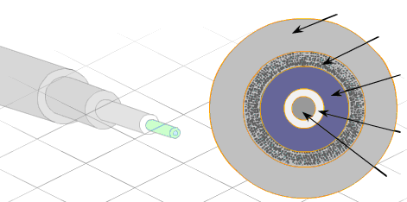

24. Explain in detail the two types of fiber optic cabling.

Multimode –

Single Mode –

25.
Activity
Decide if fiber is the best solution to a cabling requirement. Put a check mark in the correct choice.
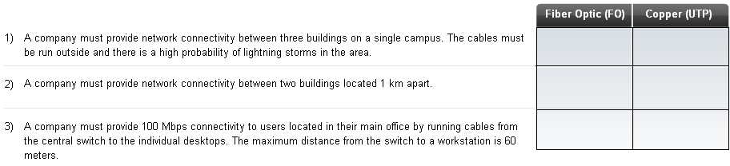

4.5

26. Why is it important to follow cabling standards, which have been developed by different organizations?

27. Fully explain what cabling standards are and what they specify.

28. What is the difference between T568A and T568B pinouts.

29. What type of cable is needed for “like devices”?

30. What type of cable is needed for “unlike devices”?

31. Identify if a crossover or straight through cable is necessary to connect the devices listed below.

Computer to Computer
Switch to Computer
Router to Computer
Router to Router
Hub to Switch
Switch to Router
Hub to Computer
Hub to Hub

Complete Lab Activity 4.5.3

32. Explain in detail the characteristics of a patch panel.

33. Why is untwisting more cable than necessary to be avoided when terminating a female RJ-45 connector?

Complete Lab Activity 4.5.4
34. Explain the difference between a cable tester and a cable certifier.

35. Explain in detail the following faults.

Short –

Open –

Split Pair –

Reversed-Pair -

36. Identify the wire faults.

___________________________________ 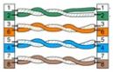

___________________________________ 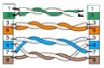
___________________________________ 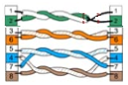
___________________________________ 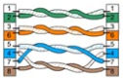

37. Explain attenuation in detail.

38. Explain the term near-end crosstalk (NEXT).

39. Explain the term far-end crosstalk (FEXT).

40. What is the cause and recommended solution to removing cross talk issues from a cable?

Complete Lab Activity 4.5.5

41. Explain the six recommended steps, called best practices, to ensure that cable termination is successful.

1.

2.

3.

4.

5.

6.

42. What two purposes does cable management serve?

a.

b.

43.
