Name ___________________
Why do programmers always get Christmas and Halloween mixed up?

Convert the following binary numbers into decimal. Then solve the riddle by filling in the blanks with the appropriate characters from the ASCII chart below. Remember, leading zeros may be omitted. Be sure to show your work!

- 1000010 ___________________________
- 1100101 ___________________________
- 1100011 ___________________________
- 1100001 ___________________________
- 1110101 ___________________________
- 1110011 ___________________________
- 1000100 ___________________________
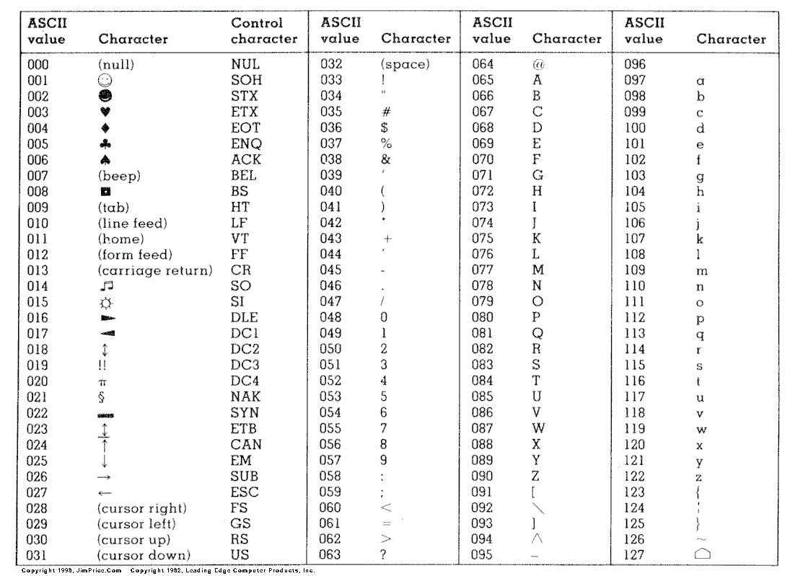
- 1000101 ___________________________
- 1000011 ___________________________
- 110010 ___________________________
- 110101 ___________________________
- 111101 ___________________________
- 1001111 ___________________________
- 1010100 ___________________________
- 110011 ___________________________
- 110001 ____________________________

1 | 2 | 3 | 4 | 5 | 6 | 2 |  | 7 | 8 | 9 |  | 10 | 11 |  | 12 |  | 13 | 9 | 14 |  | 15 | 16

