NAME:___________________________________________

DNS Homework
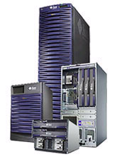
- What is the command to view your current IP address?_______________________

- What is your current IP address?___________________

- What is the command to view your IP address, Subnet mask, default gateway?____________________

- What is the default gateway on your PC?_______________________________________

- How would you feel if you had to remember the IP address of every Web site you visit every day?

- PING is a great tool for DNS server diagnosis. Ping yourschool.org.(ask your instructor for the name). What happened?

- What does Ping Test?

- What does PING stand for?

- Use the NSLOOKUP command. What appears?

- Use Traceroute (TRACERT) to follow the route to abc.com.

  - What is the IP address of ABC.com?___________________________

  - How many hops does it take to get there?_________________________

- Go to http://www.dnsstuff.com/
  - Do a Whois Look up for YOURSCHOOL (see name above)
    - What is the street address for our school?____________________
  - Do a reverse lookup for 64.233.187.99
    - Who does this IP address belong to?________________________

- What is DNS and what does it do?

