Name _______________________________________________________ Date ________________

Chapter 6
Reading Organizer

After completion of this chapter, you should be able to:

- Compare and contrast clients and servers, and their interaction over the network.
- Describe they type of interactions of Internet applications.
- Describe the purpose of a layered model.
- Illustrate the interaction of various protocols.

6.1

1. What is the key characteristic of client/server systems?

2. Explain the following protocols:

Application Protocol –

Transport Protocol –

Internetwork Protocol –

3. What protocols are associated with the Application layer?

4. Explain in detail how TCP sends information through the network.

5. What are two protocols that use TCP to ensure delivery of data?

6. Explain how UDP differs from TCP?

7. Why is UDP prefered with applications such as streaming audio, video and voice over IP (VoIP)?

8.
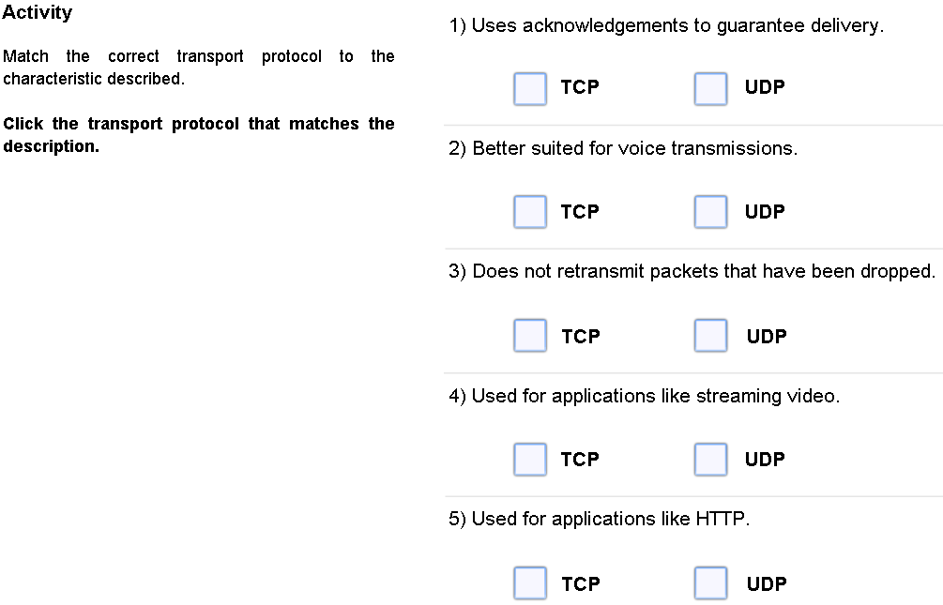

9. When a message is delivered using either TCP or UDP, the protocols and services requested are identified by a port number. Explain what port numbers are and how they are used.

6.2

10. What does the Domain Name System (DNS) provide?

11. Domain name servers maintain a table. What information do these tables contain?

Complete Lab Activity 6.2.1
12. When a web client receives the IP address of a web server what occurs?

13. What protocol do web servers use to transfer data?

Complete Packet Tracer Activity 6.2.2

14. What is the purpose of ( File Transfer Protocol FTP)?

15. Which two port numbers are associated with FTP?

Complete Lab Activity 6.2.1

16. What is Simple Mail Transfer Protocol (SMTP) used for?

17. What port number is associated with SMTP?

18. Explain in detail the differences between POP3 and IMAP4?

Post Office Protocol (POP3) –

Internet Message Access Protocol (IMAP4) –

Complete Lab Activity 6.2.4

19. Explain what Instant Messaging (IM) is used for.

20. Explain in detail Voice over IP (VoIP).

21. It is necessary for a server to know which services are being requested by a client (such as: DNS, Web, Email, FTP, etc). How can these client requests be identified by the server?

22. Ports are broken into three categories and range in number from 1 to 65,535. Ports are assigned and managed by an organization known as the Internet Corporation for Assigned Names and Numbers (ICANN ).
List and explain the three port number categories.

______________________________________ -

______________________________________ -

______________________________________ -

6.3

23. List and explain the four layers of the TCP/IP model.

______________________________________ -

______________________________________ -

______________________________________ -

______________________________________ -

24. Of the four layers, which layer will deal with cabling issues? (Circle one)

Layer 4 Layer 3 Layer 2 Layer1

25. What are four advantages of the layered model?

a.

b.

c.

d.

26. When sending messages on a network, the protocol stack on a host operates from top to bottom. Explain in detail what happens during this process.

27. What information is contained in an IP header during the above process?

28. What three items are contained in an IP header and trailer during the above process?

a.

b.

c.

29. When messages are received from the network, the protocol stack on a host operates from bottom to top. The process of receiving the web page starts the de-encapsulation of the message by the client. Explain this process in detail.

30. In what order does the four step de-encapsulation process of a message by the client occur?

a.

b.

c.

d.
31. List and explain the purpose of the seven layers of the Open System Interconnect Model (OSI model).

Layer 7- ______________________________________ -

Layer 6 –______________________________________ -

Layer 5 –______________________________________ -

Layer 4 –______________________________________ -

Layer 3 –______________________________________ -

Layer 2 –______________________________________ -

Layer 1 –______________________________________ -

Complete Packet Tracer Activity 6.3.3

