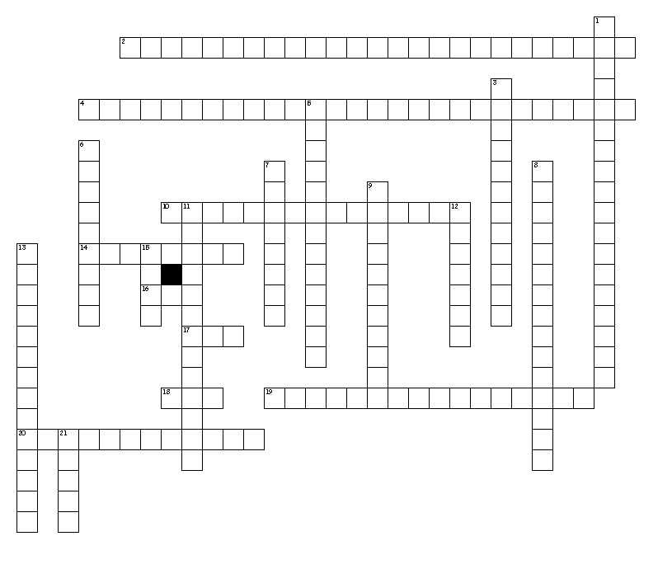
CCNA Discovery
Chapter Six
Vocabulary
Across
2. HTTP
4. TCP
10. ports used for specific applications like IM
14. layer that defines optical electrical, and mechanical characteristics
16. used for streaming video; best effort delivery
17. uses acknowledgements to guarantee delivery
18. port numbers 20 & 21
19. associates a name with an IP address
20. ports that can be used by any application
Down
1. uses port 110 for e-mail
3. layer that encodes and decodes user data and standardizes data format for use between different types of systems
5. layer that accesses the physical media
6. layer that provides end-to-end delivery services--segments
7. layer that handles the routing of data--packets
8. process of receiving data from the network layer one to seven
9. layer with HTTP, FTP, DNS, DHCP
11. process of packaging data for the transmission layer seven to one
12. layer that maintains logical links between systems
13. ports 1 to 1023
15. used by e-mail clients and uses port 25
21. e-mail client that stores mail on a server
Word List--Key

TCP used for streaming video; best effort delivery
UDP uses acknowledgements to guarantee delivery
TransmissionControlProtocol TCP
HypertextTransferProtocol HTTP
Application layer with HTTP, FTP, DNS, DHCP
DomainNameSystem associates a name with an IP address
FTP port numbers 20 & 21
SMTP used by e-mail clients and uses port 25
PostOfficeProtocol uses port 110 for e-mail
IMAP4 e-mail client that stores mail on a server
WellKnownPorts ports 1 to 1023
RegisteredPorts ports used for specific applications like IM
PrivatePorts ports that can be used by any application
Transport layer that provides end-to-end delivery services--segments
internet layer that handles the routing of data--packets
networkAccess layer that accesses the physical media
encapsulation process of packaging data for the transmission layer seven to one
deencapsulation process of receiving data from the network layer one to seven
Physical layer that defines optical electrical, and mechanical characteristics
session layer that maintains logical links between systems
presentation layer that encodes and decodes user data and standardizes data format for use between different types of systems

