Name _______________________________________________________ Date ________________

Chapter 7
Reading Organizer
Answer Key
7.1

1. What are the two most common wavelengths used for public wireless communications?

a. Infrared
b. Part of the Radio Frequency (RF) band

2. Explain in detail Infrared (IR) technology.

Infrared (IR) is relatively low energy and cannot penetrate through walls or other obstacles. However, It is commonly used to connect and move data between devices such as Personal Digital Assistants (PDAs) and PCs. A specialized communication port known as an Infrared Direct Access (IrDA) port uses IR to exchange information between devices. IR only allows a one-to-one type of connection.

IR is also used for remote control devices, wireless mice, and wireless keyboards. It is generally used for short-range, line-of-sight,

3. Explain in detail Radio Frequency (RF) technology.

RF waves can penetrate through walls and other obstacles, allowing a much greater range than IR.

Certain areas of the RF bands have been set aside for use by unlicensed devices such as wireless LANs, cordless phones and computer peripherals. This includes the 900 MHz, 2.4 GHz and the 5 GHz frequency ranges. These ranges are known as the Industrial Scientific and Medical (ISM) bands and can be used with very few restrictions.

4. Why can 2.4 GHz and 5GHz bands that conform to the IEEE 802.11 standards transmit greater distances than Bluetooth?

2.4 GHz and 5GHz bands transmit at a much higher power level, which gives them a greater range.

5.
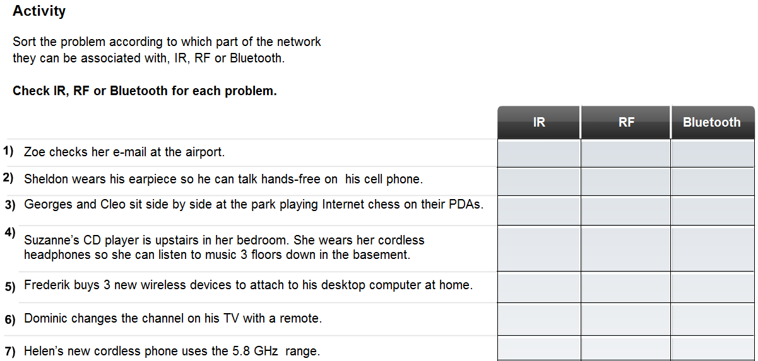

6. What are three advantages of wireless technology over wired?

a. the ability to provide anytime, anywhere connectivity
b. fairly easy and inexpensive to install
c. enables networks to be easily expanded, without the limitations of cabled connections

7. What devices can interfere with wireless network technologies?

Many devices such as microwave ovens and cordless phones use these frequencies and can interfere with WLAN communications.

8. Explain in detail why security is a major concern with wireless security.

Wireless provides ease of access. It does this by broadcasting data in a manner that allows anyone the ability to access it. However, this same feature also limits the amount of protection wireless can provide for the data. It allows anyone to intercept the communication stream, even unintended recipients. To address these security concerns, techniques have been developed to help secure wireless transmissions including encryption and authentication.

9. Wireless networks are grouped into three major categories, List and explain these areas:

a. Wireless Personal Area networks (WPAN) –
This is the smallest wireless network used to connect various peripheral devices such as mice, keyboards and PDAs to a computer. All of these devices are dedicated to a single host with usually use IR or Bluetooth technology.

b. Wireless Local Area networks (WLAN) –
WLAN is typically used to extend the boundaries of the local wired network (LAN). WLANs use RF technology and conform to the IEEE 802.11 standards. They allow many users to connect to a wired network through a device known as an Access Point (AP). An Access Point provides a connection between wireless hosts and hosts on an Ethernet wired network.

c. Wireless Wide Area networks (WWAN) –
WWAN networks provide coverage over extremely large areas. A good example of a WWAN is the cell phone network. These networks use technologies such as Code Division Multiple Access (CDMA) or Global System for Mobile Communication (GSM) and are often regulated by government agencies.

10.
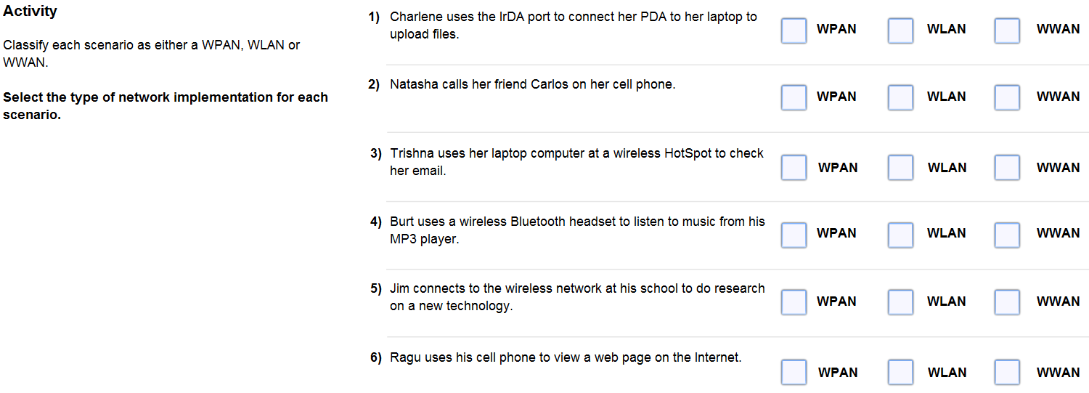

7.2

11. A number of standards have been developed by organizations such as the IEEE. What is the purpose of these standards?

To ensure that wireless devices can communicate

12. Which standard governs the WLAN environment?

IEEE 802.11

13. What does the Wi-Fi logo on a device signify?

The Wi-Fi logo on a device means that this equipment meets standards and should interoperate with other devices of the same standard.

14. Explain the following wireless LAN standards

802.11a -
Uses 5 GHz RF spectrum
Not compatible with 2.4 GHz spectrum, i.e. 802.11b/g/n devices
Range is approximately 33% that of the 802.11 b/g
Relatively expensive to implement compared to other technologies.
Increasingly difficult to find 802.11a compliant equipment

802.11b -
First of the 2.4 GHz technologies
Maximum data-rate of 11 Mbps
Range of approximately 46 m (150 ft) indoors/96 m (300 ft.) outdoors

802.11g -
2.4 GHz technologies
Maximum data-rate increase to 54 Mbps
Same range as the 802.11b
Backwards compatible with 802.11b

802.11n -
Newest standard in development
2.4 GHz technologies (draft standard specifies support for 5 GHz)
Extends the range and data throughput
Backwards compatible with existing 802.11g and 802.11b equipment (draft standard specifies 802.11a support)

15. Explain the functions of a Wireless bridge.

a. Used to connect two wired networks through a wireless link.
b. Allows long range point to point connections between networks
c. Using the unlicensed RF frequencies, networks 40 km ((25 miles) or more apart can be connected without the use of wires.

16. Explain the two types of antennas listed below:

Directional antennas –
concentrate the signal strength into one direction

Omni-
directional antennas are designed to emit equally in all directions.

17. Explain in detail the purpose of a Service Set Identifier (SSID).

The SSID is a case-sensitive, alpha-numeric string that is up to 32-characters. It is sent in the header of all frames transmitted over the WLAN. The SSID is used to tell wireless devices which WLAN they belong to and with which other devices they can communicate.

Regardless of the type of WLAN installation, all wireless devices in a WLAN must be configured with the same SSID in order to communicate.

18. There are two basic forms of WLAN installations: Ad-hoc and infrastructure mode. Explain each in detail.

Ad-hoc -

The simplest form of a wireless network is created by connecting two or more wireless clients together in a peer-to-peer network. A wireless network established in this manner is known as an ad-hoc network and does not include an AP. All clients within an ad-hoc network are equal. The area covered by this network is known as an Independent Basic Service Set (IBSS). A simple ad-hoc network can be used to exchange files and information between devices without the expense and complexity of purchasing and configuring an AP.

Infrastructure Mode-

Although an ad-hoc arrangement may be good for small networks, larger networks require a single device that controls communications in the wireless cell. If present, an AP will take over this role and control who can talk and when. This is known as infrastructure mode and is the mode of wireless communication most often used in the home and business environment. In this form of WLAN, individual STAs can not communicate directly with each other. To communicate, each device must obtain permission from the AP. The AP controls all communications and ensures that all STAs have equal access to the medium. The area covered by a single AP is known as a Basic Service Set (BSS) or cell.

19. Explain what a Request to Send (RTS) is and how it works and why it’s needed.

Within a WLAN, the lack of well-defined boundaries makes it impossible to detect if collisions occur during transmission. Therefore, it is necessary to use an access method on a wireless network that ensures collisions do not occur.

Wireless technology uses an access method called Carrier Sense Multiple Access with Collision Avoidance (CSMA/CA). CSMA/CA creates a reservation on the channel for use by a specific conversation. While a reservation is in place, no other device may transmit on the channel thus possible collisions are avoided.

How does this reservation process work? If a device requires use of a specific communication channel in a BSS, it must ask permission from the AP. This is known as a Request to Send (RTS). If the channel is available, the AP will respond to the device with a Clear to Send (CTS) message indicating that the device may transmit on the channel. A CTS is broadcast to all devices within the BSS. Therefore, all devices in the BSS know that the requested channel is now in use.

Once the conversation is complete, the device that requested the channel sends another message to the AP known as an Acknowledgement (ACK). The ACK indicates to the AP that the channel can be released. This message is also broadcast to all devices on the WLAN. All devices within the BSS receive the ACK and know that the channel is once again available.

Complete Lab Activity 7.2.5

20. Explain what an STA is.

A wireless host, or STA, is defined as any device that contains a wireless NIC and wireless client software.

Complete Lab Activity 7.2.6

7.3

21. Explain in detail what war driving is.

War driving is the process of driving around an area searching for wireless LANs. Once discovered, the location of the WLAN is logged and shared. The goal of war driving is to bring attention to the fact that most wireless networks are insecure and also to show the widespread acceptance and use of wireless LAN technology.

22. Explain in detail the advantages and disadvantages of SSID.

All computers connecting to the wireless network must know the SSID. By default, wireless routers and access points broadcast SSIDs to all computers within the wireless range. With SSID broadcast activated, any wireless client can detect the network and connect to it, if no other security features are in place.

The SSID broadcast feature can be turned off. When it is turned off, the fact that the network is there is no longer made public. Any computer trying to connect to the network must already know the SSID.

23. Explain why is it important to change the default settings on all your wireless network devices.

Wireless devices are shipped preconfigured with settings such as SSIDs, passwords, and IP addresses in place. These defaults make it easy for an attacker to identify and infiltrate a network.

24. Explain how MAC address filtering works.

MAC address filtering uses the MAC address to identify which devices are allowed to connect to the wireless network. When a wireless client attempts to connect, or associate, with an AP it will send MAC address information. If MAC filtering is enabled, the wireless router or AP will look up its MAC address a preconfigured list. Only devices whose MAC addresses have been prerecorded in the router's database will be allowed to connect.

If the MAC address is not located in the database, the device will not be allowed to connect to or communicate across the wireless network.
25. What are three types of wireless authentication methods?

a. open authentication
b. PSK
c. EAP

26. By default, wireless devices do not require authentication. Explain what type of authentication this is and the ramifications of not requiring authentication.

Any and all clients are able to associate regardless of who they are. This is referred to as open authentication. Open authentication should only be used on public wireless networks such as those found in many schools and restaurants. It can also be used on networks where authentication will be done by other means once connected to the network.

27. What is required between the AP and client in order for Pre-shared keys (PSK) to work?

With PSK both the AP and client must be configured with the same key or secret word.

28. Explain what is encryption and why is it necessary?

Since there are no distinct boundaries on a wireless network, and all traffic is transmitted through the air, it is easy for an attacker to intercept, or sniff the wireless frames. Encryption is the process of transforming data so that even if it is intercepted it is unusable.

29. What is Wired Equivalency Protocol (WEP)?

It is an advanced security feature that encrypts network traffic as it travels through the air. WEP uses pre-configured keys to encrypt and decrypt data.

30. How many characters are in a WEP key?

A WEP key is entered as a string of numbers and letters and is generally 64 bits or 128 bits long.

31. What is the advantage WPA has over WEP?

WPA, unlike WEP, generates new, dynamic keys each time a client establishes a connection with the AP. For this reason, WPA is considered more secure than WEP because it is significantly more difficult to crack.

32. What is traffic filtering?

It controls the types of traffic transmitted across a WLAN. This is accomplished using traffic filtering.

Complete Lab Activity 7.3.5

7.4

33. When implementing a wireless network solution, it is important to plan before performing any installation. This should include:

a. Determining the type of wireless standard to use
b. Determining the most efficient layout of devices
c. An installation and security plan
d. A strategy for backing up and updating the firmware of the wireless devices.

34. Some of the more basic and advanced security measures that need to be included in a WLAN installation are:

a. Change default values for the SSID, usernames and passwords.
b. Disable broadcast SSID
c. Configure MAC Address Filtering
d. Configure encryption using WEP or WPA
e. Configure authentication
f. Configure traffic filtering

