Name _______________________________________________________ Date ________________

Chapter 7
Reading Organizer

After completion of this chapter, you should be able to:

- Describe wireless technology.
- Describe the various components and structure of a wireless LAN.
- Describe wireless security issues and mitigation strategies.
- Configure an integrated wireless access point and wireless client.

7.1

1. What are the two most common wavelengths used for public wireless communications?

a.

b.

2. Explain in detail Infrared (IR) technology.

3. Explain in detail Radio Frequency (RF) technology.

4. Why can 2.4 GHz and 5GHz bands that conform to the IEEE 802.11 standards transmit greater distances than Bluetooth?

5.
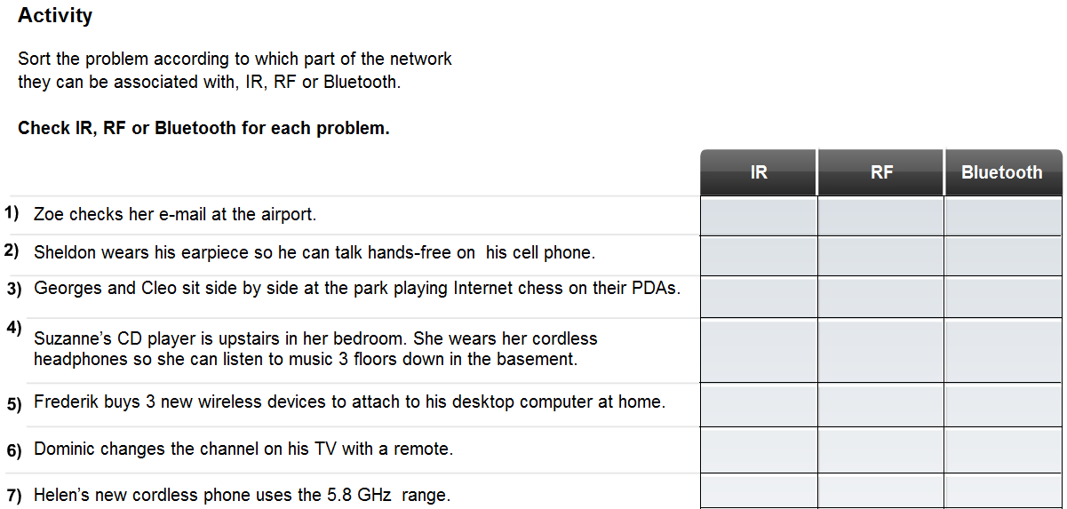

6. What are three advantages of wireless technology over wired?

a.

b.

c.

7. What devices can interfere with wireless network technologies?

8. Explain in detail why security is a major concern with wireless security.

9. Wireless networks are grouped into three major categories, List and explain these areas:

a. ______________________________________________ –

b. ______________________________________________ –

c. ______________________________________________ –

10.
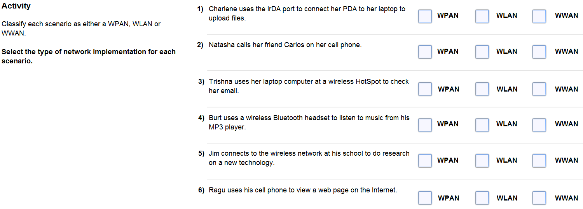

7.2

11. A number of standards have been developed by organizations such as the IEEE. What is the purpose of these standards?

12. Which standard governs the WLAN environment?

13. What does the Wi-Fi logo on a device signify?

14. Explain the following wireless LAN standards

802.11a -

802.11b -

802.11g -

802.11n -

15. Explain the functions of a Wireless bridge.

a.

b.

c.

16. Explain the two types of antennas listed below:

Directional antennas –

Omni-

17. Explain in detail the purpose of a Service Set Identifier (SSID).

18. There are two basic forms of WLAN installations: Ad-hoc and infrastructure mode. Explain each in detail.

Ad-hoc -

Infrastructure Mode-

19. Explain what a Request to Send (RTS) is and how it works and why it’s needed.

Complete Lab Activity 7.2.5

20. Explain what an STA is.

Complete Lab Activity 7.2.6

7.3

21. Explain in detail what war driving is.

22. Explain in detail the advantages and disadvantages of SSID.

23. Explain why is it important to change the default settings on all your wireless network devices.

24. Explain how MAC address filtering works.

25. What are three types of wireless authentication methods?

a.

b.

c.

26. By default, wireless devices do not require authentication. Explain what type of authentication this is and the ramifications of not requiring authentication.

27. What is required between the AP and client in order for Pre-shared keys (PSK) to work?

28. Explain what is encryption and why is it necessary?

29. What is Wired Equivalency Protocol (WEP)?

30. How many characters are in a WEP key?

31. What is the advantage WPA has over WEP?

32. What is traffic filtering?

Complete Lab Activity 7.3.5

7.4

33. When implementing a wireless network solution, it is important to plan before performing any installation. This should include:

a.

b.

c.

d.

34. Some of the more basic and advanced security measures that need to be included in a WLAN installation are:

a.

b.

c.

d.

e.

f.

