Name _______________________________________________________ Date ________________

Chapter 8
Reading Organizer

After completion of this chapter, you should be able to:

- Identify and describe the various networking threats.
- Identify different methods of attack.
- Describe security procedures and applications.
- Describe the features of a firewall and how it can be used to protect against an attack.

8.1

1.
Once the hacker gains access to the network, four types of threat may arise. List and explain each of these four threats.

a. ________________________________________-

b. ________________________________________-

c. ________________________________________-

d. ________________________________________-

2. Activity
Identify the type of security threat described by connecting the correct threat with its definition.
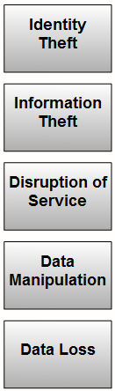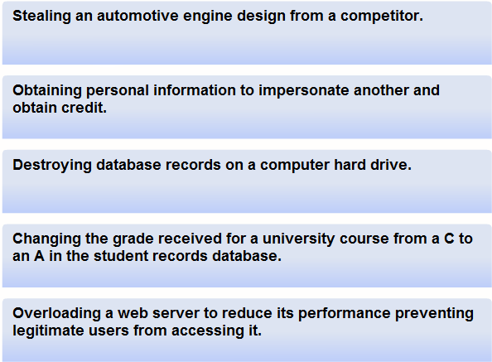

3. Explain what External Threats are.

4. Explain what Internal Threats are.

5. Explain Social Engineering including how it relates to computer and networking security.

6. List and explain the three most commonly used techniques in social engineering.

________________________________________-

________________________________________-

________________________________________-

8.2

7. Explain in detail the following terms:

Viruses –

Worms –

Trojan Horses –

Denial of Service (DoS) –

SYN (synchronous) Flooding –

Ping of death –

Distributed Denial of Service (DDoS) –

Brute Force –

Spyware –

Tracking Cookies –

Adware –

Pop-ups and pop-unders –

8. How does the Cisco curriculum explain what Spam is?

8.3

9. Explain what an acceptable use policy is.

10. List possible security tools and applications used in securing networks.

a.

b.

c.

d.

e.

f.

11. What is a patch?

12. What is an update?

13. List common signs that a virus, worm or Trojan horse may be present on a computer.

a.

b.

c.

d.

e.

f.

g.

14. Anti-virus software relies on what information to remove viruses?

15. What is Anti-Spam software?

16. What is the draw back to Anti-Spam software?

8.4

17. In addition to using spam blockers, what are other preventative actions you can use to prevent the spread of spam?

a.

b.

c.

d.

e.

f.

g.

18. Activity
Identify the type of security tool described by connecting it to the correct definition.

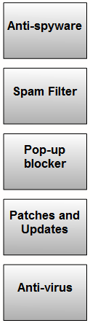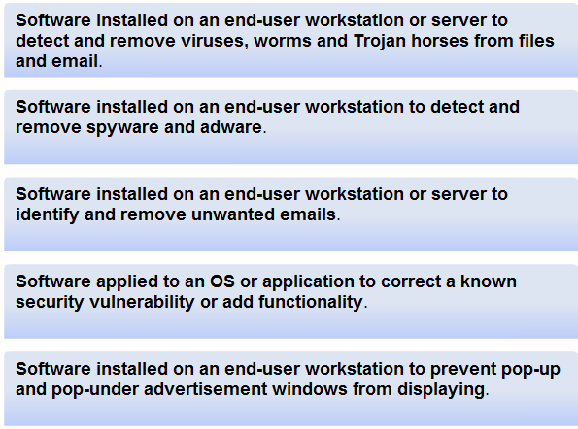
19. Explain how firewalls use NAT to help with network security?

20. Firewall products come packaged in various forms. List and explain each.

Appliance-based firewalls –

Server-based firewalls –

Integrated Firewalls –

Personal firewalls –

21. What is a demilitarized zone or DMZ?

22. Using an ISR a more restrictive DMZ can be set up using the port forwarding capability. Explain how this operates.

23. The wireless access point within the integrated router is considered part of the internal network. Why can this be a problem?

Complete Lab Activity 8.4.2
Complete Lab Activity 8.4.3

24. List the several recommended practices to help mitigate the risks they pose.

a.

b.

c.

d.

e.

f.

g.

h.

i.

