Name _______________________________________________________ Date ________________

Chapter 9
Reading Organizer

After completion of this chapter, you should be able to:

- Describe the trouble shooting process.
- Describe the utilities used to verify TCP/IP connectivity.
- Identify and describe common hardware and connection issues in wired and wireless networks.
- Use the troubleshooting process to document problems and interact with a help desk.

9.1

1. What is troubleshooting?

2. When troubleshooting, proper documentation must be maintained. What should this documentation include?

a.

b.

c.

3. One of the first ways to gather information is to question the individual who reported the problem as well as any other affected users. Questions can include:

a.

b.

c.

4. There are three common structured troubleshooting techniques available. List and explain each.

_________________________________________ –

_________________________________________ –

_________________________________________ –

5. Explain the following approaches to troubleshooting.

Trial and Error –

Substitution –

6.
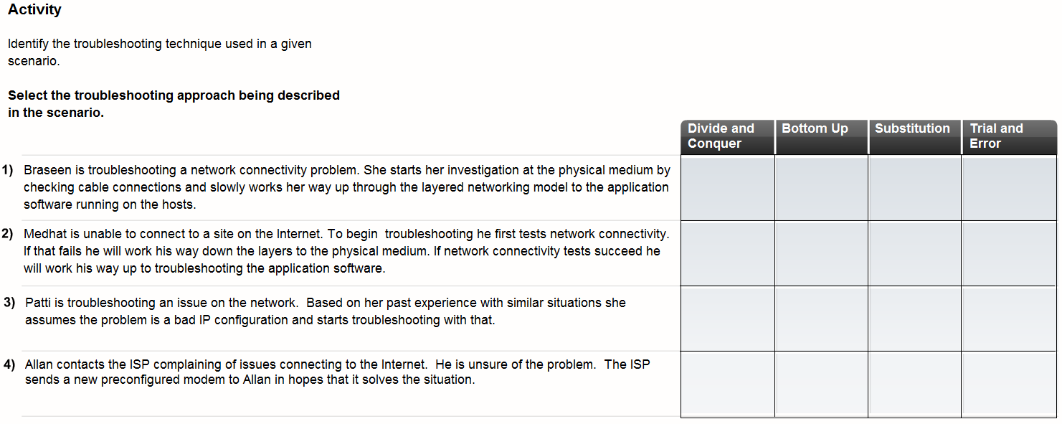

9.2

7. A number of software utility programs are available that can help identify network problems. List and give a brief explanation of each.

a. ________________________ –

b. ________________________ –

c. ________________________ –

d. ________________________ –

e. ________________________ –

8. Ipconfig is used to display the current IP configuration information for a host. Explain the following ipconfig switches.

Ipconfig /all –

pconfig /release –

ipconfig /renew-

Complete Packet Tracer Activity 9.2.3

9. If you ping both the name and IP address of a host and they are both successful, but the user is still unable to access the application, where is the problem most likely to reside?

Complete Packet Tracer Activity 9.2.4

10. What information does the Netstat command give users?

11. What specific information does the nslookup utility allow end users to discover?

a.

b.

12. Why would a technician use the nslookup utility?

Lab Activity 9.2.7

9.3

13. What type of troubleshooting technique is your best option when troubleshooting wireless networks, wired networks and networks that use both?

14. What do inactive LEDs potently indicate?

a.

b.

c.

15. You are troubleshooting a Linksys ISR. What do the following LED lights indicate?

Solid Green –

Flashing Green –

Amber –

No Light –

16. There are several issues to watch for in cabling. List and explain each.

a.

b.

c.

d.

e.

Lab Activity 9.3.3

17. If the wireless client is unable to connect to the AP, it may be because of wireless connectivity problems. What factors can affect your ability to connect hosts using RF?

a.

b.

c.

d.

e.

18. Modern WLANs incorporate various technologies to help secure the data on the WLAN: incorrect configuration of any of these can prevent communication. List three.

a.

b.

c.

Complete Packet Tracer Activity 9.3.5
19. An integrated router or ISR, such as the Linksys wireless router, acts as a DHCP server for local wired and wireless clients and provides IP configuration. What information does it provide?

a.

b.

c.

d.

20.
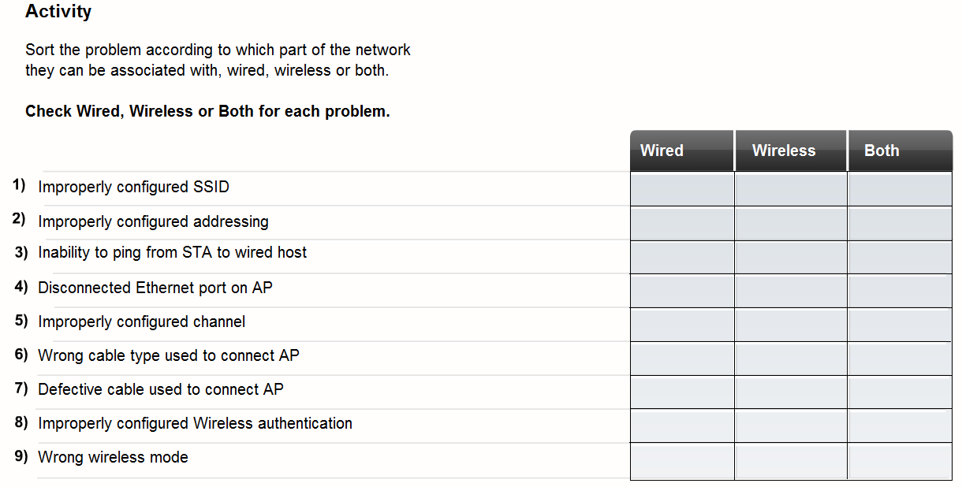

21. There are many ways to verify connectivity between the integrated router and the ISP. List three.

a.

b.

c.

9.4

22. When should network baseline documentation be done?

a.

b.

23. When troubleshooting, documentation should be maintained during the troubleshooting process. This documentation can be a valuable reference and can be used when future issues arise. Good troubleshooting documentation should include:

a.

b.

c.

d.

e.

f.

24. The helpdesk is a group of individuals with the knowledge and tools required to help diagnose and correct common problems. What assistance do they provide?

a.

b.

c.

25. If necessary, the helpdesk can take control of a local host through remote access software. What does this allow helpdesk technicians to do?

26. As an end user, it is important to give the help desk as much information as possible. What information will the helpdesk need?

a.

b.

c.

d.

e.

27. What information should the helpdesk record?

a.

b.

c.

d.

e.

f.

