Name _______________________________________________________ Date ________________

Chapter 9
Reading Organizer
Answer Key
9.1

1. What is troubleshooting?

Troubleshooting is the process of identifying, locating and correcting problems that occur.

2. When troubleshooting, proper documentation must be maintained. What should this documentation include?

a. The problem encountered
b. Steps taken to determine the cause of the problem
c. Steps to correct the problem and ensure that it will not reoccur

3. One of the first ways to gather information is to question the individual who reported the problem as well as any other affected users. Questions can include:

a. end user experiences
b. observed symptoms
c. error messages and information about recent configuration changes to devices or applications

4. There are three common structured troubleshooting techniques available. List and explain each.

Top-down –
Top-down starts with the application layer and works down. It looks at the problem from the point of view of the user and the application. Is it just one application that is not functioning, or do all applications fail? For example, can the user access various web pages on the Internet, but not email? Do other workstations have similar issues?

Bottom-up -
Bottom-up starts with the physical layer and works up. The physical layer is concerned with hardware and wire connections. Have cables been pulled out of their sockets? If the equipment has indicator lights, are they on or off?

Divide-and-conquer –
Divide-and-Conquer typically begins troubleshooting at one of the middle layers and works up or down from there. For example, the troubleshooter may begin at the network layer, by verifying IP configuration information.

5. Explain the following approaches to troubleshooting.

Trial and Error –

Trial and error relies on individual knowledge to determine the most probable cause of a problem. A troubleshooter makes an educated guess on the most likely solution based on past experience and knowledge of the network structure. Once the solution is implemented, if it does not work, the troubleshooter uses this information to help determine the next most likely cause. This process is repeated until the problem is isolated and solved.

Substitution –

With this technique the problem is assumed to be caused by a specific hardware component or a configuration file. The defective part or code is replaced by a known good device or file. While not necessarily locating the problem, this technique can save time and quickly restore network functionality. This relies on the availability of substitute parts, components, and backup configuration files which can be very expensive to maintain.

6.
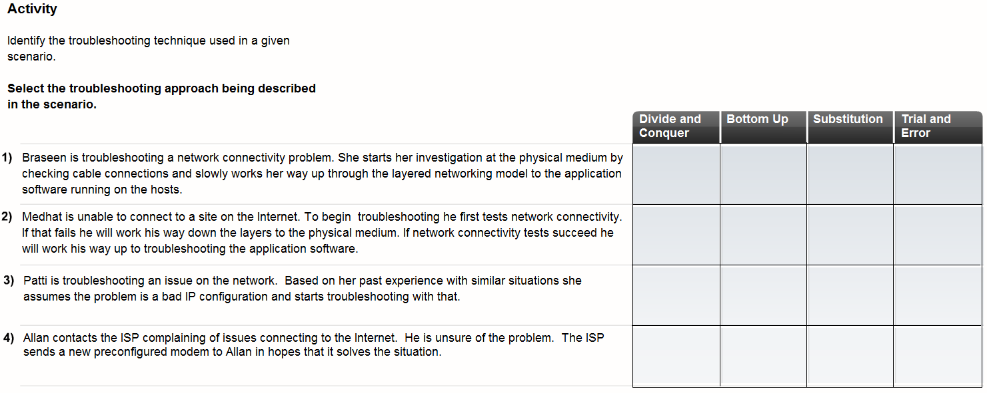

9.2

7. A number of software utility programs are available that can help identify network problems. List and give a brief explanation of each.

a. ipconfig - Displays IP configuration information
b. ping - Tests connections to other IP hosts
c. tracert - Displays route taken to destination
d. netstat - Displays network connections
e. nslookup - Directly queries the name server for information on a destination domain

8. Ipconfig is used to display the current IP configuration information for a host. Explain the following ipconfig switches.

Ipconfig /all –
The command ipconfig /all displays additional information including the MAC address, IP addresses of the default gateway and the DNS servers. It also indicates if DHCP is enabled, the DHCP server address and lease information.

pconfig /release –
If IP addressing information is assigned dynamically, the command ipconfig /release will release the current DHCP bindings.

ipconfig /renew-
Ipconfig /renew will request fresh configuration information from the DHCP server.

Complete Packet Tracer Activity 9.2.3

9. If you ping both the name and IP address of a host and they are both successful, but the user is still unable to access the application, where is the problem most likely to reside?

In the application on the destination host.

Complete Packet Tracer Activity 9.2.4

10. What information does the Netstat command give users?

Netstat lists the protocol in use, the local address and port number, the foreign address and port number, and the state of the connection.

11. What specific information does the nslookup utility allow end users to discover?

a. The IP address of the DNS server being used
b. The IP address associated with the specified DNS name

12. Why would a technician use the nslookup utility?

Nslookup is often used as a troubleshooting tool for determining if the DNS server is performing name resolution as expected.

Lab Activity 9.2.7

9.3

13. What type of troubleshooting technique is your best option when troubleshooting wireless networks, wired networks and networks that use both?

A divide-and -conquer technique

14. What do inactive LEDs potently indicate?

a. device failure
b. port failure
c. cabling issues.

15. You are troubleshooting a Linksys ISR. What do the following LED lights indicate?

Solid Green –
Solid green indicates that a device is plugged into the port but no traffic is flowing.

Flashing Green –
Flashing green indicates the device is plugged in and receiving traffic.

Amber –
Amber indicates the device is making adjustments to the way the port is operating.

No Light –
No light indicates that nothing is plugged into the port, or there is an issue with the wired or wireless connection.

16. There are several issues to watch for in cabling. List and explain each.

a. Be sure to use the correct type of cable. Two types of TP cables are commonly encountered in networking: Straight-through cables and Cross-over cables. Using the wrong type of cable may prevent connectivity.

b. Improper cable termination is one of the main problems encountered in networks. To avoid this, cables should be terminated according to standards.
Terminate cables via 568A or 568B termination standard
Avoid untwisting too much cable during termination
Crimp connectors on the cable jacket to provide strain relief

c. Maximum cable run lengths exist based on characteristics of the different cables. Exceeding these run lengths can have a serious negative impact on network performance.

d. If connectivity is a problem, verify that the correct ports are being used between the networking devices.

e. Protect cables and connectors from physical damage. Support cables to prevent strain on connectors and run cable through areas that will not be in the way.

Lab Activity 9.3.3
17. If the wireless client is unable to connect to the AP, it may be because of wireless connectivity problems. What factors can affect your ability to connect hosts using RF?

a. Not all wireless standards are compatible. The 802.11a (5 GHz band) is not compatible with the 802.11b/g/n standards (2.4 GHz band). Within the 2.4 GHz band, each standard uses different technology. Unless specifically configured, equipment that conforms to one standard may not function with that conforming to another.

b. Each wireless conversation must occur on a separate, non-overlapping channel. Some AP devices can be configured to select the least congested or highest throughput channel. Although automatic settings work, manual setting of the AP channel provides greater control and may be necessary in some environments.

c. The strength of an RF signal decreases with distance. If the signal strength is too low, devices will be unable to reliably associate and move data. The signal may be dropped. The NIC client utility can be used to display the signal strength and connection quality.

d. RF signals are susceptible to interference from outside sources, including other devices functioning on the same frequency. A site survey should be used to detect for this.

e. APs share the available bandwidth between devices. As more devices associate with the AP, the bandwidth for each individual device will decrease causing network performance problems. The solution is to reduce the number of wireless clients using each channel.

18. Modern WLANs incorporate various technologies to help secure the data on the WLAN: incorrect configuration of any of these can prevent communication. List three.

a. the SSID
b. authentication
c. encryption.

Complete Packet Tracer Activity 9.3.5

19. An integrated router or ISR, such as the Linksys wireless router, acts as a DHCP server for local wired and wireless clients and provides IP configuration. What information does it provide?

a. IP address
b. subnet mask
c. default gateway
d. possibly even IP addresses of DNS servers

20.
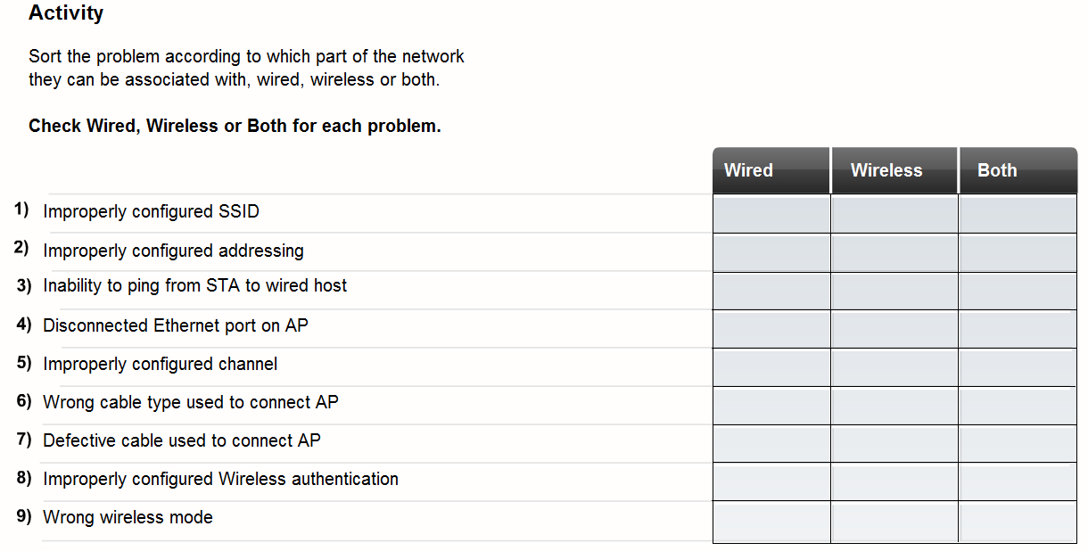

21. There are many ways to verify connectivity between the integrated router and the ISP. List three.

a. Examine the router status page

b. Check all physical connections

c. LED indicators

9.4

22. When should network baseline documentation be done?

a. The baseline should be documented just after the network is installed, when it is running optimally.
b. Baseline performance should be re-established after any major changes to the network are implemented.

23. When troubleshooting, documentation should be maintained during the troubleshooting process. This documentation can be a valuable reference and can be used when future issues arise. Good troubleshooting documentation should include:

a. Initial problem
b. Steps taken to isolate the problem
c. Results of all steps taken, both successful and unsuccessful
d. Final determined cause of the problem
e. Final problem resolution
f. Preventative measures
24. The helpdesk is a group of individuals with the knowledge and tools required to help diagnose and correct common problems. What assistance do they provide?

a. To determine if a problem exists
b. The nature of the problem
c. The solution.

25. If necessary, the helpdesk can take control of a local host through remote access software. What does this allow helpdesk technicians to do?

Run diagnostic programs and interact with the host and network without having to physically travel to a job site.

26. As an end user, it is important to give the help desk as much information as possible. What information will the helpdesk need?

a. Symptoms encountered
b. Who encountered the problem
c. When the problem manifests
d. Steps taken to identify the problem
e. Results of steps taken

27. What information should the helpdesk record?

a. Time/date of call
b. Name/ID of technician
c. Problem reported
d. Course of action taken
e. Resolution/escalation
f. Next steps (follow-up)

