Introduction to Java RECURSIVE CIRCLES – Lab Lab Value - 100 points

Lab Goal : This lab was designed to teach you more about recursion.

Lab Description : This program will use recursion to draw a series of circles on the screen.

Requirements : Use the program shell below to start you out with this program. You are to cut and paste your completed code into a new Notepad document. Make sure you have your name in your program. Drop the document into the Dropbox, Recursive Circles – Lab.

Example of recursion – type this into the Interactions pane in Dr. Java and run it to see how it works. Change the value passed from the main to see how it affects the output.

public void demo( int x )
{
if( x > 0 )
OUTPUT
20
15
10
5
{
System.out.println(x);
demo(x-5);
}
}

//test your code by using 20 as x.

Sample Output :

In this lab, you are to complete the recursive drawCircles() method so that it will draw all of the circles in the image below. It currently only draws the first and smallest circle. Use the program shell below to get you started.

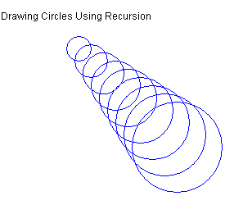

public class RecursiveCircles extends JFrame //JFrame is a built in class that draws a window
{

public RecursiveCircles()
{
setSize( 640, 480 );
setBackground(Color.white); //draws the screen to the color specified
setVisible(true);
}

// this method draws the stuff on the window
public void paint( Graphics window )
{

window.setColor(Color.black);
window.drawString( "RecursiveCircles", 20, 40 );
window.drawString( "Drawing Circles Using Recursion ", 20, 80 );

drawCircles(window, 10, 10);

}

void drawCircles(Graphics window, int x, int y)
{
//base case
window.setColor( Color.blue );

window.drawOval( 90+x, 90+y, 20+x, 20+x );

//drawCircles(window, x+10, y+10);

}

public static void main( String args[] )
{
RecursiveCircles graphlab = new RecursiveCircles();

}

}

