Name : ___________________________ Date : _________________

Arrays and Lists Lab

DIRECTIONS: Complete the following Activities

Hands-on Activity

- Mankala is a board game that is played by two players. The object of the game is to collect as many stones as possible. The board is made up of rows and columns.
- An explanation of how to play the game can be found at the following website:
http://www.ehow.com/how_2082739_play-mancala.html

Additionally a picture of a board can be found below.
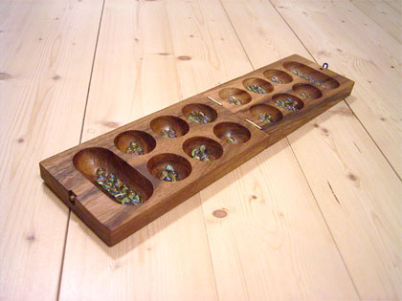

- Create a program that allows the user to play against the computer. It is your choice as the programmer how to represent the game board. You may represent it in a text-based program or a graphical based program.

Extra Credit: Create different levels (Beginner, Intermediate, Expert) for the user to choose.

