



27110-06

- The stairway shown in the figure above is classified as a _____ stairway (Page 10.3, Section 2.0.0 Figure 6)

- The stairway shown in the figure above is classified as a _____ stairway (Page 10.3, Section 2.0.0 Figure 7)

- The stairway shown in the figure above is classified as a _____ stairway (Page 10.3, Section 2.0.0 Figure 8)

- What types of stairs are included in the geometrical stairs category (Page 10.4, Section 2.0.0)?

- The stair parts marked A in the picture are _____ (Page 10.5, Section 3.0.0 Figure 10).

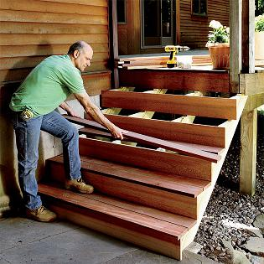
A

- The stair parts marked B in the picture are _____ (Page 10.5, Section 3.0.0 Figure 10).

B

- The stair parts marked C in the picture are _____ (Page 10.5, Section 3.0.0 Figure 10).

C

- What is a gooseneck (Page 10.6, Section 3.0.0)?

- What parts of an interior stairway make up a balustrade (Page 10.6, Section 3.0.0)?

- The stair part marked A in the picture is called the (Page 10.7, Section 3.0.0 Figure 12).

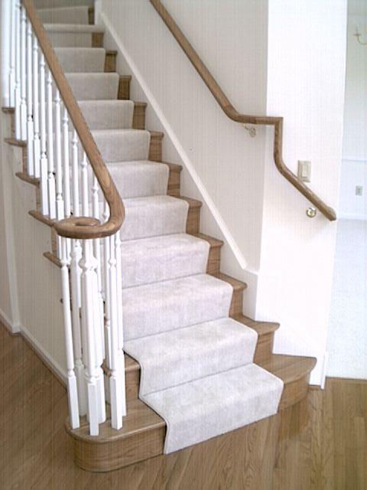
A
- The stair part marked B in the picture is called the (Page 10.7, Section 3.0.0 Figure 12)

B

- The stair part marked C in the picture is called the (Page 10.7, Section 3.0.0 Figure 12).

C

- Where is a skirtboard found (Page 10.8, Section 3.0.0)

- What is the minimum standard headroom for a stairway used in a public (commercial) building? (Page 10.8, Section 4.1.0)

- What is the standard width range for a stair width (Page 10.8, Section 4.4.0)?

- If a set of stairs does not have a landing, what should its maximum rise be (Page 10.11, Section 5.1.1 Note)?

- How is the tread run (unit run) measured (Page 10.12, Section 5.1.2)?

- How many risers and what will their individual height be for a stair with a total rise of 8'-2“ (Page 10.13, Section 5.1.2)?

- How many treads will a stair with a total rise of 8'-2" and a total run of 9'-9",using the stairwell header used as the last riser have (Page 10.13, Section 5.1.2)?

- How wide would the treads be for stairs with a total rise of 8'-2" and a total run of 9'-9" and using the stairwell header as the last riser (Page 10.13, Section 5.1.2)?

- What part of a framing square is used to measure the unit rise of a stair stringer (Page 10.18, Section 5.3.0 Figure 22)?

- What part of a framing square is used to measure the unit run of a stair stringer (Page 10.18, Section 5.3.0 Figure 22)?

