Module 26101-08
Orientation to the Electrical Trade
Lesson 1 of 1: Orientation to the Electrical Trade
This lesson is a classroom session in which the students will be introduced to the various types of equipment used in the three major fields of electrical work: residential, commercial, and industrial. They will also become familiar with the job opportunities in each of the three areas of study, as well the requirements of their apprenticeship program.
Objectives
Upon completion of this lesson, the student should be able to:
- Describe the apprenticeship/training process for electricians.
- Describe various career paths/opportunities one might follow in the electrical trade.
- Define the various sectors of the electrical industry.
- State the tasks typically performed by an electrician.
- Explain the responsibilities and aptitudes of an electrician.
Performance Requirements
  - None
Reading Assignment
  - Module 26101, Sections 1.0.0 thru 6.0.0
Slide Presentation
  - Module 26101, Slides 1 thru 12
Suggested Equipment/Materials
  - Help-wanted section from one or more electrical trade publications
  - Examples of NCCER Apprentice Training Recognition forms
  - Example of an employee manual
  - Various examples of personal protective equipment
Suggested Student Activity
  - Visit a local construction site to view modern construction in process. Identify the equipment and components installed by the electrical trade.
Testing
  - Module Review Questions 1 - 10
  - CONTREN Connect Active Figures 1 and 2
  - Module 26101-08 Exam
Suggested Lab Activities
  - None
Additional Resources
  - National Electrical Code® Handbook, Latest Edition. Quincy, MA: National Fire Protection Association.
  - Exploring Careers in Construction (available from NCCER).
  - Contren Connect Electrical 1 Anotated Instructors Guide (available from NCCER).
  - 29 CFR Part 1926, Standards for the Construction Industry. Occupational Safety and Health Administration, U.S. Department of Labor.
MODULE 26101
LESSON 1
INSTRUCTOR NOTES

SLIDE 1

- Read and explain the objectives of the module.
- Explain that students must obtain a score of 70% and perform certain tasks to the satisfaction of the instructor to receive credit for the module.
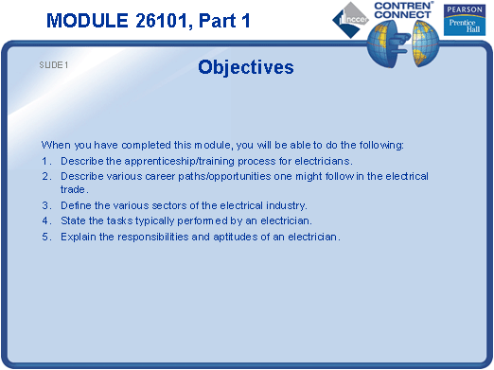

SLIDE 2

- Have the trainees list the components in a typical residential service.
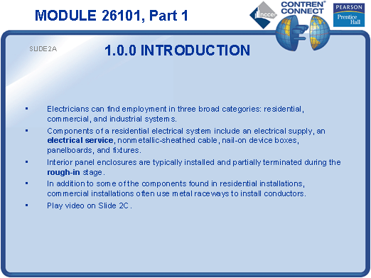

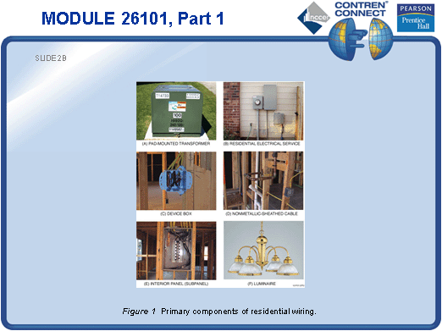

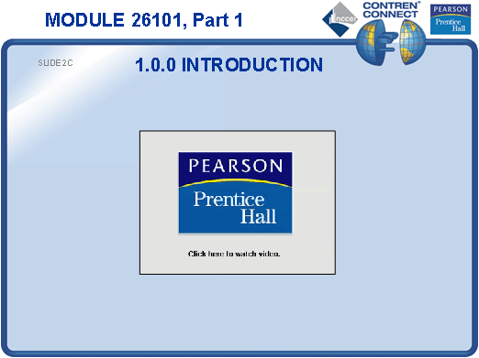

SLIDE 3

- Have the trainees identify the components in a typical commercial service, such as that in the training center.
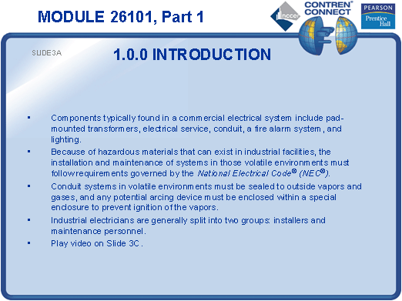

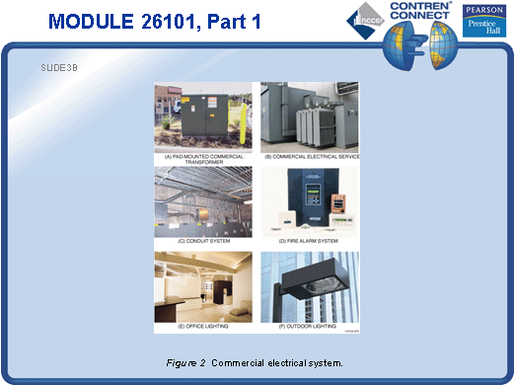

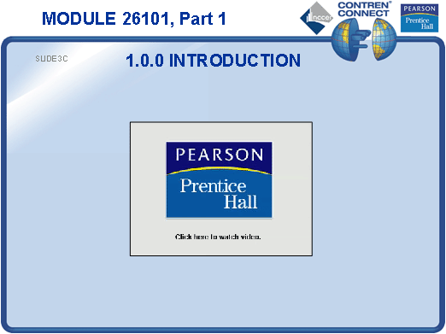

SLIDE 4

- Point out the special requirements of industrial work.
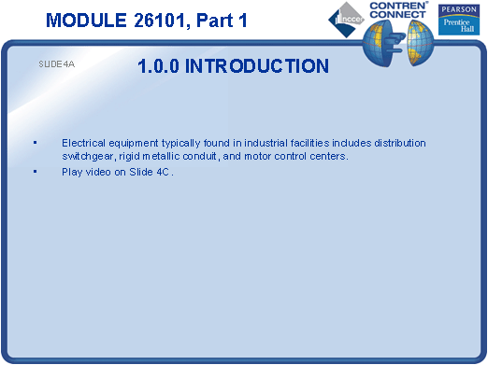

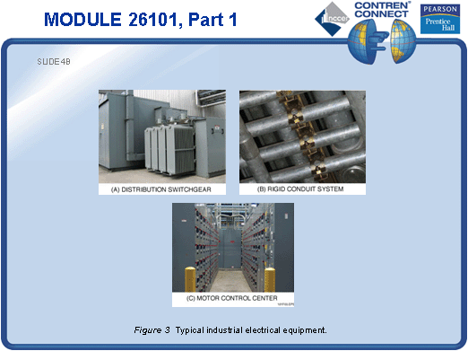

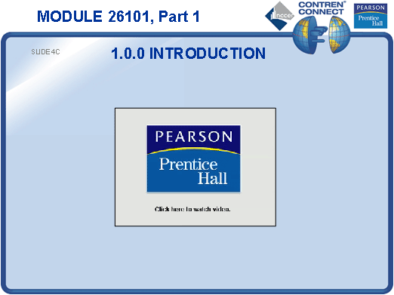

SLIDE 5

- Invite an electrical contractor to discuss job opportunities with the class.
- Provide a copy of the NCCER publication Exploring Careers in Construction for the trainees to examine.
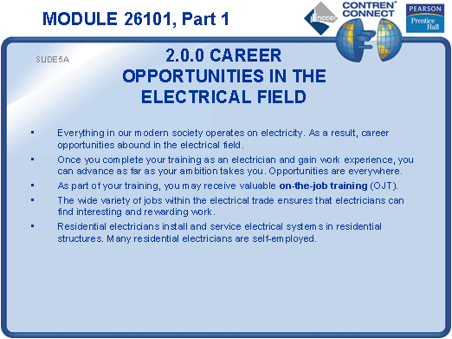

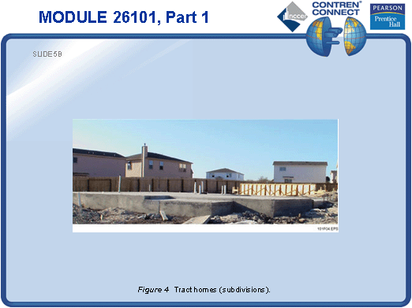

SLIDE 6

- No notes
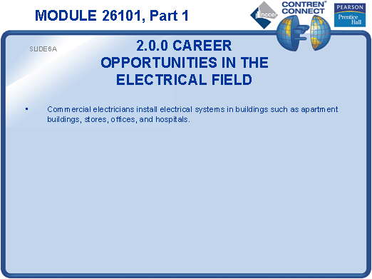
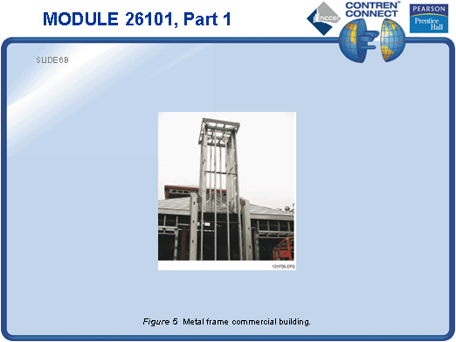

SLIDE 7

- Provide the help-wanted section from an electrical trade publication and identify which jobs are for residential, commercial, or industrial electricians.
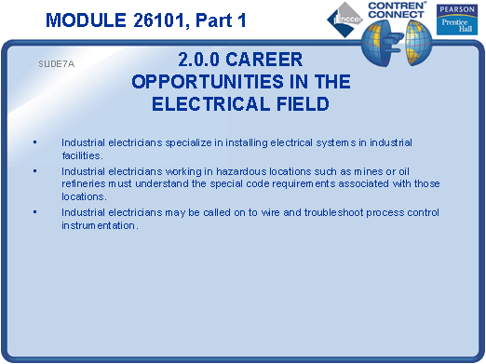
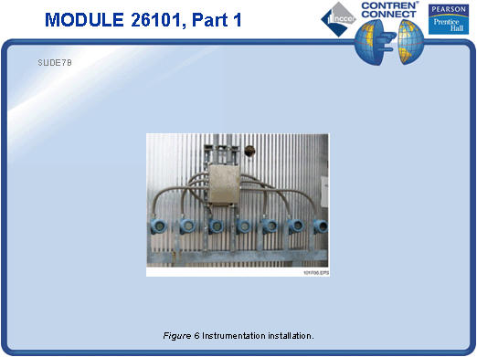
SLIDE 8

- If time permits, take the trainees to a local construction site to view the installation of an electrical system.
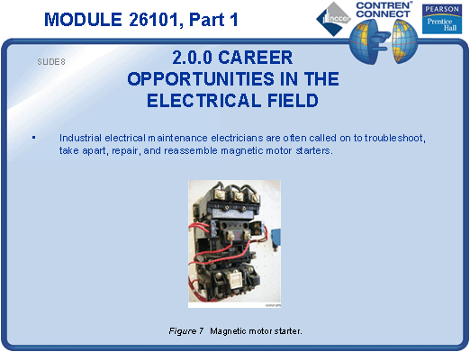

SLIDE 9

- Provide samples of NCCER Apprentice Training Recognition forms for the trainees to examine.
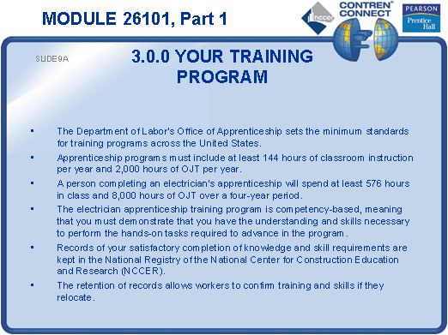
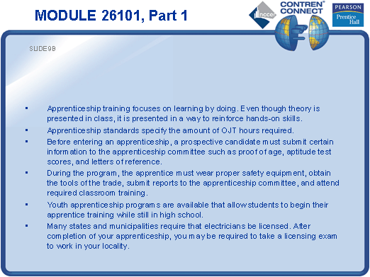
SLIDE 10

- Ask the trainees to give examples of professional and unprofessional behavior.
- Provide a typical employee manual for the trainees to examine.
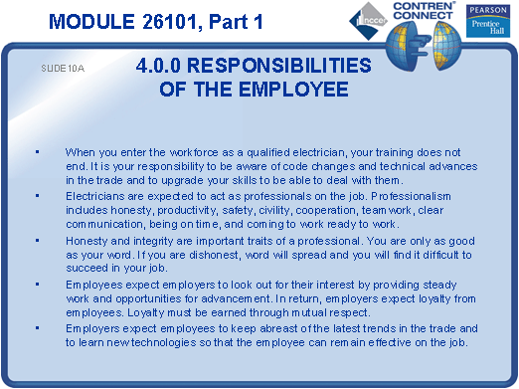
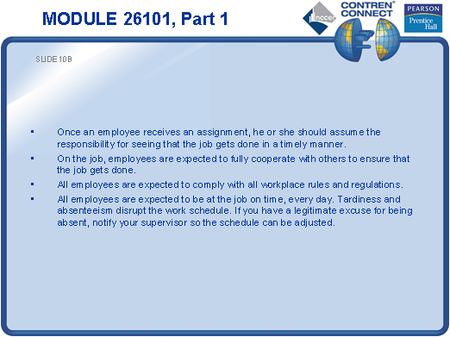
SLIDE 11

- Discuss employer responsibilities.
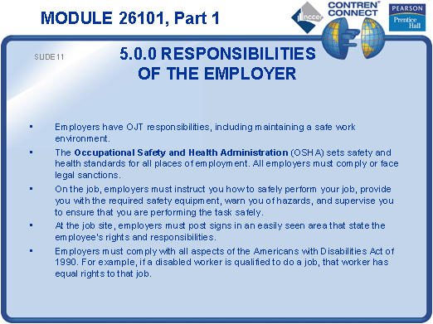

SLIDE 12

- Provide copies of OSHA Standard 1926, NFPA 70E, and the NEC® for the trainees to examine.
- Show examples of various types of safety equipment.
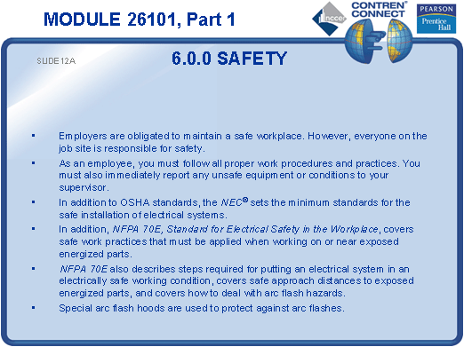

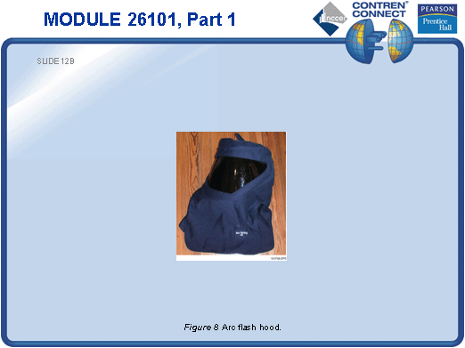

TESTING

- Have students complete Active Figures 1 and 2.
- Have students complete the Trade Terms Quiz.
- Have students answer Review Questions 1 thru 10. Provide correct answers and remediation at the end of the quiz.
- Administer the Module Exam.

