Module 26102-08
Electrical Safety
Lesson 1 of 3: Protecting Against the Effects of Electrical Hazards
This lesson is a classroom and lab session in which the students will learn about the hazard of electrical shock, including its effect on the human body, how to reduce potential injury due to electrical shock, and OSHA-mandated safe work practices related to electrical shock. A demonstration of selecting, inspecting, and putting on voltage-rated gloves is included, as well as OSHA-recommended lockout/tagout procedures.
Objectives
Upon completion of this lesson, the student should be able to:
- Identify the effects of current flow through the human body.
- Maintain a safe approach distance based on the voltage level present.
- Select, inspect, and properly put on voltage-rated insulating gloves.
- Define OSHA and the electrical safe work practices mandated and/or recommended by OSHA
- Comply with a lockout/tagout plan.
- Understand the purpose of NFPA 70E.
Performance Requirements
  - None
Reading Assignment
  - Module 26102, Sections 1.0.0 thru 5.0.0
Slide Presentation
  - Module 26102, Part 1 (Slides 1 thru 14)
Suggested Equipment/Materials
  - At least three classes of voltage-rated gloves
  - Lockout/tagout devices and disconnecting devices to practice applying locks and tags
  - Insulating PPE such as blankets, aprons, etc.
  - GFCI circuit breaker and GFCI receptacle
  - Hot stick, fuse puller, and any other electrical safety equipment available
  - Disassembled double-insulated tool
Suggested Student Activity
  - Have students locate electrical utility work being performed in their area, and from a safe approach distance, list electrical safety equipment and safe work practices being used or applied. Include such equipment and devices as insulated bucket trucks, insulated tools, gloves, blankets, safe distances, etc.
Testing
  - Module Review Questions 1 – 8
  - CONTREN Connect Active Figure 3
Suggested Lab Activity
  - Have the students select the correct voltage-rated glove for a given voltage. Use Performance Project 26102-3, Selecting, Testing, and Using Voltage-Rated Gloves.
  - Have the students apply a lock and tag to a disconnecting device. Use Performance Project 26102-2, Perform Hazard Assessment and Follow Lockout/Tagout Procedures.
Additional Resources
  - NFPA 70E, Standard for Electrical Safety in the Workplace, National Fire Protection Association, Quincy, MA: National Fire Protection Association.
  - OSHA 29 CFR Part 1910 and OSHA 29 CFR Part 1926, Occupational Safety and Health Administration, U.S. Department of Labor.
  - Performance Projects: Job Sheets for the Electrical Industry, Level One, New York: Prentice Hall.
  - Contren Connect Electrical 1 Anotated Instructors Guide (available from NCCER).
SLIDE 1
  - Review the objectives to be covered in this module. Ask the students if they have any questions.
  - Explain that students must obtain a score of 70% on the Module Exam and perform certain tasks to the satisfaction of the instructor to receive credit for the module.
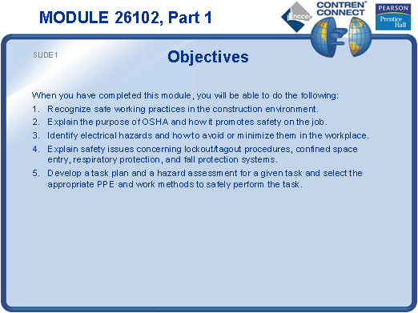
SLIDE 2
  - List common electrical hazards.
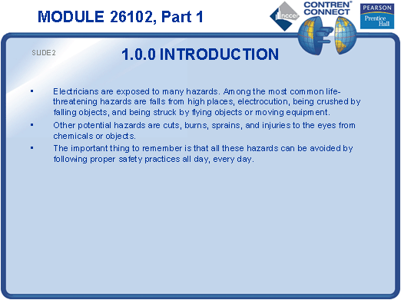
SLIDE 3
  - Explain that the effects of electrical shock are dependent on many variables.
  - Explain that the reason the majority of fatal shocks are caused by voltages below 600 volts is because of frequent exposure to these voltages.
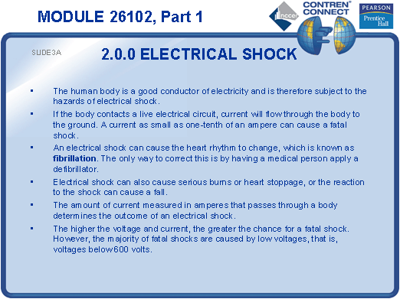

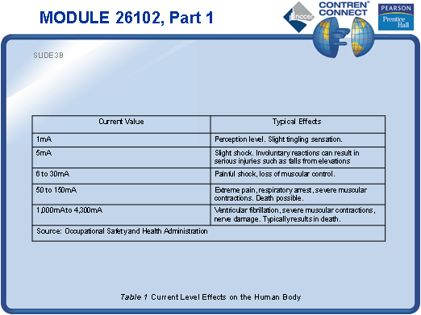
SLIDE 4
  - Emphasize the importance of using grounded or double-insulated tools and GFCIs.
  - Point out that electrical burns can be caused by current flow through the body or by arc flash, which can also throw objects and molten metal.
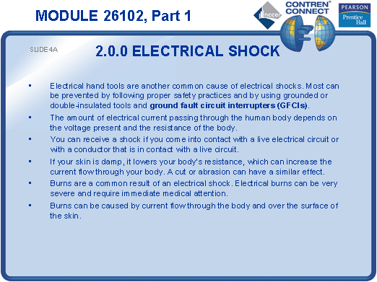
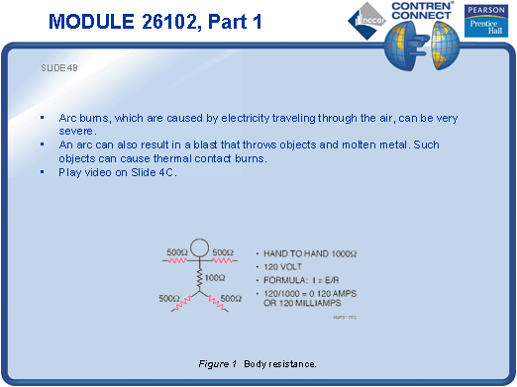

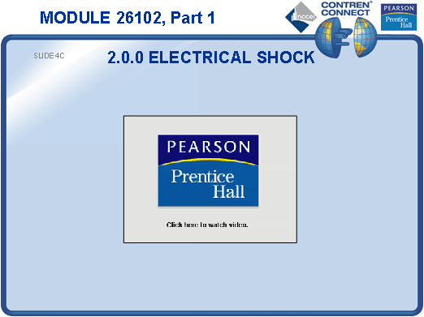

SLIDE 5
  - Explain that the approach distances listed relate to qualified persons.
  - Note that unqualified persons must maintain a much greater approach distance.
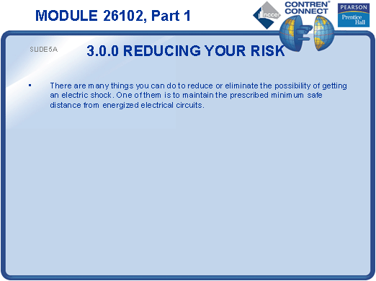

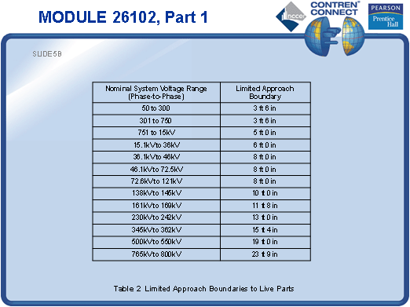
SLIDE 6
  - Provide voltage-rated rubber gloves for the students to examine.
  - Explain that the insulating properties are provided by the rubber gloves, and the leather sleeves only protect the rubber gloves from punctures.
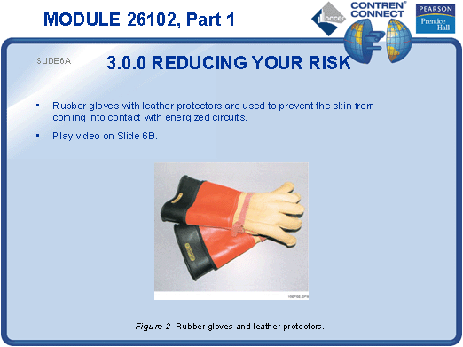

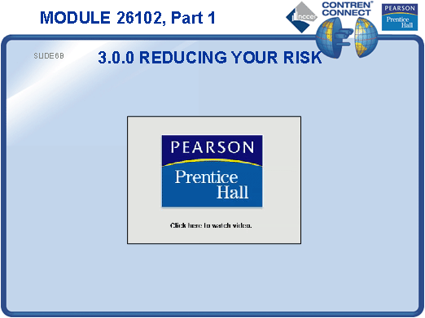

SLIDE 7
  - Show how to identify the voltage rating on a pair of gloves.
  - Demonstrate how to inspect rubber gloves.
  - Explain that gloves must be tested by a certified testing lab every six months.
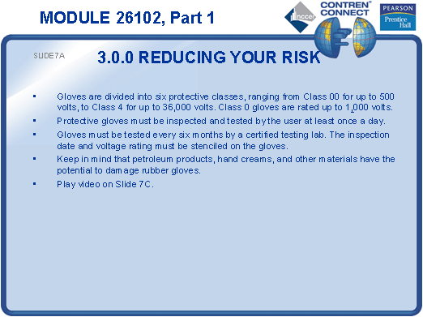
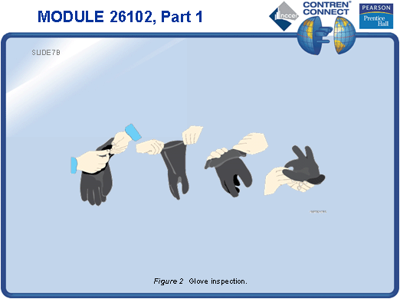
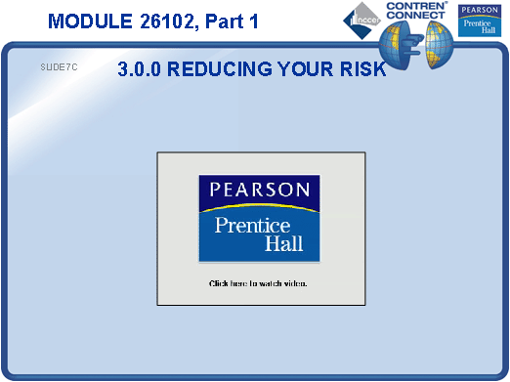
SLIDE 8
  - Provide samples of other PPE such as blankets, aprons, gauntlets, hot sticks, fuse pullers, grounding straps, face shields, and other eye protection.
  - Emphasize that all circuits are considered energized until proper steps have been taken to put the circuit or equipment in an electrically safe work condition.
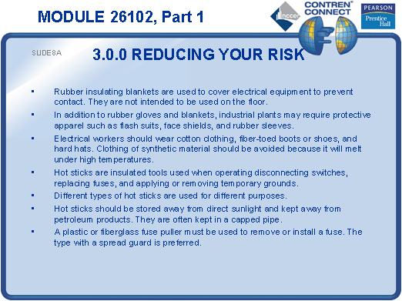
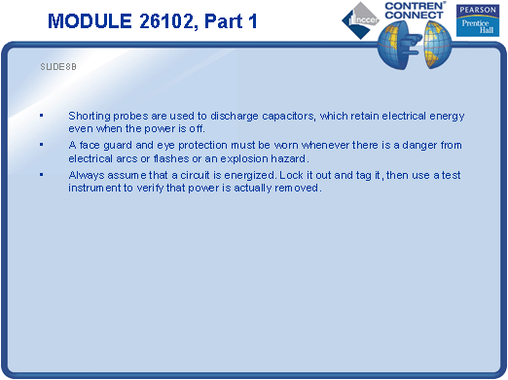
SLIDE 9
  - Explain that OSHA 29 CFR Part 1910 covers safety regulations related to general industry, and OSHA 29 CFR Part 1926 covers safety regulations related to the construction industry.
  - Explain the importance of lockout/tagout and the proper techniques used to safely turn on or reset a circuit breaker.
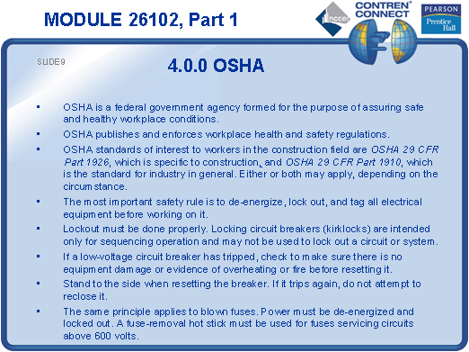
SLIDE 10
  - Pass around a double insulated tool that has been disassembled so that the students can see how the interior insulation lines the housing. (Make sure the power cord has been removed to prevent the tool from being energized.)
  - Explain that electrical tools that are not double insulated must have a power cord that includes a grounding conductor.
  - Emphasize the importance of NEVER removing the grounding prong from either an extension cord or an electrical tool.
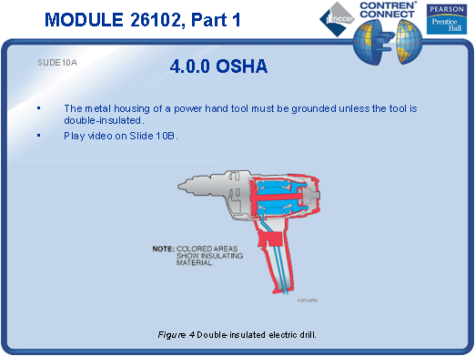
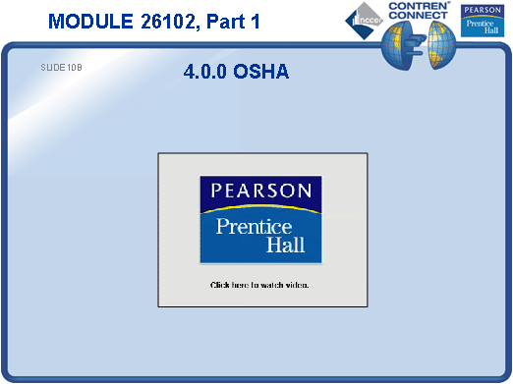
SLIDE 11
  - Explain how a GFCI device provides electrical safety to the user.
  - Pass around a GFCI circuit breaker and a GFCI receptacle.
  - Explain that a GFCI circuit breaker protects all outlets connected to the circuit, whereas a GFCI receptacle only protects whatever is connected to it.
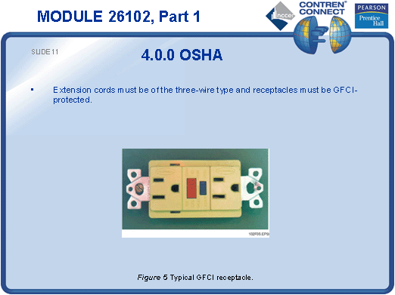
SLIDE 12
  - Explain that lockout/tagout procedures may differ for various locations.
  - Explain the importance of reviewing and complying with the lockout/tagout procedures for the facility you are working in.
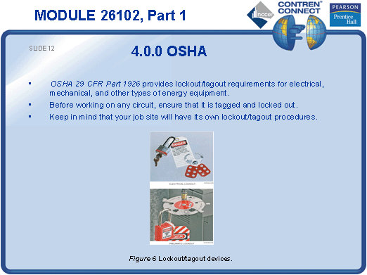
SLIDE 13
  - Create a simple lockout/tagout program in class and have the students demonstrate their understanding by applying locks and tags to a disconnecting device according to the in-class program developed.
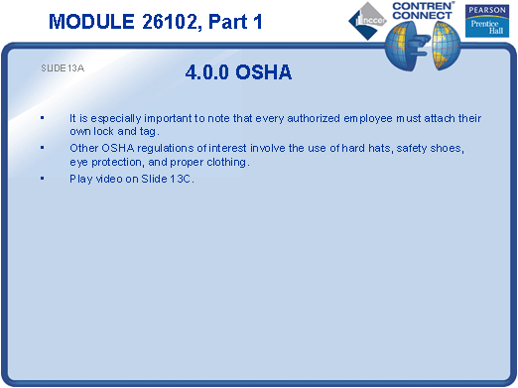
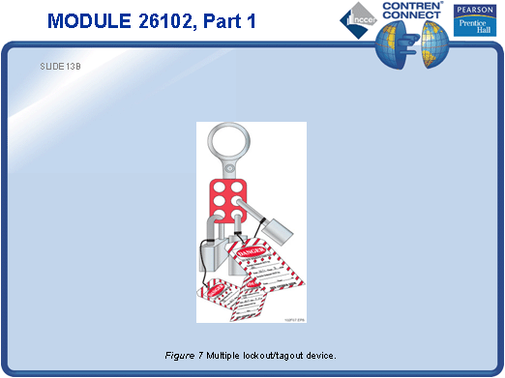
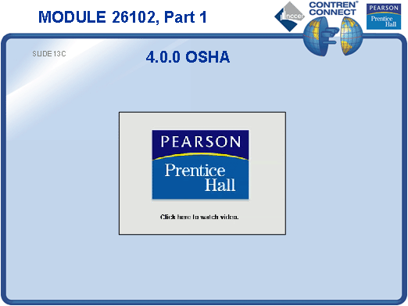
SLIDE 14
  - Discuss the purpose of NFPA 70E.
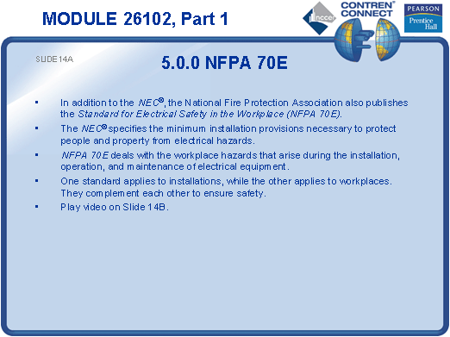
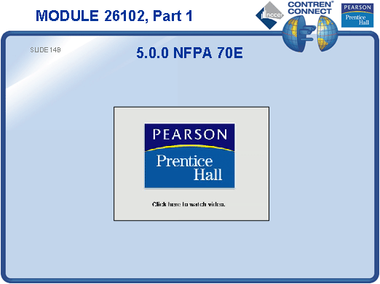
TESTING and PERFORMANCE
- Have the students complete CONTREN Connect Active Figure 3.
- Have the students answer Review Questions 1 – 8 for Sections 1.0.0 – 5.0.0. Provide correct answers and remediation at the end of the quiz.

