Module 26106-08
DEVICE BOXES
Lesson 1 of 2: Types of Boxes; Sizing Outlet Boxes
This lesson is a classroom/lab session in which the students will be introduced to the various types of device boxes and learn how to select and size them for a given application.
Objectives
Upon completion of this lesson, the student should be able to:
- Describe the different types of nonmetallic and metallic boxes.
- Calculate the NEC® fill requirements for device boxes.
- Identify the appropriate box type and size for a given application.
Performance Requirements
  - Identify the appropriate box type and size for a given application. This task satisfies module Performance Task 1.
Reading Assignment
  - Module 26106, Sections 1.0.0 thru 3.0.0
Slide Presentation
  - Module 26106, Part 1 (Slides 1 thru 12)
Suggested Equipment/Materials
  - Conduit caps
  - Various metal and nonmetallic boxes
  - Raised device covers
  - Extension rings
  - Cable clamps
  - Switches and receptacles
  - Hickeys
  - Fixture studs
  - Various lengths of conductors, including grounding conductors
  - Grounding clips and screws
  - Box connectors and locknuts
  - Wire nuts
Suggested Student Activity
- Visit a commercial facility under construction to see how conduit is connected to boxes.
Testing
  - Module Review Questions 1 – 7
  - CONTREN Connect Active Figure 10
Suggested Lab Activities
- Assemble a selection of device boxes. Have the students identify each type and state its uses.
  - Assemble raised device covers, extension rings, cable clamps, switches and receptacles, hickeys, fixture studs, various lengths of conductors (including grounding conductors), grounding clips, grounding screws, box connectors, and locknuts. For each item, have the students identify whether it adds to or reduces box capacity.
Additional Resources
- National Electrical Code® Handbook, Quincy, MA: National Fire Protection Association.

- Contren Connect Electrical 1 Anotated Instructors Guide (available from NCCER).
SLIDE 1
  - Review the objectives to be covered in this module. Ask the students if they have any questions.
  - Explain that students must obtain a score of 70% on the Module Exam and perform certain tasks to the satisfaction of the instructor to receive credit for the module.
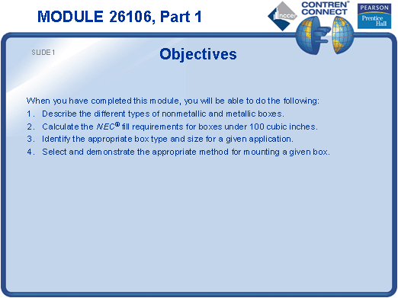

SLIDE 2
  - List the common applications of boxes in a raceway system.
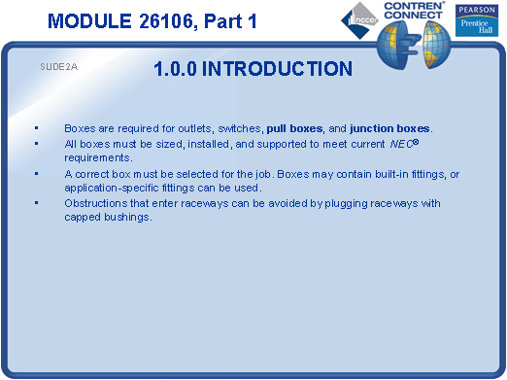

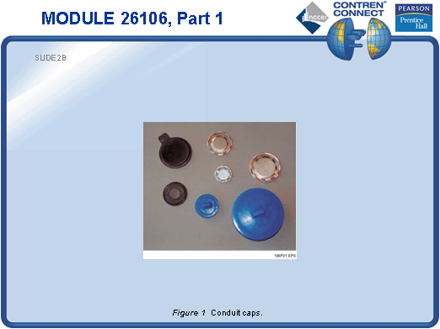
SLIDE 3

- Show examples of metal and nonmetallic boxes and allow the students to examine them.
- Point out the special requirements for boxes used with lighting fixtures and ceiling fans.
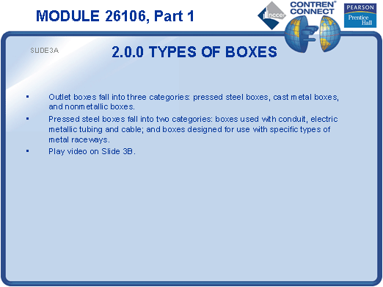

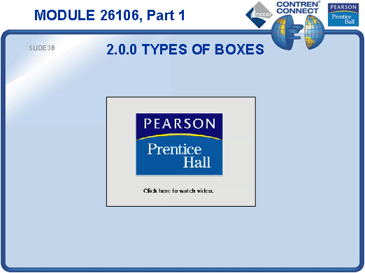

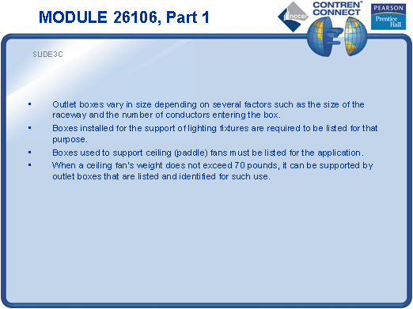

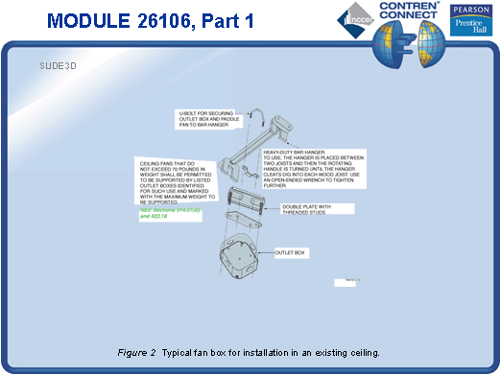
SLIDE 4

- Explain that octagon and round boxes are commonly used with wall- and ceiling-mounted lighting fixtures.
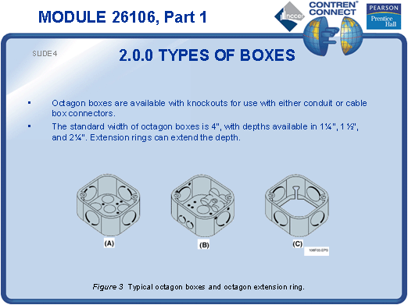

SLIDE 5

- No notes.
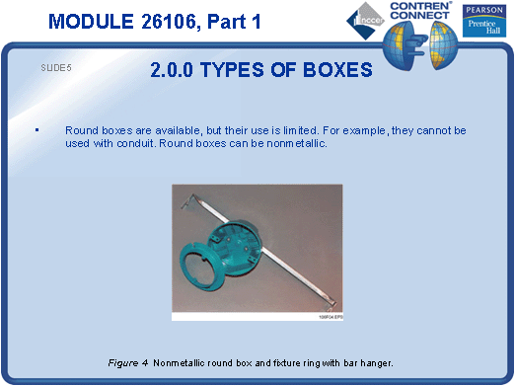

SLIDE 6

- Discuss the NEC® requirements for round boxes.
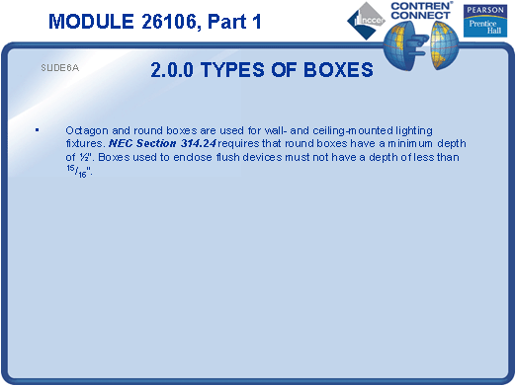
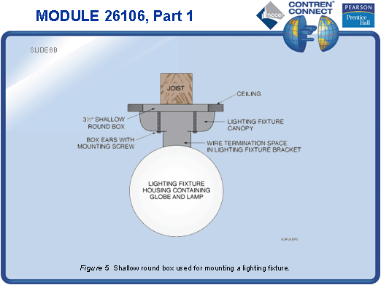

SLIDE 7

- Demonstrate how an extension ring can be used to add volume to a box.
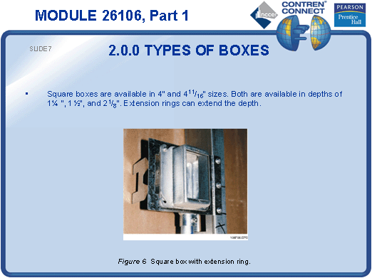

SLIDE 8

- Point out the depth gauge on a typical device box.
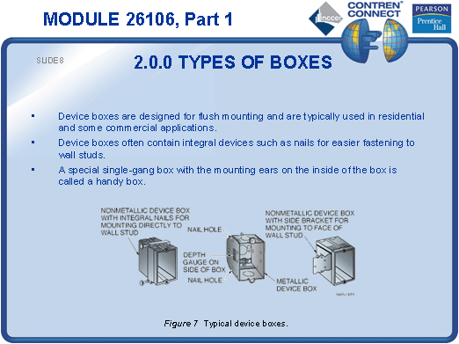

SLIDE 9

- Explain that special boxes are required for wet or damp locations.
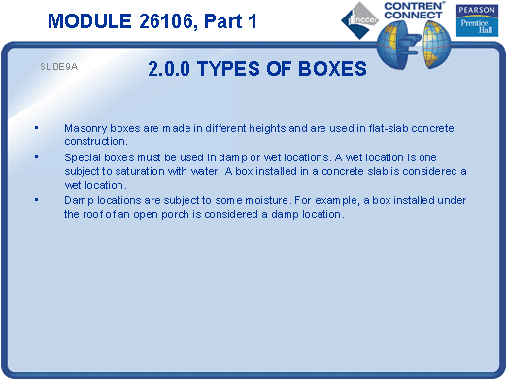

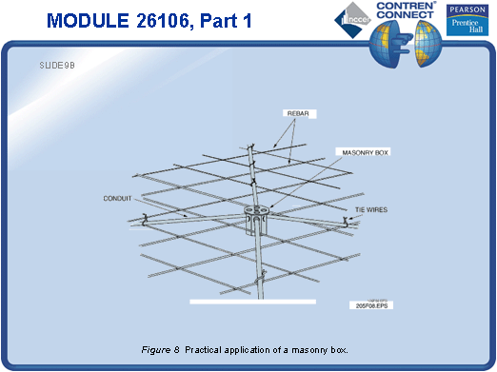
SLIDE 10

- Show examples of components that add to outlet box capacity.
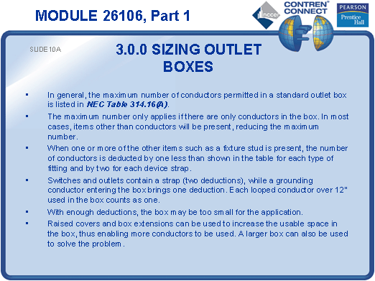
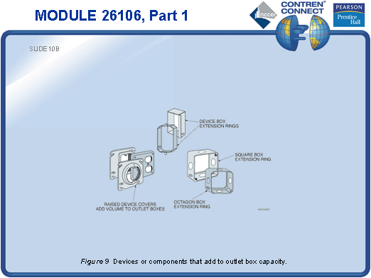
SLIDE 11

- Show examples of components that require deductions in outlet box capacity.
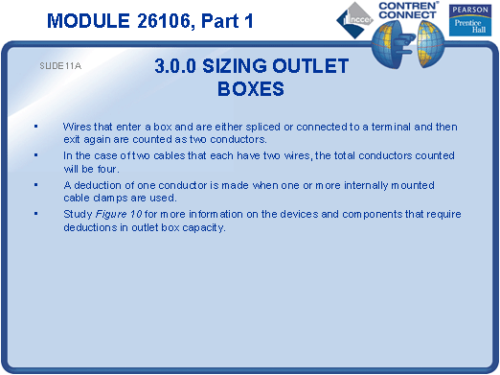
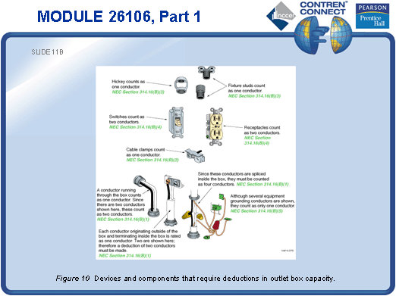
SLIDE 12

- Show examples of components that can be disregarded when calculating outlet box capacity.
- Demonstrate how to select the appropriate box for a typical installation and then calculate its capacity. Have the students practice selecting boxes and calculating box capacity.
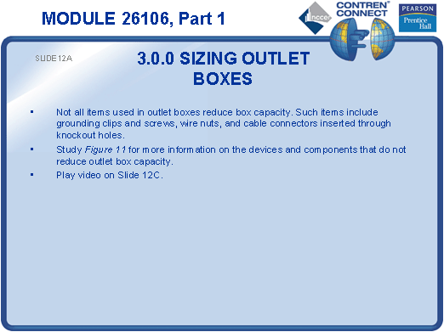

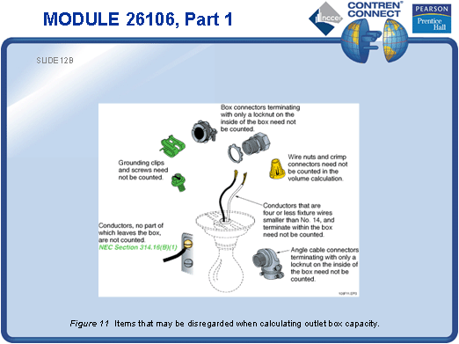
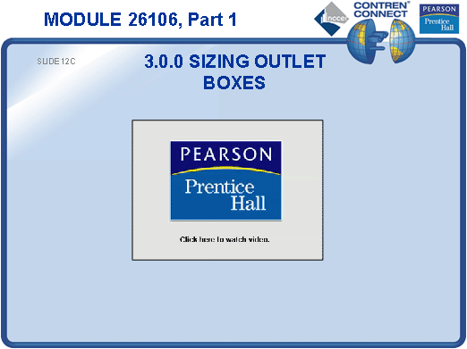
TESTING and PERFORMANCE
- Have the students complete Active Figure 10.
- Have the students complete Review Questions 1 – 7 for Sections 1.0.0 – 3.0.0. Provide correct answers and remediation at the end of the quiz.
- Students must identify the appropriate box type and size for a given application. This can be done during the presentation of Slide 12 or at the end of the lesson. This satisfies Performance Task 1.

