Module 26106-08
DEVICE BOXES
Lesson 2 of 2: Pull and Junction Boxes; Installing Boxes
This lesson is a classroom/lab session in which the students will be introduced to the various types of pull and junction boxes and learn how to select and size them for a given application. They will also learn how to install boxes in a raceway system.
Objectives
Upon completion of this lesson, the student should be able to:
- Calculate the NEC® fill requirements for pull and junction boxes under 100 cubic inches.
- Identify the appropriate box type and size for a given application.
- Select and demonstrate the appropriate method for mounting a given box.
Performance Requirements
  - Select the minimum size pull or junction box for conduit entering and exiting for a straight pull and conduit entering and exiting at an angle. This task satisfies module Performance Task 2.
Reading Assignment
  - Module 26106, Sections 4.0.0 thru 5.2.0
Slide Presentation
  - Module 26106, Part 2 (Slides 13 thru 22)
Suggested Equipment/Materials
  - Examples of pull and junction boxes
  - Various lengths of wire
  - Wire nuts
  - Stripping tools
Suggested Student Activity
- Visit a commercial facility under construction to identify various pull and junction boxes and to see how conduit is connected to boxes.
Testing
  - Module Review Questions 8 – 10
  - Module 26106-08 Exam
Suggested Lab Activities
- Assemble a selection of pull and junction boxes and label each with a specific application (for example, three 2" conduit runs entering at a right angle). Have the students identify whether the box would be suitable for the application.
- Have the students install a device box. Use Performance Project 26106-1, Selecting and Installing a Weatherproof Device Box with Plastic or Metal Sleeve or Wedge Anchors.
Additional Resources
- National Electrical Code® Handbook, Quincy, MA: National Fire Protection Association.
- Performance Projects: Job Sheets for the Electrical Industry, Level One, New York: Prentice Hall.
- Contren Connect Electrical 1 Anotated Instructors Guide (available from NCCER).

SLIDE 13

- Review the objectives to be covered in this lesson. Ask the students if they have any questions.
- Provide several straight pull box sizing problems and have the students solve them.
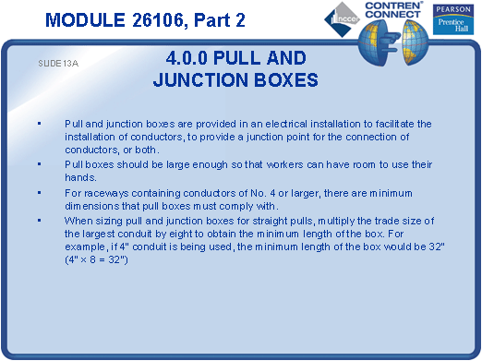

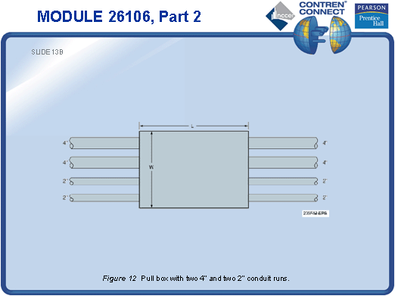

SLIDE 14

- Provide several angle pull box sizing problems and have the students solve them.
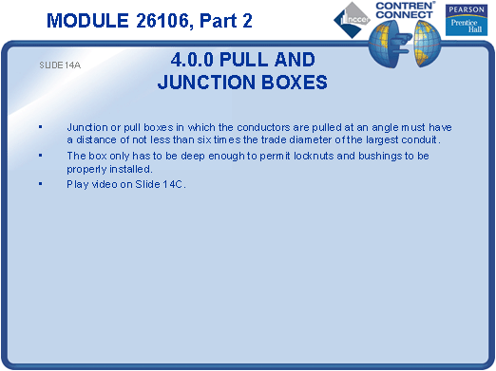
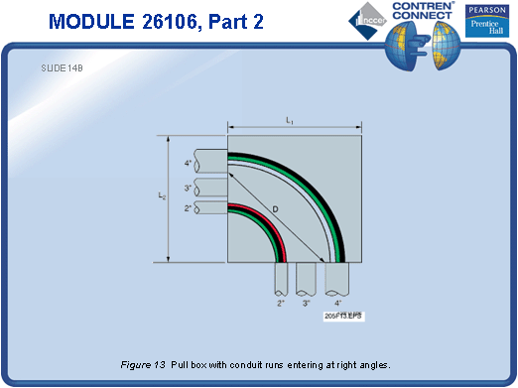

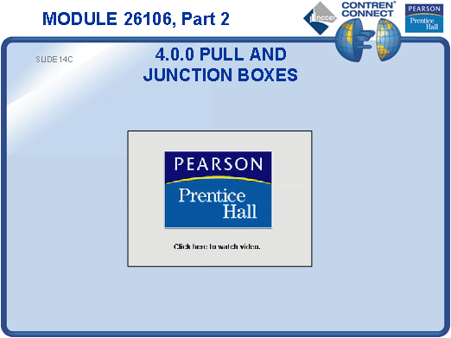
SLIDE 15

- Have the students look up the installation requirements for boxes in the NEC®.
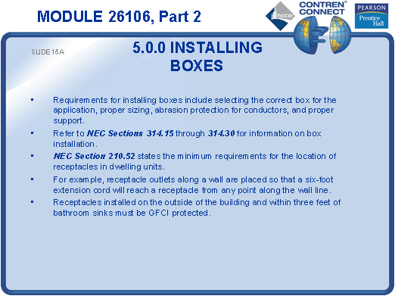
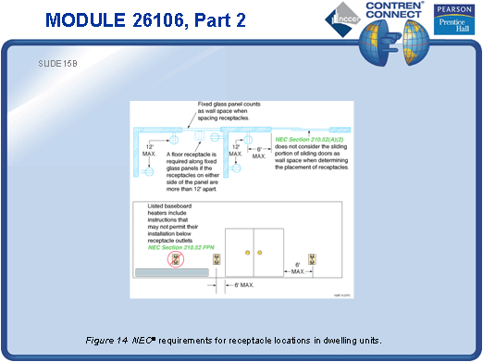
SLIDE 16

- Point out the NEC® and industry standards for receptacle placement.
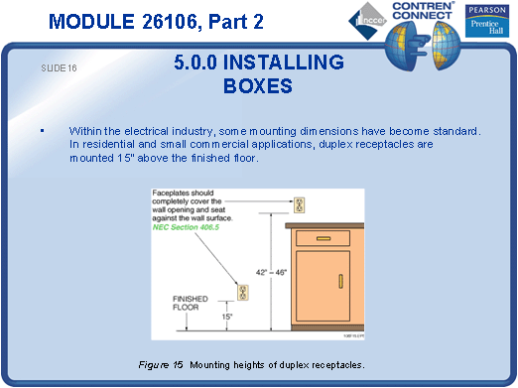
SLIDE 17

- No notes.
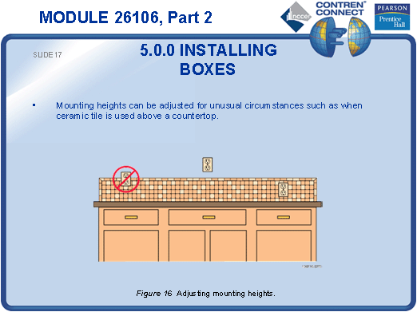

SLIDE 18

- Remove the cover plates from the classroom light switches and/or receptacles and have the trainees identify whether they meet the NEC® gap and setback requirements.
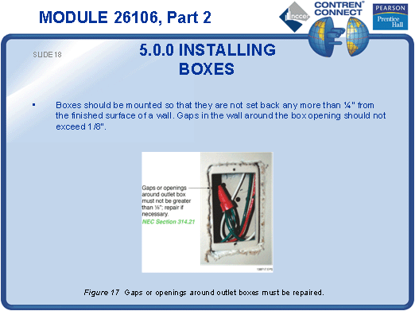

SLIDE 19

- No notes.
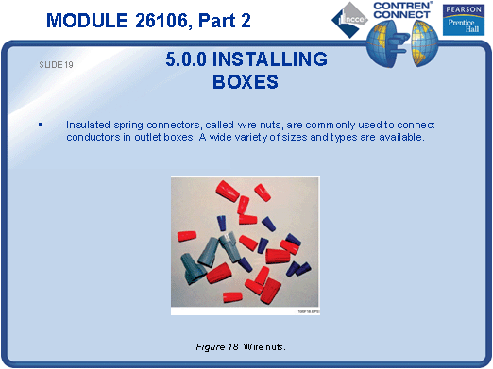

SLIDE 20

- Demonstrate how to strip wires and connect them using wire nuts.
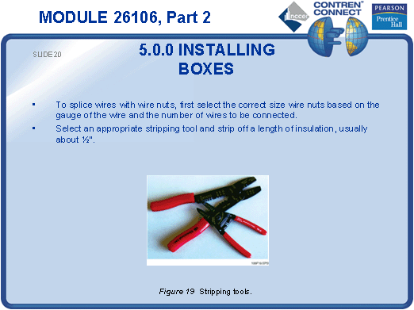
SLIDE 21

- No notes.
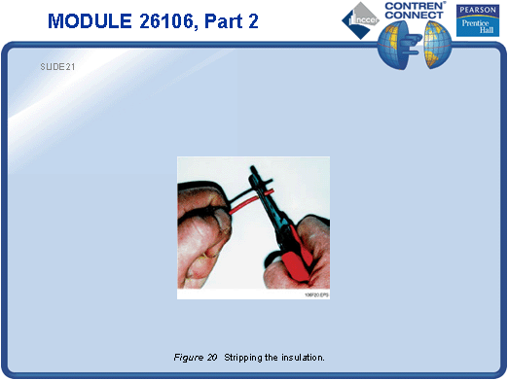
SLIDE 22

- Have the students practice wire stripping and connections.
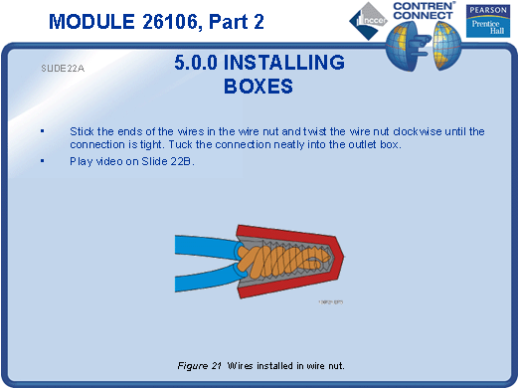
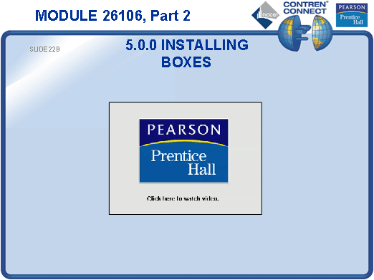
TESTING and PERFORMANCE
- Have the students complete Review Questions 8 – 10 for Sections 4.0.0 – 5.2.0. Provide correct answers and remediation at the end of the quiz.
- Have the students complete the Trade Terms Quiz.
- Select the minimum size pull or junction box for conduit entering and exiting for a straight pull and conduit entering and exiting at an angle. This can be done during the presentation of Slides 13 and 14 or at the end of the lesson. This satisfies Performance Task 2.
- Administer the Module Exam.

