Module 26103-08
Introduction to Electrical Circuits
Lesson 1 of 2: Introduction to Electrical Theory and Ohm’s Law
This is a classroom and lab lesson that includes an introduction to electricity and basic atomic theory. The lesson also covers the construction of a simple breadboard circuit and explains how Ohm’s law is applied to solve for an unknown value when at least two other values are known.
Objectives
Upon completion of this lesson, the student should be able to:
- Recognize what atoms are and how they are constructed.
- Define voltage and identify the ways in which it can be produced.
- Explain the difference between conductors and insulators.
- Define the units of measurement that are used to measure the properties of electricity.
- Explain how voltage, current, and resistance are related to each other.
Performance Requirements
  - None
Reading Assignment
  - Module 26103, Sections 1.0.0 thru 6.0.0
Slide Presentation
  - Module 26103, Part 1 (Slides 1 thru 15)
Suggested Equipment/Materials
  - Calculators
  - Paper and pencils
  - Small horseshoe magnets and metal filings
  - Breadboards
  - 6-volt batteries
  - Switches
  - 18-22 AWG wire
  - 6-volt lamps/sockets
  - Electrical drawings containing schematic symbols found on Slide 15
Suggested Student Activity
  - Experiment with magnets and metal shavings as a learning tool to help understand the movement of electrons in an electrical circuit.
  - Create safe, low-voltage circuits using batteries and low-voltage lamps, switches, and resistors to learn the characteristics and relationships of components in a circuit.
  - Interpret electrical schematics/drawings.
Testing
  - Module Review Questions 1 thru 6
  - CONTREN Connect Active Figure 10
Suggested Lab Activities
  - Build a simple DC circuit to demonstrate Ohm’s law principles. Use Performance Project 26103-1: Demonstrate Ohm’s Law by Building a Circuit.
  - Demonstrate the movement of metal shavings between magnet poles to illustrate the movement of electrons.
Additional Resources
  - Electronics Fundamentals: Circuits, Devices, and Applications, Thomas L. Floyd, New York: Prentice Hall.
  - Performance Projects: Job Sheets for the Electrical Industry, Level One, New York: Prentice Hall.
  - Principles of Electric Circuits, Thomas L. Floyd, New York: Prentice Hall.
  - Contren Connect Electrical 1 Anotated Instructors Guide (available from NCCER).
SLIDE 1
  - Review the objectives to be covered in this module. Ask the students if they have any questions.
  - Explain that students must obtain a score of 70% on the Module Exam and perform certain tasks to the satisfaction of the instructor to receive credit for the module.
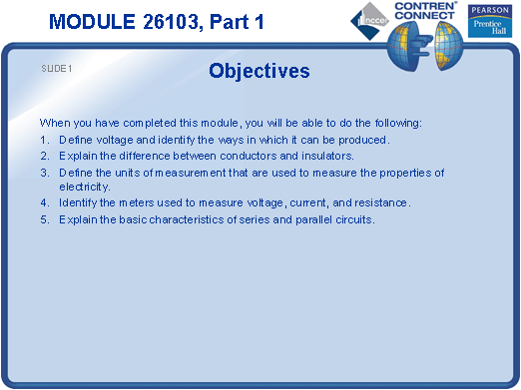
SLIDE 2
  - Discuss the minimum requirements of an electrical circuit.
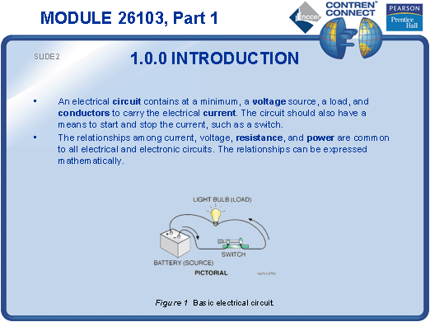
SLIDE 3
  - Describe the basic elements and charges of an atom.
  - Explain that the electrons are held in orbit, much like the planets in our solar system, by the difference in charges between the electrons and the nucleus.
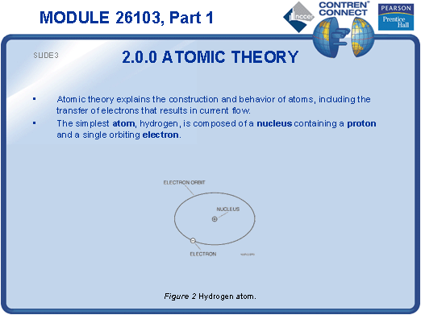

SLIDE 4
  - Demonstrate the movement of metal shavings using opposite-pole magnets to simulate electron movement.
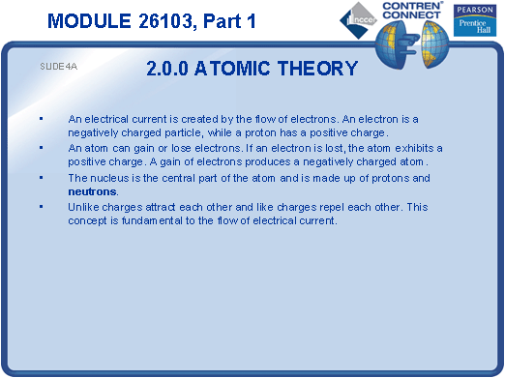
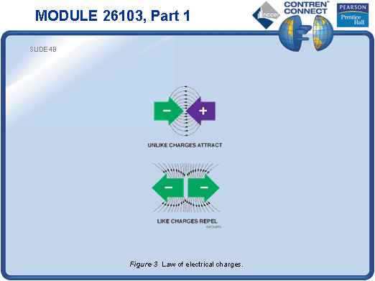
SLIDE 5
  - Explain that a conductor is material composed of atoms with valence electrons and an insulator is a material composed of atoms with little or no valence electrons.
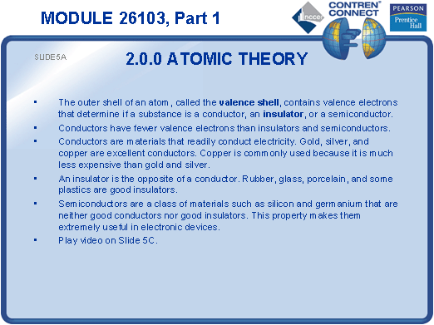
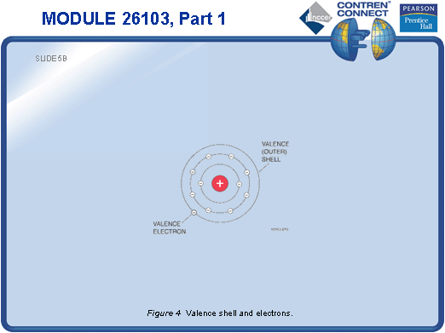
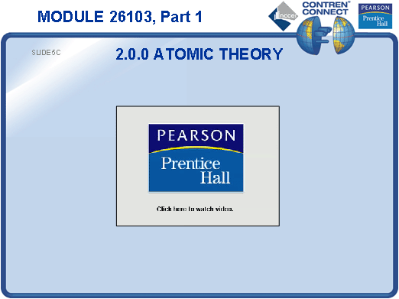
SLIDE 6
  - Discuss the applications of electromagnets (motors, generators, relays, etc.).
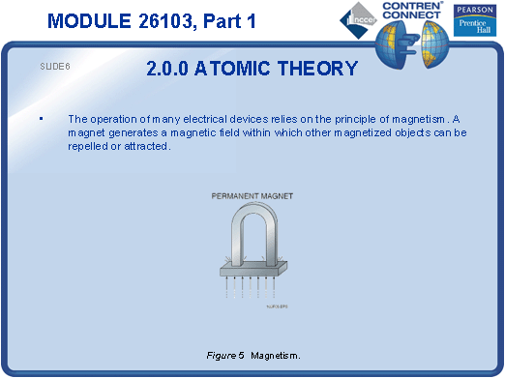
SLIDE 7
  - Use a battery as an example of stored voltage to get across the understanding of the difference of charges between two poles or points.
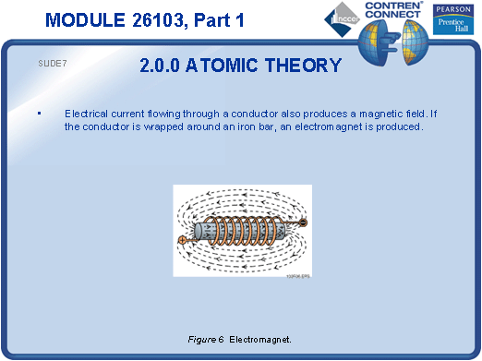
SLIDE 8
  - Discuss various types of power generation, including green power.
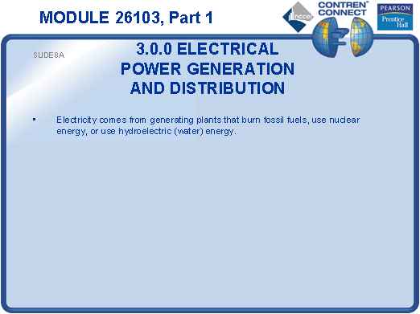
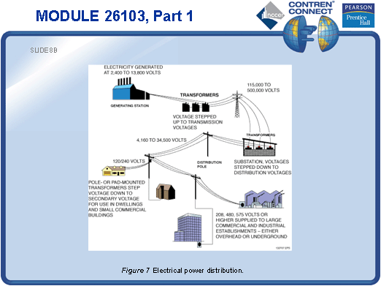
SLIDE 9
  - Trace the path of power into the training building and to a final point of service, such as a receptacle.
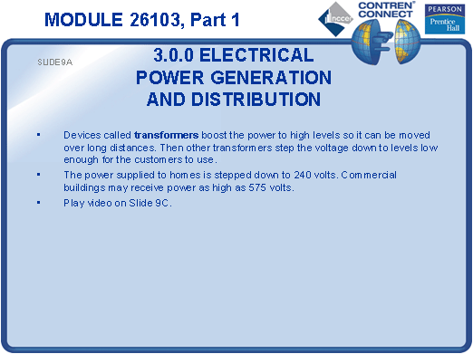
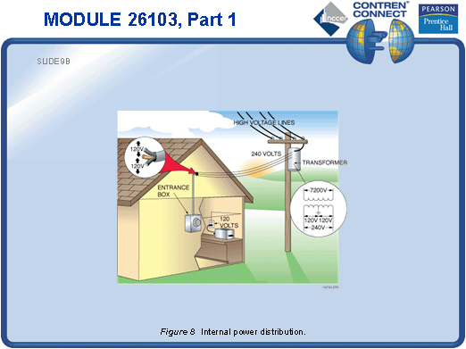
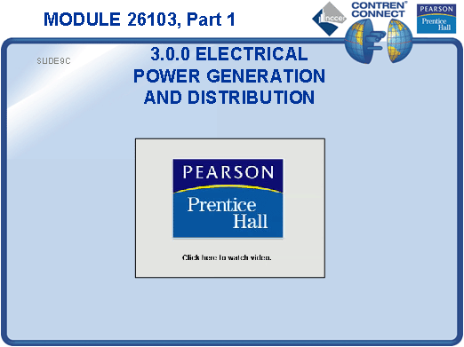
SLIDE 10
  - Explain that voltage, similar to a magnet, is the difference of charges between two poles or points. When the two poles or points of a voltage potential are applied across a conductor, the difference of charges moves the valence electrons of the conductor’s atoms from one atom to another.
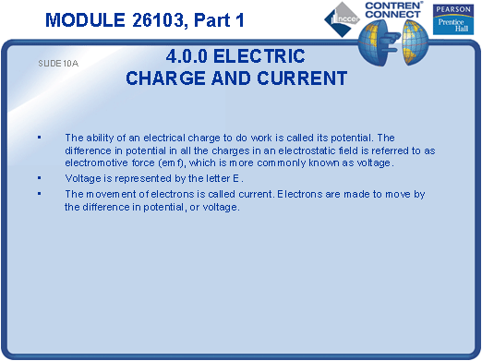
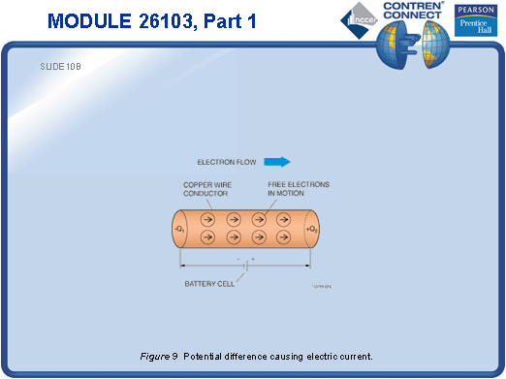
SLIDE 11
  - List the units of voltage, current, and resistance.
  - Illustrate how resistance can be compared to a restriction in a conductive path that only slows down the movement of electrons through the conductor.
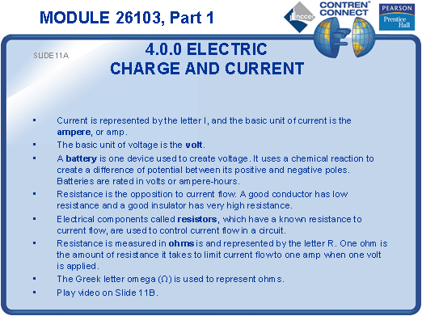
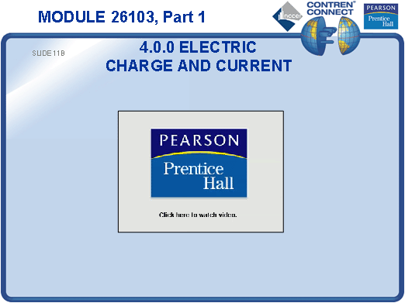
SLIDE 12
  - Compare the resistance of various conductive materials using the table given in the slide.
  - Explain the effect of ambient temperature on resistance (the more heat, the more resistance).
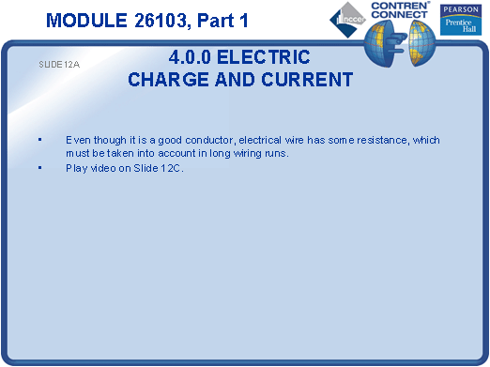
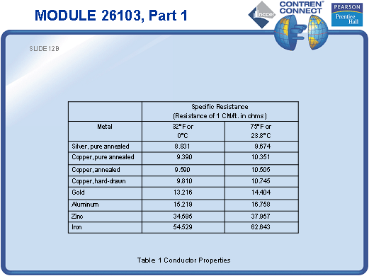
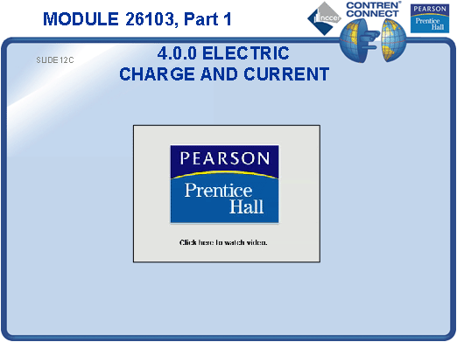
SLIDE 13
  - Introduce Ohm’s law as a tool that can be used not to only demonstrate the relationship between voltage, current, and resistance, but also to solve for an unknown property value when the other two are known.
  - Draw some basic circuits on the board and have the students work out simple Ohm’s law problems.
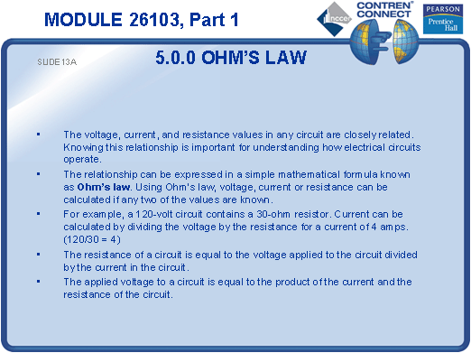

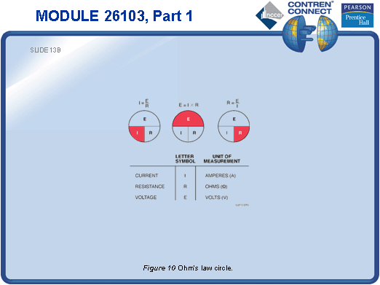
SLIDE 14
  - Have the students help you build simple circuits using batteries, switches, and low-voltage lamps so that they can actually see a circuit operate.
  - Explain the function of each component in the circuit and how it relates to the theory just learned.

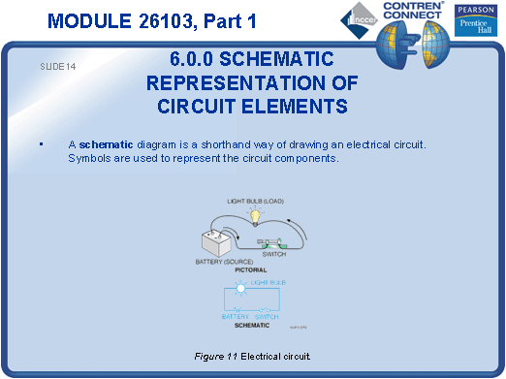
SLIDE 15
  - Have the students identify circuit elements in a simple electrical drawing or schematic using the schematic representation in the slide.
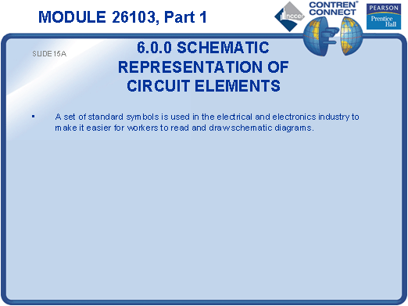
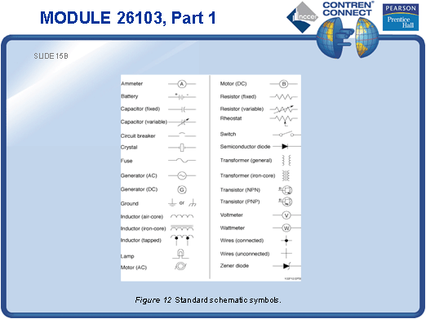
TESTING and PERFORMANCE
- Have the students complete Active Figure 10.
- Have students answer Review Questions 1 – 6 for Sections 1.0.0 – 6.0.0. Provide correct answers and remediation at the end of the quiz.

