Module 26103-08
Introduction to Electrical Circuits
Lesson 2 of 2: Resistors, Meter Operations, and Power
This lesson expands on resistance by teaching the fundamentals behind resistor color coding. The lesson also covers basic meters, including voltmeters, ammeters, and ohmmeters. The lesson concludes with a discussion on power and power equations. Lab work includes resistor identification by color code, meter applications, and the use of power formulas in circuits.
Objectives
Upon completion of this lesson, the student should be able to:
- Determine the value of a resistor by reading the resistor color bands.
- Explain how meters are applied in circuits to read circuit values.
- Apply the power formula to determine values in a circuit.
Performance Requirements
  - None
Reading Assignment
  - Module 26103, Sections 7.0.0 thru 10.2.0
Slide Presentation
  - Module 26103, Part 2 (Slides 16 thru 31)
Suggested Equipment/Materials
  - Calculators
  - Paper and pencils
  - Various carbon composition resistors (color bands including resistor value and tolerance)
  - Wire-wound resistors
  - Variable resistors
  - Various meters (voltmeter, ammeter, ohmmeter, voltage tester, continuity tester)
  - 6-volt circuits built in Lesson 1 of 2
  - Expanded Ohm’s law circle handouts (wallet cards available at most electrical supply houses)
Suggested Student Activity
  - Practice reading resistors by interpreting the color bands.
  - Practice interpreting circuit values using the expanded Ohm’s law circle distributed by the instructor.
  - Calculate the power consumption of a resistor by applying the power formula.
Testing
  - Module Review Questions 7 thru 10
  - CONTREN Connect Active Figure 15
  - Module 26103-08 Exam
Suggested Lab Activities
  - Determine values of carbon resistors by interpreting the color bands.
  - Take circuit readings using the 6-volt circuit built in the previous lesson.
  - Practice using the expanded Ohm’s law circle to determine unknown values.
Additional Resources
  - Electronics Fundamentals: Circuits, Devices, and Applications, Thomas L. Floyd, New York: Prentice Hall.
  - Principles of Electric Circuits, Thomas L. Floyd, New York: Prentice Hall.
SLIDE 16
  - Review the objectives to be covered in this lesson. Ask the students if they have any questions.
  - Present examples of both types of resistors: carbon composite and wire wound.
  - Dissect a resistor to demonstrate its construction.
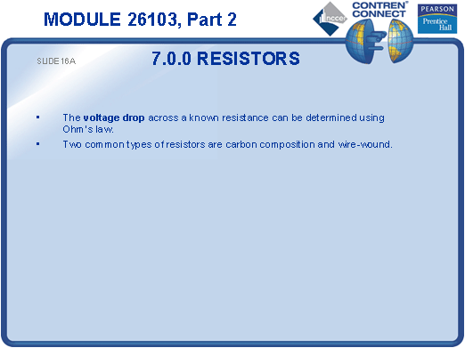
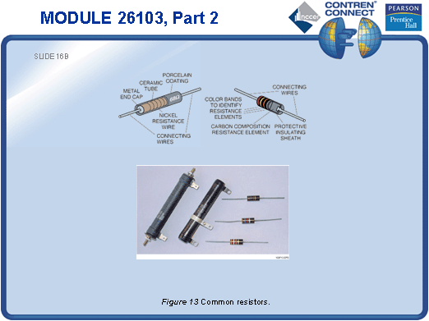
SLIDE 17
  - Introduce variable resistors.
  - Provide various types of variable resistors for the students to examine.

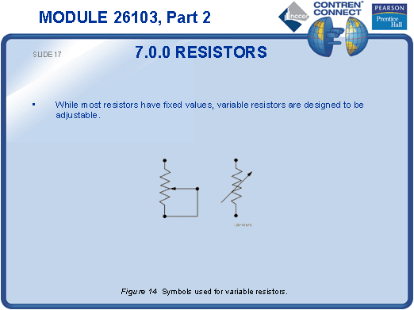
SLIDE 18
  - Explain the color coding system used to determine resistor value and tolerance on carbon composite resistors.
  - Note that if a resistor has no tolerance band, the default tolerance value is 20%.
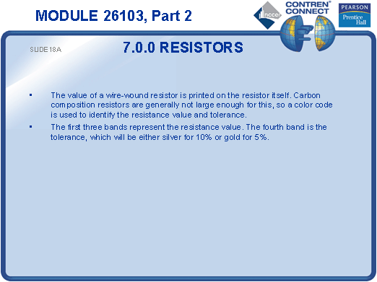
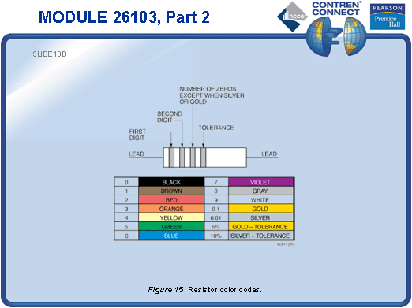
SLIDE 19
  - Have a practice session for students to read various color-coded resistors.

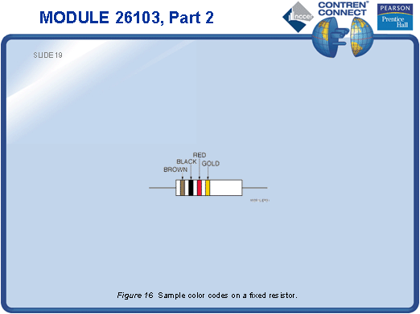
SLIDE 20
  - Use the circuits built in the previous lesson to show connections in series, parallel, and series-parallel.
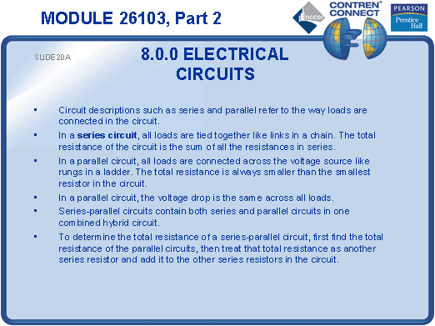
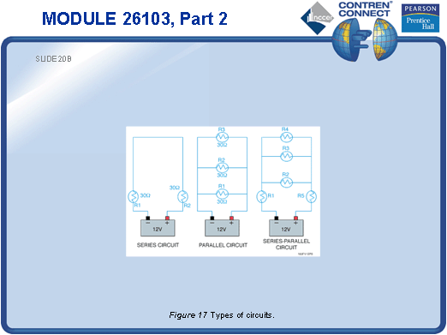
SLIDE 21
  - Show various meters.
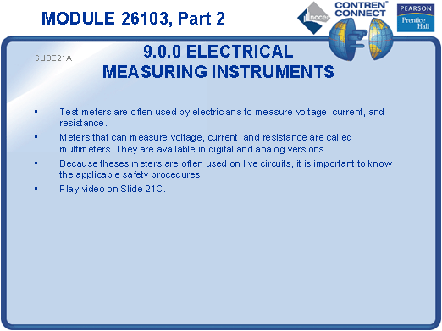
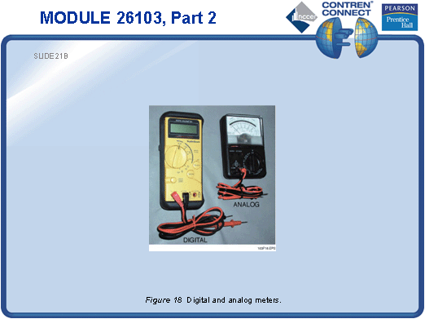
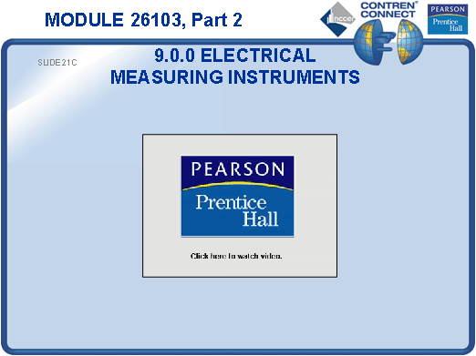
SLIDE 22
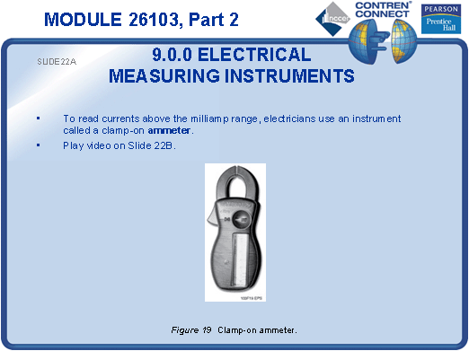
  - No notes.

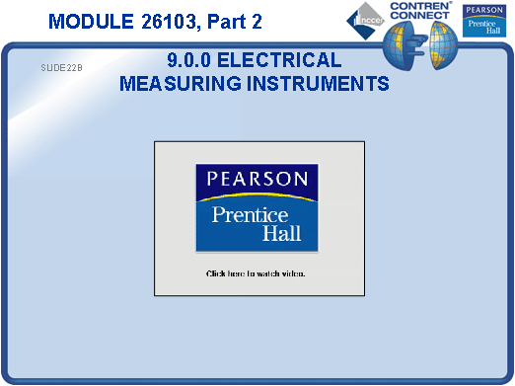
SLIDE 23
  - Demonstrate how to use a clamp-on ammeter.

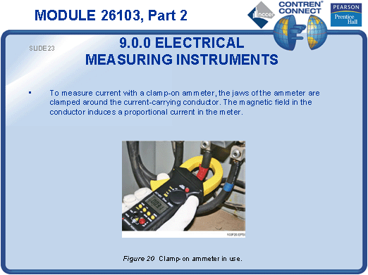
SLIDE 24
  - Demonstrate how to connect an ammeter.
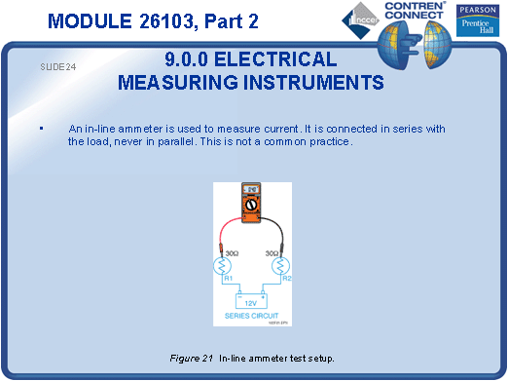
SLIDE 25
  - Demonstrate how to connect a voltmeter.
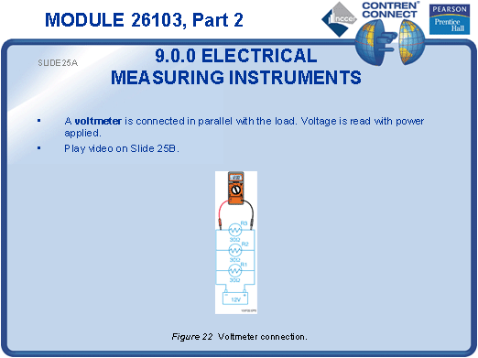
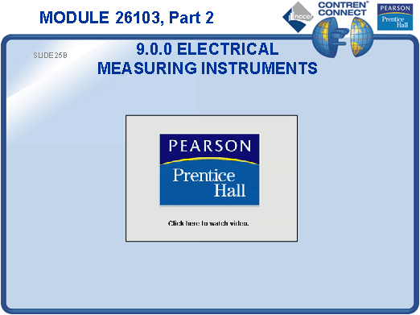
SLIDE 26
  - Measure voltage, current, and resistance using the circuits built in the previous lesson.
  - You may want to add resistance to these circuits by adding known values of resistors to the circuits. This will be an opportunity to bring it all together.
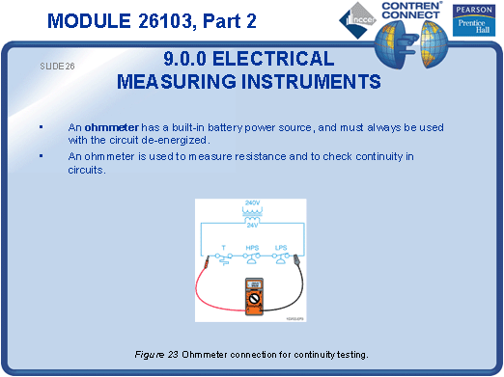
SLIDE 27
  - Demonstrate how to use a continuity tester.

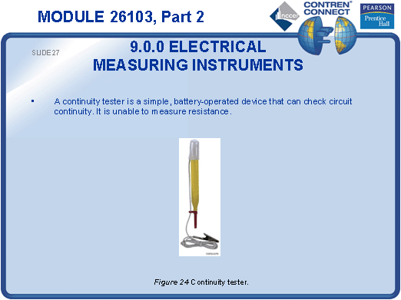
SLIDE 28
  - Demonstrate how to use a voltage tester.
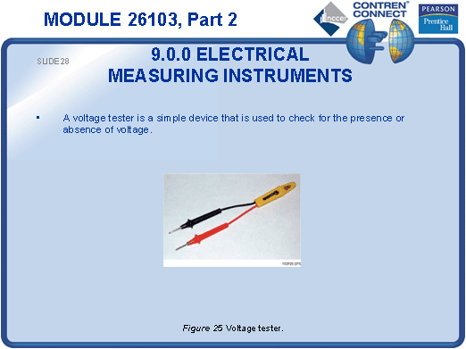
SLIDE 29
  - Explain how watt-hours are used to determine the amount of power consumed.
  - Point out that electricity is priced according to how many watts are consumed per hour (watt-hour).
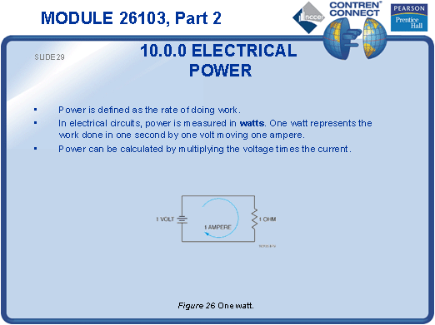
SLIDE 30
  - Have the students calculate electrical power by giving them several examples of current and voltage.
  - Make sure that the examples include values that require expressing the electrical power in terms of watts, kilowatts, and megawatts.
  - Have the students convert their wattage answers into horsepower.
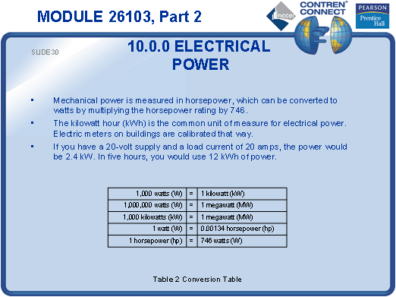
SLIDE 31
  - Have the students practice solving problems using the Expanded Ohm’s law circle.
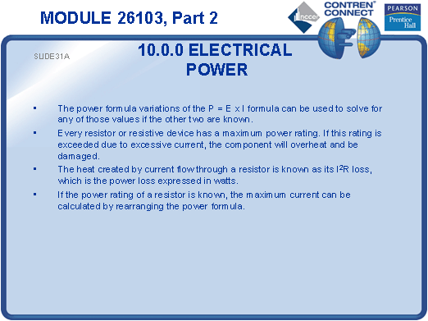
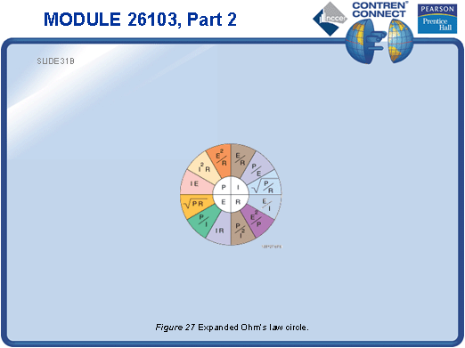
TESTING and PERFORMANCE
- Have the students complete Active Figure 15.
- Have students answer Review Questions 7 – 10 for Sections 7.0.0 – 10.2.0. Provide correct answers and remediation at the end of the quiz.
- Have the students complete the Trade Terms Quiz.
- Administer the Module Exam.

