Module 26110-08
Basic Electrical Construction Drawings
Lesson 1 of 2: Introduction to Construction Drawings and Scales
This lesson is a classroom session in which the students will be introduced to construction drawings, including drafting lines, electrical symbols, and the interpretation of various types of scales.
Objectives
Upon completion of this lesson, the student should be able to:
- Explain the basic layout of a set of construction drawings.
- Describe the information included in the title, approval, and revision blocks of a drawing.
- Explain the procedure for approval and revision of an architectural drawing.
- Identify the types of drafting lines used on construction drawings.
- Identify common symbols used on construction drawings.
- Understand the use of architect’s and engineer’s scales.
- Interpret electrical drawings, including site plans, floor plans, and detail drawings.
Performance Requirements
- Using an architect’s scale, state the actual dimensions of a given drawing component. This satisfies module Performance Task 1.
Reading Assignment
  - Module 26110, Sections 1.0.0 thru 5.3.0
Slide Presentation
  - Module 26110, Part 1 (Slides 1 thru 36)
Suggested Equipment/Materials
  - Architect’s scales (both flat and triangular)
  - Engineer’s scale
  - One or more complete drawing set(s)
Suggested Student Activity
  - Have the students visit a construction site and use the drawings to locate specified electrical equipment.
Testing
  - Module Review Questions 1 – 12
  - CONTREN Connect Active Figures 15 and 17
Suggested Lab Activities
  - Students must use an architect’s scale to state the actual dimensions of a given drawing component. Use Performance Project 26110-2, Interpret an Architect’s Scale.
Additional Resources
  - Performance Projects: Job Sheets for the Electrical Industry, Level One, New York: Prentice Hall.
  - Contren Connect Electrical 1 Anotated Instructors Guide (available from NCCER).
SLIDE 1
  - Review the objectives to be covered in this module. Ask the students if they have any questions.
  - Explain that students must obtain a score of 70% on the Module Exam and perform certain tasks to the satisfaction of the instructor to receive credit for the module.
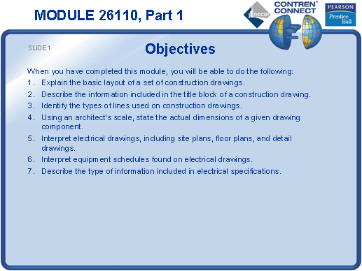
SLIDE 2
  - Discuss the types of drawings typically included in the drawing set for a project.
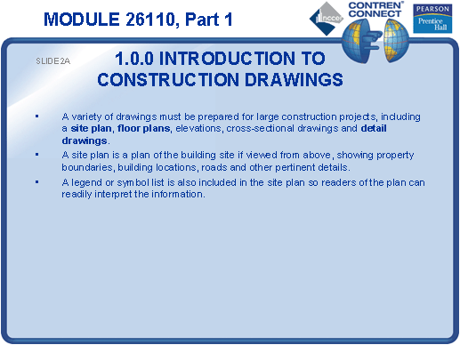

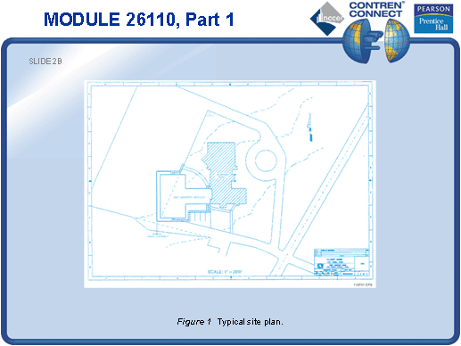

SLIDE 3
  - Explain the types of information conveyed by floor plans.
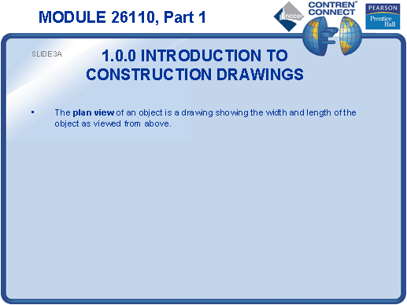

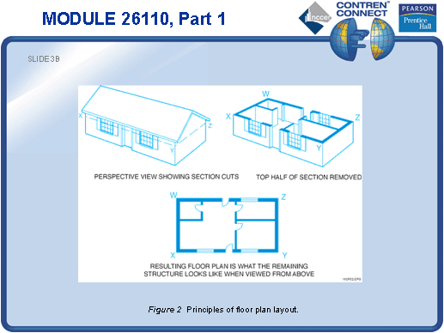

SLIDE 4
  - Show the students how to orient themselves to the various rooms and levels of a floor plan.
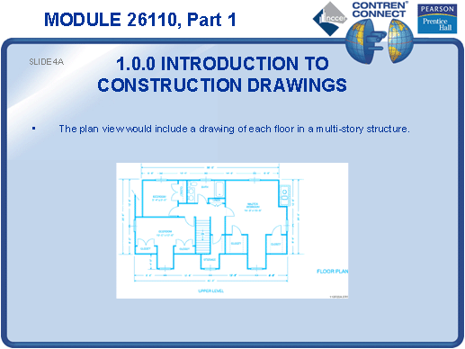

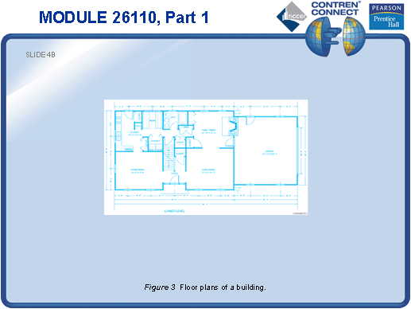

SLIDE 5
  - Discuss the types of information conveyed by elevation drawings.
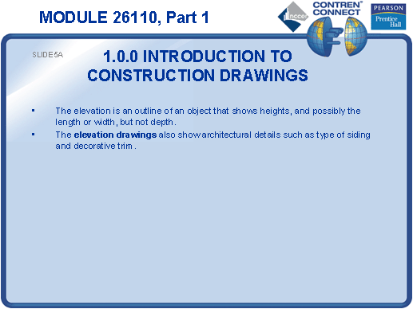
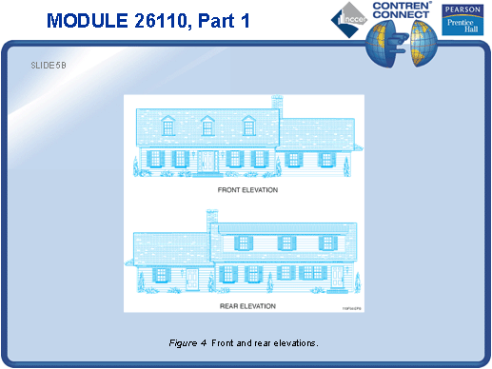

SLIDE 6
  - No notes
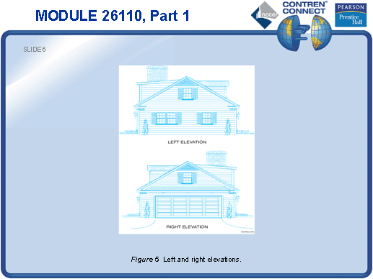
SLIDE 7
  - Discuss sectional drawings.
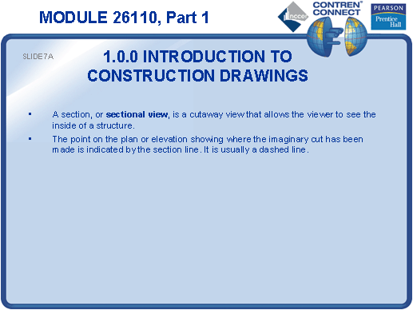
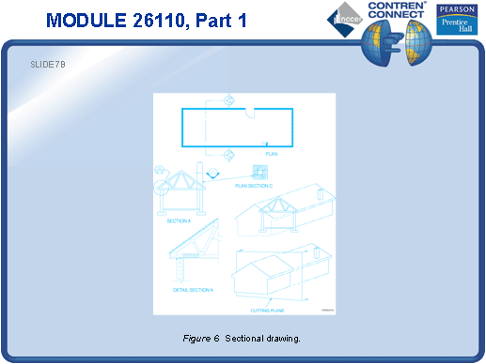

SLIDE 8
  - Explain the difference between an electrical drawing and a shop drawing.
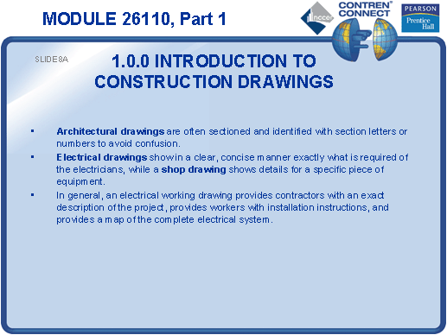

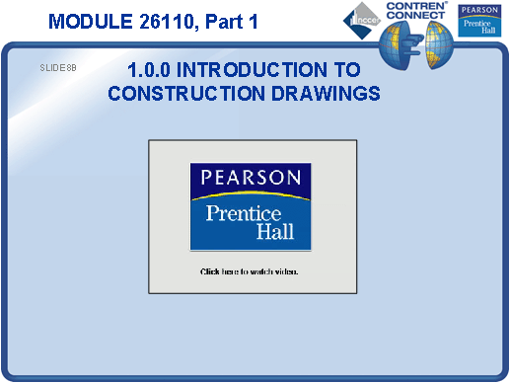

SLIDE 9
  - Point out the engineer’s and architect’s title blocks on a typical drawing.
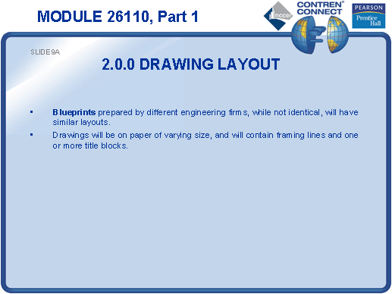

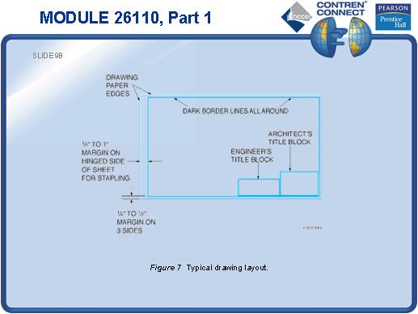

SLIDE 10
  - Discuss the information found on a title block.
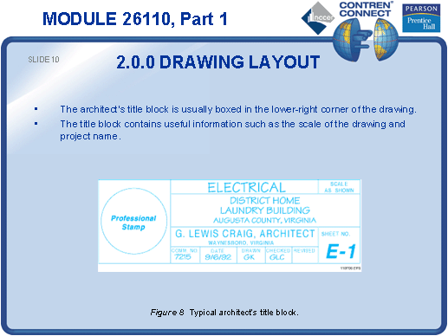
SLIDE 11
  - No notes
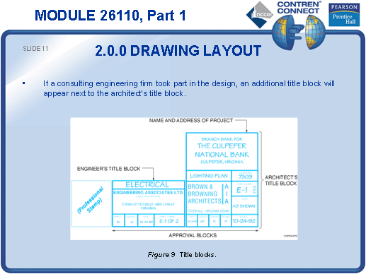
SLIDE 12
  - Discuss the information found on an approval block.
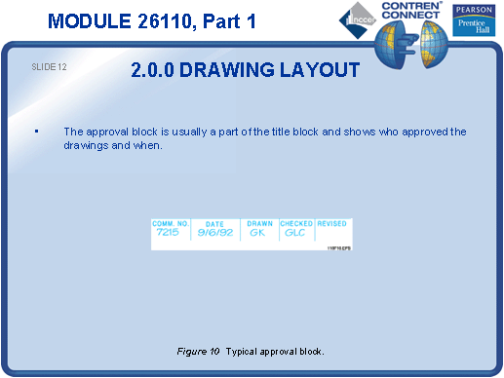
SLIDE 13
  - Explain that approval blocks may be laid out differently from firm to firm.
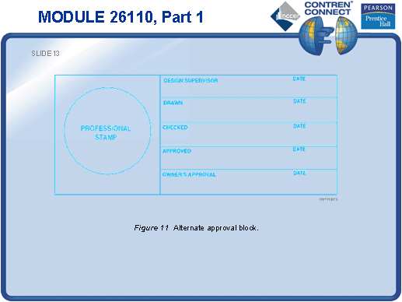
SLIDE 14
  - Emphasize the importance of using the most up-to-date set of drawings.
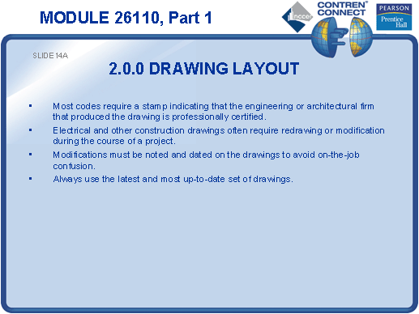
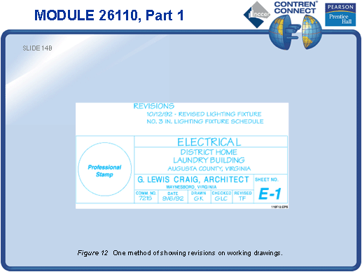

SLIDE 15
  - Discuss alternate methods of indicating revisions to drawings.
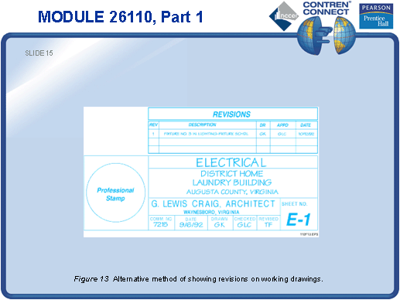
SLIDE 16
  - Identify each type of drafting line and explain its purpose.
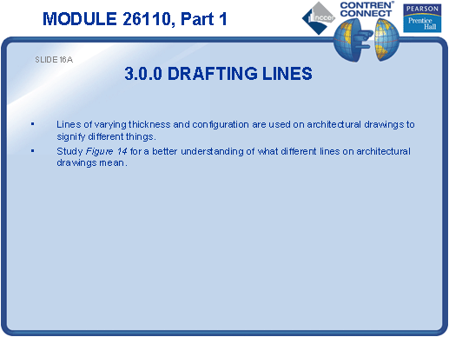
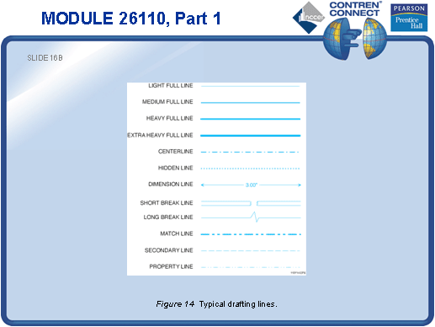

SLIDE 17
  - Identify each type of electrical drawing line and explain its purpose.
  - Have the students identify different types of electrical drafting lines on an electrical drawing.
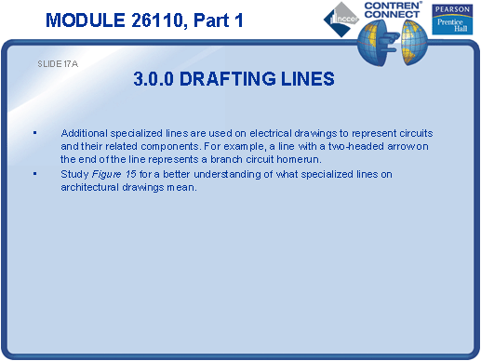
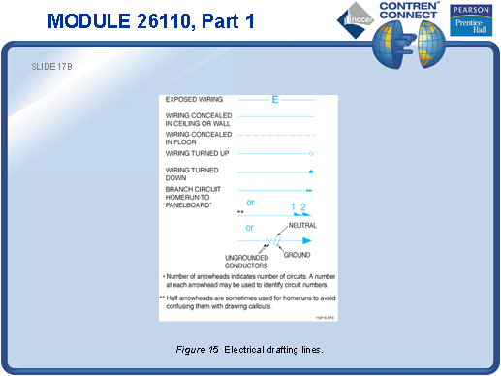

SLIDE 18
- Identify common electrical symbols.
- Have the students find and identify components on an electrical drawing.
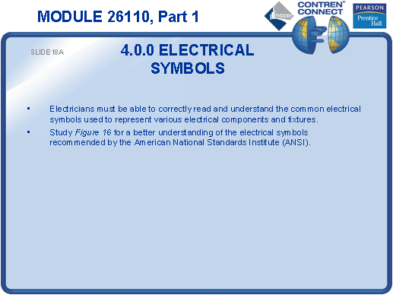
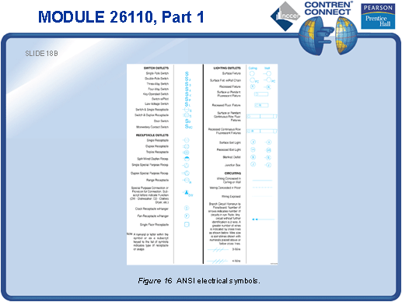

SLIDE 19
- Identify the various receptacle symbols used on electrical drawings.
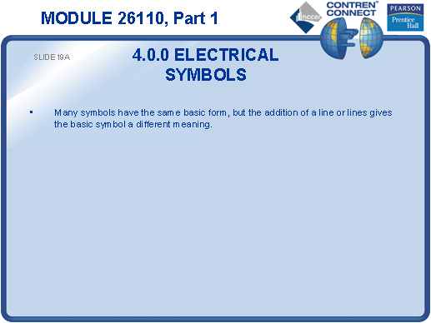
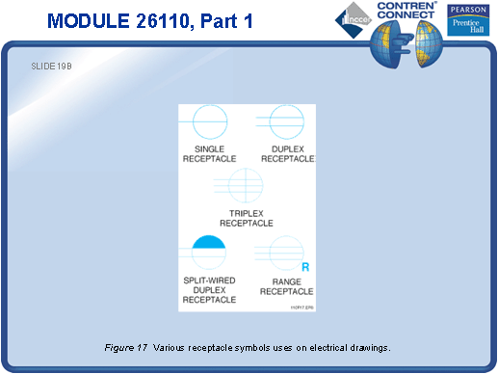

SLIDE 20
- Explain that abbreviations can be used with symbols to communicate different meanings.
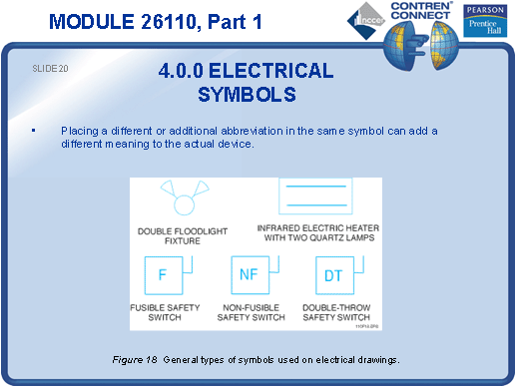
SLIDE 21
- Discuss the use of subscripts, such as a key operated switch represented by the symbol S_{K}.
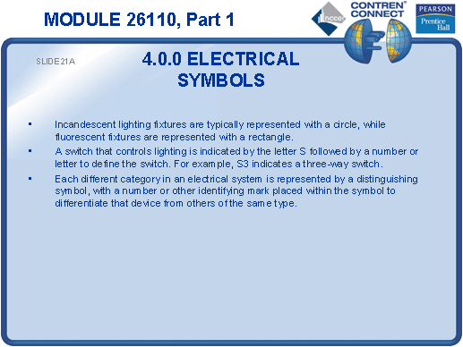
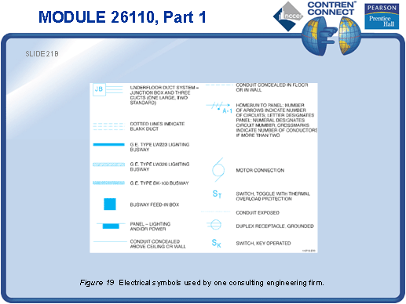

SLIDE 22
- Review the recommended electrical symbols in Figure 20 and point out the different categories such as power, low-voltage systems, etc.
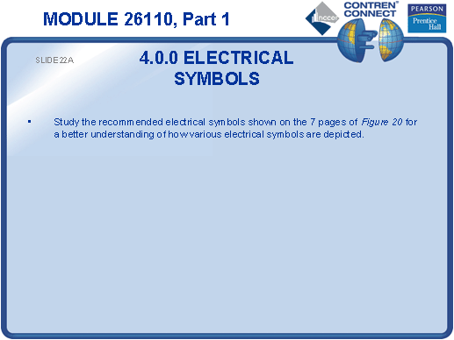
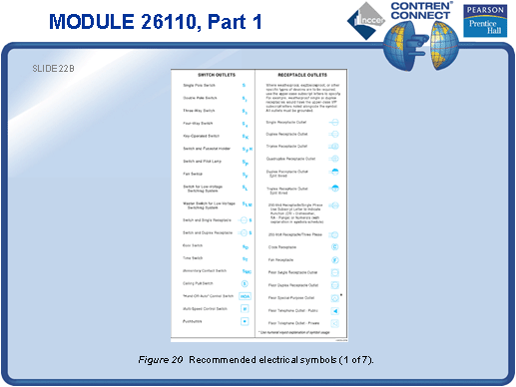

SLIDE 23
- No notes
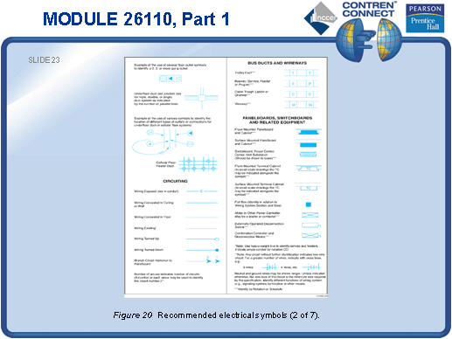
SLIDE 24
- No notes
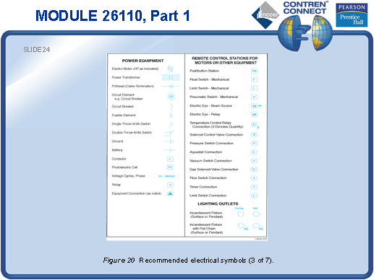
SLIDE 25
- No notes
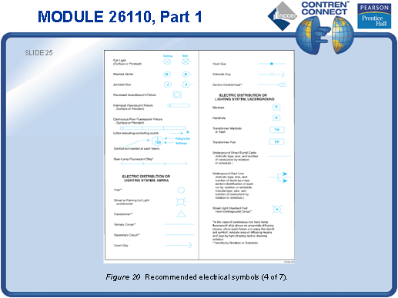
SLIDE 26
- No notes
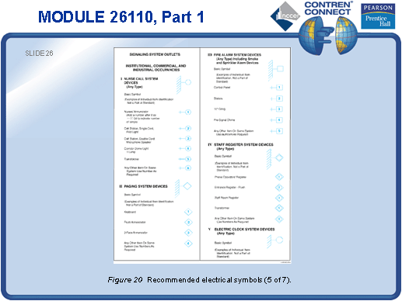
SLIDE 27
- No notes
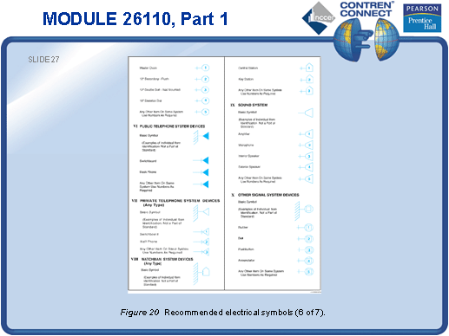
SLIDE 28
- No notes
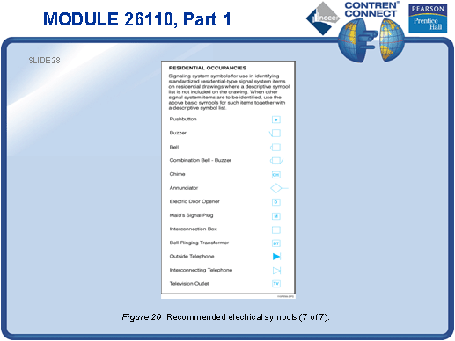
SLIDE 29
- Identify the scale of a drawing.
- Explain how to convert the scaled information into actual dimensions.
- Have a student try performing conversions without using an architect’s scale. Use this exercise to demonstrate the usefulness of architect’s scales.
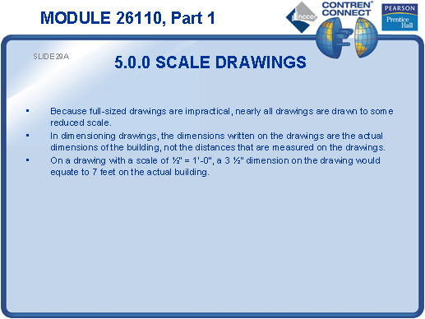

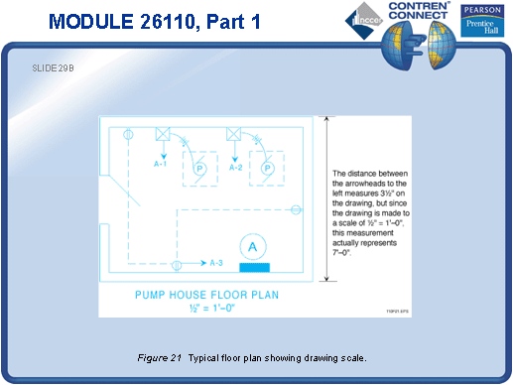

SLIDE 30
- Pass around a flat architect’s scale for the students to examine.
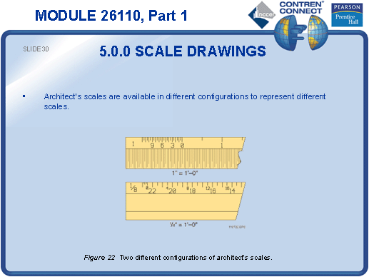
SLIDE 31
- Identify the numbers and markings on a one-inch architect’s scale.
- Demonstrate how to use an architect’s scale. Have the students practice using an architect’s scale.
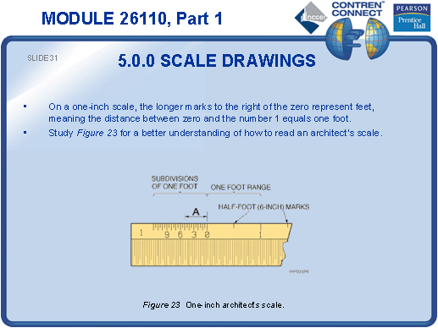
SLIDE 32
- Describe how to use a triangular architect’s scale. Provide an example for the trainees to examine.
- Identify the numbers and markings on a triangular architect’s scale and explain their use.
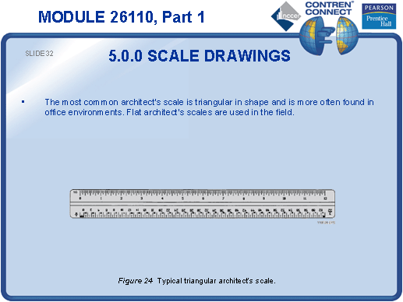
SLIDE 33
- Demonstrate how to perform conversions with a triangular architect’s scale.
- Have the students use a triangular architect’s scale to determine the dimensions of selected structures on a drawing.
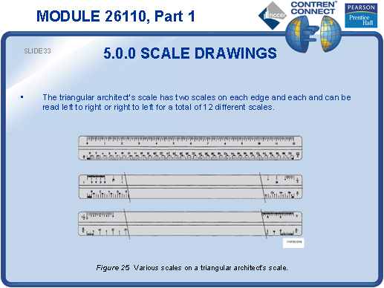
SLIDE 34
- Explain that a flat architect’s scale can be used to determine dimensions on the job site.
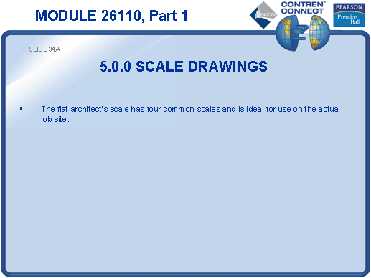

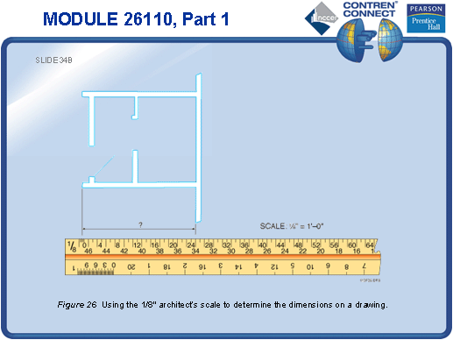

SLIDE 35
- Compare an engineer’s scale with an architect’s scale.
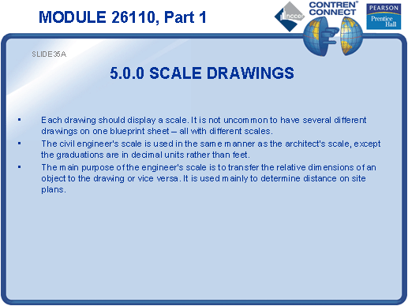
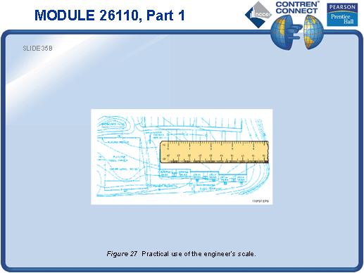

SLIDE 36
- Describe the use of a metric architect’s scale.
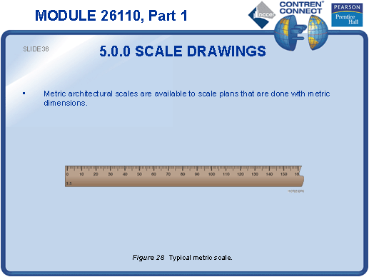
TESTING and PERFORMANCE
- Have the students complete Active Figures 15 and 17.
- Have the students answer Review Questions 1 – 12 for Sections 1.0.0 – 5.3.0. Provide correct answers and remediation at the end of the quiz.
- Have the students demonstrate the use of an architect’s scale. This can be done during the presentation of Slide 31 or 33 (depending on the type of architect’s scale used) or at the end of the lesson. This corresponds to Performance Task 1.

