Module 26110-08
Basic Electrical Construction Drawings

Lesson 2 of 2: Analyzing Electrical Drawings, Including Power Plans, Lighting Floor Plans, Electrical Details, and Diagrams
This lesson is a classroom session in which the students will be introduced to electrical drawings, schedules, and specifications.
Objectives
Upon completion of this lesson, the student should be able to:
- Read equipment schedules found on electrical drawings.
- Identify fixtures on a lighting schedule by symbol, type, manufacturer and catalog number, mounting location, and number and type of lamps.
- Describe the types of information included in electrical specifications.
Performance Requirements
- Make a material takeoff of the lighting fixtures specified in Performance Profile Sheet 2 using the drawing provided on Performance Profile Sheet 3. The takeoff requires that all lighting fixtures be counted, and where applicable, the total number of lamps for each fixture type must be calculated. This satisfies Performance Task 2.
Reading Assignment
  - Module 26110, Sections 6.0.0 through 10.2.0
Slide Presentation
  - Module 26110, Part 2 (Slides 37 thru 59)
Suggested Equipment/Materials
  - A set of electrical drawings
  - A set of specifications
Suggested Student Activity
  - Have the students identify various building components, systems, and devices in the classroom and determine their proper specification division according to the Construction Specification Institute (CSI).
Testing
  - Module Review Questions 17 – 20
  - CONTREN Connect Active Figure 42
  - Module 26110-08 Exam
Suggested Lab Activities
  - Have the students practice performing a material takeoff. Use Performance Project 26110-1, Perform a Material Takeoff from a Set of Residential Electrical Floor Plans.
Additional Resources
  - Performance Projects: Job Sheets for the Electrical Industry, Level One, New York: Prentice Hall.
  - Specification information can be found at the Construction Specifications Institute website, www.csinet.org.
  - Contren Connect Electrical 1 Anotated Instructors Guide (available from NCCER).
SLIDE 37
  - Review the objectives to be covered in this lesson. Ask the students if they have any questions.
  - Emphasize that the ability to understand electrical drawings is critical.
  - Show an electrical site plan from an instructor-supplied set of drawings and have the students identify the scale, elevations, and north arrow.

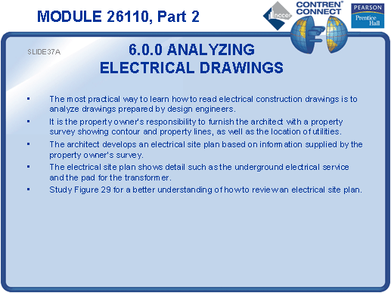

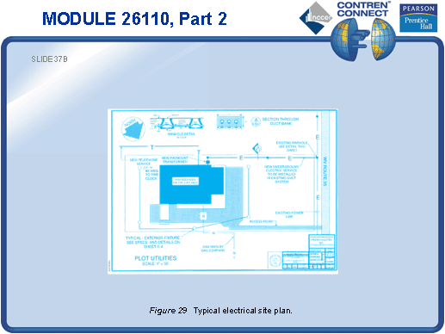

SLIDE 38
  - Pass around an electrical power plan from an instructor-supplied set of drawings and have the students identify various types of information.
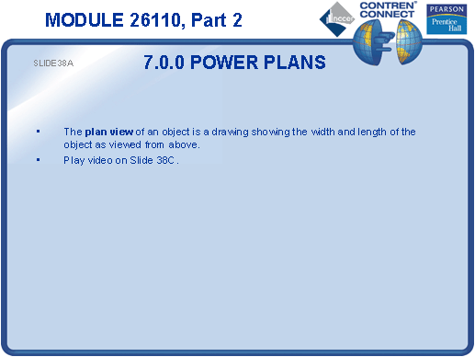
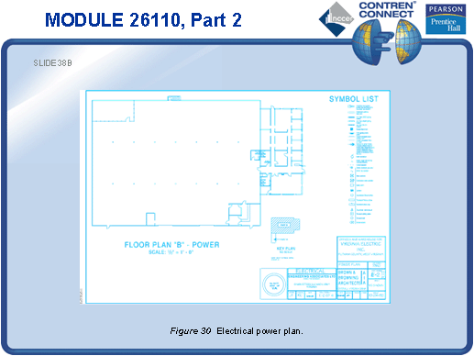

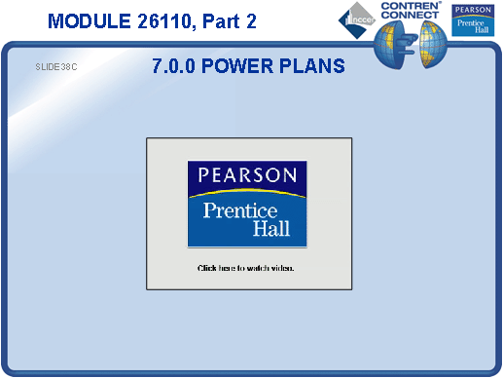

SLIDE 39
  - Explain the purpose of a key plan.
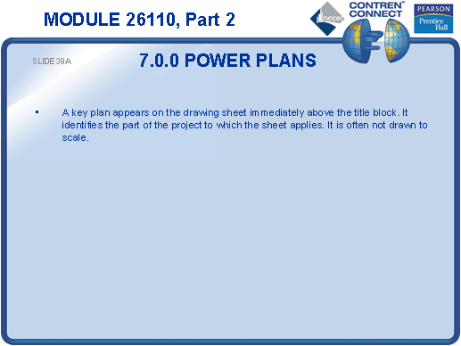

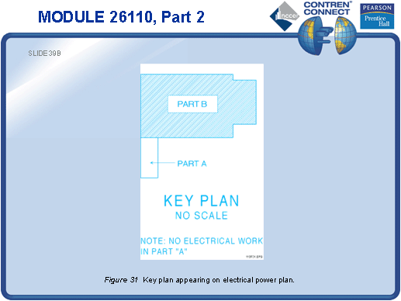

SLIDE 40
  - Note that symbols may vary from drawing to drawing and the legend should always be consulted before beginning work.
  - Using 3 x 5 flash cards with an object’s symbol drawn on one side of the card and the title of the object on the other side of the card, ask the students to identify the object.
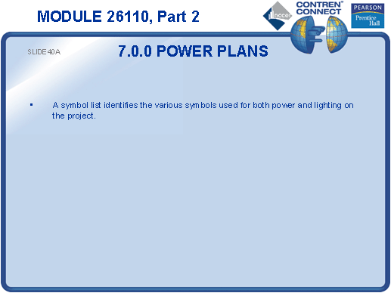
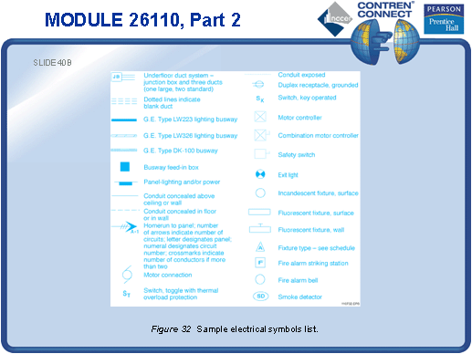

SLIDE 41
  - Discuss the types of information conveyed by power plans.
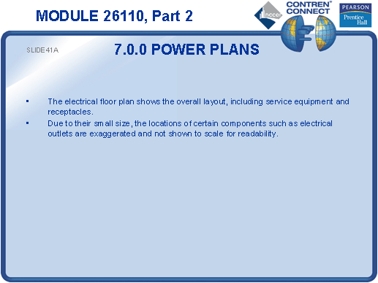

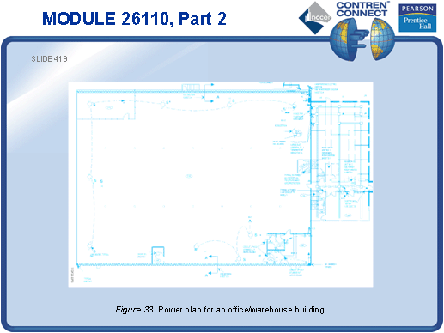

SLIDE 42
  - Explain that only the power busway is shown on the power plan; the lighting busways will appear on the lighting plan.
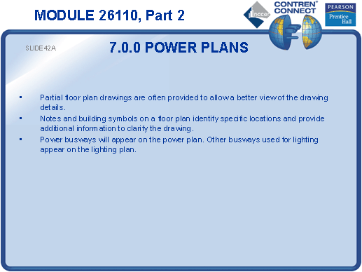

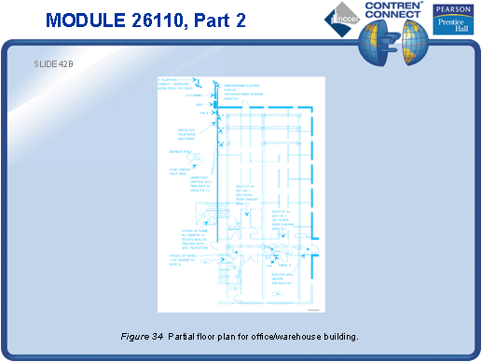

SLIDE 43
  - Pass around a floor plan from an instructor-supplied set of drawings and have the students identify the outlets.
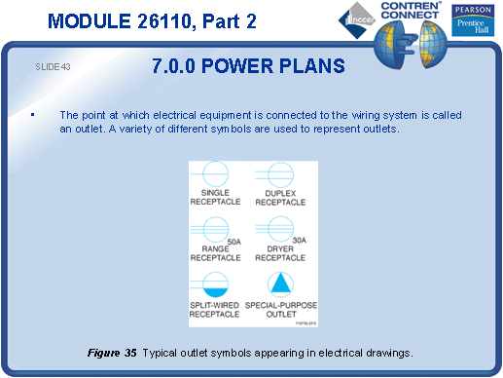
SLIDE 44
  - Discuss common lines and symbols used to indicate branch circuits.
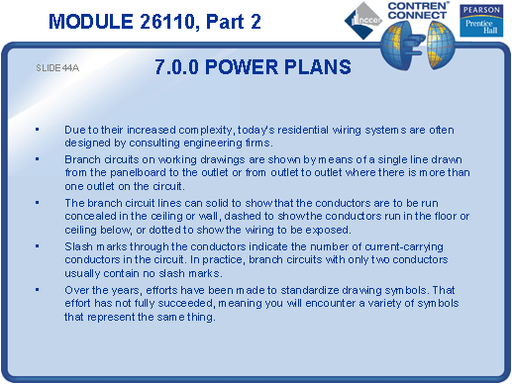
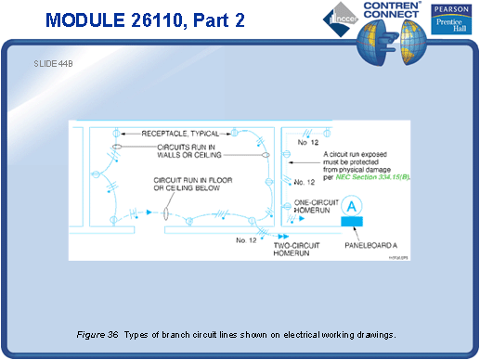

SLIDE 45
  - Discuss the NEC® requirements for locating receptacles in dwelling units.
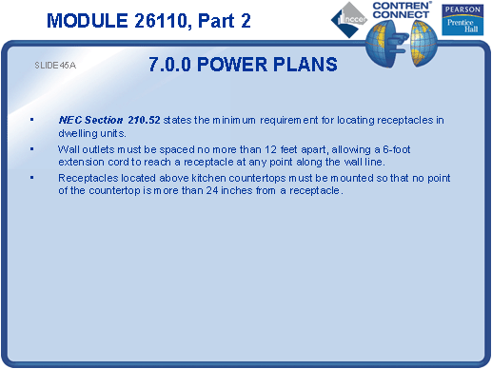

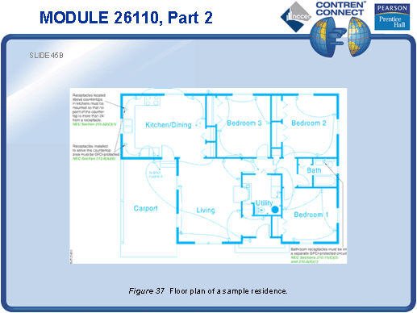

SLIDE 46
  - Discuss the types of information found on a lighting plan.
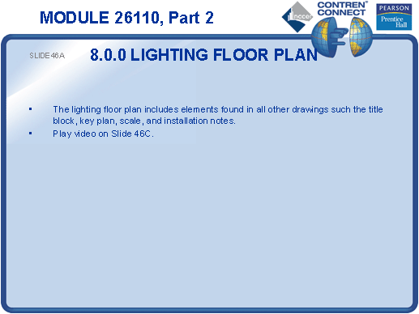
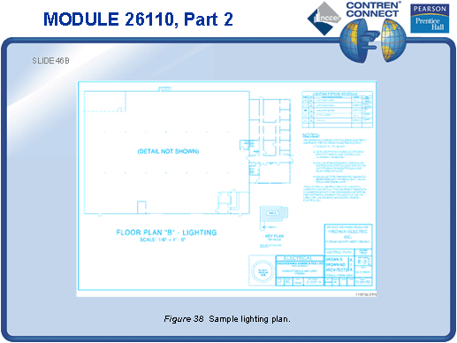

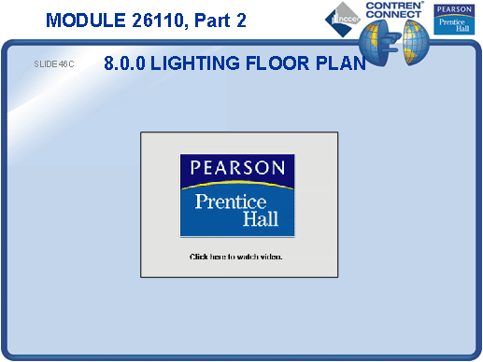

SLIDE 47
  - Discuss the types of information found on a lighting fixture schedule.
- Pass around a lighting floor plan and schedule from a set of instructor-supplied drawings. Have the students identify various fixture types and their locations.
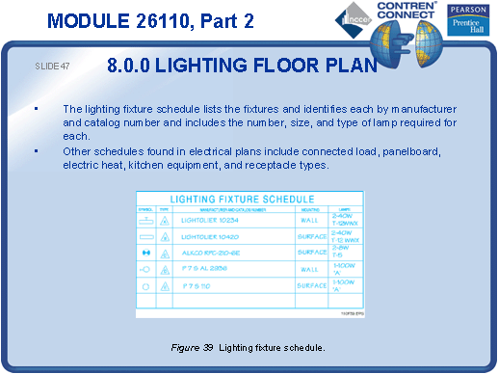
SLIDE 48
- Review a typical lighting plan.
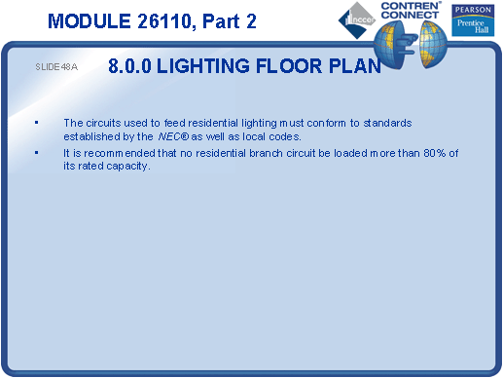

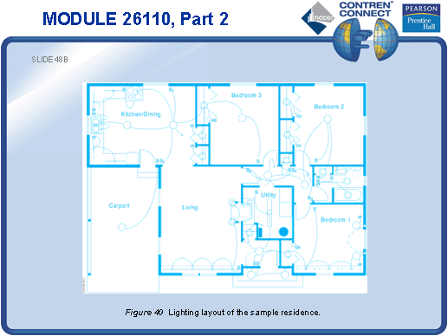

SLIDE 49
- Review common lighting symbols.
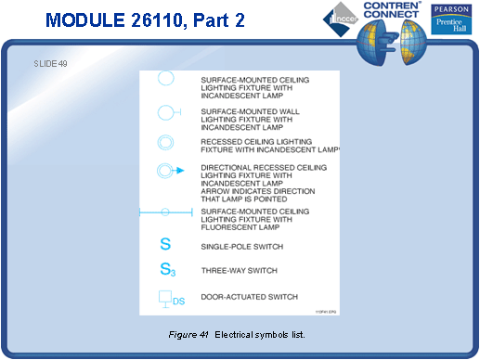
SLIDE 50
- Discuss the types of information conveyed by power-riser diagrams.
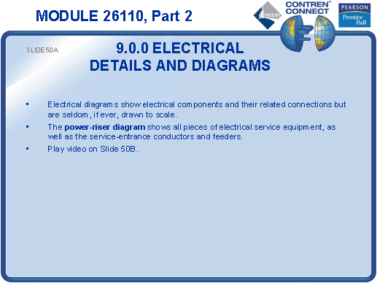
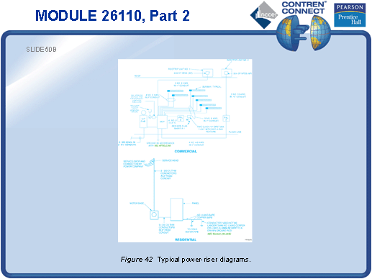

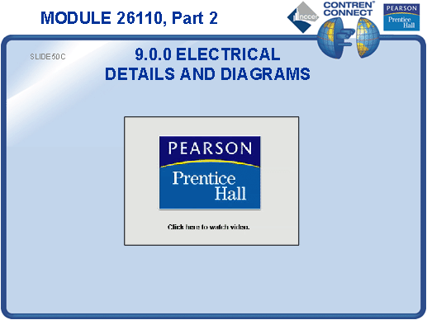

SLIDE 51
- Discuss the types of information conveyed by panelboard schedules.
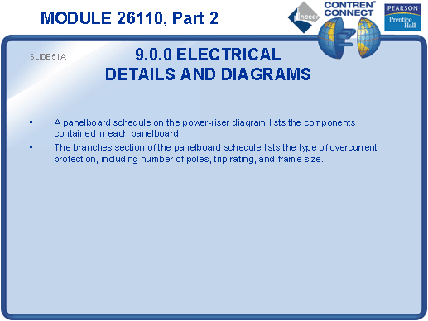
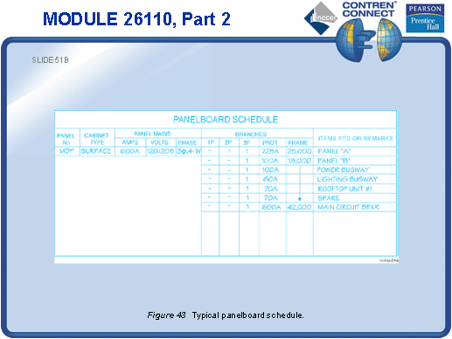

SLIDE 52
  - Note that schematic wiring diagrams will not indicate the physical location of the equipment. Coordinating with other drawings will ensure proper identification and location of equipment and fixtures.
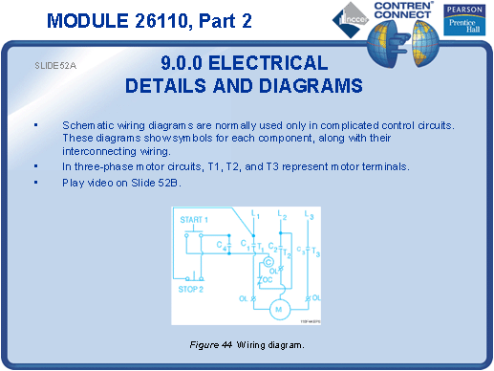

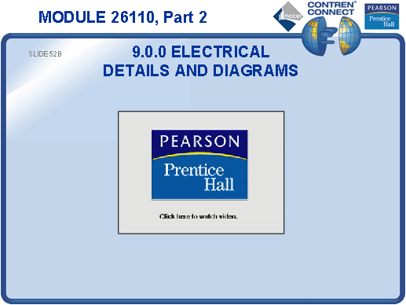

SLIDE 53
  - Define normally open and normally closed.
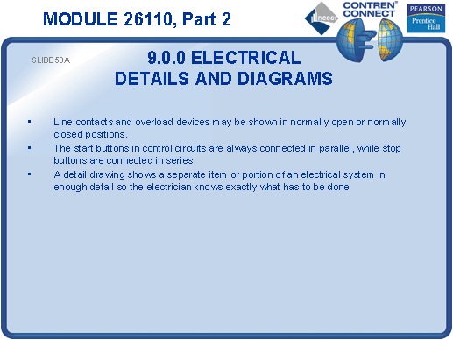
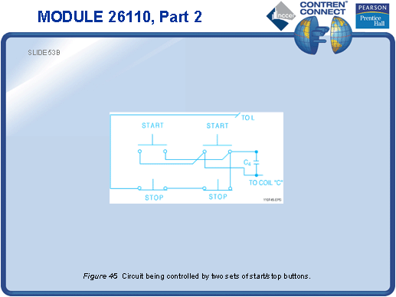

SLIDE 54
  - Discuss the MasterFormatTM standard for construction specifications.

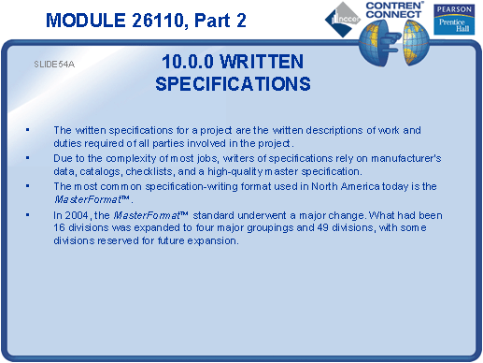

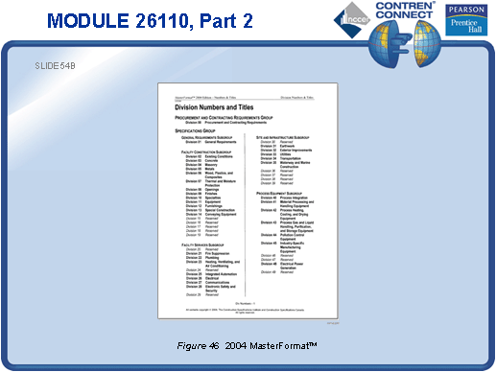
SLIDE 55
  - Review the detailed breakdown of Division 26.
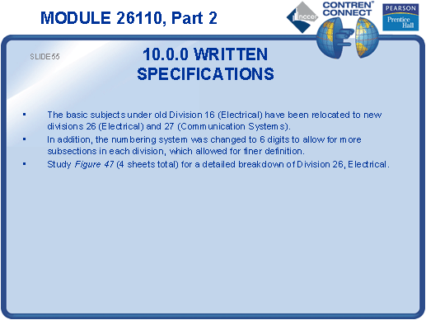
SLIDE 56
  - No notes
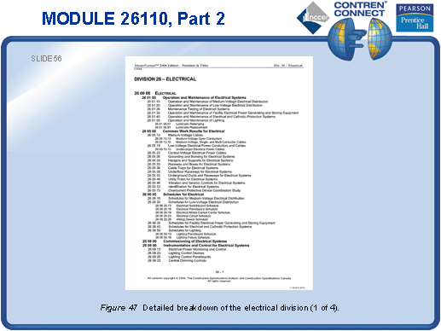
SLIDE 57
  - No notes
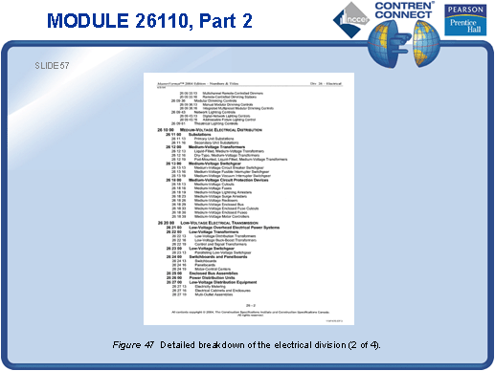
SLIDE 58
  - No notes
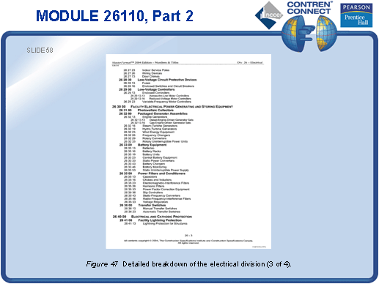
SLIDE 59
  - No notes
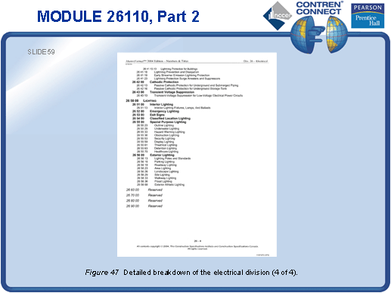
TESTING and PERFORMANCE
- Have the students complete Active Figure 42.
- Have the students complete Review Questions 13 – 20 for Sections 6.0.0 – 10.2.0. Provide correct answers and remediation at the end of the quiz.
- Have the students complete the Trade Terms Quiz.
- Have the students make a material takeoff of the lighting fixtures specified in a lighting plan. This can be done during the presentation of Slide 47 or at the end of the lesson. This corresponds to Performance Task 2.
- Administer the Module Exam.

