Module 26108-08
RACEWAYS AND FITTINGS
Lesson 1 of 4: Conduit Types and Their Uses
This lesson is a classroom session in which the students will be introduced to the various types of metal and nonmetallic conduit used to protect electrical wiring.
Objectives
Upon completion of this lesson, the student should be able to:
- Identify various types of conduit.
- State the applications and limitations of the various types of conduit as specified by the NEC®.
- Identify the methods used to join various types of conduit.
Performance Requirements
  - None
Reading Assignment
  - Module 26108, Sections 1.0.0 thru 3.2.10
Slide Presentation
  - Module 26108, Part 1 (Slides 1 thru 13)
Suggested Equipment/Materials
  - EMT conduit
  - Rigid metal conduit
  - Intermediate metal conduit
  - PVC conduit
  - Liquidtight flexible metal conduit
  - Flexible metal conduit
  - Various types of fittings and connectors
Suggested Student Activity
- Have the students visit a commercial, industrial, or medical facility and observe the types of conduit used. Use the NEC® to verify whether the conduit is correct for the application and identify other types of conduit, if any, that could have been used.
Testing
  - Module Review Questions 1 – 4
  - CONTREN Connect Active Figure 5
Suggested Lab Activities
- Assemble a variety of conduit and associated fittings. Have the students identify the types of conduit, state their permitted uses as defined by the NEC®, and identify the fittings used with the conduit.
Additional Resources
- User Guide to Product Specifications for Metal Electrical Conduit and Tubing, www.nema.org.
- Contren Connect Electrical 1 Annotated Instructors Guide (available from NCCER).
SLIDE 1
  - Review the objectives to be covered in this module. Ask the students if they have any questions.
  - Explain that students must obtain a score of 70% on the Module Exam and perform certain tasks to the satisfaction of the instructor to receive credit for the module.
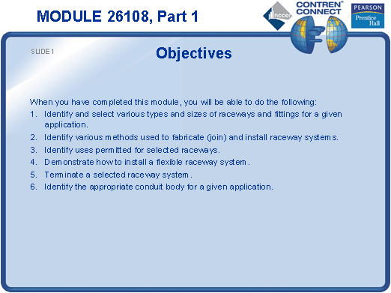
SLIDE 2
- Explain that raceway must be installed to meet the requirements of the NEC®.
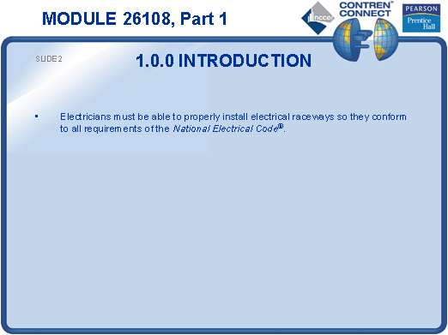
SLIDE 3
- Define the term raceway and discuss the different types of raceways.
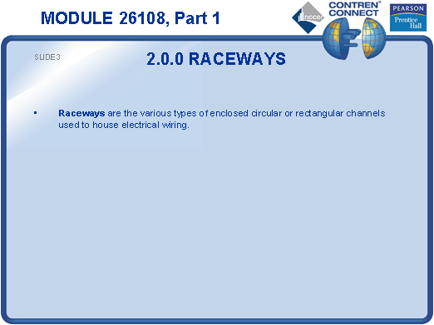
SLIDE 4
- Compare the wall thicknesses of the three types of conduit. Provide examples for the students to examine.
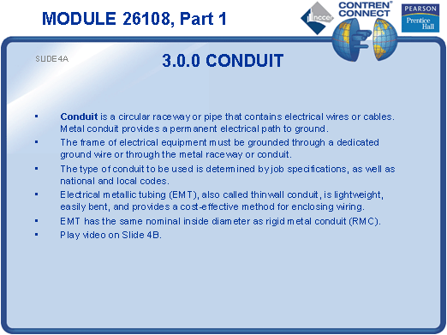

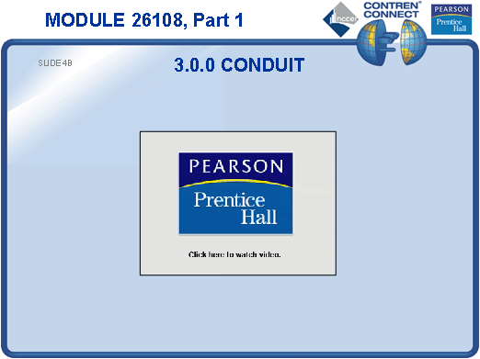
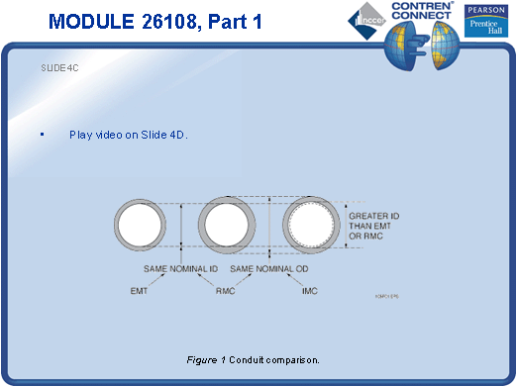

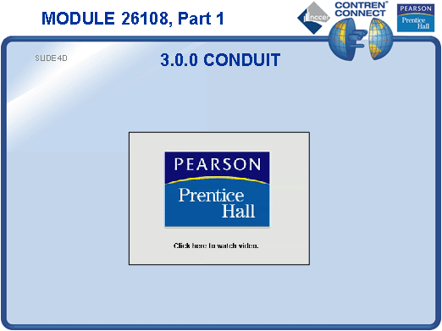
SLIDE 5
- Discuss the uses of EMT, including its limitations.
- Refer the students to NEC Article 358.
- Provide EMT fittings for the students to examine.
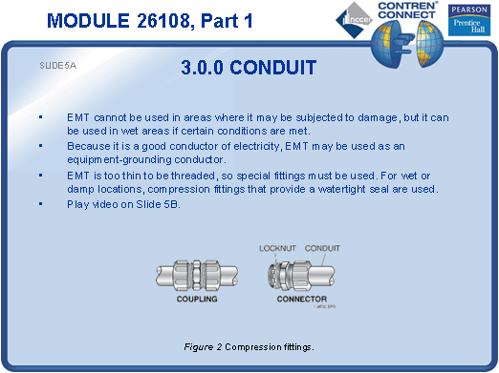

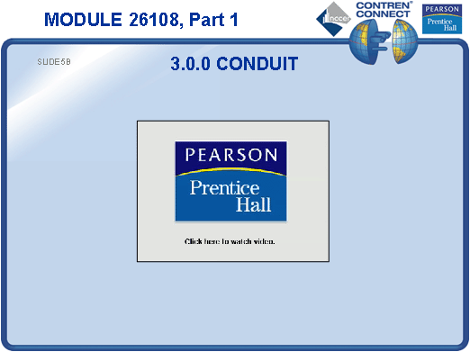

SLIDE 6
- Demonstrate how setscrew fittings are installed on EMT.
- Allow the students to examine some setscrew fittings.
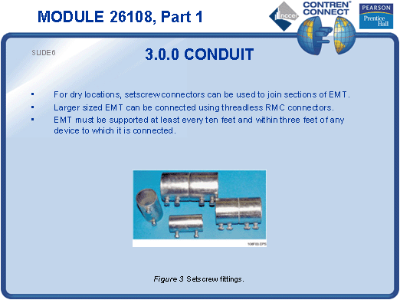
SLIDE 7
- Discuss the advantages and disadvantages of RMC.
- Refer the students to NEC Article 344.
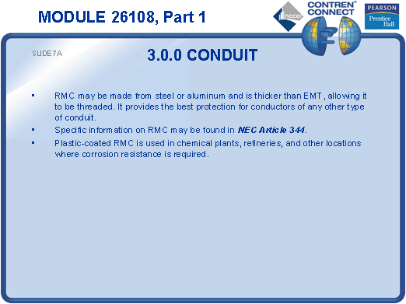

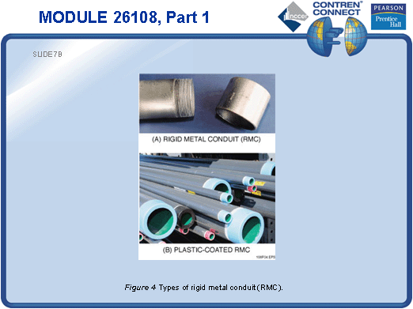
SLIDE 8
- Discuss the advantages and disadvantages of aluminum conduit.
- Discuss the advantages and disadvantages of IMC.
- Refer the students to NEC Article 342.
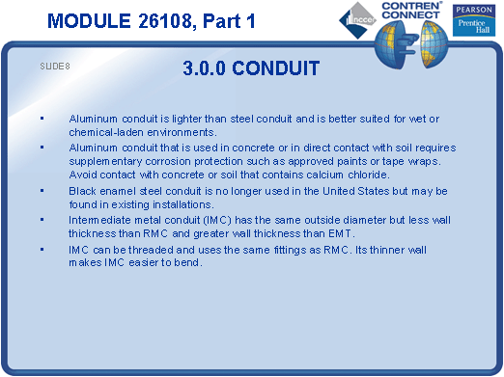
SLIDE 9
- Discuss the conditions under which PVC conduit can be used.
- Refer the students to NEC Article 352.
- Explain how to interpret the markings on PVC.
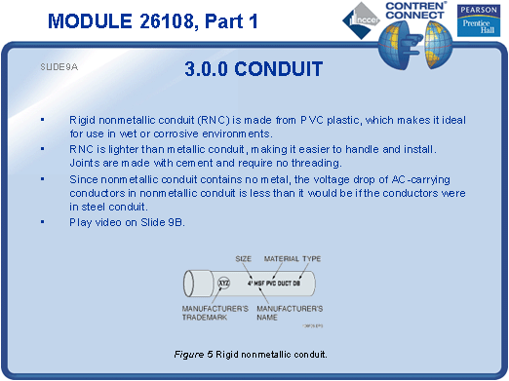

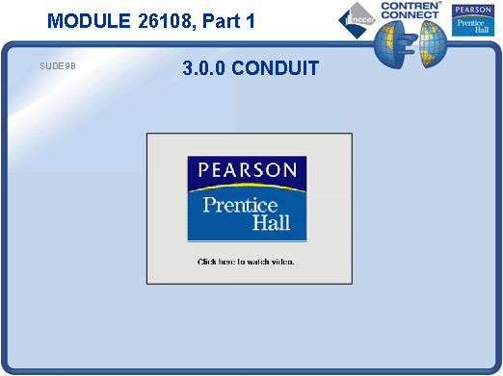
SLIDE 10
- Emphasize the importance of expansion couplings.
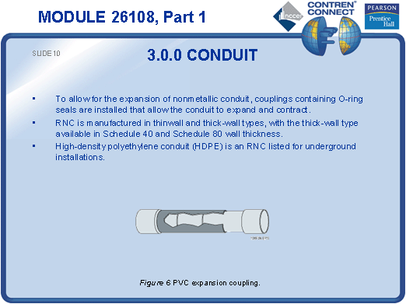
SLIDE 11
- Discuss common applications for LFNC. Provide an example for the students to examine.
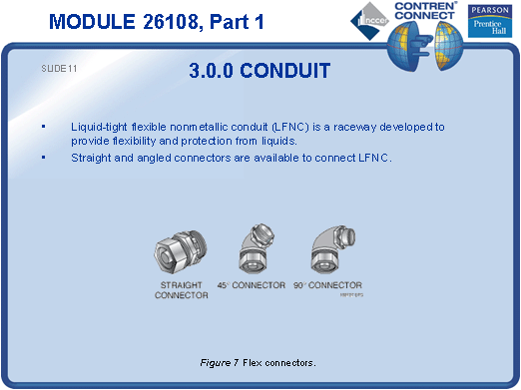
SLIDE 12
- Explain that flexible metal conduit is often used to connect equipment that vibrates during operation.
- Show the students a section of flexible metal conduit and allow them to examine it.
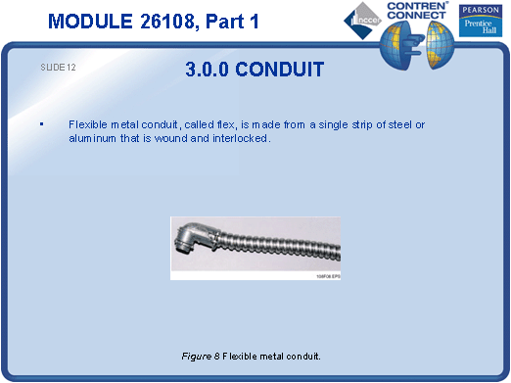
SLIDE 13
- Show the students examples of couplings used to adapt flexible metal conduit to other types.
- Discuss the support requirements for various types of conduit. Refer the students to the applicable sections of the NEC®.
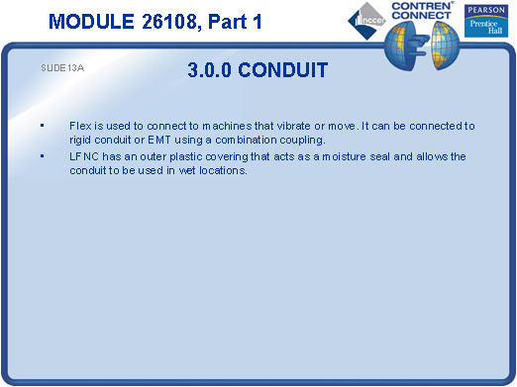

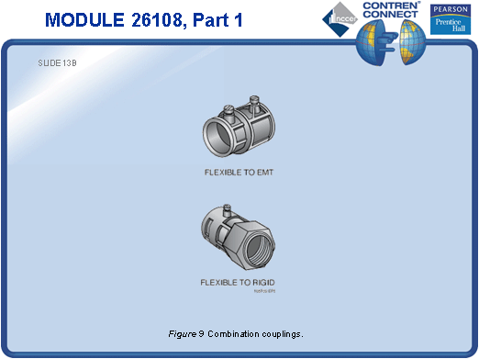
TESTING and PERFORMANCE
- Have the students complete CONTREN Connect Active Figure 5.
- Have the students complete Review Questions 1 – 4 for Sections 1.0.0 – 3.2.10. Provide correct answers and remediation at the end of the quiz.

