Module 26108-08
RACEWAYS AND FITTINGS

Lesson 2 of 4: Conduit Fittings
This lesson is a classroom and lab session in which the students will be introduced to the various types of fittings used with metal conduit.
Objectives
Upon completion of this lesson, the student should be able to:
- Identify and describe the uses of the various types of conduit couplings.
- Identify and describe the uses of the various types of conduit bodies.
- Identify and describe the uses of grounded and ungrounded insulating bushings.
- Identify and describe the uses of offset nipples.
- Explain the uses of metal and nonmetallic boxes.
- Describe how to remove pryouts and knockouts.
- Describe how bushings and locknuts are used to connect conduit to boxes.
- Identity sealing fittings and explain their uses.
Performance Requirements
  - Identify the appropriate conduit body for a given application. This satisfies module Performance Task 4.
  - Students must terminate a raceway system by making a conduit-to-box connection. This satisfies module Performance Task 3.
Reading Assignment
  - Module 26108, Sections 4.0.0 thru 6.0.0
Slide Presentation
  - Module 26108, Part 2 (Slides 14 thru 27)
Suggested Equipment/Materials
  - Various metal couplings
  - Conduit bodies
  - Threaded hubs
  - Insulating bushings
  - Metallic and nonmetallic boxes
  - Various lengths of EMT
  - Screwdriver
  - Various types of locknuts and bushings
  - Offset nipples
  - Sealing fittings and sealing compound
Suggested Student Activity
- Visit a commercial facility under construction and see how conduit bodies are used and how conduit is connected to boxes.
Testing
  - Module Review Questions 5 and 6
  - CONTREN Connect Active Figures 13 and 22
Suggested Lab Activities
- Assemble a selection of conduit bodies, bushings, and boxes. Have the students identify each type and state its uses.
- Have the students make a conduit-to-box connection. Use Performance Project 26108-1, Selecting and Installing Raceways and Device Boxes.
- Have the students install a sealing fitting. Use Performance Project 26108-2, Installing a Sealing Fitting, Conductors, and Sealing Compound.
Additional Resources
- Performance Projects: Job Sheets for the Electrical Industry, Level One, New York: Prentice Hall.
- Contren Connect Electrical 1 Annotated Instructors Guide (available from NCCER).
SLIDE 14
- Review the objectives to be covered in this lesson. Ask the students if they have any questions.
- Have the students look up the requirements for boxes and fittings in NEC Section 300.15.
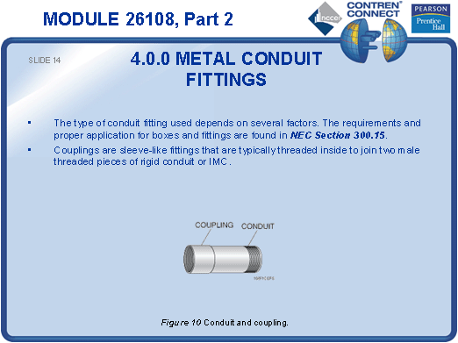
SLIDE 15
- Show example of metal couplings and allow the students to examine them.
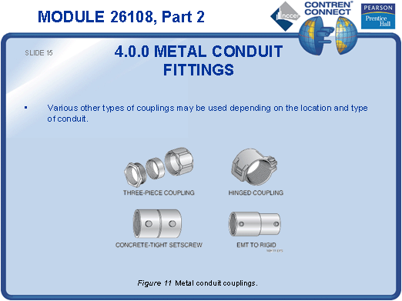
SLIDE 16
- Explain what a conduit body is and show examples of various types.
- Discuss the NEC® fill requirements for conduit bodies.
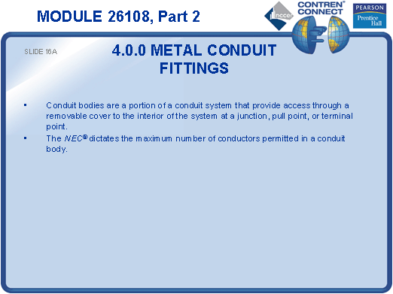

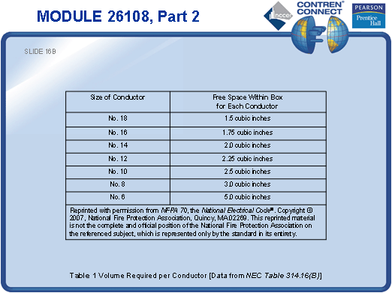
SLIDE 17
- Explain why pull points are needed in wiring runs.
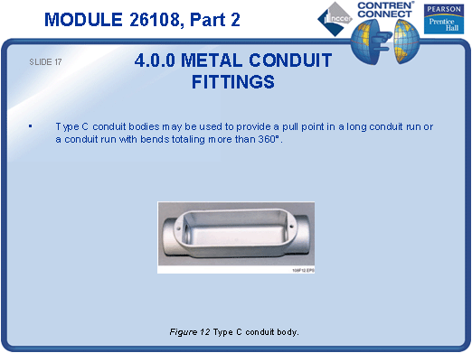
SLIDE 18
- Discuss the different Type L conduit bodies and explain how to identify them.
- Allow the students to practice identifying conduit bodies.
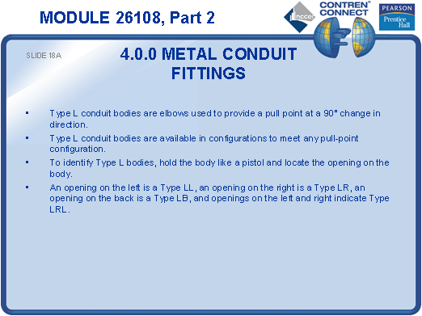

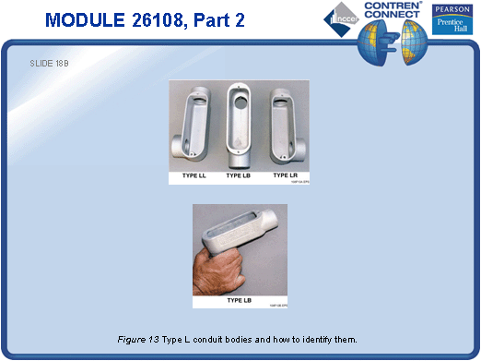
SLIDE 19
- Ask the students to describe a situation where a Type T conduit body would be needed.
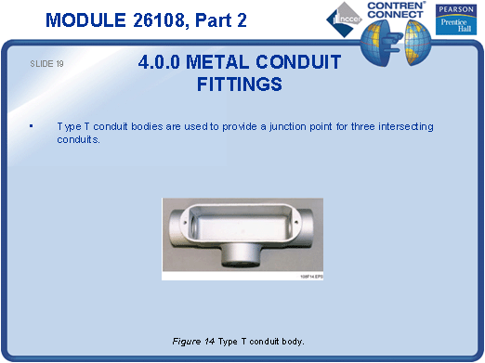
SLIDE 20
- Ask the students to describe a situation where a Type X conduit body would be needed.
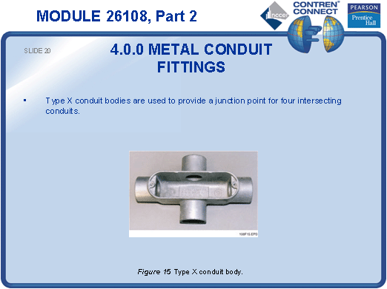

SLIDE 21
- Show examples of threaded waterproof hubs and allow the students to examine them.
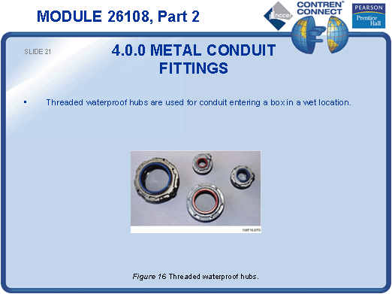
SLIDE 22
- Use a section of conduit, an insulating bushing, and a box to show the students how insulating bushings are installed.
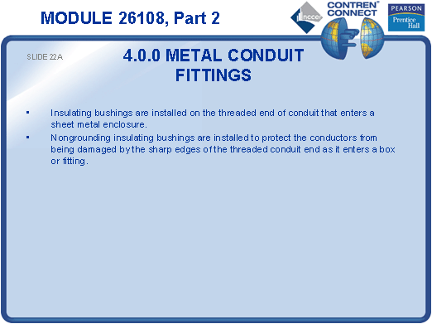

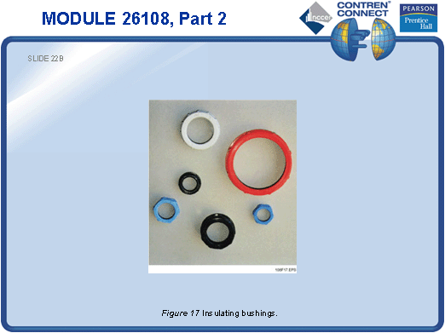
SLIDE 23
- Describe some conditions in which grounded insulating bushings would be used.
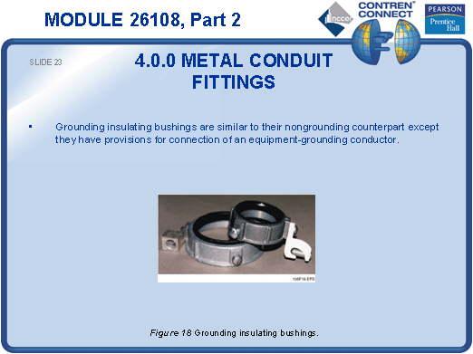
SLIDE 24
- Ask the students to describe some situations in which offset nipples might be used.
- Show examples of offset nipples and allow the students to examine them.
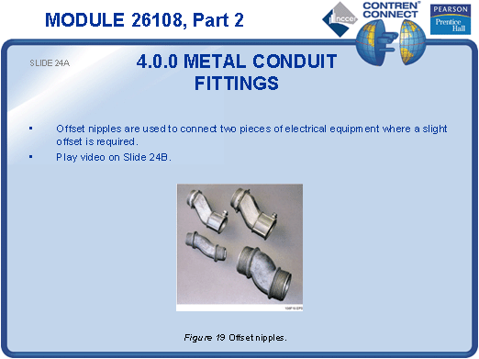

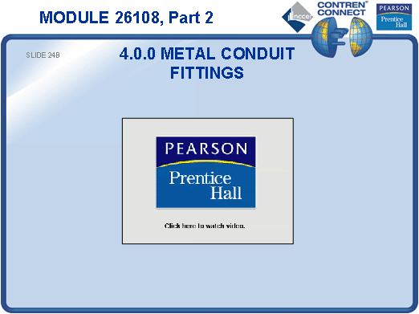
SLIDE 25
- Show various types of locknuts and bushings and identify the purpose of each type.
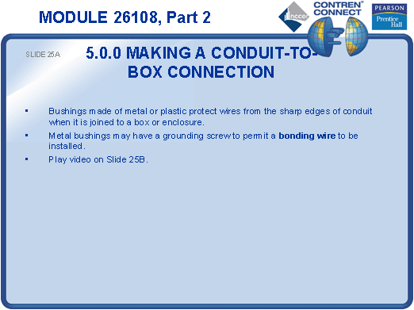
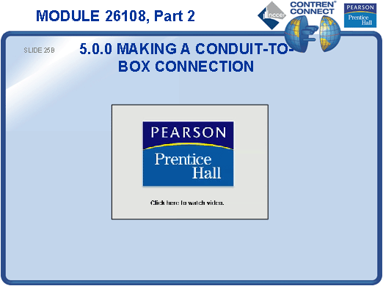

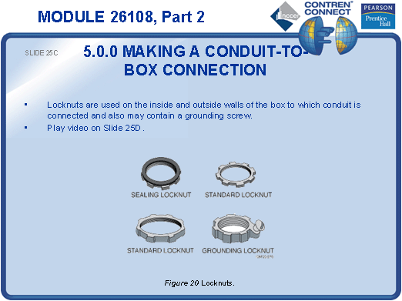

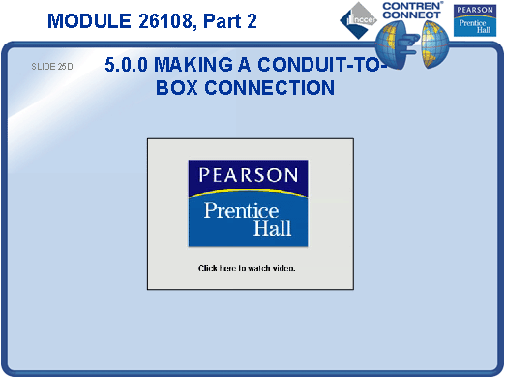
SLIDE 26
- Demonstrate how to make a conduit-to-box connection.
- Have the students practice making conduit-to-box connections.
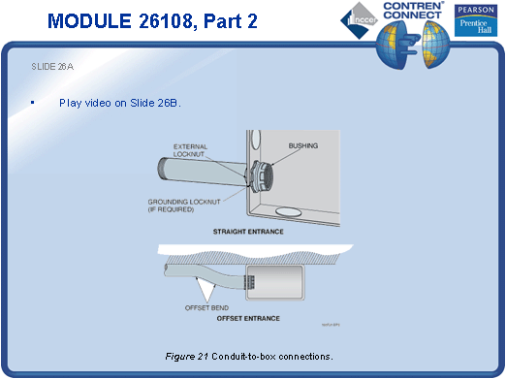
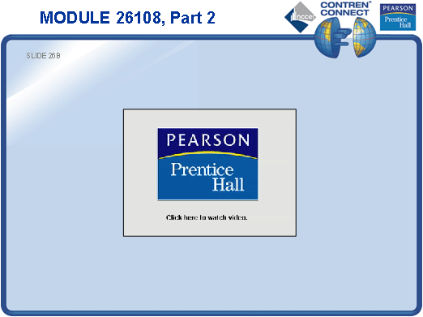
SLIDE 27
- Discuss the purpose of sealing fittings.
- Show examples of sealing fittings and allow the students to examine them.
- Demonstrate how the fittings are sealed.
- Ask the students to identify environments in which such fittings might be required.
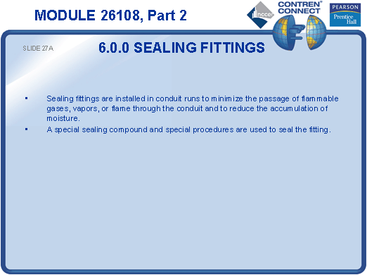

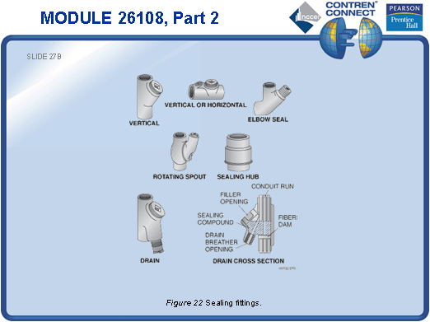
TESTING and PERFORMANCE
- Have the students complete CONTREN Connect Active Figures 13 and 22.
- Have the students answer Review Questions 5 and 6 for Sections 4.0.0 – 6.0.0. Provide correct answers and remediation at the end of the quiz.
- Students must identify the appropriate conduit body for a given application. This can be done during the presentation of Slide 18 or at the end of the session. This satisfies Performance Task 4.
- Students must terminate a raceway system by making a conduit-to-box connection. This can be done during the presentation of Slide 26 or at the end of the session. This satisfies Performance Task 3.

