Module 26108-08
RACEWAYS AND FITTINGS

Lesson 3 of 4: Fasteners, Raceway Supports, and Wireways
This lesson is a classroom and lab session in which the students will be introduced to the various types of fasteners and support devices used with conduit, as well as the trough systems and wireways used to house wiring and cables in commercial and industrial applications.
Objectives
Upon completion of this lesson, the student should be able to:
- Identify and describe the uses of various fasteners, straps, standoff supports, beam clamps, and framing channels.
- Identify and describe the uses of the various components that make up a wireway.
- Identify and describe the uses of the various support devices used to support wireways.
- Identify and describe the uses of pancake and surface raceways.
Performance Requirements
  - Identify various raceways, fittings, and fasteners and state their applications. This satisfies module Performance Task 1.
Reading Assignment
  - Module 26108, Sections 7.0.0 thru 9.4.6
Slide Presentation
  - Module 26108, Part 3 (Slides 28 thru 69)
Suggested Equipment/Materials
  - Various tie wraps and cable straps
  - Wood screws
  - Lag screws and shields
  - Concrete screws
  - Thread-forming and thread-cutting screws
  - Drywall screws
  - Drive screws
  - Power drill with various bits and material scraps to demonstrate fastener use
  - Hammer-driven pins, installation tool, and hammer
  - Various one-step, bolt, screw, and self-drilling anchors
  - Various toggle bolts
  - Various sleeve-type, wallboard, and metal drive-in anchors
  - Conduit support straps
  - Beam clamps
  - Wireway components and supports
  - Various examples of raceways and associated fittings
Suggested Student Activity
- Visit a commercial facility such as an office building that uses surface raceways to carry power wiring and low-voltage cabling. Identify the different types of raceways used.
Testing
  - Module Review Questions 8 and 9
  - CONTREN Connect Active Figures 33 and 45
Suggested Lab Activity
- Assemble a selection of fasteners, conduit supports, wireway supports, and surface raceway components. Have the students identify each type and state its uses.
Additional Resources
- Surface raceway system application data and installation details can be found at www.panduit.com.
- Contren Connect Electrical 1 Annotated Instructors Guide (available from NCCER).
SLIDE 28
- Review the objectives to be covered in this lesson. Ask the students if they have any questions.
- Discuss the use of tie wraps and cable straps. Provide examples for the students to examine.
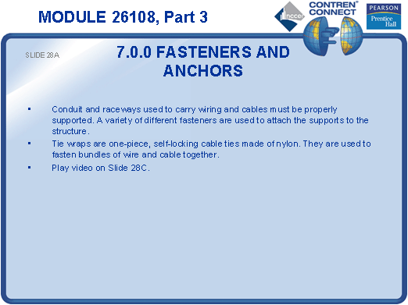
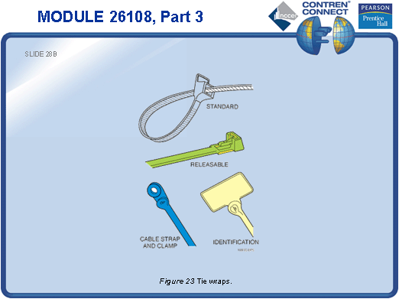
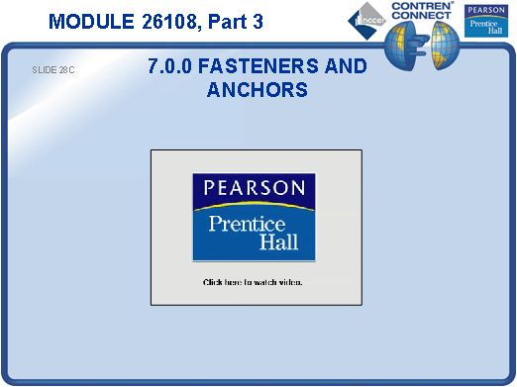
SLIDE 29
- Discuss the use of wood screws. Provide examples for the students to examine.
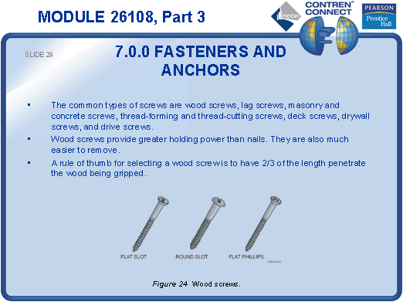
SLIDE 30
- Discuss the use of lag screws. Provide examples for the students to examine.
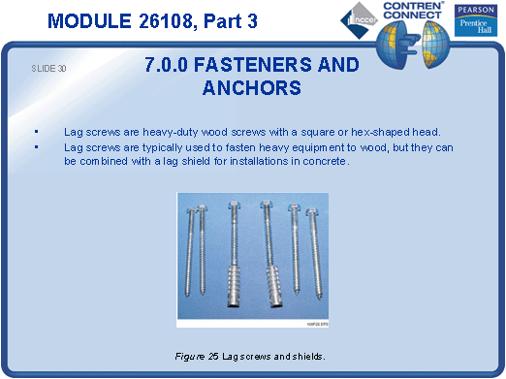
SLIDE 31
- Show examples of concrete screws.
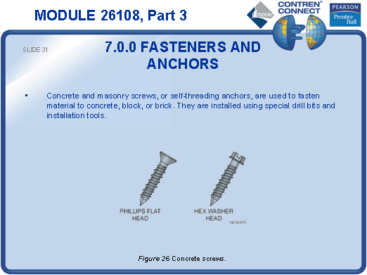
SLIDE 32
- Note the advantage of thread-forming screws. Provide examples for the students to examine.
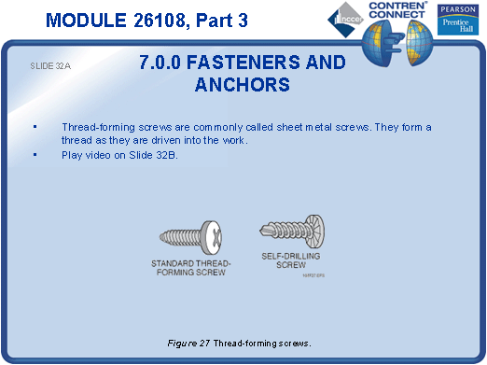

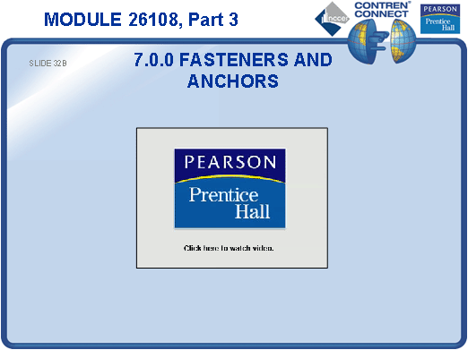
SLIDE 33
- Discuss the use of thread-cutting screws. Provide examples for the students to examine.
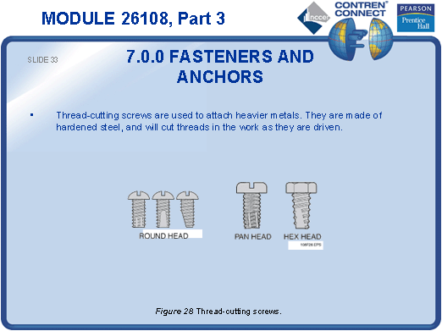
SLIDE 34
- Provide examples of drywall screws for the students to examine.
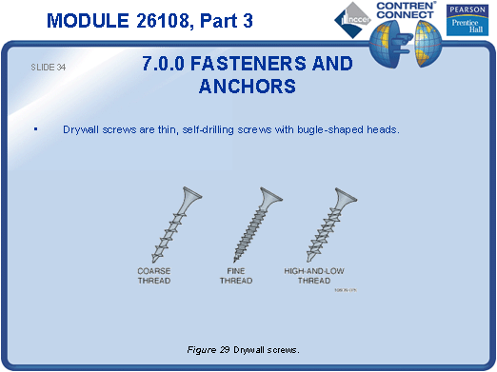
SLIDE 35
- Point out that drive screws are installed using a hammer. Provide examples for the students to examine.
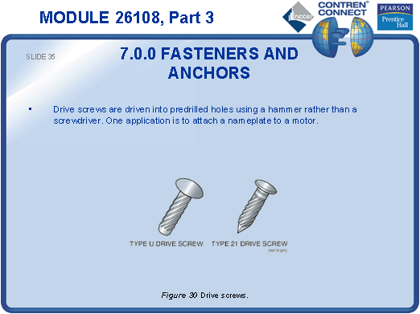
SLIDE 36
- Discuss the use of hammer-driven pins. Point out that they require a special installation tool. Provide examples for the students to examine.
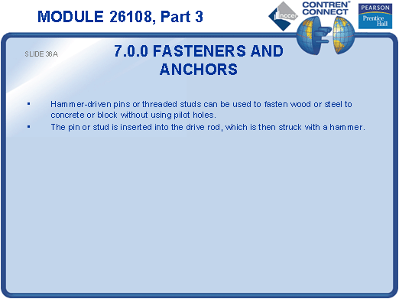

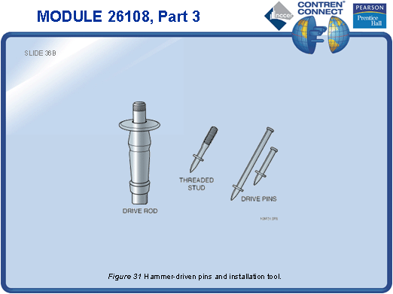
SLIDE 37
- Explain that a powder-actuated fastener is installed using a gunpowder charge and can be deadly if used carelessly or by untrained operators.
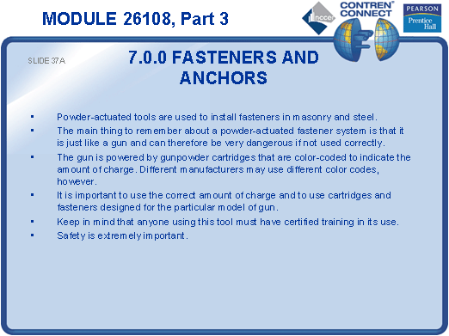

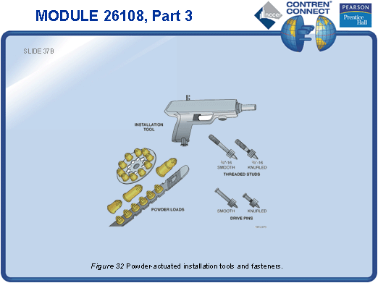
SLIDE 38
- Discuss the various types of one-step anchors. Provide examples for the students to examine.
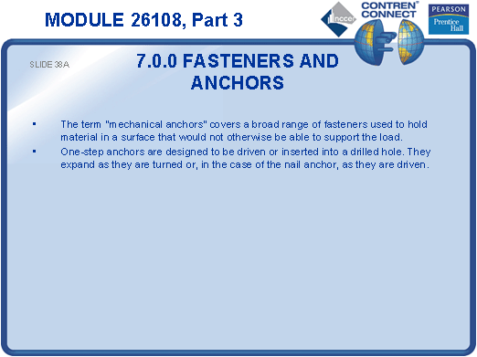

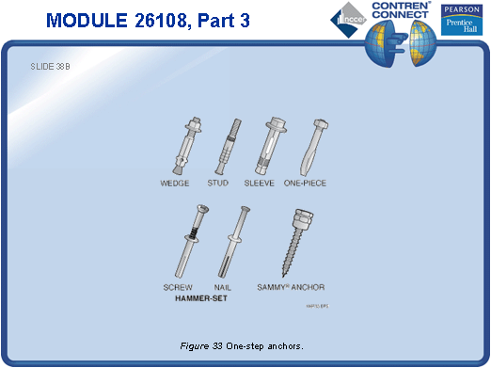
SLIDE 39
- Explain that bolt anchors provide a means of bolting equipment into a finished surface, such as a concrete floor. Provide examples for the students to examine.
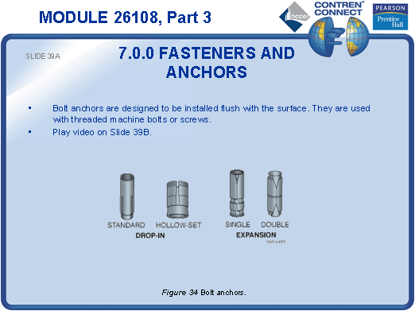

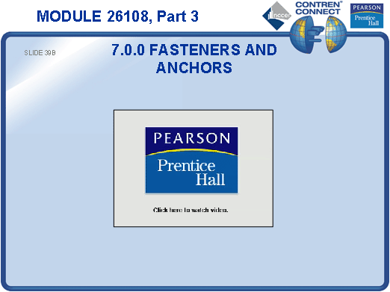
SLIDE 40
- Discuss the various types of screw anchors. Provide examples for the students to examine.
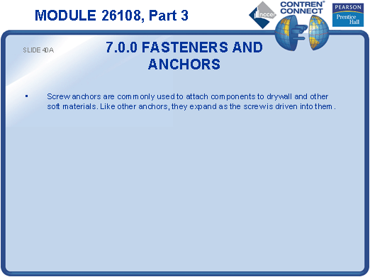

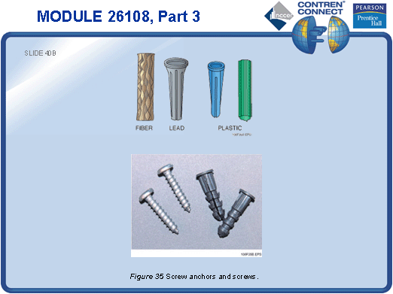
SLIDE 41
- Show examples of self-drilling anchors and explain that they are installed using a hammer drill.
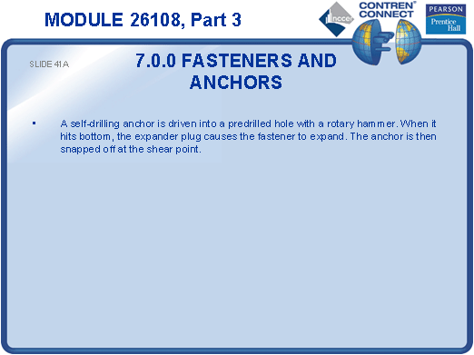

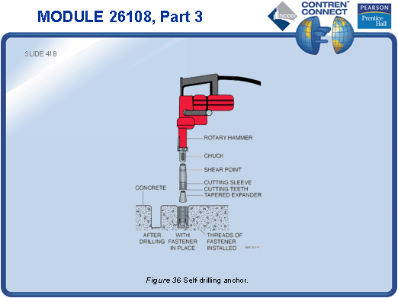
SLIDE 42
- Emphasize the importance of following the fastener manufacturer’s instructions when drilling pilot holes.
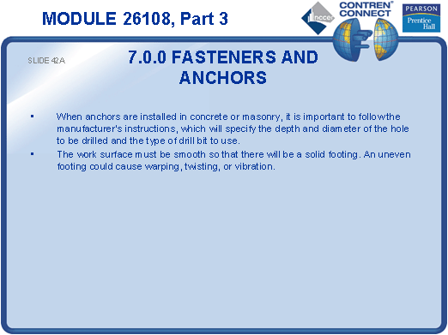

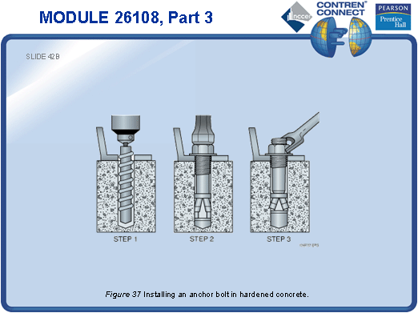
SLIDE 43
- Show examples of various toggle bolts.

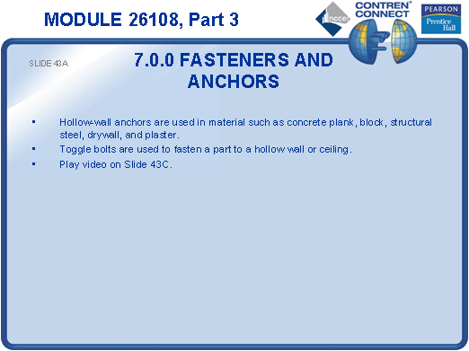
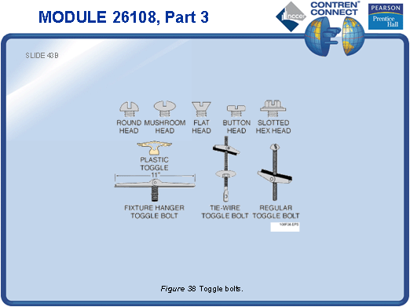
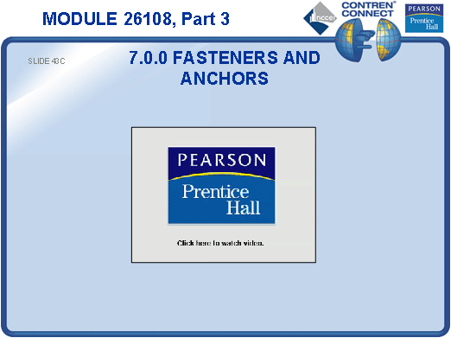

SLIDE 44
- Discuss sleeve-type, wallboard, and metal drive-in anchors. Provide examples for the students to examine.
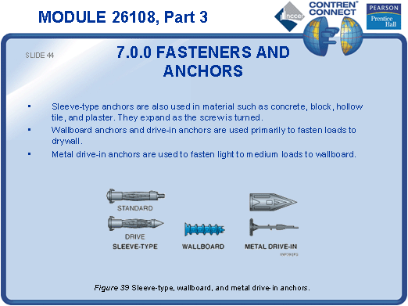
SLIDE 45
- Point out that epoxy holds well but hardens very quickly.
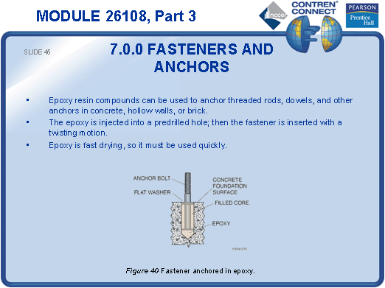
SLIDE 46
- Show the different types of straps used to support conduit. Allow the students to examine the straps.
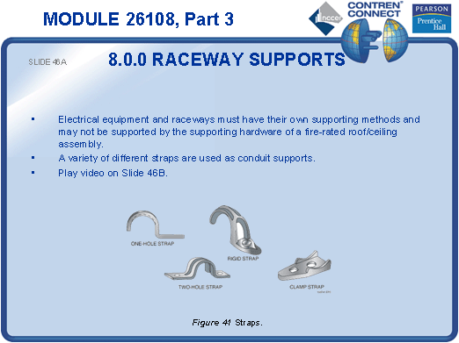

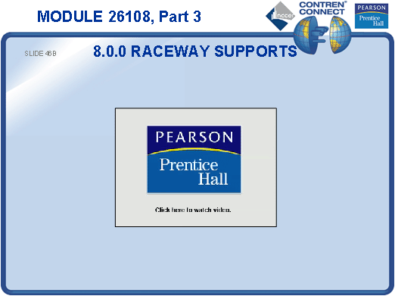
SLIDE 47
- Show a typical standoff support.
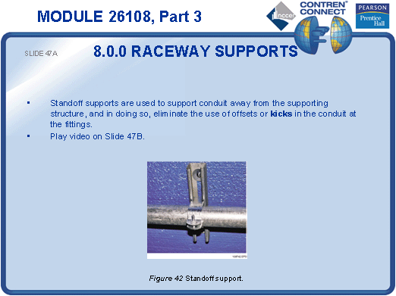
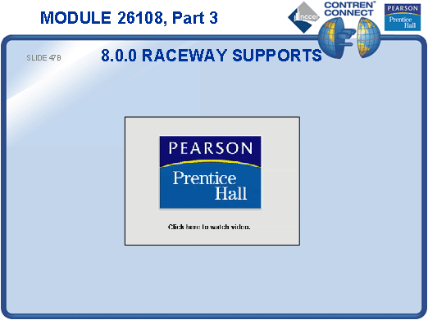
SLIDE 48
- Explain the purpose of framing channels.
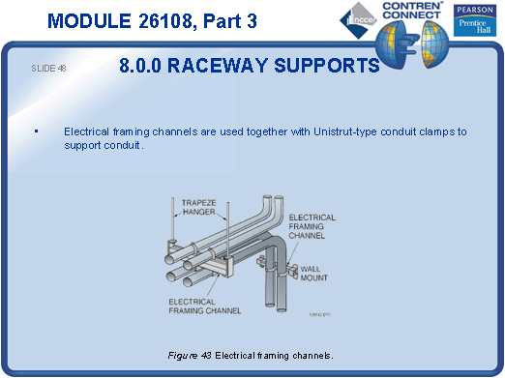
SLIDE 49
- Explain how beam clamps are used to support framing channels and other suspended wireway systems.
- Show the students a beam clamp and allow them to examine it.
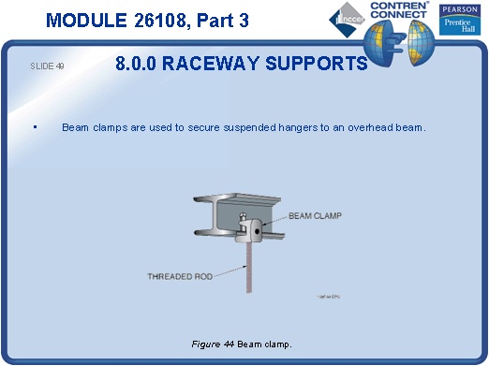
SLIDE 50
- Have the students look up the fill factors and derating factors for wireways in the NEC®.
- Describe some environments in which wireway systems might be used.
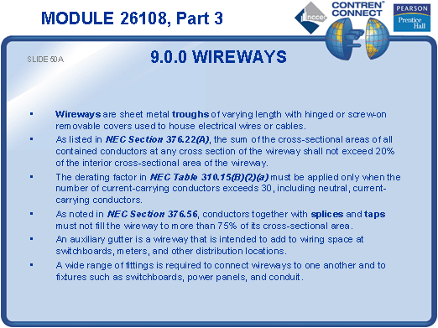

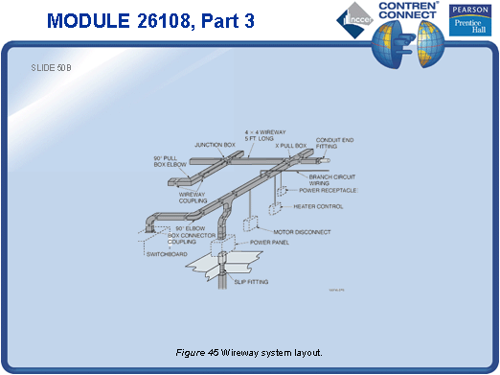
SLIDE 51
- Discuss the difference between a raintight trough and a raintight lay-in wireway. If available, show the students an example of each.
- Describe some conditions under which each type might be used.
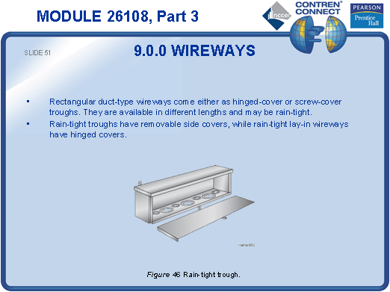
SLIDE 52
- Show the students how a section of wire trough is assembled, including the cover and end caps.
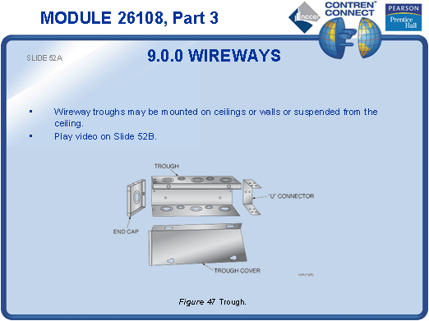

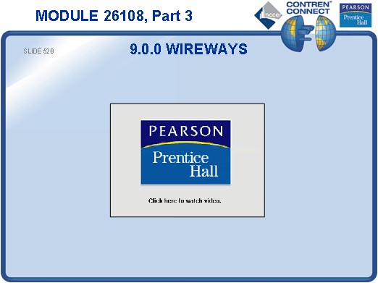
SLIDE 53
- If available, show the students components and fittings of wireway systems, including screw-on, hinged, and snap-on types.
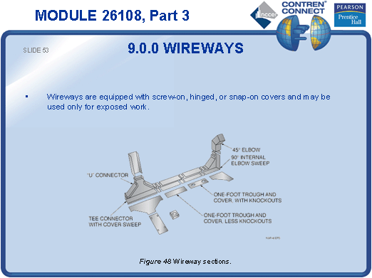
SLIDE 54
- Demonstrate how connectors are attached to a wireway.
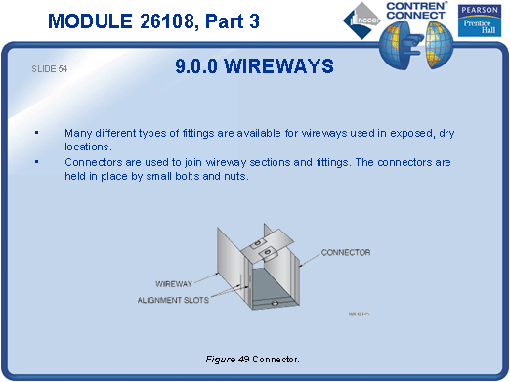
SLIDE 55
- Describe the different types of connectors and fittings used with wire trough systems.
- If available, show various wireway connectors and fittings and allow the students to examine them.
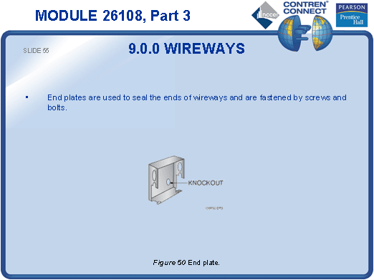
SLIDE 56
- No notes
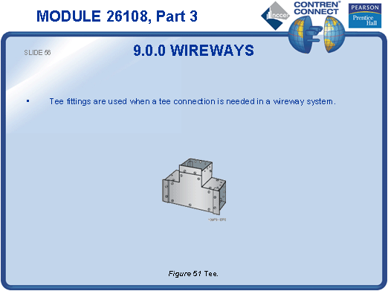
SLIDE 57
- No notes
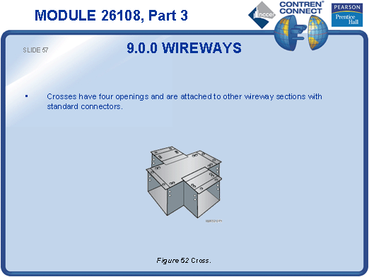
SLIDE 58
- No notes
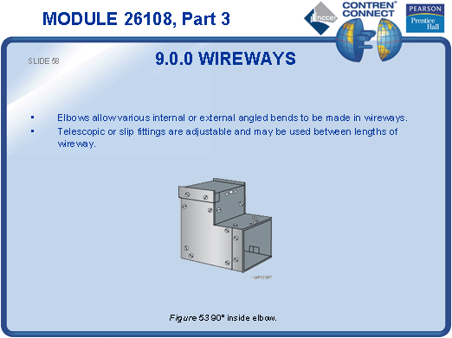
SLIDE 59
- Point out that wireways must be supported every 5 feet.
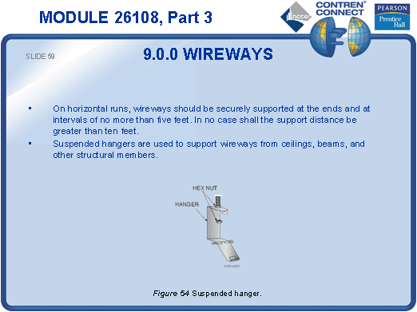
SLIDE 60
- No notes
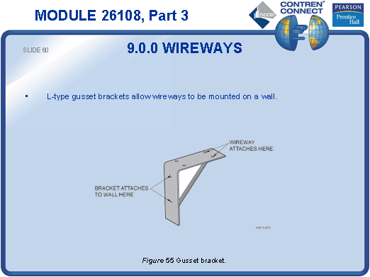
SLIDE 61
- No notes
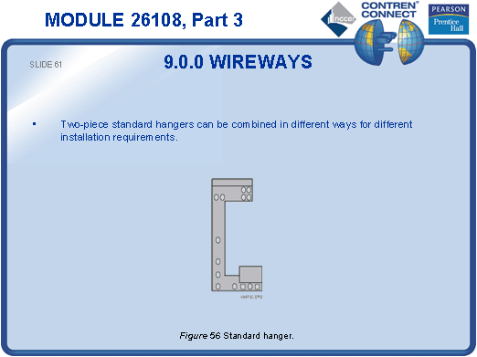
SLIDE 62
- Provide an example of a wireway hanger for the students to examine.
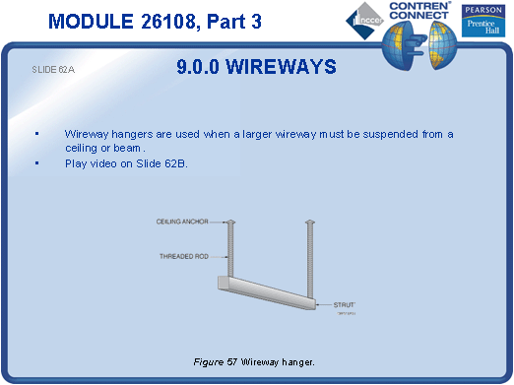
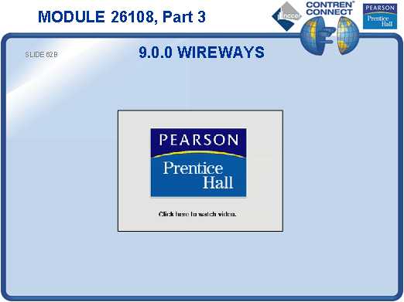
SLIDE 63
- Provide examples of surface raceway for the students to examine.
- Have the students look up the requirements for surface raceways in the NEC®.
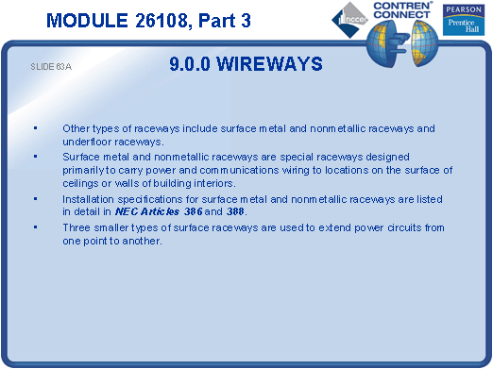

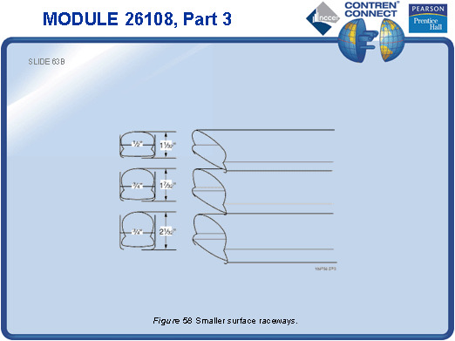
SLIDE 64
- Show the students a section of pancake raceway and allow them to examine it.
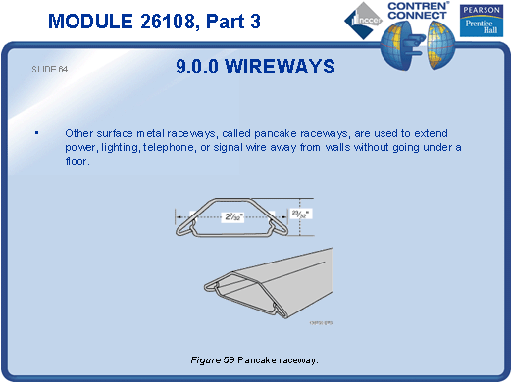
SLIDE 65
- Note that special barriers are required when running both power and signal wiring through the same raceway.
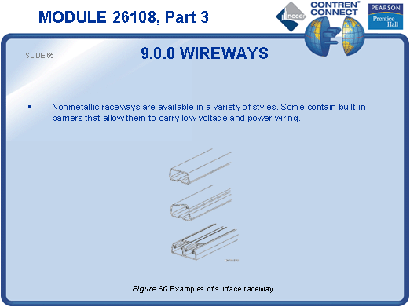
SLIDE 66
- Discuss the advantages of multi-outlet systems.
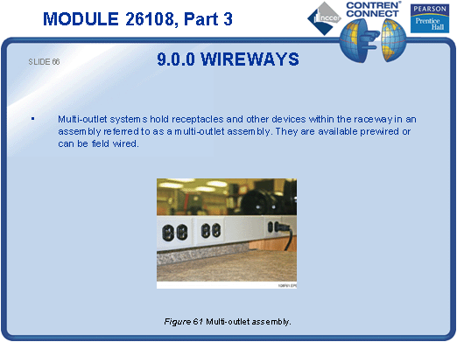
SLIDE 67
- No notes
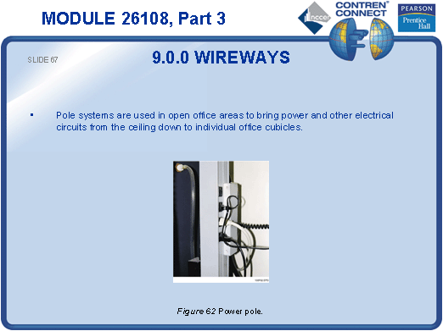
SLIDE 68
- Explain the advantages of underfloor raceway systems.
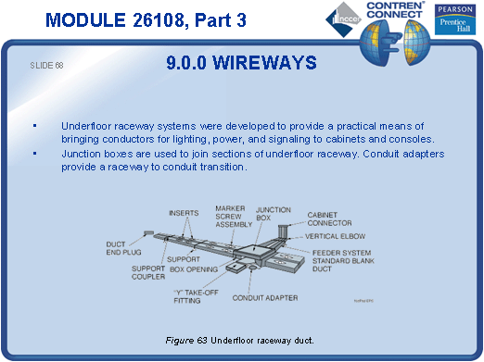
SLIDE 69
- Explain that concrete decks are often poured on corrugated metal forms. Power and low-voltage conductors can be routed through the openings in the cellular floor.
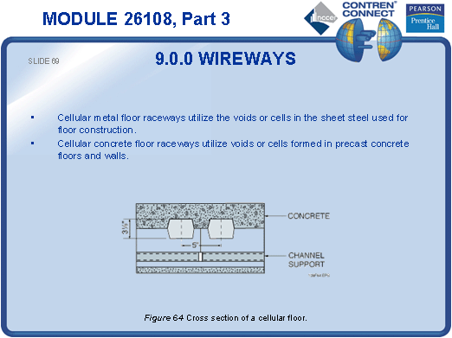
TESTING and PERFORMANCE
- Have the students complete CONTREN Connect Active Figures 33 and 45.
- Have the students answer Review Questions 7 – 9 for Sections 7.0.0 – 9.4.6. Provide correct answers and remediation at the end of the quiz.
- Students must identify various raceways, fittings, and fasteners and state their applications. This satisfies module Performance Task 1.

