Module 26108-08
RACEWAYS AND FITTINGS

Lesson 4 of 4: Cable Trays; Handling and Storing Raceways; Ducting; Construction Methods
This lesson is a classroom and lab session in which the students will be introduced to the cable tray systems used to carry large quantities of cabling. In addition, students will learn about the proper handling and storage of raceway components, underground duct systems, and construction methods.
Objectives
Upon completion of this lesson, the student should be able to:
- Identify the components of a cable tray system.
- Describe the support devices and requirements for cable tray systems.
- Describe the correct methods for storing raceway components.
- Describe the correct methods for handling raceway components.
- Describe the methods used to run cable underground.
- Describe and/or demonstrate how to make box connections in various types of construction.
Performance Requirements
  - Install a flexible raceway system. This satisfies module Performance Task 2.
Reading Assignment
  - Module 26108, Sections 10.0.0 thru 14.4.0
Slide Presentation
  - Module 26108, Part 4 (Slides 70 thru 88)
Suggested Equipment/Materials
  - Cable tray components and supports
  - Metal boxes and tile rings
  - Nail plate
  - Exposed steel stud wall
  - Bushings
  - Locknuts
  - Flexible raceway and associated fittings
Suggested Student Activity
- Visit a commercial or industrial facility and see how cable tray is used.
Testing
  - Module Review Question 10
  - CONTREN Connect Active Figure 63
  - Module 26108-08 Exam
Suggested Lab Activities
- Have the students identify cable tray components and state their applications and limitations as specified in the NEC®.
Additional Resources
- Cable tray facts and instructions are available at www.cabletrays.com.
- Contren Connect Electrical 1 Annotated Instructors Guide (available from NCCER).
SLIDE 70
- Review the objectives to be covered in this lesson. Ask the students if they have any questions.
- Refer the students to NEC Article 392 and discuss the uses and limitations of cable tray.
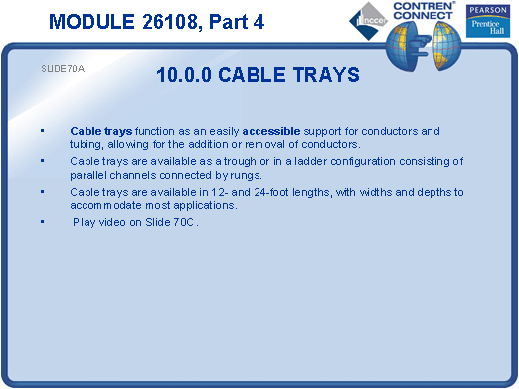

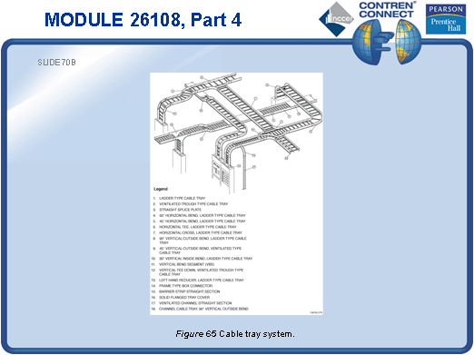

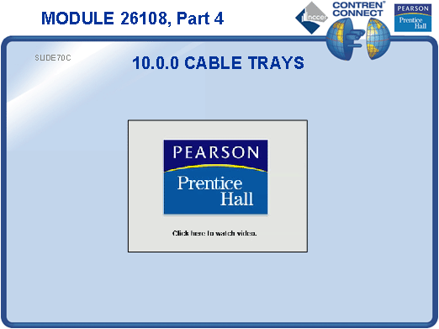
SLIDE 71
- Identify different cable tray components. Provide examples for the students to examine.
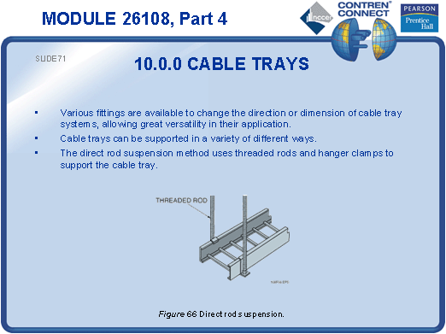
SLIDE 72
- Describe the different types of suspension/support methods for cable tray.
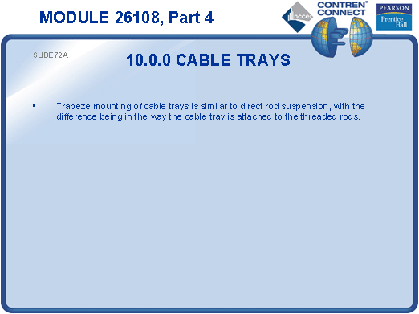
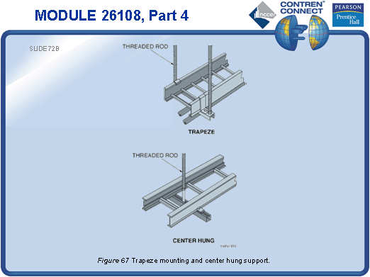
SLIDE 73
- No notes
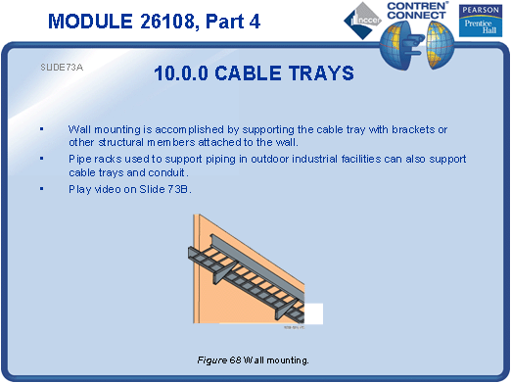
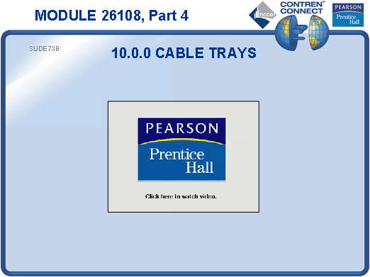
SLIDE 74
- Explain that proper storage prevents waste and speeds installation.
- Point out the need to seal conduit ends.
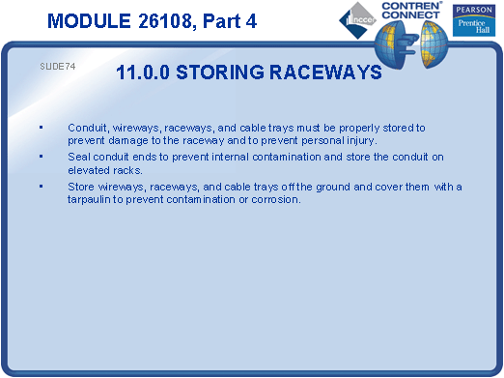
SLIDE 75
- Discuss the correct methods for handling raceway.
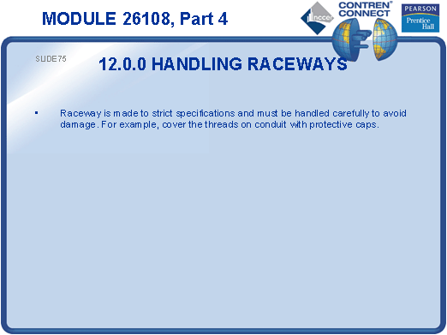
SLIDE 76
- Give some examples of situations in which electricians may encounter underground duct systems.
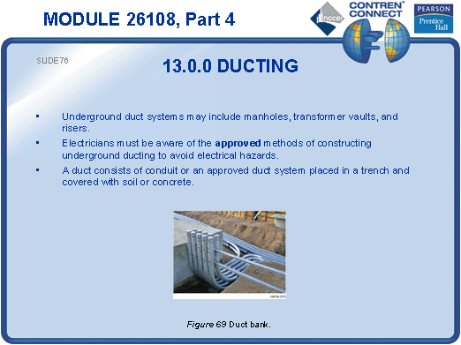
SLIDE 77
- Explain that underground electrical facilities are commonly accessed through manholes.
- Discuss monolithic and cable-in-duct systems.
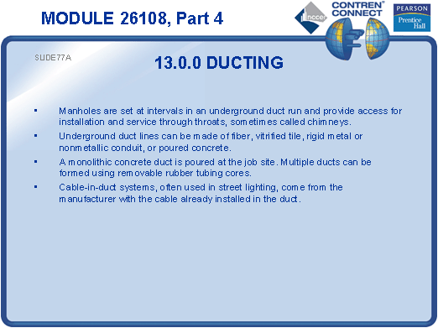

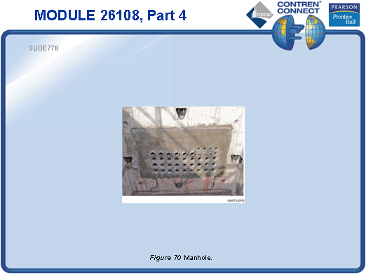
SLIDE 78
- Explain that box and conduit installation requirements vary depending on the type of construction.
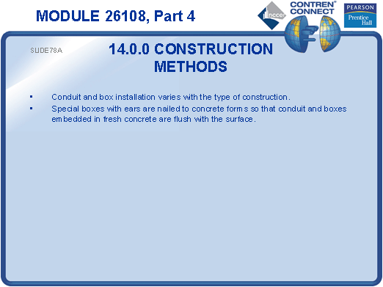

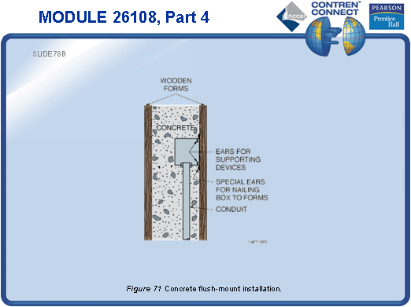
SLIDE 79
- Show an example of a tile ring.
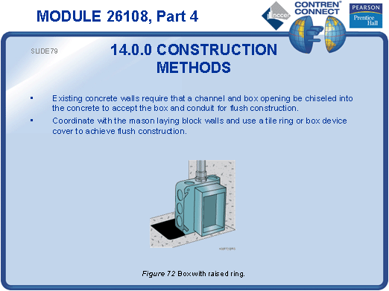
SLIDE 80
- Explain that masonry boxes are preferred when installing boxes in a concrete wall.
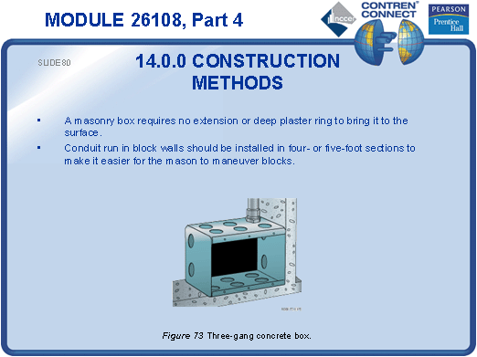
SLIDE 81
- Demonstrate how to attach a box to a steel stud and connect it to a flexible raceway system. Have the students practice installing boxes and raceways.
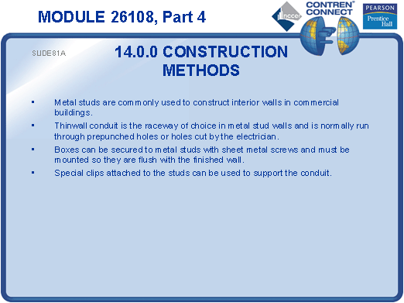

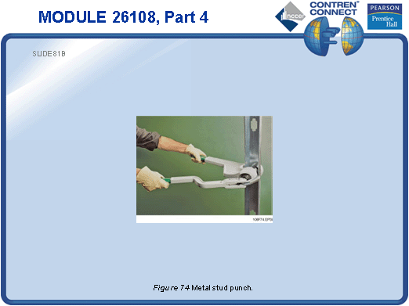
SLIDE 82
- Point out that NM cable must be protected when run through metal studs.
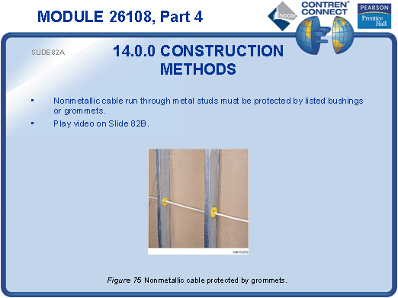
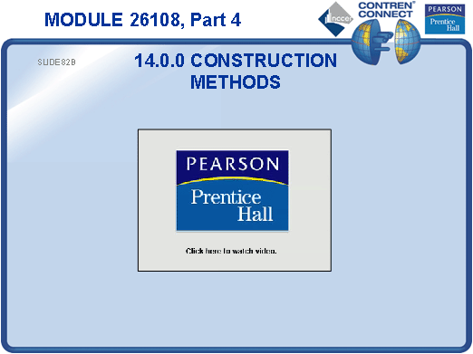
SLIDE 83
- Describe the NEC® requirements for running EMT through wooden studs.
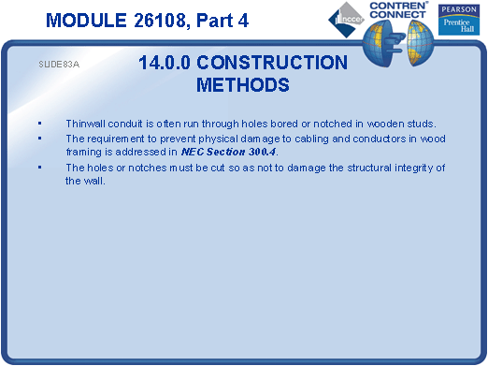
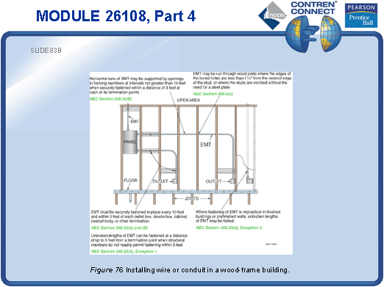
SLIDE 84
- Discuss the use of nail plates. Provide an example for the students to examine.
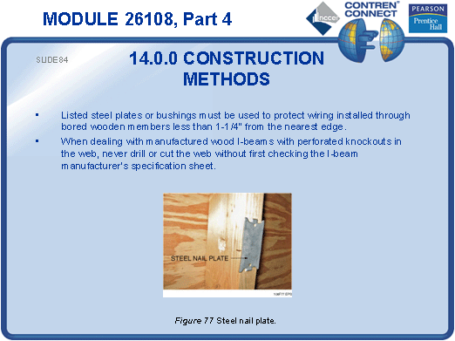
SLIDE 85
- Note the special requirements for routing conduit across structural roofing members.
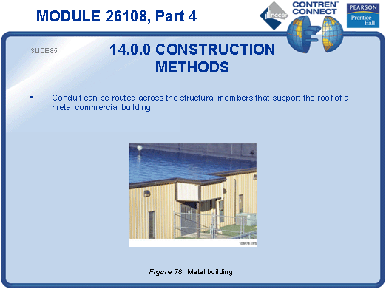
SLIDE 86
- No notes
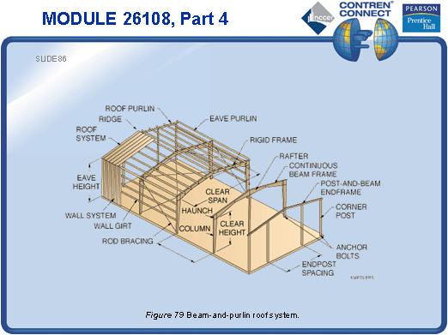
SLIDE 87
- No notes
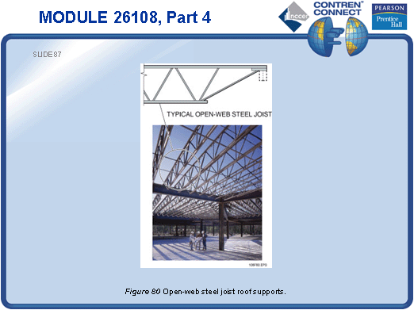
SLIDE 88
- Explain that structural steel beams and other support members cannot be drilled for conduit runs, so the conduit must be suspended using special anchoring devices.
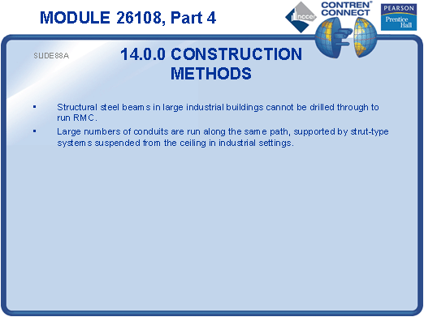

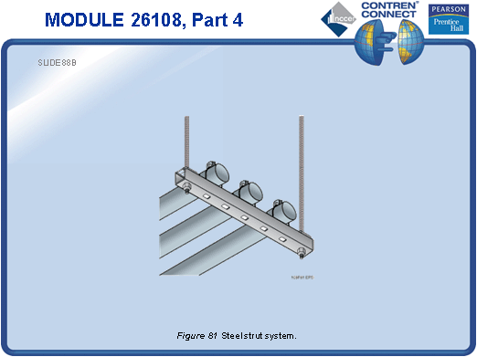
TESTING and PERFORMANCE
- Have the students complete CONTREN Connect Active Figure 63.
- Have the students answer Review Question 10 for Sections 10.0.0 – 14.4.0. Provide correct answers and remediation at the end of the quiz.
- Have the students complete the Trade Terms Quiz.
- Students must install a flexible raceway system. This can be done during the presentation of Slide 81 or at the end of the session. This satisfies Performance Task 2.
- Administer the Module Exam.

