Module 26107-08
Hand Bending
Lesson 1 of 3: Introduction to Hand Bending
This lesson is a classroom and lab session in which the students will be introduced to hand-operated equipment that is used to make bends in all types of conduit, including electrical metallic tubing (EMT), PVC, and rigid conduit. The lesson will conclude with a performance requirement in which the students will make a 90° bend and back-to-back bends in EMT using a hand bender.
Objectives
Upon completion of this lesson, the student should be able to:
- Identify various types of hand bending equipment and on what type of conduit it is used.
- Apply basic geometric rules in making 90° bends in conduit.
- Make a single 90° bend in EMT.
- Make back-to-back 90° bends in EMT.
Performance Requirements
  - Make a 90° bend and back-to-back 90° bends in EMT using a hand bender.
These tasks partially satisfy module Performance Task 1.

Reading Assignment
  - Module 26107, Sections 1.0.0 thru 2.4.0
Slide Presentation
  - Module 26107, Part 1 (Slides 1 thru 12)
Suggested Equipment/Materials
  - Appropriate personal protective equipment
  - Sufficient sections of ½" EMT for lab work
  - ¾" and 1" EMT pieces for demonstration only
  - Hacksaw
  - ½", ¾", and 1" EMT hand benders
  - ½" rigid conduit hickey bender
  - PVC bending unit
  - PVC bending plug set
  - PVC conduit
  - Wet rags for cooling heated PVC
  - Sufficient sections of ½" rigid metal conduit
  - Sufficient sections of ½" intermediate metal conduit
  - Conduit reamer
  - Tape measure
  - Marker
  - Plastic 90° triangle
  - Torpedo level
Suggested Student Activity
  - Students should identify the different types of conduit and conduit bends that are visible when visiting shopping malls, home improvement stores, and other public buildings. The National Electrical Code® requires all wiring in commercial buildings to be installed in some type of raceway, unlike residences in which cable may be run within walls and ceiling areas.
Testing
  - Module Review Questions 1 - 6
  - CONTREN Connect Active Figures 6 and 8
Suggested Lab Activities
  - Students must make a single 90° bend in a section of ½” EMT. Use Performance Project 26107-1, Hand Bending a Stub-up.
  - Students must make two back-to-back 90° bends in a section of ½” EMT.
Additional Resources
  - Tom Henry’s Conduit Bending Package. Winter Park, FL: Code Electrical Classes, Inc.
  - Performance Projects: Job Sheets for the Electrical Industry, Level One, New York: Prentice Hall.
  - Contren Connect Electrical 1 Annotated Instructors Guide (available from NCCER).
SLIDE 1
  - Review the objectives to be covered in this module. Ask the students if they have any questions.
  - Explain that students must obtain a score of 70% on the Module Exam and perform certain tasks to the satisfaction of the instructor to receive credit for the module.
  - Tell the students that safe work practices will be complied with during any of the lab or hands-on assignments, including safety glasses, goggles when necessary, and work gloves.
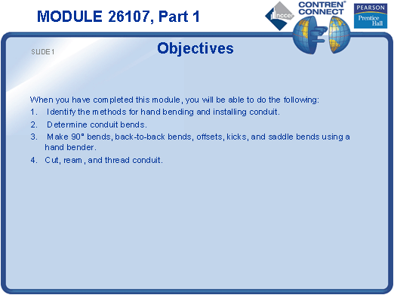
SLIDE 2
  - Point out that good bending techniques avoid waste and simplify conductor installation.
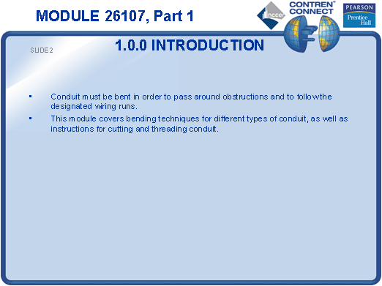
SLIDE 3
  - Introduce EMT hand benders.
  - Show the students how each bender size is designed for a specific EMT size by placing an EMT sample into the bending head.
  - Explain that it is important to use the correct size bender for the conduit to prevent conduit kinking or creasing.
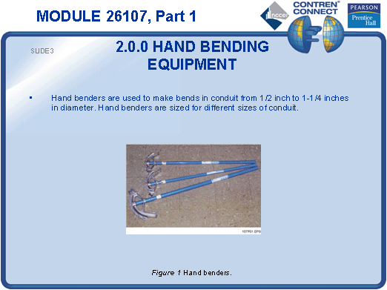
SLIDE 4
  - Use a ½" bender and a piece of ½" EMT to demonstrate a bend.
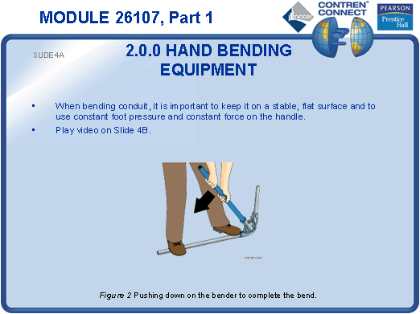
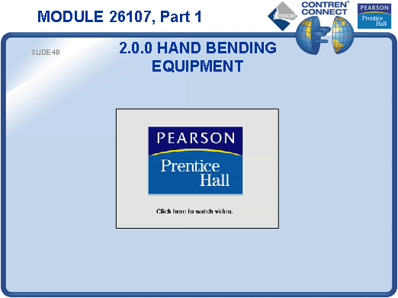
SLIDE 5
  - Explain that a hickey bender is designed for bending rigid metal conduit or intermediate metal conduit.
  - Show samples of RMC and IMC, and explain the difference between the two types.
  - Demonstrate how to bend conduit using a hickey.
  - Have the students practice making hickey bends.
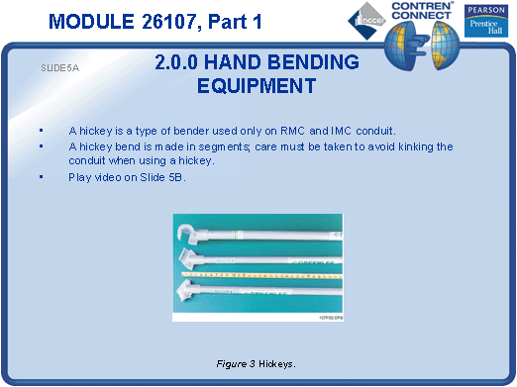
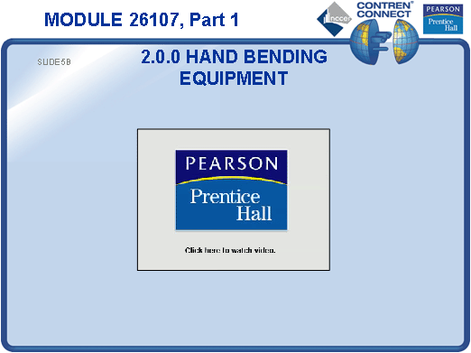
SLIDE 6
  - Demonstrate how to bend PVC conduit using a PVC heating unit.
  - Explain to students that if a heating unit is not available, PVC conduit can be bent using a propane hand torch, but this requires practice in order to prevent conduit from burning and/or kinking.
  - At the discretion of the instructor, students may practice bending PVC, but only under strict supervision and safe work practices.
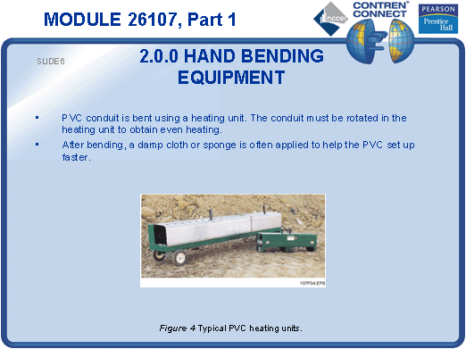
SLIDE 7
  - Demonstrate the use of PVC bending plugs, if available.
  - Explain that plug sets are typically used for bending PVC conduit that is 2 inches in diameter or larger.
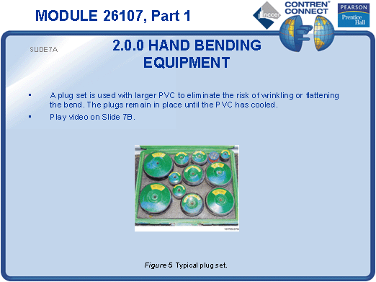
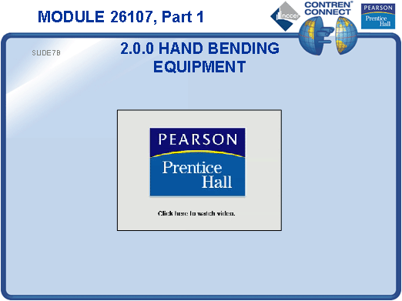
SLIDE 8
  - Define the three sides of a 90° triangle using a plastic triangle.
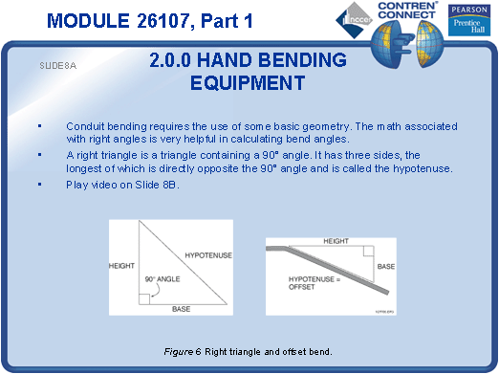
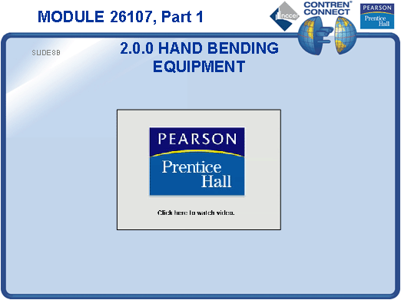
SLIDE 9
  - Explain the formula for finding the circumference of a circle.
  - Have the students practice finding the circumference of a circle based on different radii and diameter measurements.
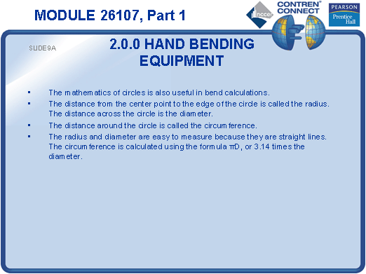
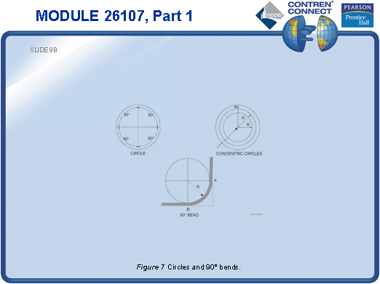
SLIDE 10
  - Demonstrate how to make a 90° bend in ½" EMT using a hand bender.
  - Have each student measure, mark, and bend a 90° bend in a section of ½" EMT.
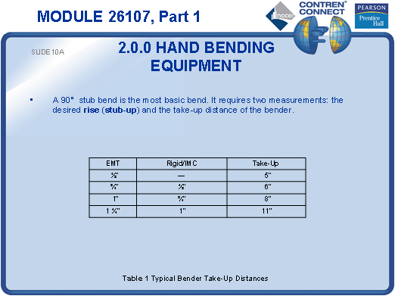
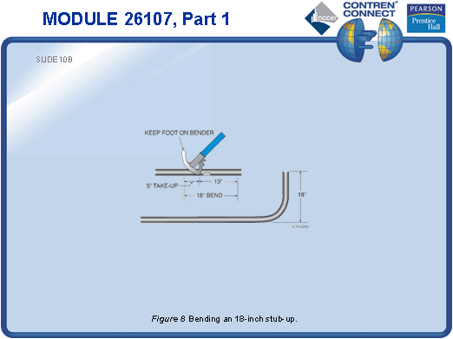
SLIDE 11
  - Go over the gain table with the students and explain how it is used to obtain an exact stub length.
  - Demonstrate how to cut a piece of ½" EMT and make a 90° bend using the hand bender so that the measurement of the stub length is 12 inches ± ½-inch.

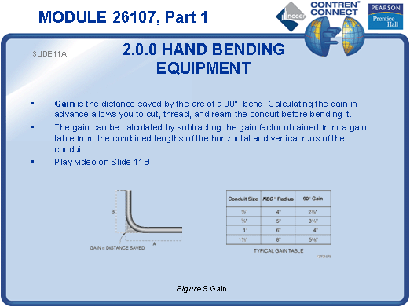
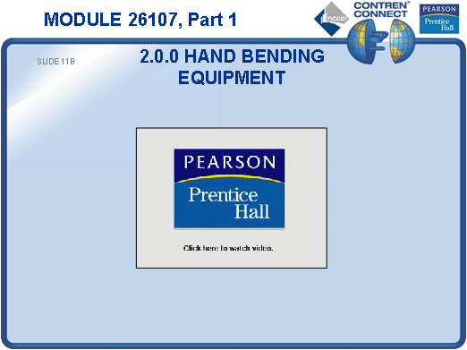
SLIDE 12
- Discuss the situations in which back-to-back 90° bends might be used.
- Demonstrate how to make back-to-back 90° bends.
- Have each student practice making back-to-back 90° bends.
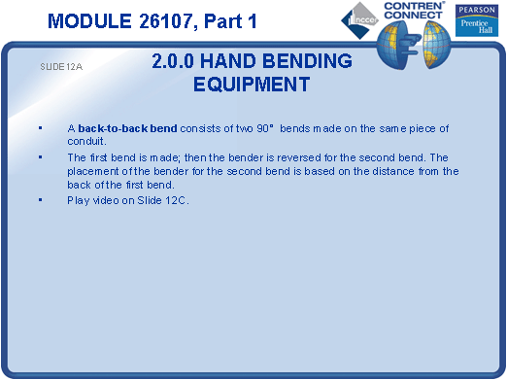
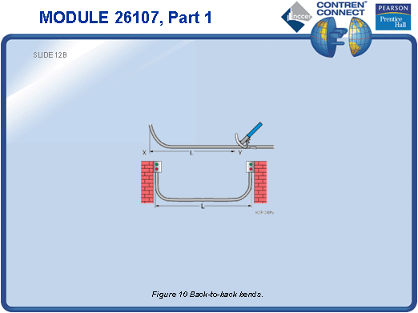
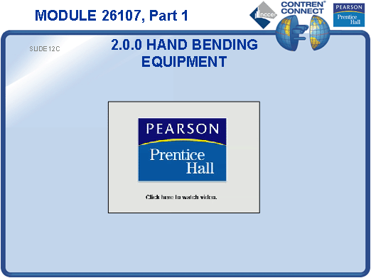
TESTING and PERFORMANCE
- Have the students answer Review Questions 1 thru 6 for Sections 1.0.0 – 2.4.0. Provide correct answers and remediation at the end of the quiz.
- Have the students complete Active Figures 6 and 8.
- Students must make an acceptable 90° bend and back-to-back 90° bends in ½" EMT using a hand bender. This can be done during the presentation of Slides 10 and 12 or at the end of the lesson. This partially satisfies Performance Task 1.

