Module 26107-08
Hand Bending
Lesson 2 of 3: Offset and Saddle Bends
This lesson is a classroom and lab session in which the students will learn how to use hand benders to make offset bends and saddle bends. Offset bends are used whenever conduit must change elevation such as when entering a box or enclosure. Saddle bends are used when an obstacle stands in the way of conduit the conduit must be bent to go around the obstacle. There are two types of saddle bends: the three-bend saddle and the four-bend saddle. As the instructor, you will teach the students how to make offset bends and both types of saddles then have the students demonstrate their knowledge by making these bends.
Objectives
Upon completion of this lesson, the student should be able to:
- Know when to use an offset bend and when to use either type of saddle.
- Make a single offset bend using a hand bender.
- Make parallel offset bends.
- Make a three-bend saddle.
- Make a four-bend saddle.
Performance Requirements
  - Make an offset bend.
  - Make a three-bend saddle.
  - Make a four-bend saddle.
These tasks partially satisfy module Performance Task 1
Reading Assignment
  - Module 26107, Sections 2.5.0 thru 2.8.0
Slide Presentation
  - Module 26107, Part 2 (Slides 13 thru 23)
Suggested Equipment/Materials
  - Appropriate personal protective equipment
  - ½" EMT benders
  - Sufficient sections of ½" EMT
  - Hacksaw
  - Tape measure
  - Marker
  - Torpedo level
  - EMT reamer (or lineman pliers)
  - Hand tools (screwdrivers, pliers, etc.)
  - Sufficient number of ½" EMT box connectors
  - Switch boxes or similar boxes with ½" knockouts
  - Short section of 2" PVC pipe
  - ½" EMT one- or two-hole straps
  - Two 2-inch pipe straps
  - Screws for straps
  - Project board such as sheet of plywood
  - 6" x 8" block of wood to be used as obstacle for a four-bend saddle
Suggested Student Activity
  - Visit a local construction site to observe the installation of various runs of EMT.
Testing
  - Module Review Questions 7 and 8
Suggested Lab Activities
  - Students must make a single offset bend. Use Performance Project 26107-2, Hand Bending Offsets to Clear an 8-inch Concrete Block.
  - Students must make a three-bend saddle.
  - Students must make a four-bend saddle.
  - Group the students to make offset bends in parallel runs.
Additional Resources
  - Tom Henry’s Conduit Bending Package. Winter Park, FL: Code Electrical Classes, Inc.
  - Performance Projects: Job Sheets for the Electrical Industry, Level One, New York: Prentice Hall.
  - Contren Connect Electrical 1 Annotated Instructors Guide (available from NCCER).
SLIDE 13
  - Review the objectives to be covered in this lesson. Ask the students if they have any questions.
  - Emphasize safe work practices (safety glasses/goggles and gloves).
  - Demonstrate how to bend a box offset and a 6" offset. Connect the box offset to a setscrew fitting on a mounted box.
  - Have each student to bend a box offset and a 6" offset.
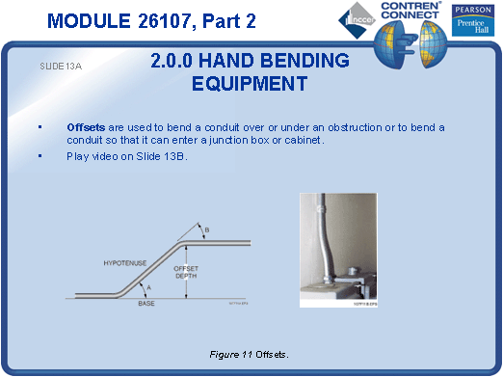
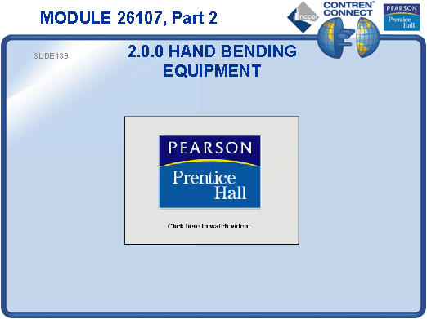
SLIDE 14
  - Explain how to calculate conduit shrinkage and how it must be applied when bending offsets (or any bend) to reduce the amount of scrap conduit created by cutting off excess lengths.
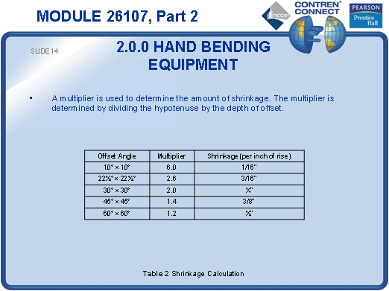
SLIDE 15
  - Introduce offset bends in parallel runs of conduit.
  - Discuss offset factors.
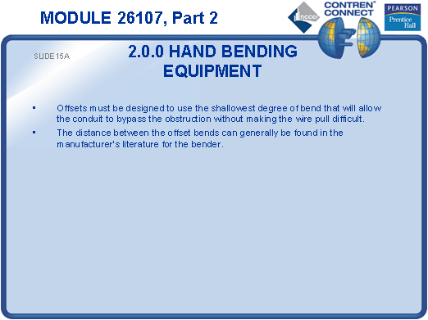
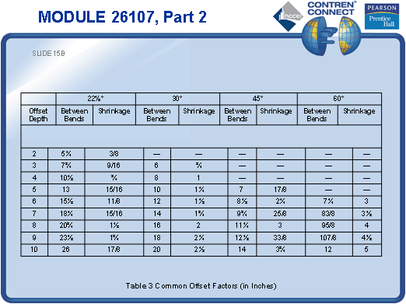
SLIDE 16
  - Support presentation with photos of both quality and substandard offset bends in parallel runs of conduit.
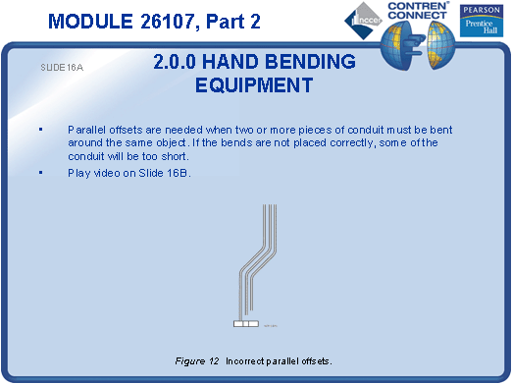
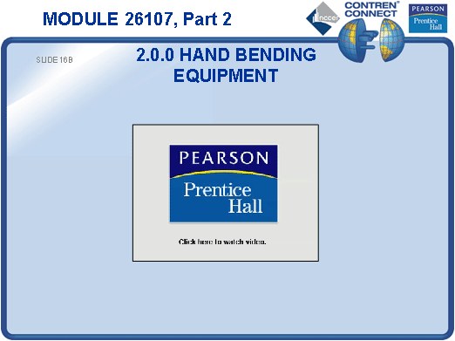
SLIDE 17
  - Lay out three sections of ½" conduit and explain how to find the center of the first bend.
  - Find the centerline of each of the other conduits in the parallel run.
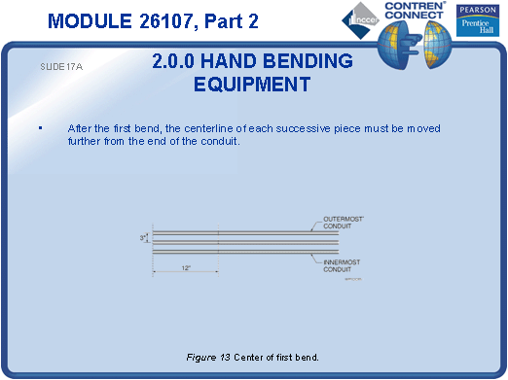
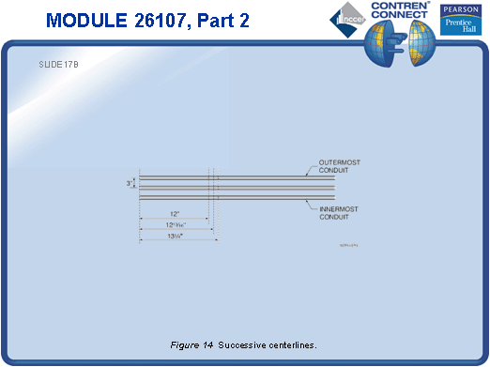
SLIDE 18
  - Explain the math required for placing the bending marks at the correct locations on the conduit.
  - Mark the conduit and make the bends.
  - Work with the students in groups to create offsets in parallel runs of conduit.
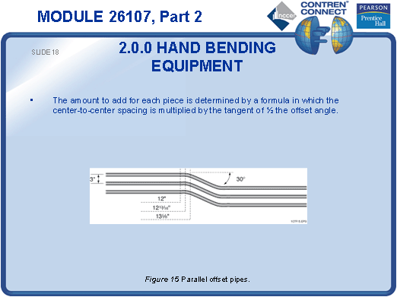
SLIDE 19
  - Explain how a three-bend saddle is the best type of bend to use when a small obstruction such as a pipe lies in the path of a proposed conduit run.
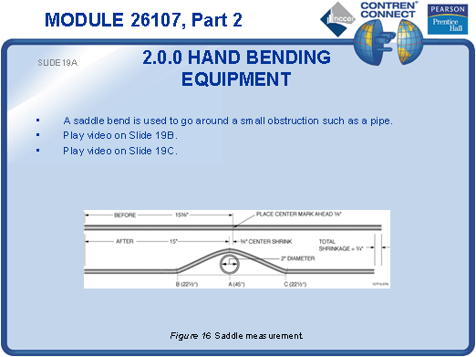
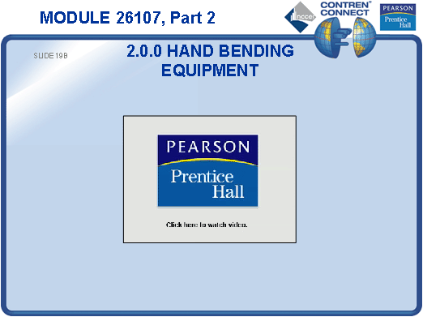
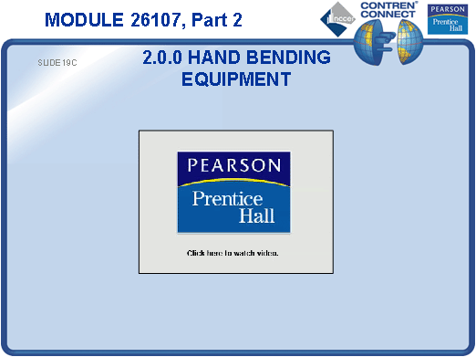
SLIDE 20
  - Explain that when creating a three-bend saddle in ½" EMT the center of the saddle shortens by ³/₁₆" for every inch of saddle depth.
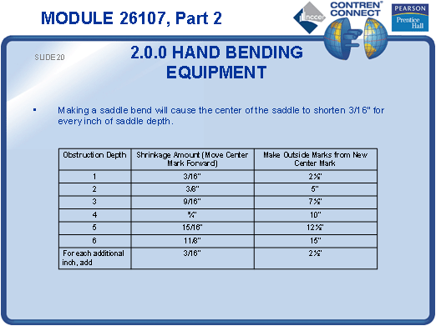
SLIDE 21
  - Measure and mark a section of ½" EMT at the locations where the three bends will take place.
  - Show the students how to place the bender and make the bends.
  - Have each student create a three-bend saddle.
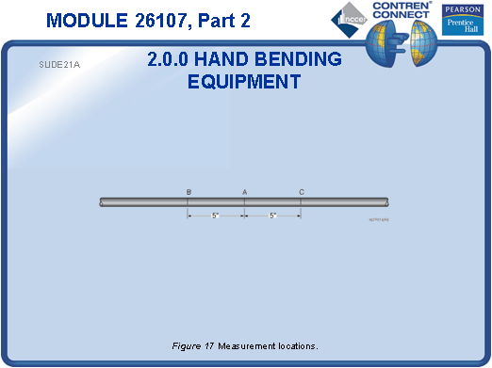
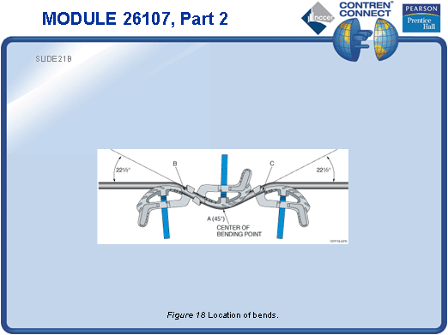
SLIDE 22
  - Use a 6" x 8" block of wood to demonstrate that a three-bend saddle won’t work to clear a large obstruction.
  - Explain to the students that two 30° back-to-back offsets will be used to create the four-bend saddle needed to clear the obstacle.
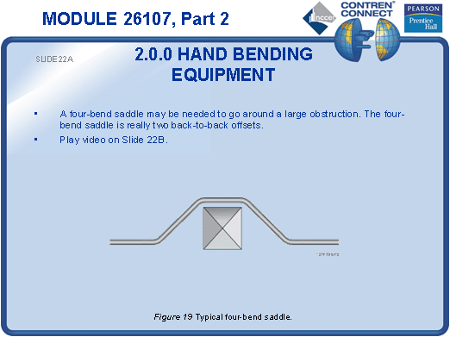
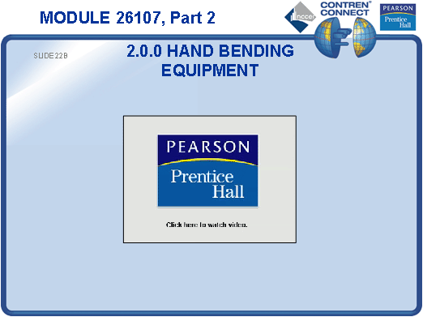
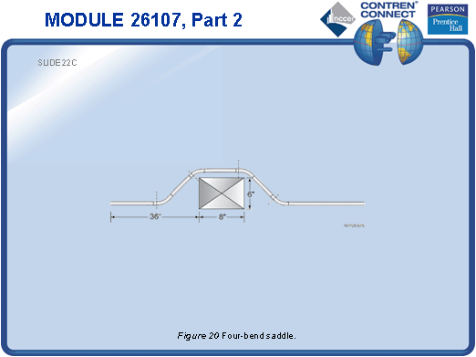
SLIDE 23
  - Show the students how to measure and mark the ½" EMT in preparation for making a four-bend saddle to clear the 6" x 8" obstacle.
  - Demonstrate the four bends in the proper sequence.
  - Have each student complete a four-bend saddle in a piece of ½" EMT.
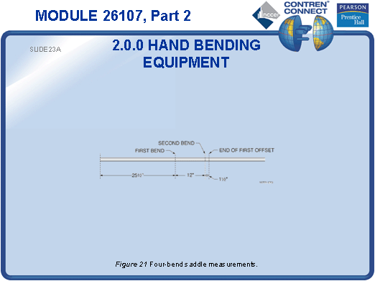
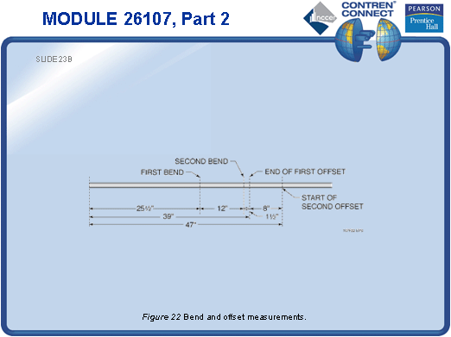
TESTING and PERFORMANCE
- Have the students answer Review Questions 7 and 8 for Sections 2.5.0 through 2.8.0. Provide correct answers and remediation at the end of the quiz.
- Students must make an acceptable offset, a three-bend saddle, and a four-bend saddle in a section of ½" EMT using a hand bender. This can be done during the presentation of Slides 13, 21, and 23 or at the end of the lesson. This partially satisfies Performance Task 1.

