Module 26107-08
Hand Bending
Lesson 3 of 3: Cutting, Reaming, and Threading Conduit
This lesson is a classroom and lab session in which the students will learn how to cut, ream, and thread conduit. Metallic conduit connections are very important for two reasons: 1) they connect conduit to form an integrated raceway system in which conductors are installed, and 2) they provide a low-resistance electrical path back to the source of electricity for any current that may flow due to a short circuit or ground fault condition. For these reasons, cutting, reaming, threading, and connecting metal conduit play important roles in safe work practices for the electrical trades.
Objectives
Upon completion of this lesson, the student should be able to:
- Select the proper cutting tool and cut rigid metal conduit (RMC).
- Safely ream RMC.
- Thread RMC.
- Cut and connect PVC conduit.
Performance Requirements
  - Cut, ream, and thread conduit.
This task satisfies Performance Task 2.
Reading Assignment
  - Module 26107, Sections 3.0.0 thru 3.5.0
Slide Presentation
  - Module 26107, Part 3 (Slides 24 thru 29)
Suggested Equipment/Materials
  - Appropriate personal protective equipment
  - Sufficient sections of ½" or ¾" RMC
  - Sufficient sections of ½" or ¾" PVC conduit
  - Sufficient number of ½" or ¾" PVC couplings
  - Hacksaw
  - Sufficient hacksaw blades (32 teeth/inch and 24 teeth/inch)
  - Pipe cutter
  - ½" or ¾" pipe die with ratchet handle
  - Thread cutting oil
  - Thread gauge
  - Pipe vise
  - Tape measure
  - Marker
  - Pipe reamer
  - Half-round file
  - PVC cement
  - Rags
Suggested Student Activity
  - Visit a local construction site to observe the cutting, threading, and installation of rigid conduit.
Testing
  - Module Review Questions 9 and 10
  - Module 26107-08 Exam
Suggested Lab Activities
  - Students should cut EMT using different hacksaw blades. Use Performance Project 26107-3, Compare Cutting EMT Conduit Using 24 Teeth/Inch Hacksaw Blade versus 32 Teeth/Inch Hacksaw Blade.
  - Students must cut RMC with a pipe cutter.
  - Students must use a hand reamer to ream RMC.
  - Students must thread RMC using a hand die set.
  - Students should cut and connect PVC conduit.
Additional Resources
  - Tom Henry’s Conduit Bending Package. Winter Park, FL: Code Electrical Classes, Inc.
  - Performance Projects: Job Sheets for the Electrical Industry, Level One, New York: Prentice Hall.
  - Contren Connect Electrical 1 Annotated Instructors Guide (available from NCCER).
SLIDE 24
  - Review the objectives to be covered in this lesson. Ask the students if they have any questions.
  - Emphasize safe work practices (safety glasses/goggles and gloves).
  - Demonstrate how to properly install a hacksaw blade, with the teeth slanting forward.
  - Demonstrate how to cut RMC using a hacksaw.
  - Have students cut RMC first using a hacksaw with a 32 teeth/inch blade and then a 24 teeth/inch blade. Discuss their findings.
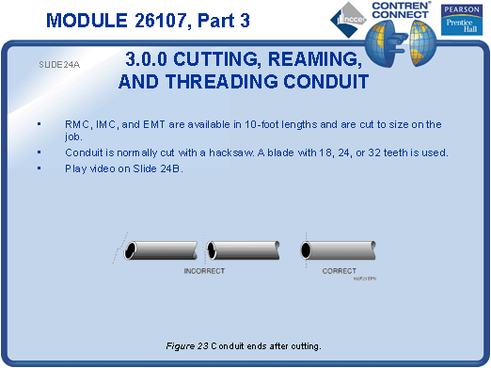
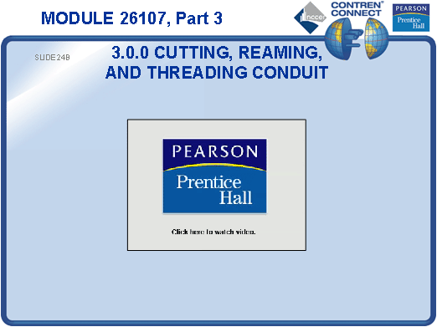
SLIDE 25
  - Demonstrate how to use a pipe cutter to cut RMC. Point out that it is important to oil the threader.
  - Have the students secure RMC in a pipe vise and cut it using a pipe cutter.
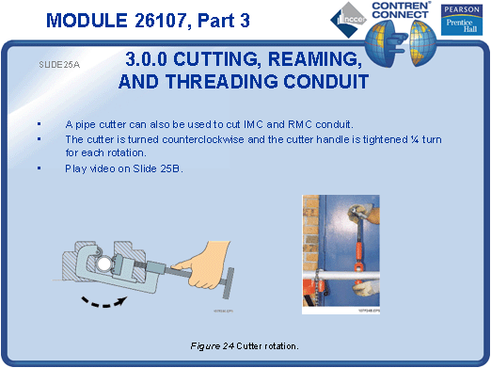
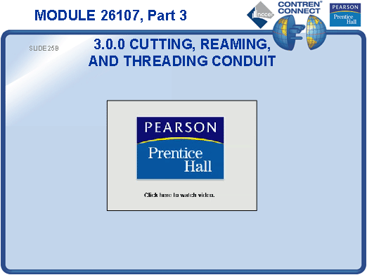
SLIDE 26
  - Emphasize the potential hazards associated with using a spiral-cut pipe reamer on rotating pipe.
  - Demonstrate how to ream RMC using a hand reamer.
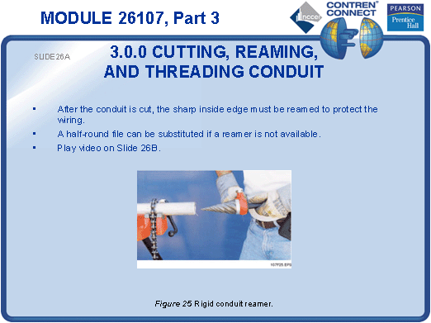
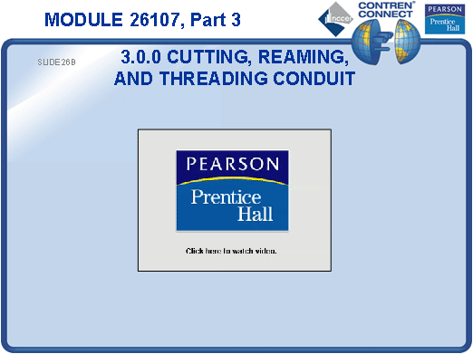
SLIDE 27
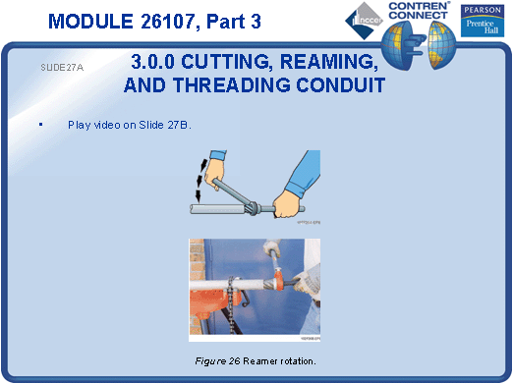
  - Have the students hand ream RMC.

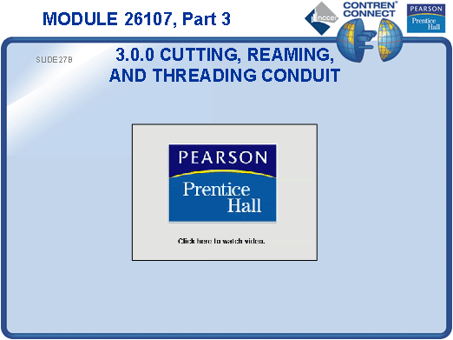
SLIDE 28
  - Demonstrate safe RMC threading.
  - Have each student thread at least one end of RMC.
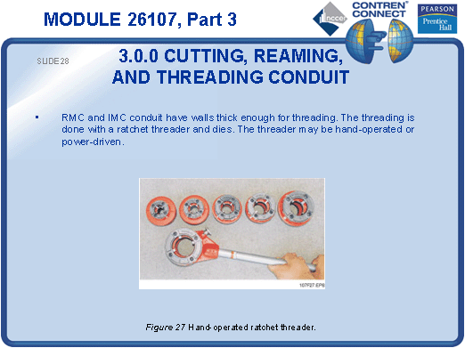
SLIDE 29
  - Demonstrate how to cut and join PVC conduit.
  - Have each student cut and join two pieces of PVC conduit.
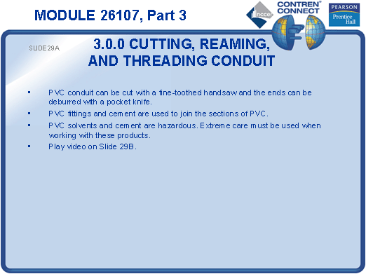
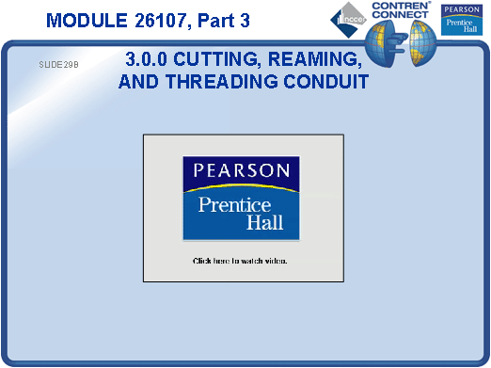
TESTING and PERFORMANCE
- Have the students answer Review Questions 9 and 10 for Sections 3.0.0 through 3.5.0. Provide correct answers and remediation at the end of the quiz.
- Have the students complete the Trade Terms Quiz.
- Students must cut, ream, and thread conduit. This can be done during the presentation of Slides 25, 26, and 28 or at the end of the lesson. This satisfies Performance Task 2.
- Administer the Module Exam.

