Module 26109-08
Conductors
Lesson 1 of 2: Conductors and Insulation
This lesson is a classroom session in which the students will be introduced to the various types of conductors and learn how conductors are rated by the National Electrical Code® (NEC®).
Objectives
Upon completion of this lesson, the student should be able to:
- Explain the various sizes and gauges of wire in accordance with American Wire Gauge standards.
- Identify insulation and jacket types according to conditions and applications.
- Describe voltage ratings of conductors and cables.
- Read and identify markings on conductors and cables.
- Use the tables in the NEC® to determine the ampacity of a conductor.
- State the advantage of stranded wire.
- State the advantage of compressed conductors.
- Describe the different materials from which conductors are made.
- Describe the different types of conductor insulation.
- Describe the color coding of insulation.
- Describe instrumentation control wiring.
Performance Requirements
  - None
Reading Assignment
  - Module 26109, Sections 1.0.0 thru 2.7.3
Slide Presentation
  - Module 26109, Part 1 (Slides 1 thru 24)
Suggested Equipment/Materials
  - Variety of solid wire conductors
  - Variety of stranded cables
  - Channel wire assemblies
  - Instrumentation control wiring
Suggested Student Activity
  - Have the students use the NEC® to identify the different types of conductors and cables used in various settings.
Testing
  - Module Review Questions 1 – 17
  - CONTREN Connect Active Figures 5, 7, 13, and 14
Suggested Lab Activities
  - Provide the students with various types of cable and have them use the jacket markings to identify as much information as possible about each type.
Additional Resources
  - National Electrical Code® Handbook, Latest Edition. Quincy, MA: National Fire Protection Association.
  - Contren Connect Electrical 1 Annotated Instructors Guide (available from NCCER).
SLIDE 1
  - Review the objectives to be covered in this module. Ask the students if they have any questions.
  - Explain that students must obtain a score of 70% on the Module Exam and perform certain tasks to the satisfaction of the instructor to receive credit for the module.
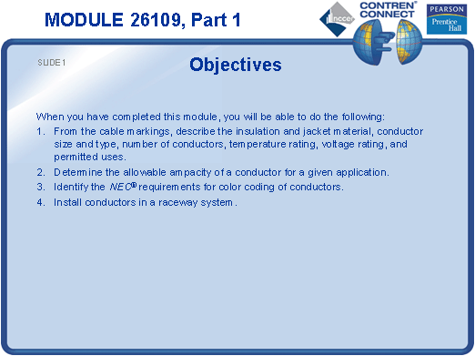
SLIDE 2
  - Emphasize the importance of proper conductor selection.
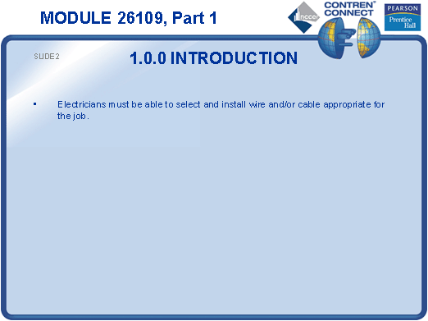
SLIDE 3
  - Discuss the American Wire Gauge system.
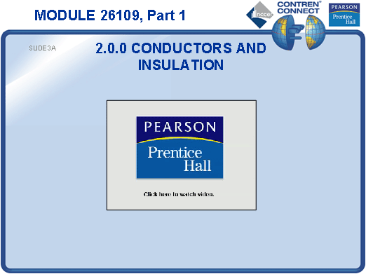
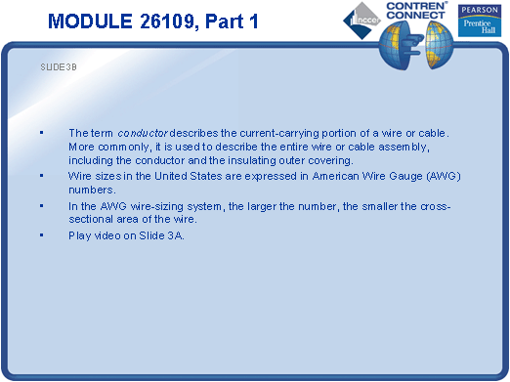
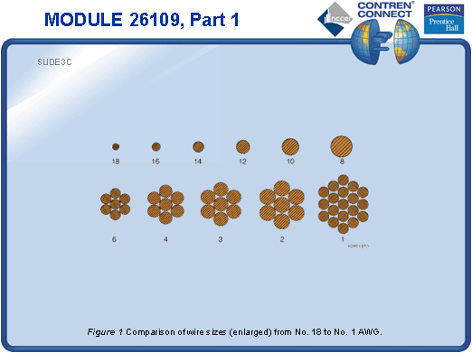
SLIDE 4
  - Pass around examples of various sizes of conductors and have the students interpret the insulation markings.
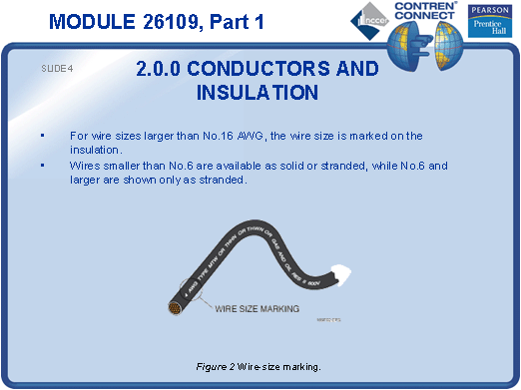
SLIDE 5
  - Show examples of common strand configurations.
  - Compare and contrast stranded and solid conductors.
  - Explain that stranding increases the flexibility of a cable.
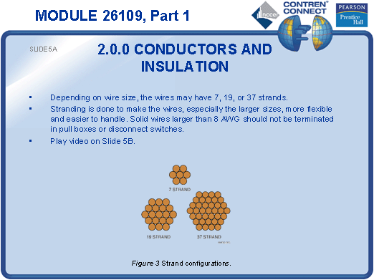
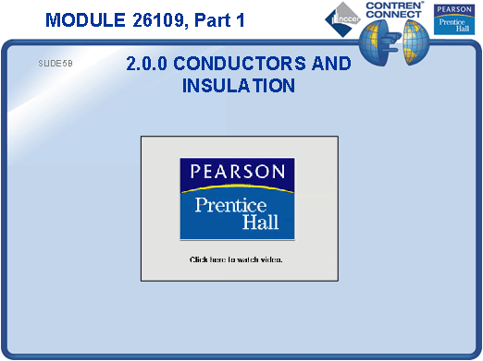
SLIDE 6
  - Define circular mil.
  - Explain that reducing the air space between strands of conductors reduces the overall diameter of the cable.
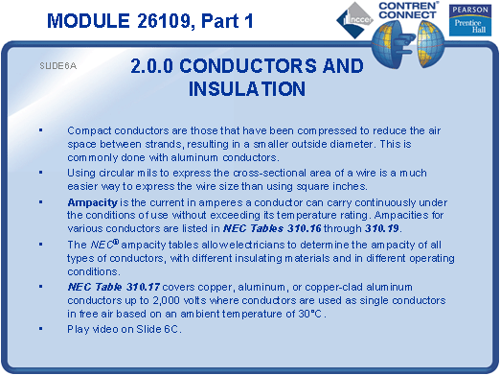
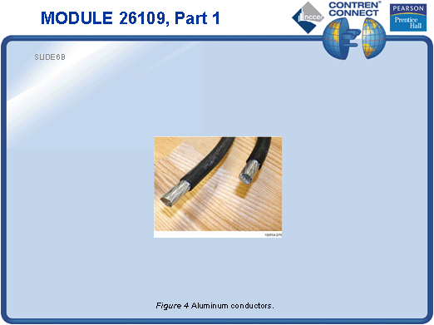
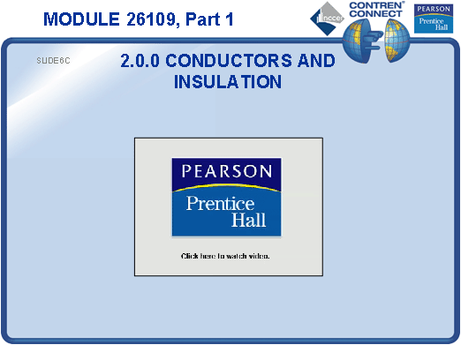
SLIDE 7
  - Discuss the factors of conductivity, cost, availability, and workability in the selection of conductor material.
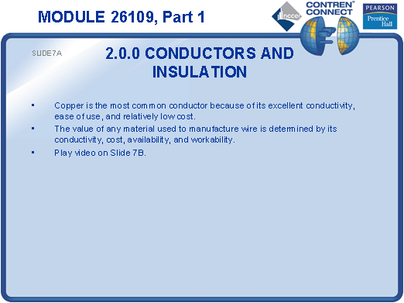
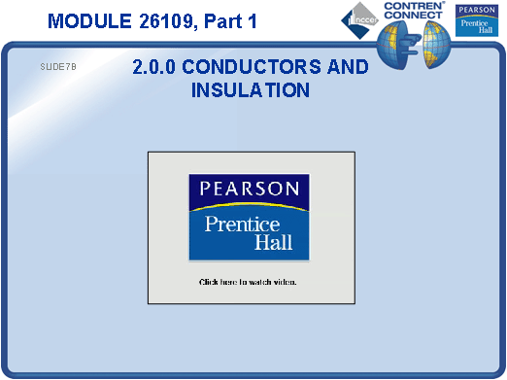
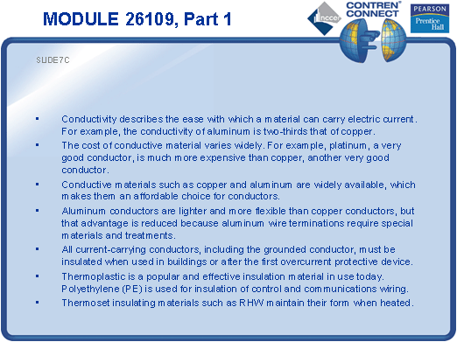
SLIDE 8
  - Discuss insulation letter codes and their definitions.
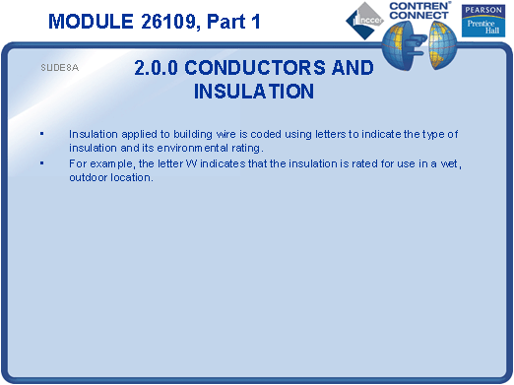
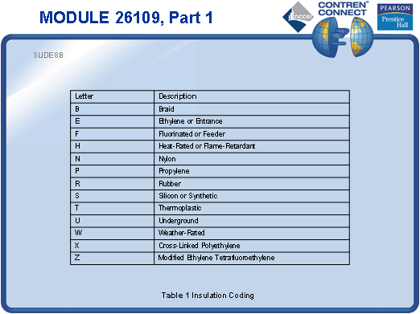
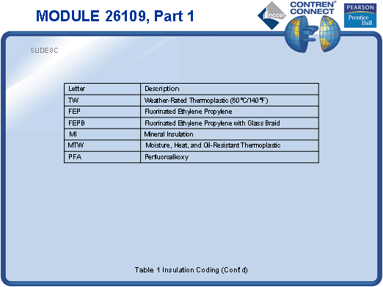
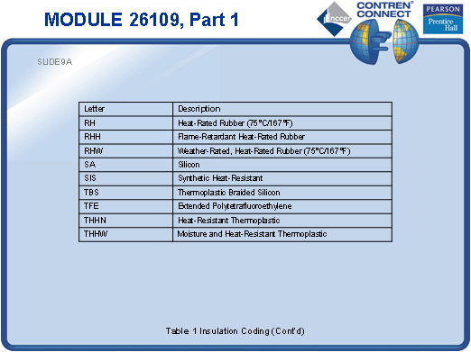
SLIDE 9
  - No notes

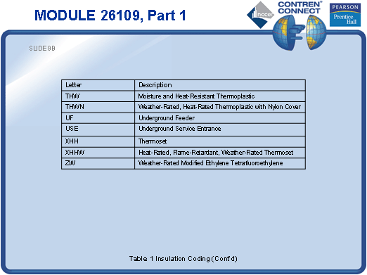
SLIDE 10
  - Discuss insulation color codes.

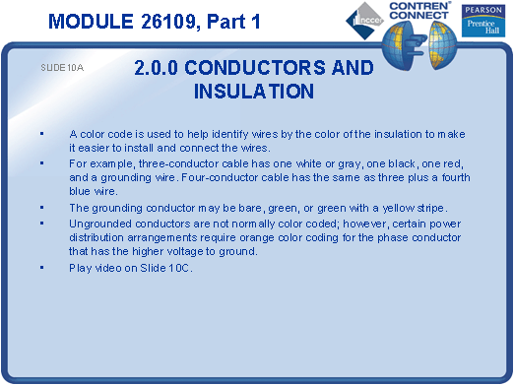
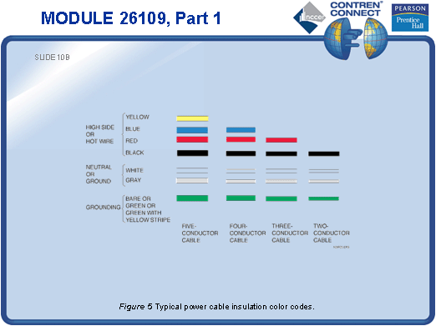
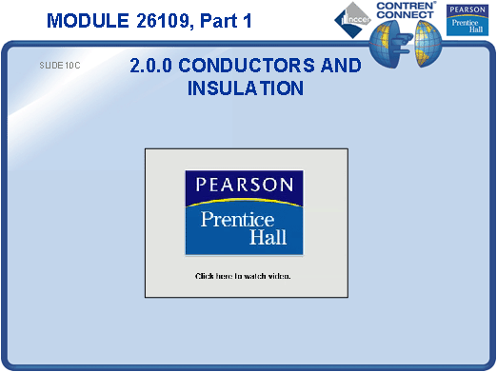
SLIDE 11
  - Point out the requirements for fixture wire in NEC Article 402.
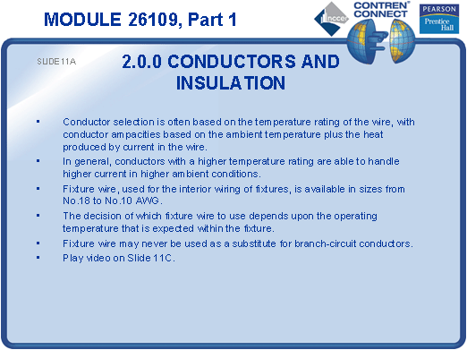
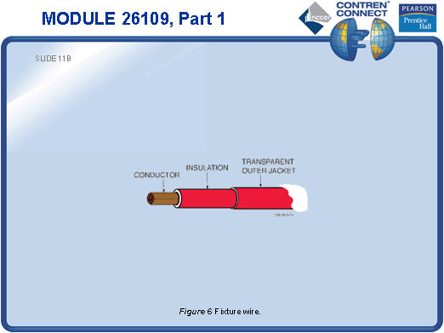
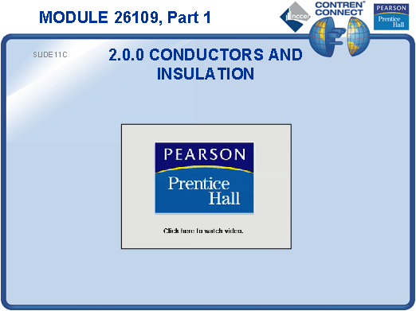
SLIDE 12
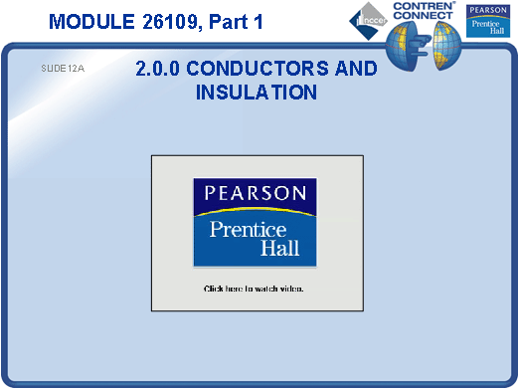
  - Discuss the use of NM cable and provide an example for the students to examine.

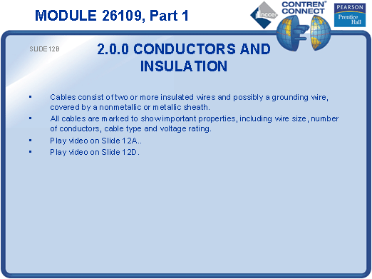
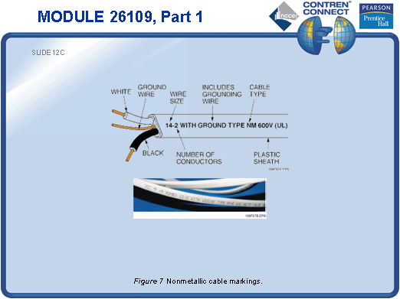
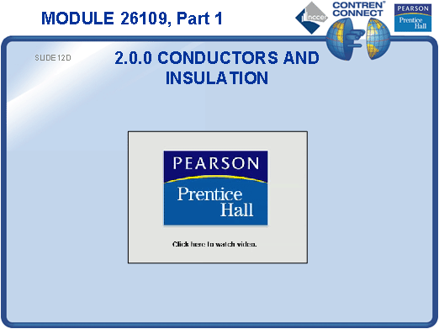
SLIDE 13
  - Explain the difference between NM and NMC.
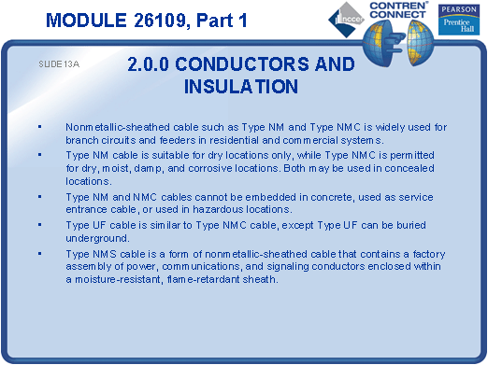
  - Discuss UF cable and its applications. Provide an example for the students to examine.

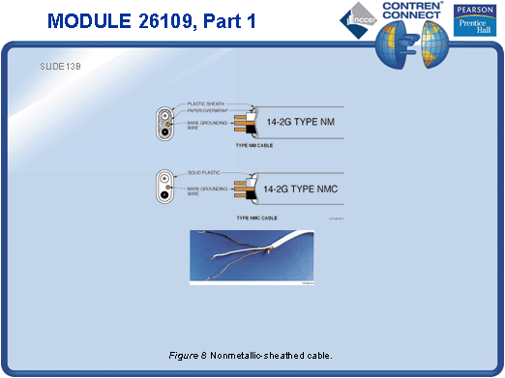
SLIDE 14
  - Discuss MV cable and its applications. Provide an example for the students to examine.

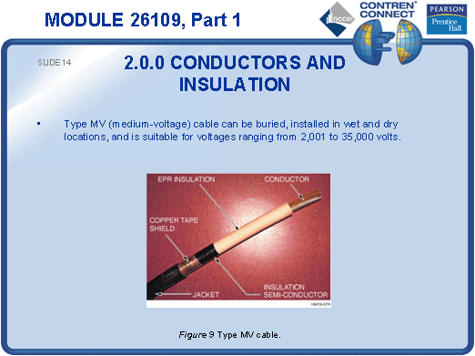
SLIDE 15
  - Discuss MC cable and its applications. Provide an example for the students to examine.
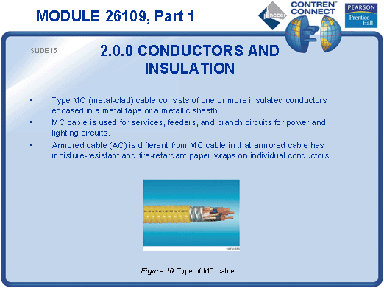
SLIDE 16
  - Discuss high-voltage cable and its applications. Provide an example for the students to examine.
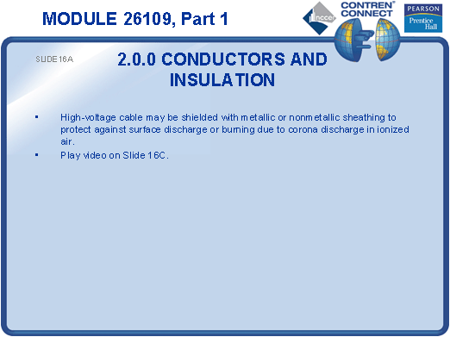
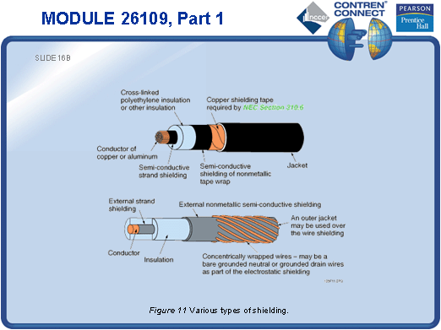
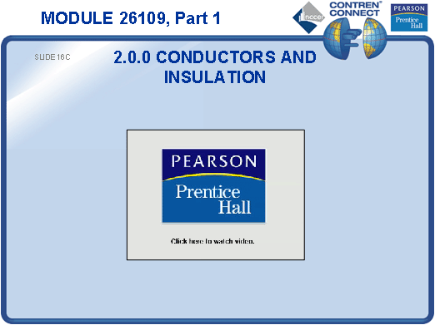
SLIDE 17
  - Note that care must be taken not to damage the shield when installing cable with high-voltage shielding. Slight nicks or cuts can cause serious power disruptions and endanger life.
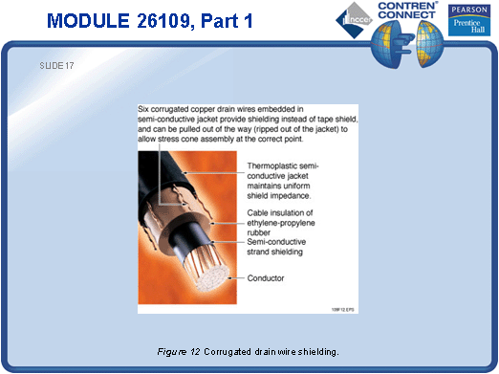
SLIDE 18
- Explain how channel wire assemblies are installed. Provide examples for the students to examine.
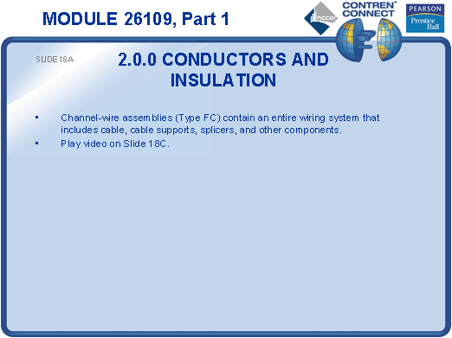
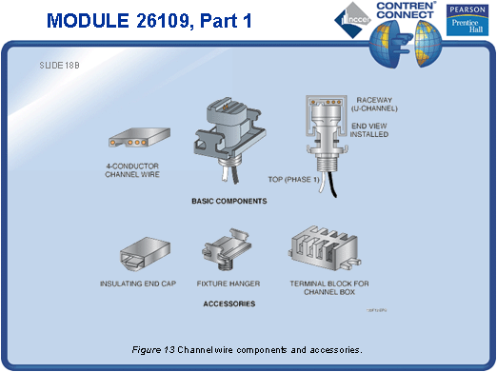
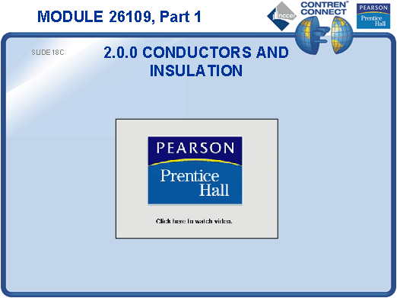
SLIDE 19
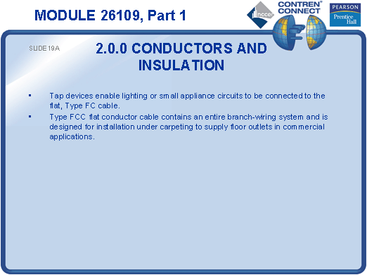
- Discuss flat conductor cable and its applications. Provide an example for the students to examine.

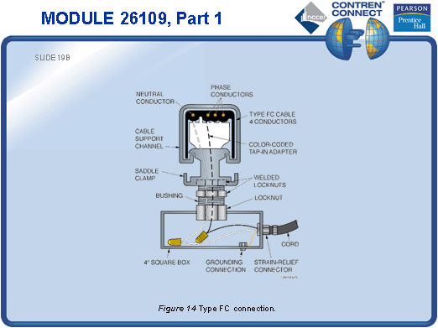
SLIDE 20
- Discuss TC cable and its applications. Provide an example for the students to examine.
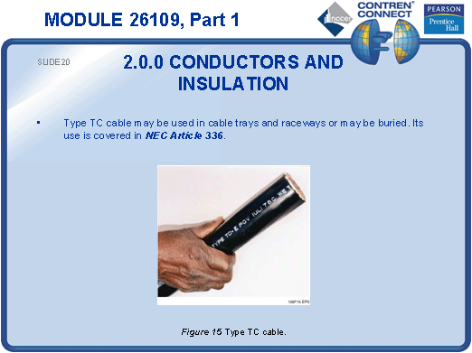

SLIDE 21
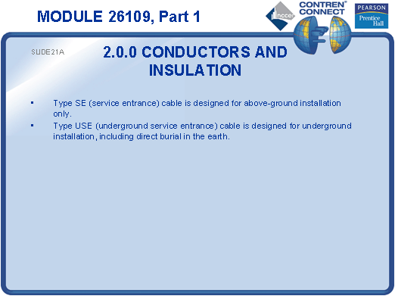
- Explain the difference between SE and USE cable. Provide examples for the students to examine.

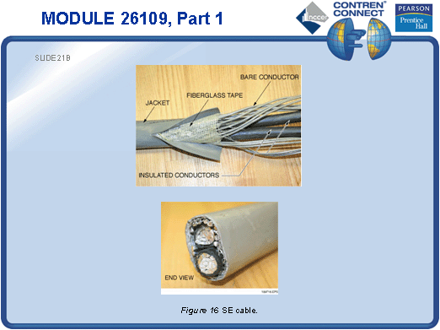
SLIDE 22
- Discuss pairing and multi-pair instrumentation cable. Provide an example for the students to examine.
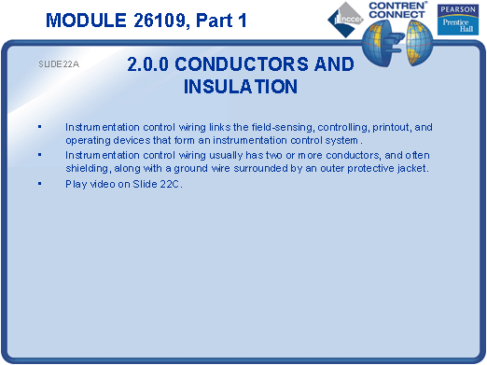
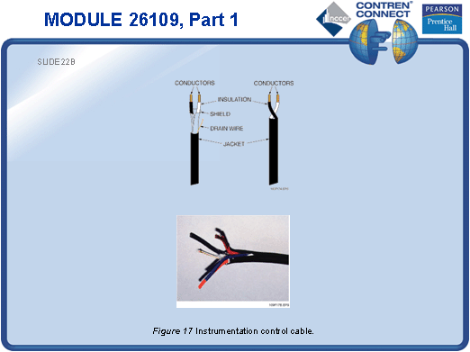
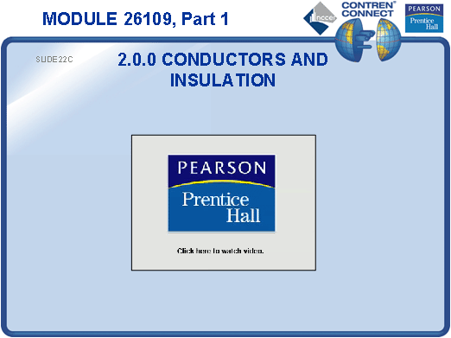
SLIDE 23
- Note that instrumentation connections are highly sensitive to slight variations in voltage and resistance. Discuss shielding, drain wire, and shield grounding connections.
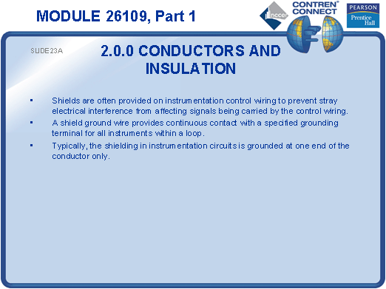
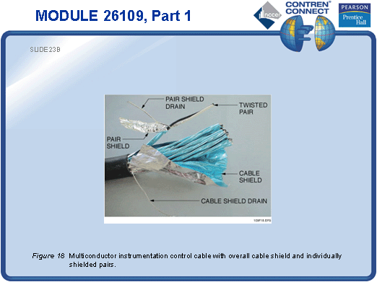
SLIDE 24
- Explain the function of plastic jacketing.
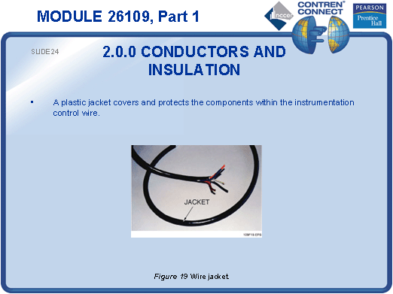
TESTING and PERFORMANCE
- Have the students complete Active Figures 5, 7, 13, and 14.
- Have the students answer Review Questions 1 – 17 for Sections 1.0.0 – 2.7.3. Provide correct answers and remediation at the end of the quiz.

