Module 26111-08
Wiring Residential
Lesson 1 of 4: Residential Load Calculation
This lesson is a classroom session in which the student will learn the basic process for calculating a service load for a residence. In this exercise, the students will learn to apply the principles for calculating lighting, appliance, and other loads, applying demand factors as defined by the NEC®, and sizing the neutral conductors.
Objectives
Upon completion of this lesson, the student should be able to:
- Describe how to determine electric service requirements for dwellings.
- Calculate loads for lighting, appliances, and heating.
- Apply demand factors based on NEC® requirements.
- Perform a residential load calculation as regulated by the NEC®.
- Size a neutral conductor for a single-family residential application based on load factors.
Performance Requirements
- For a residential dwelling of a given size, and equipped with a given list of major appliances, demonstrate or explain how to compute the lighting, small appliance, and laundry loads; compute the loads for large appliances; determine the number of branch circuits required; and size and select the service-entrance equipment (conductors, panelboard, and protective devices). This task satisfies module Performance Task 1.
Reading Assignment
  - Module 26111, Sections 1.0.0 thru 3.0.0
Slide Presentation
  - Module 26111, Part 1 (Slides 1 thru 8)
Suggested Equipment/Materials
  - Calculator
  - Load calculation worksheets
Suggested Student Activities
- Have the students visit a home under construction in which the wiring has been roughed-in to observe how branch circuits are routed to the service panel.
Testing
  - Module Review Question 1
Suggested Lab Activities
  - Have the students practice calculating residential loads. Use Performance Project 26111-1, Calculate a Residential Load.
- Have the students visit www.electricalknowledge.com for an interactive load calculator for a single-family dwelling.
Additional Resources
http://www.electricalknowledge.com/SFDLoadCalc.asp
  - Performance Projects: Job Sheets for the Electrical Industry, Level One, New York: Prentice Hall.
  - Contren Connect Electrical 1 Annotated Instructors Guide (available from NCCER).
SLIDE 1
  - Review the objectives to be covered in this module. Ask the students if they have any questions.
  - Explain that students must obtain a score of 70% on the Module Exam and perform certain tasks to the satisfaction of the instructor to receive credit for the module.
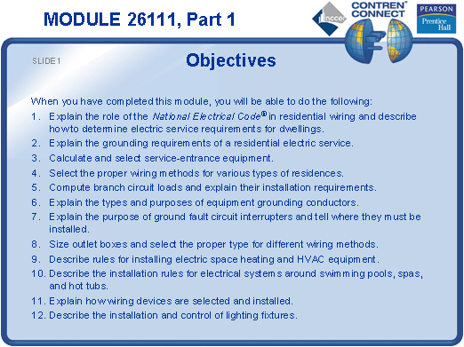
SLIDE 2
- Emphasize the importance of careful load calculations.
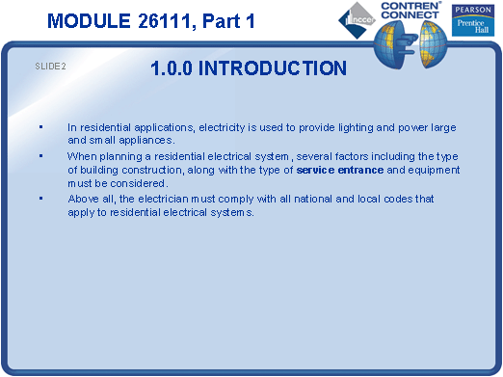
SLIDE 3
- Point out that the number of outlets must be determined before sizing the service.
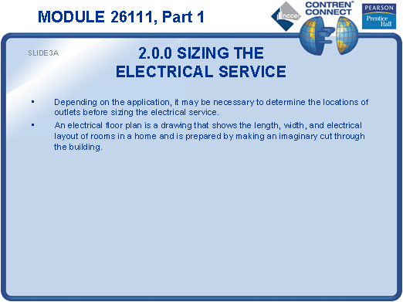

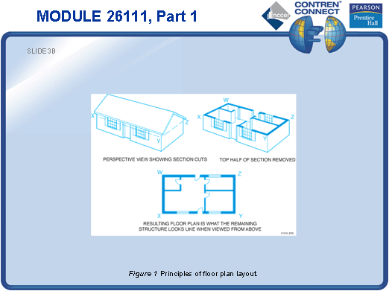
SLIDE 4
- Hand out copies of Figure 2 and have the students mark their suggested locations for 110V and 220V outlets.
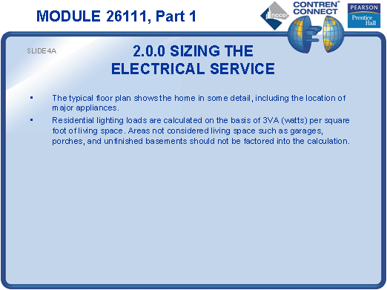

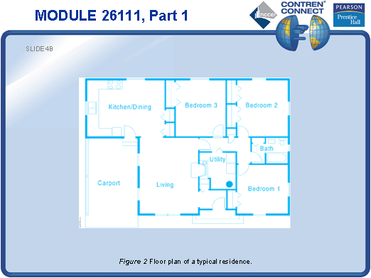
SLIDE 5
- Hand out blank load calculation sheets or have the students use Figure 3 in the text.
- Discuss each step of the load calculation process as you progress through the next few slides.
- Explain why the demand factor for lighting is used and show how it is applied.
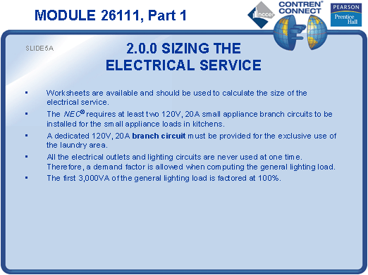

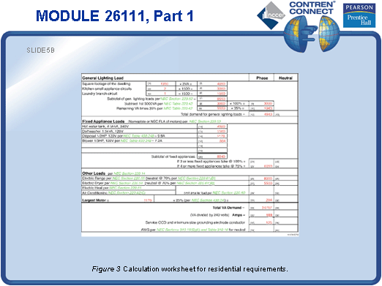
SLIDE 6
- Add the loads for fixed appliances.
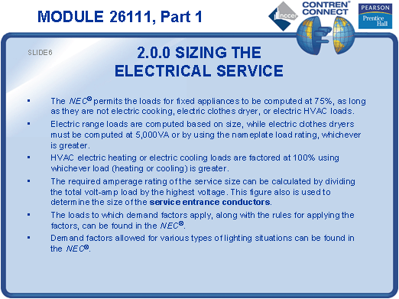
SLIDE 7
- Explain why the feeder loads are added to the laundry room branch circuits.
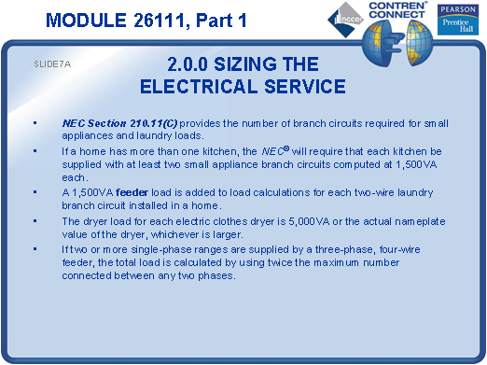

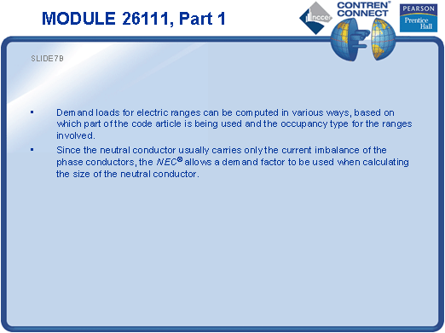
SLIDE 8
- Explain how to calculate the size of the neutral conductor for the sample residence, and how to apply demand factors to the calculation.
- Review the completed load calculation form and answer any questions the students may have.
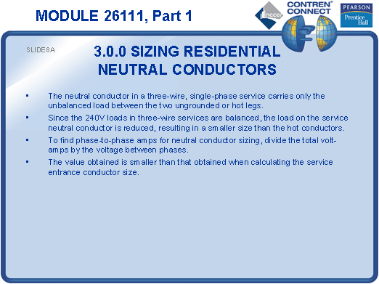

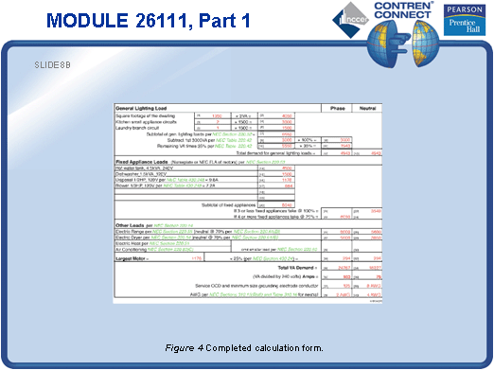
TESTING and PERFORMANCE
- Have the students complete Review Question 1 for Sections 1.0.0 – 3.0.0. Provide the correct answer and remediation at the end of the quiz.
- Have the students demonstrate how to perform a residential load calculation, including computing the lighting, small appliance, and laundry loads; computing the loads for large appliances; determining the number of branch circuits required; and sizing and selecting the service-entrance equipment (conductors, panelboard, and protective devices). This can be done during the presentation of Slides 4 thru 8 or at the end of the lesson. This corresponds to Performance Task 1.

