Module 26111-08
Wiring Residential
Lesson 2 of 4: Sizing and Laying Out an Electrical Service
This lesson is a classroom session in which the students will learn about sizing a residential load center to determine the requirements for overcurrent protection. In addition, the lesson covers the requirements for the use of GFCIs, as well as the requirements for grounding and bonding of electrical services and installation of grounding electrodes. Also covered are the requirements for installation of a residential service entrance and location of the panelboard.
Objectives
Upon completion of this lesson, the student should be able to:
1. Describe how to determine electric service requirements for dwellings.
2. Explain the grounding requirements of a residential electric service.
3. Explain the role of the National Electrical Code® in residential wiring.
4. Compute branch circuit loads and explain their installation requirements.
5. State the requirements for installing a residential service entrance.
Performance Requirements
- None
Reading Assignment
  - Module 26111, Sections 4.0.0 thru 7.0.0
Slide Presentation
  - Module 26111, Part 2 (Slides 9 thru 25)
Suggested Equipment/Materials
  - GFCI circuit breakers and receptacles
  - Plot plan showing the location of the electrical service
Suggested Student Activities
- Have the students report on the details of the service provided at their homes, including the service drop or underground power entrance, panelboard size, approximate clearances, etc.
Testing
- Module Review Questions 2 thru 4
- CONTREN Connect Active Figure 11
Suggested Lab Activities
- None
Additional Resources
- http://www.electricalknowledge.com/SFDLoadCalc.asp
- The Household Circuit, New York: Prentice Hall.
- Contren Connect Electrical 1 Annotated Instructors Guide (available from NCCER).
SLIDE 9
  - Review the objectives to be covered in this lesson. Ask the students if they have any questions.
  - Explain how to calculate the general lighting load of a residence.
  - Provide an example of the method used to determine the number of spaces required on a panelboard.
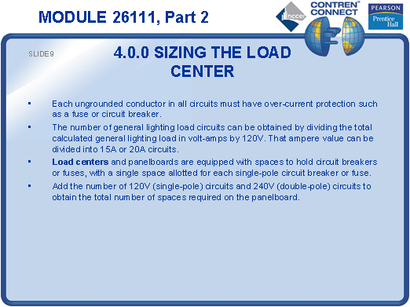
SLIDE 10
- Ask the students to list all the locations in a house that require GFCI protection.
- Describe how a basic GFCI works.
- Show the students a GFCI and allow them to examine it.
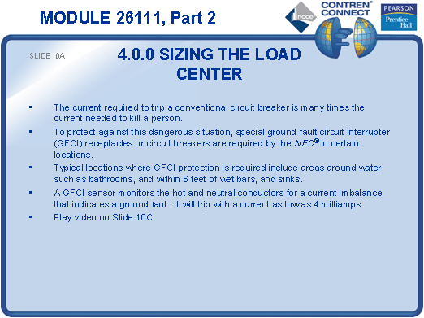
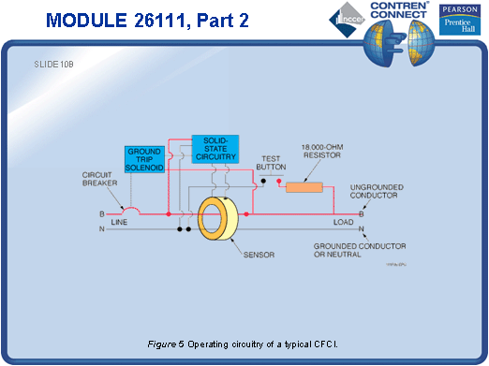
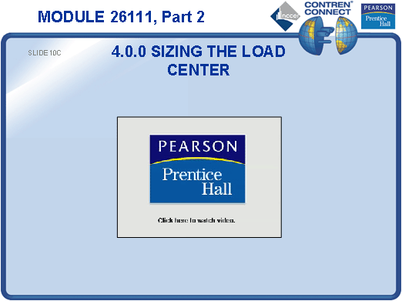
SLIDE 11
- Describe the operation of a two-pole GFCI.
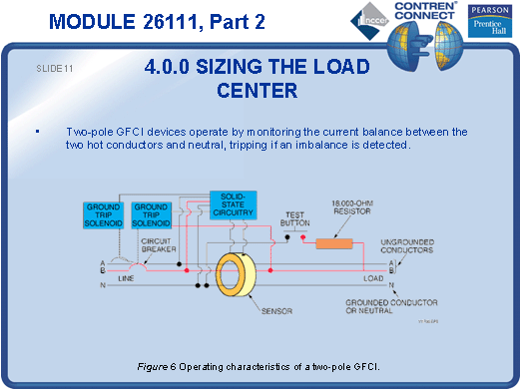
SLIDE 12
- Explain the difference between a single-pole GFCI and a two-pole GFCI.
- Discuss the conditions in which a single-pole GFCI would be used.
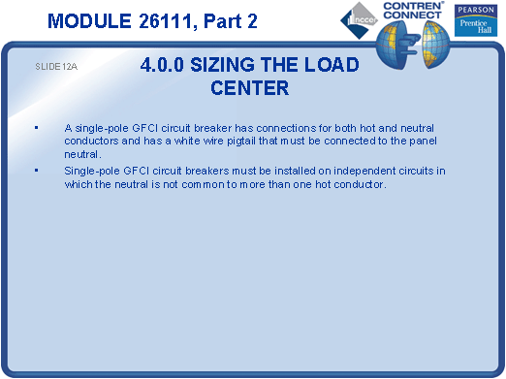

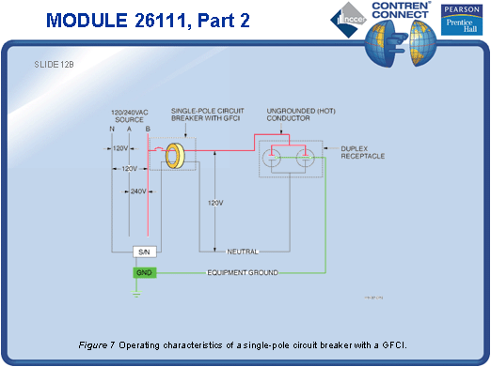
SLIDE 13
- Explain how a two-pole GFCI solves the problem of nuisance trips when using two single-pole GFCIs with a common neutral.
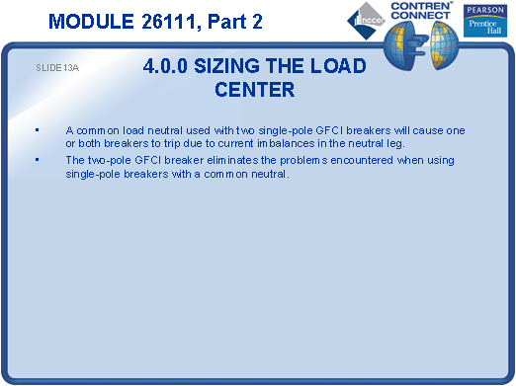

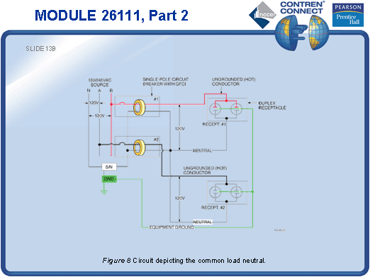
SLIDE 14
- Explain that it is common to protect several outlets with a single GFCI, and describe how the circuit works.
- Point out that if a given outlet is not working, it could be caused by a GFCI elsewhere in the house that needs to be reset.
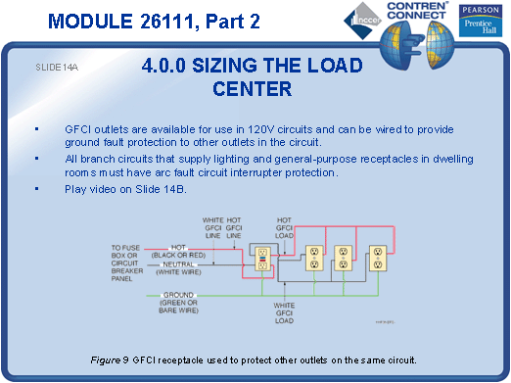

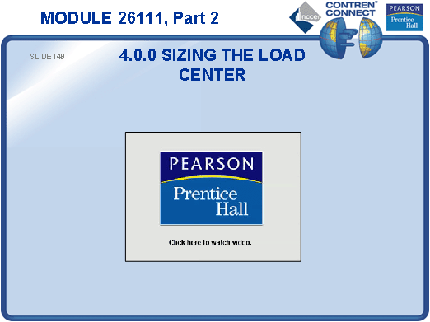
SLIDE 15
- Explain the difference between a grounded conductor and a grounding electrode conductor.
- Explain why a grounded neutral conductor may be smaller than an ungrounded conductor.
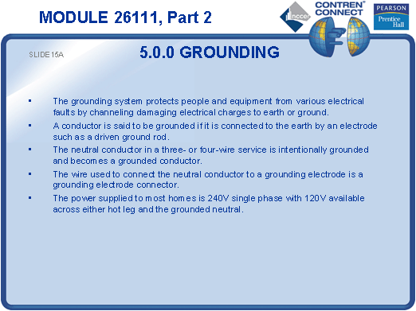
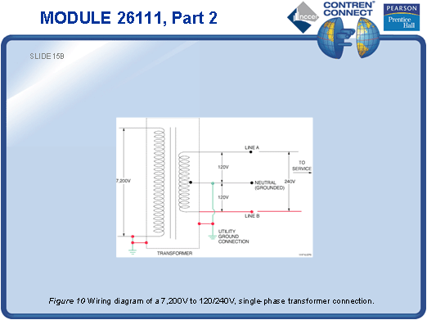
SLIDE 16
- Point out the ground and the grounded neutral in the panelboard.
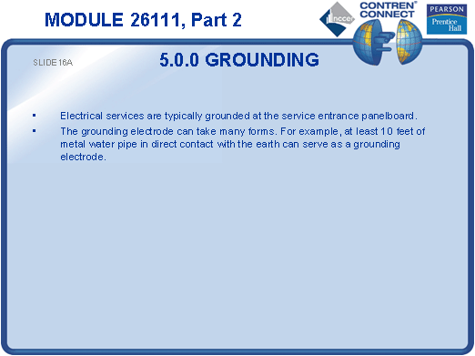
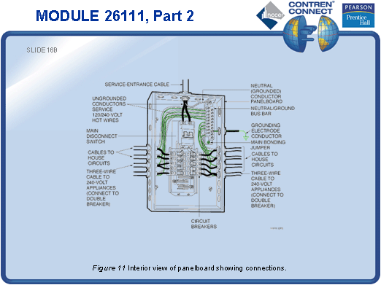
SLIDE 17
- Discuss the requirements for the installation of grounding electrodes.
- Refer the students to NEC Sections 250.52 and 250.53 to study the requirements for grounding electrodes
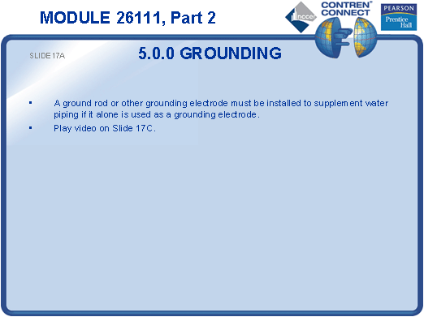
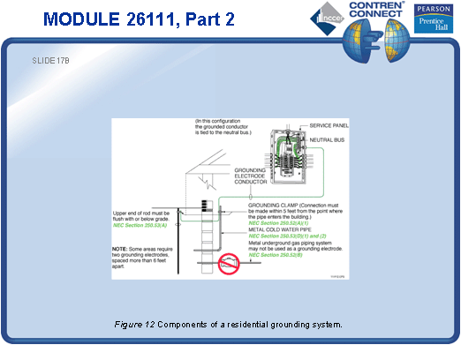
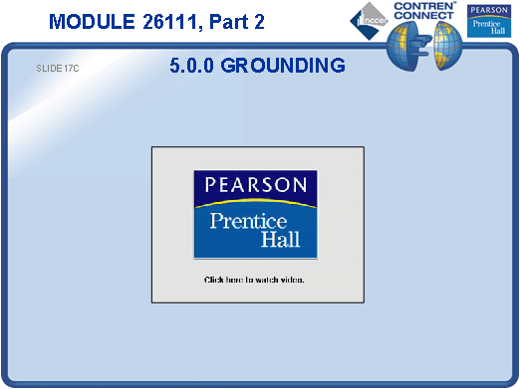
SLIDE 18
- Discuss the materials commonly used to make ground rods.
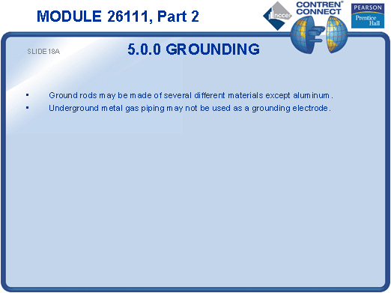
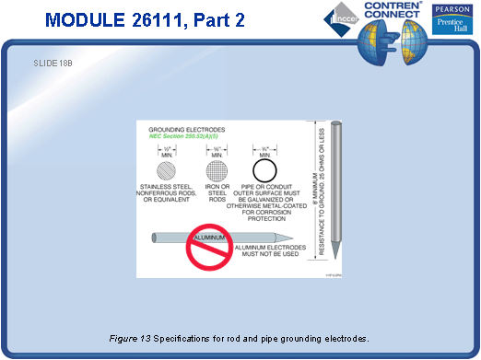
SLIDE 19
- Discuss the requirements for grounding electrodes.
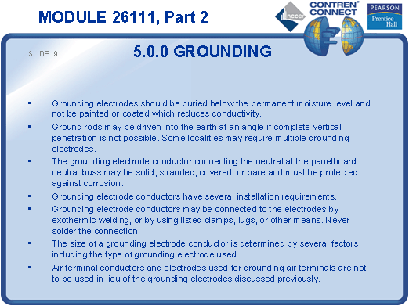
SLIDE 20
- Discuss bonding jumpers and bonding bushings.
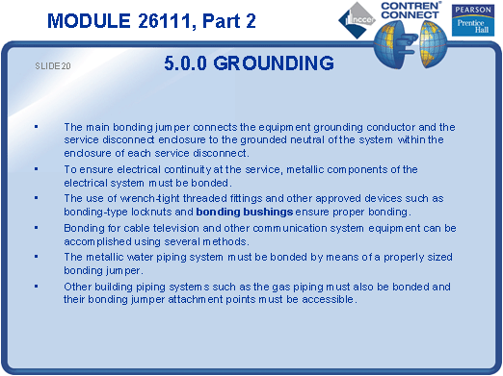
SLIDE 21
- Explain how to find the service drop location on a plot plan.
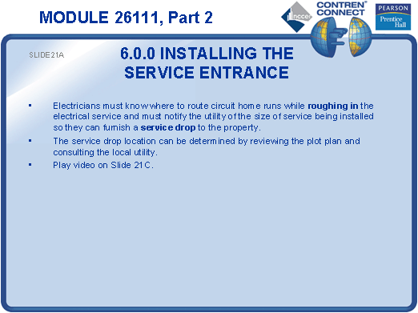
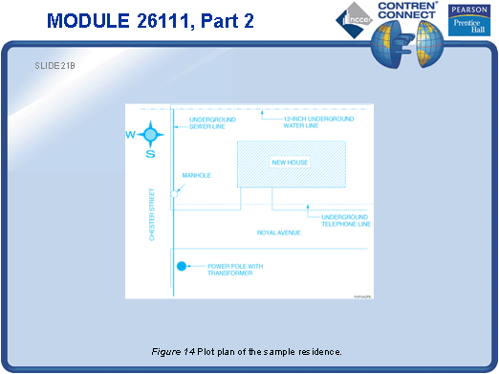
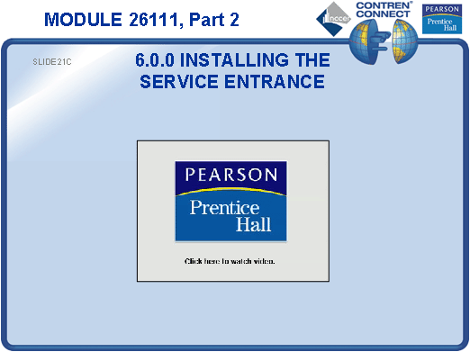
SLIDE 22
- Discuss the requirements for the installation of a service mast.
- Refer the students to NEC Sections 230.24 and 230.28 to study these requirements.
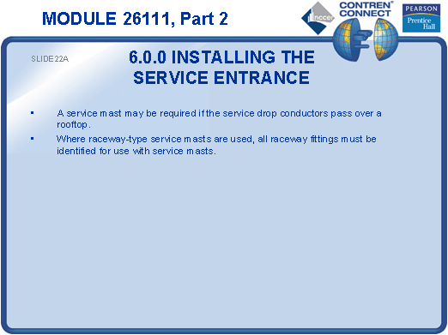
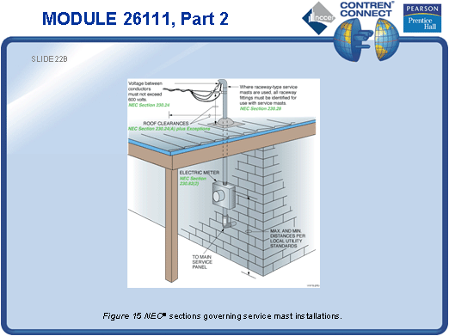
SLIDE 23
- Discuss the clearance requirements for service conductors.
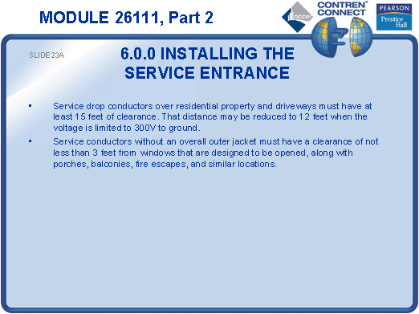
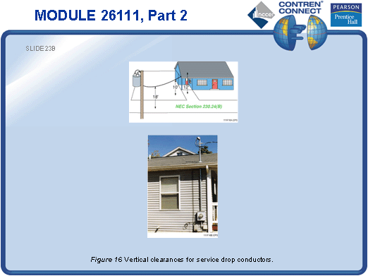
SLIDE 24
- Discuss the NEC® requirements for locating the service disconnect and panelboard.
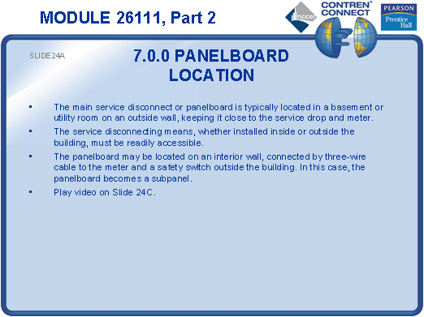
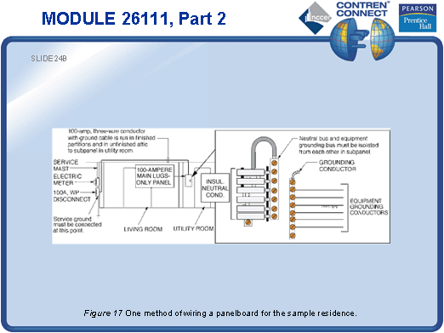
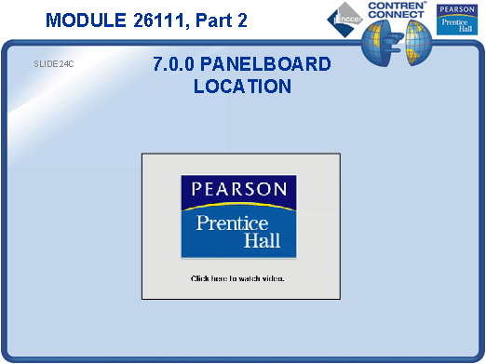
SLIDE 25
- Discuss the requirements for an underground service.
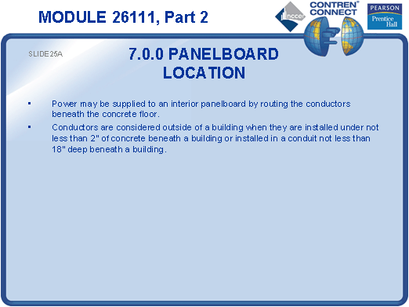
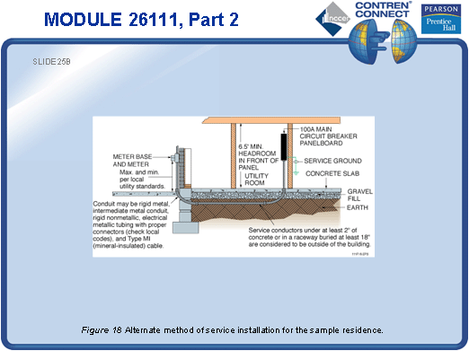
TESTING and PERFORMANCE
- Have the students complete CONTREN Connect Active Figure 11.
- Have the students complete Review Questions 2 – 4 for Sections 4.0.0 – 7.0.0. Provide correct answers and remediation at the end of the quiz.

