Module 26111-08
Wiring Residential
Lesson 3 of 4: Residential Wiring and Grounding Requirements
This lesson is a classroom and lab session in which the student will learn wiring and grounding methods and the layout of branch circuits for power and lighting.
Objectives
Upon completion of this lesson, the student should be able to:
1. Identify various types of electrical cable used in residential wiring.
2. State the permitted applications and limitations for each type of cable.
3. Explain the grounding requirements of a residential electric service.
4. Interpret the symbols used on drawings for various types of receptacles.
5. Explain the correct methods for wiring power and lighting branch circuits.
Performance Requirements
- Using an unlabeled diagram of a panelboard (Performance Profile Sheet 3), label the lettered components. This task satisfies module Performance Task 2.
Reading Assignment
  - Module 26111, Sections 8.0.0 thru 11.0.0
Slide Presentation
  - Module 26111, Part 3 (Slides 26 thru 43)
Suggested Equipment/Materials
  - Examples of cable, including type NM, AC, UF, SE/USE
  - Range receptacle
  - Examples of plugs used with special circuits
Suggested Student Activities
- Have the students check the layout of outlets in their home to see if they meet the requirements of NEC Section 210.52.
Testing
  - Module Review Questions 5 thru 14
  - CONTREN Connect Active Figures 20 and 25
Suggested Lab Activities
- Have the students install and connect a branch circuit in a panelboard. Use Performance Project 26111-2, Install and Connect a Branch Circuit in a Panelboard.
- Have the students visit www.applianceaid.com for tips on wiring appliance branch circuits.
Additional Resources
- Performance Projects: Job Sheets for the Electrical Industry, Level One, New York: Prentice Hall.
- The Household Circuit, New York: Prentice Hall.
- Contren Connect Electrical 1 Annotated Instructors Guide (available from NCCER).
SLIDE 26
- Review the objectives to be covered in this lesson. Ask the students if they have any questions.
- Show students a sample of Type NM cable and allow them to examine it.
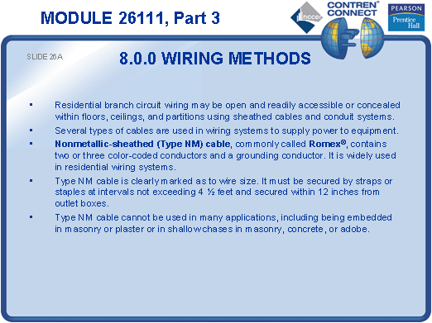
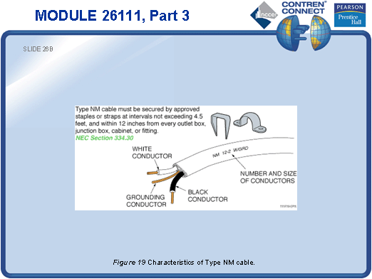
SLIDE 27
- Have a class discussion on the applications and limitations of NM cable as dictated by the NEC®.
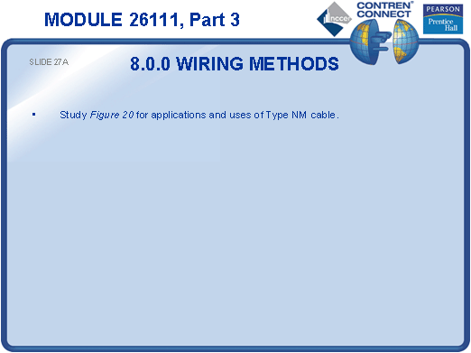
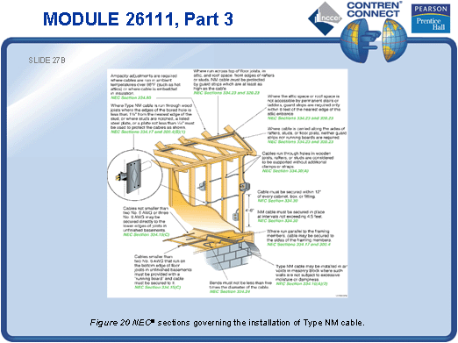
SLIDE 28
- Pass around a length of MC cable for the students to examine.
- Discuss the situations in which MC cable would be used in place of NM cable.
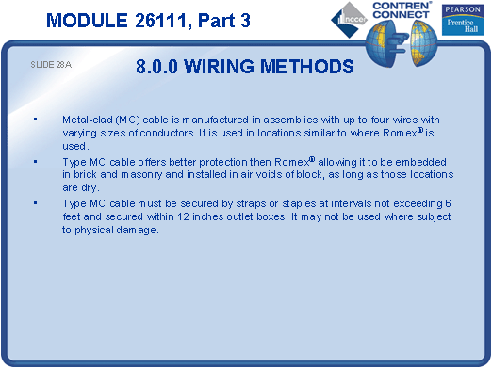
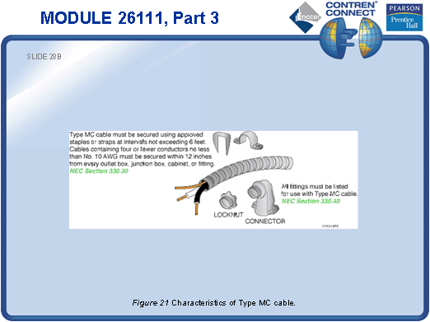
SLIDE 29
- Discuss the NEC® requirements for installing MC cable.

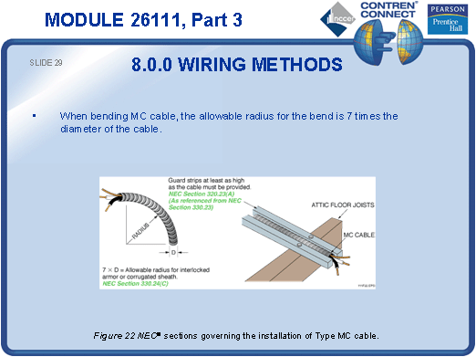
SLIDE 30
- Discuss the different applications for Types UF, SE, and USE cables.
- Ask the students to give examples of situations where these types of cables would be used.

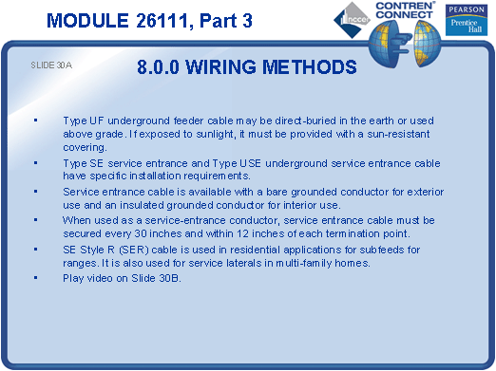
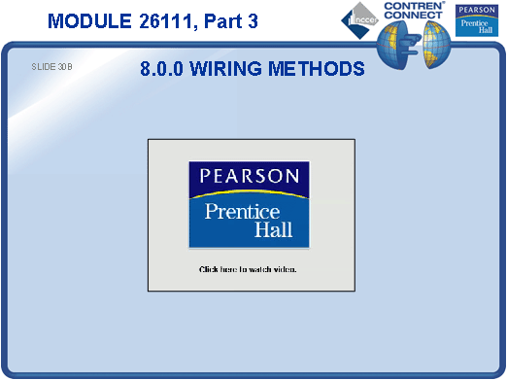
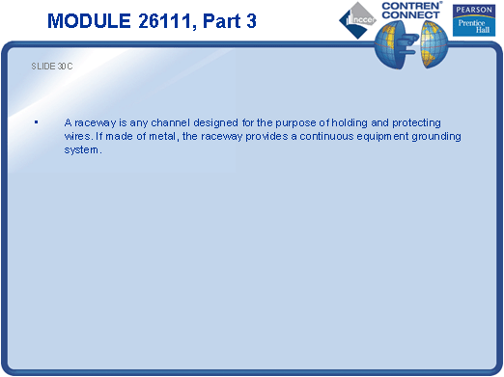
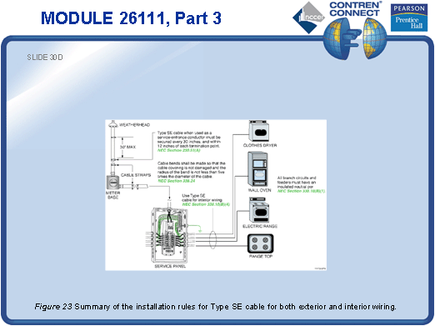
SLIDE 31
- Discuss the types of fittings that can be used for equipment grounding.
- Point out that the NEC® prohibits the use of sheet metal screws for equipment grounding.
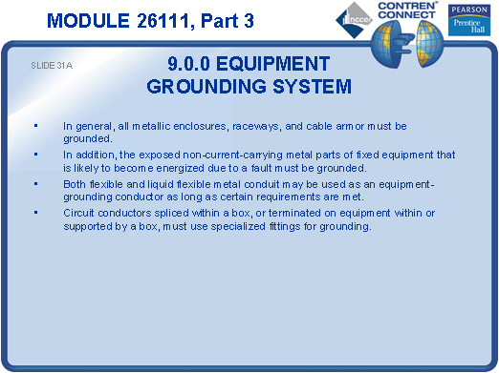
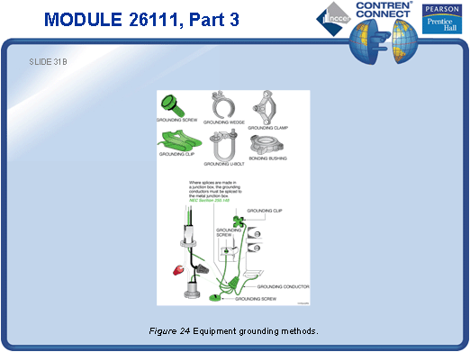
SLIDE 32
- Show common outlet symbols.
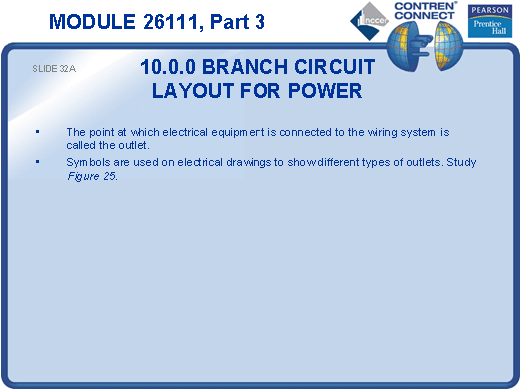
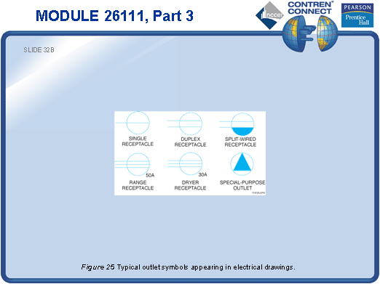
SLIDE 33
- Define branch circuit.
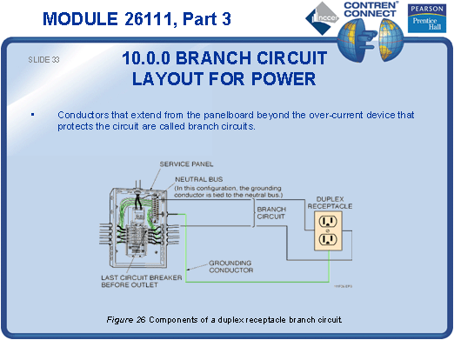
SLIDE 34
- Define feeder.
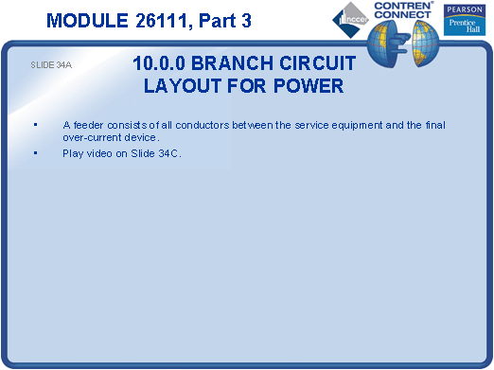
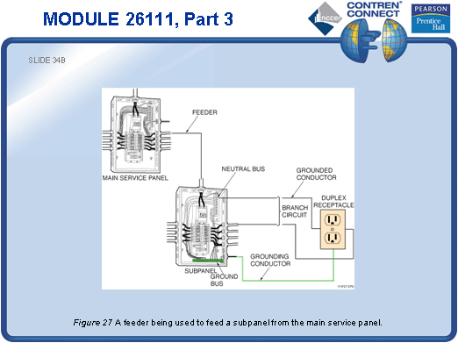
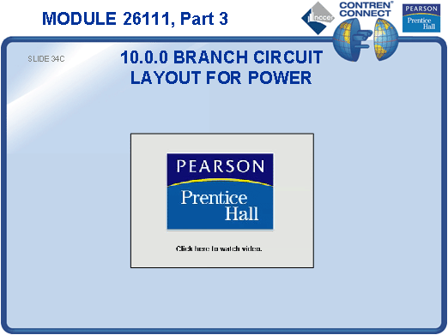
SLIDE 35
- Review common drawing lines used to designate branch circuits.

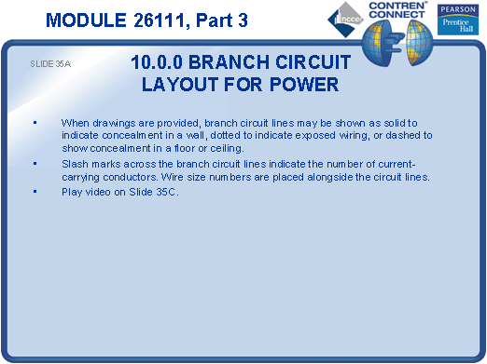
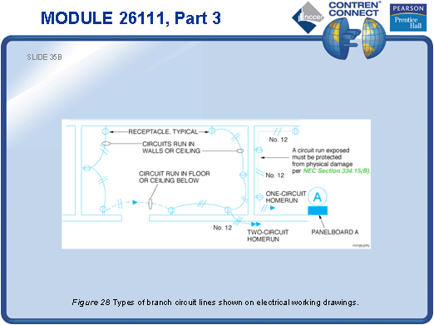
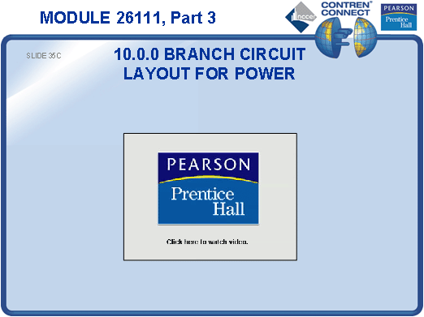
SLIDE 36
- Review the NEC® requirements for locating receptacle outlets.
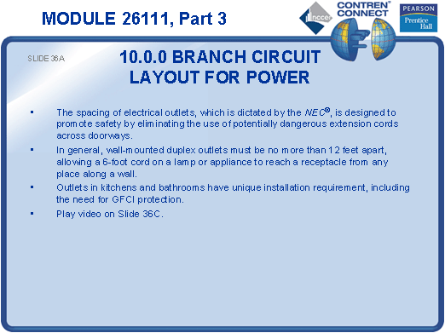
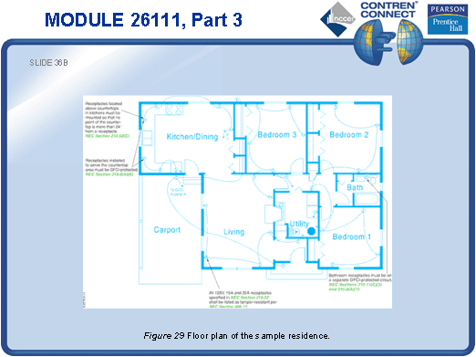
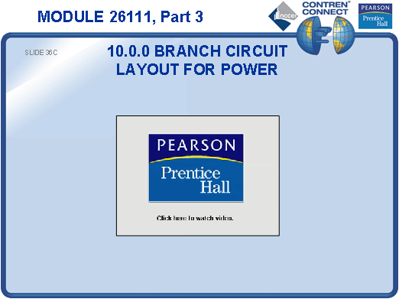
SLIDE 37
- Describe the wiring for a split-wired receptacle.
- Ask the students to identify some applications for split-wired duplex receptacles.
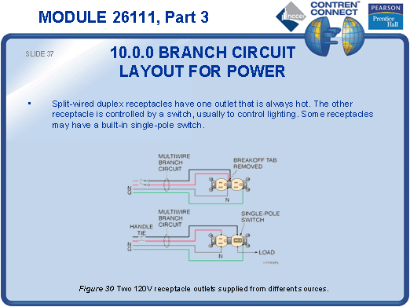
SLIDE 38
- Describe the wiring for a combination receptacle.
- Discuss some applications for these receptacles.
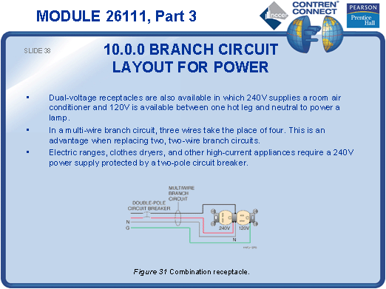
SLIDE 39
- Point out the special requirements for range receptacles. Provide an example for the students to examine.

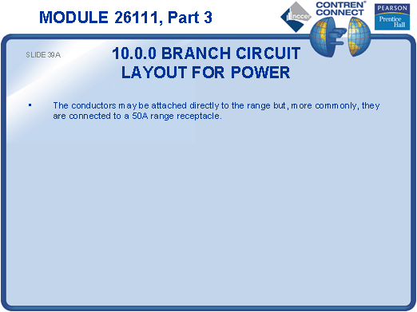
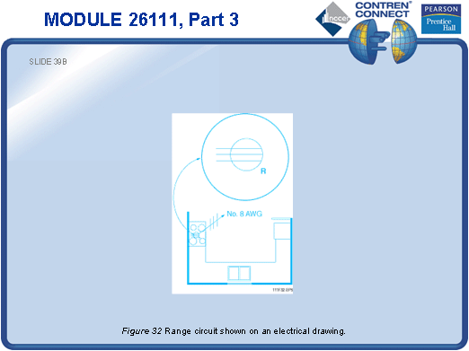
SLIDE 40
- Ask the students to identify possible applications for each type of receptacle
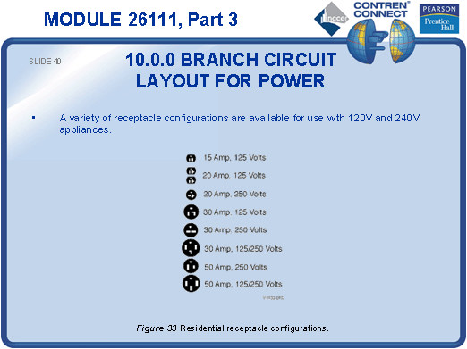
SLIDE 41
- Review the operating sequence for an electric water heater.
- Show how to calculate the branch circuit size for a water heater.
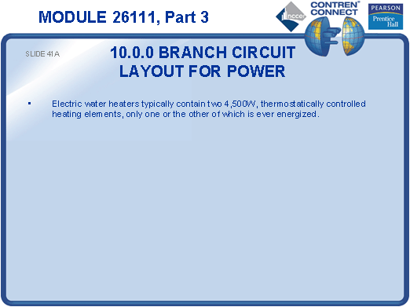
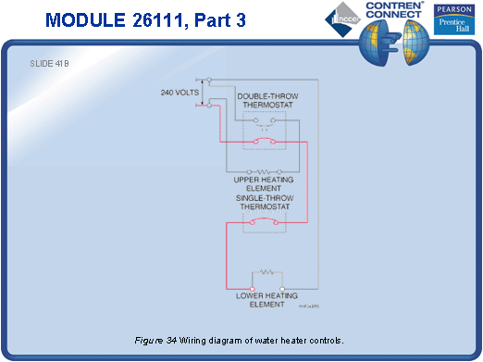
SLIDE 42
- Ask the students to determine how many lighting branch circuits are required for the layout shown in Figure 35.

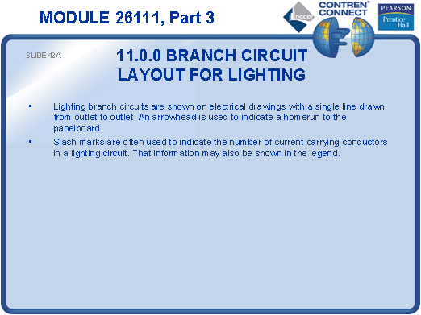
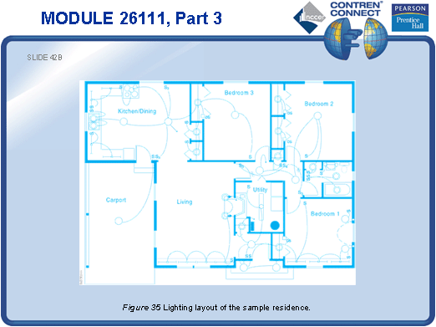
SLIDE 43
- Have the students identify each type of lighting fixture in Figure 35 based on the symbols provided in Figure 36.

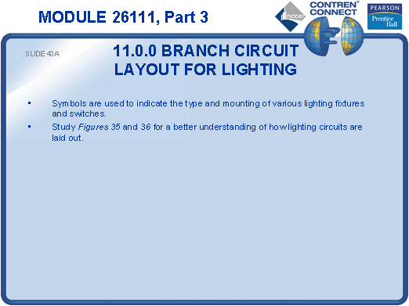
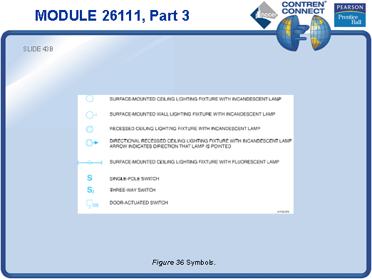
TESTING and PERFORMANCE
- Have the students complete CONTREN Connect Active Figures 20 and 25.
- Have the students complete Review Questions 5 – 14 for Sections 8.0.0 – 11.0.0. Provide correct answers and remediation at the end of the quiz.
- Have the students label the lettered components on an unlabeled diagram of a panelboard (Performance Profile Sheet 3). This corresponds to Performance Task 2.

