Module 26111-08
Wiring Residential
Lesson 4 of 4: Outlet Boxes; Wiring Devices; Lighting Controls; Heating Circuits; Swimming Pools and Spas
This lesson is a classroom and lab session in which the student will learn about the various types of residential outlet boxes, how to select outlet boxes, wiring devices, and lighting controls, as well as methods of wiring lighting control circuits. In addition, students are introduced to the wiring requirements for electric heating, hot tubs, swimming pools, and spas.
Objectives
Upon completion of this lesson, the student should be able to:
- Size outlet boxes and select the proper type for different wiring methods.
- Describe rules for installing electric space heating and HVAC equipment.
- Describe the installation rules for electrical systems around swimming pools, spas, and hot tubs.
- Explain how wiring devices are selected and installed.
- Describe the installation and control of lighting fixtures.
Performance Requirements
- Select the proper type and size outlet box needed for a given set of wiring conditions. This task satisfies module Performance Task 3.
Reading Assignment
  - Module 26111, Sections 12.0.0 thru 16.0.0
Slide Presentation
  - Module 26111, Part 4 (Slides 44 thru 62)
Suggested Equipment/Materials
  - GFCI circuit breakers and receptacles
  - Assortment of metal and plastic outlet boxes
  - Assorted types of electrical receptacles
  - Assortment of switches, including single-pole, three-way, four-way, and dimmer
Suggested Student Activities
- Have the students sketch a schematic of a circuit used to control a lighting fixture from two or more locations.
Testing
  - Module Review Question 15
  - CONTREN Connect Active Figure 40
  - Module 26111-08 Exam
Suggested Lab Activities
- Set up one or more performance test stations. Place a selection of different boxes at the station(s) and number each box. Provide a list of wiring criteria and have the students select the box or boxes that satisfy those criteria. Use Performance Project 26111-3, Select Junction Boxes According to Box Fill Requirements in the NEC®. This corresponds to module Performance Task 3.
- Have the students install various lighting controls. Use Performance Project 26111-4, Installing Single-Pole, Three-Way, and Four-Way Lighting Controls.
Additional Resources
- Performance Projects: Job Sheets for the Electrical Industry, Level One, New York: Prentice Hall.
- The Household Circuit, New York: Prentice Hall.
- Contren Connect Electrical 1 Annotated Instructors Guide (available from NCCER).
SLIDE 44
- Review the objectives to be covered in this lesson. Ask the students if they have any questions.
- Show the students different types of outlet boxes and describe their applications.
- Explain the function of a plaster ring.
- Explain how box fill limits are determined.
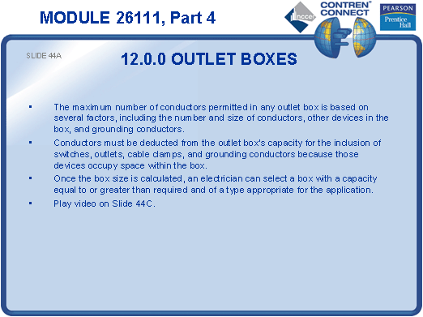
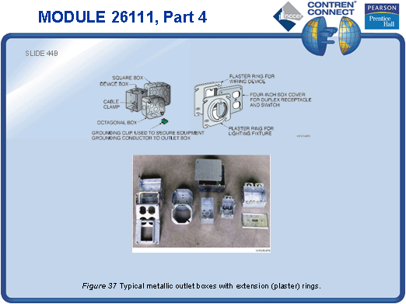
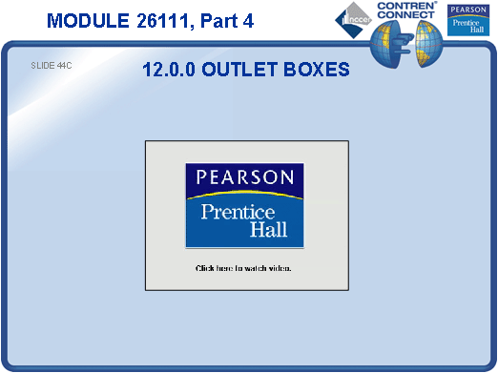
SLIDE 45
- Discuss the methods used to mount metal and nonmetallic outlet boxes.
- Show the students examples of these boxes and their mounting devices.

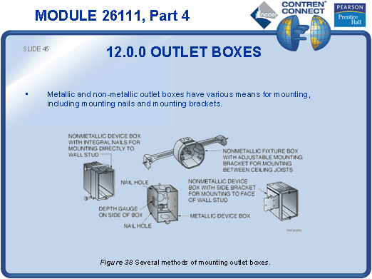
SLIDE 46
- Show the students how to properly locate and install outlet boxes.
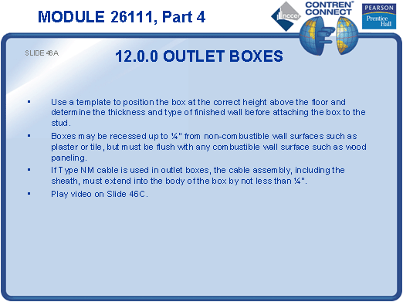
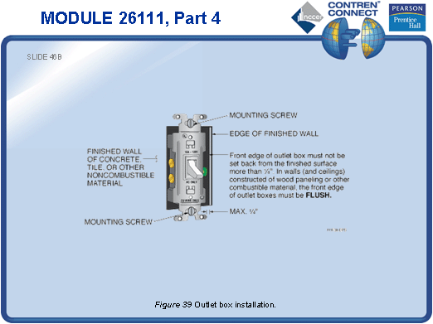
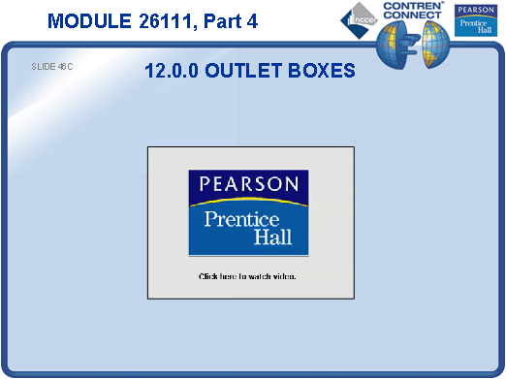
SLIDE 47
- Hand out receptacles so the students can examine them. Point out the various markings on each device.
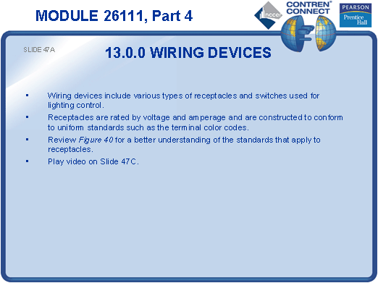
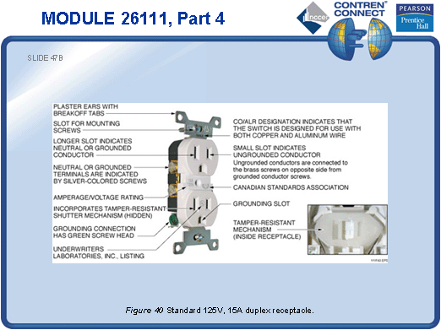
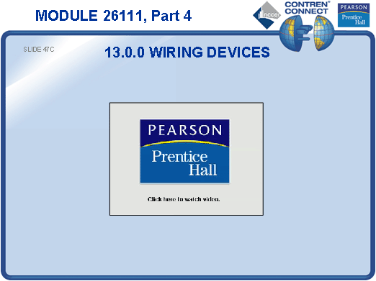
SLIDE 48
- Discuss the different types of lighting control devices and explain how they are wired.

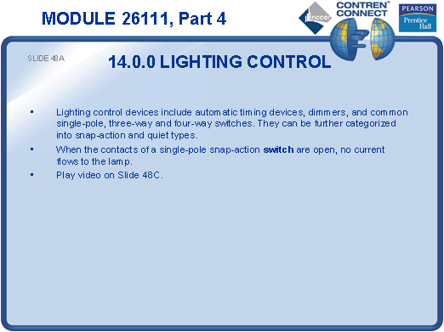
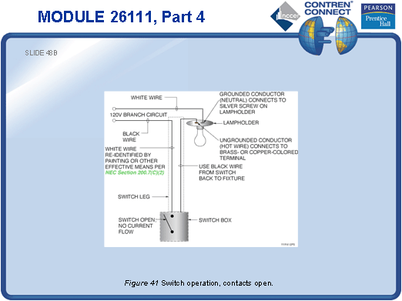
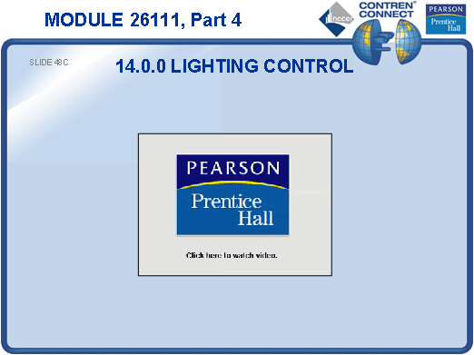
SLIDE 49
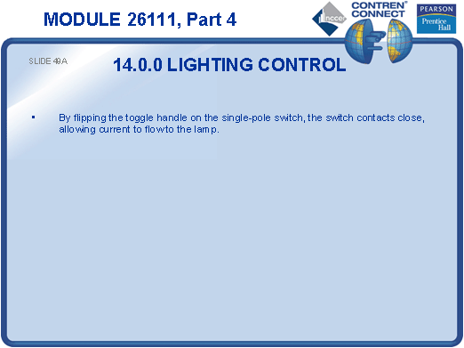
- No notes

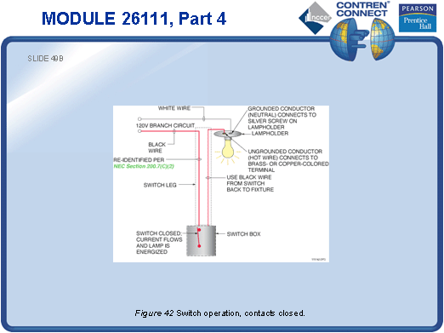
SLIDE 50
- Allow the students to examine snap-action and quiet switches.
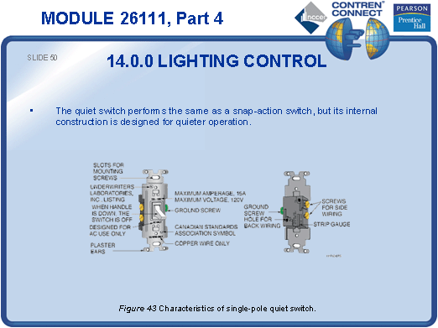
SLIDE 51
- Explain how a three-way switch differs from a common single-pole switch. Draw a schematic of the two switches on the board.

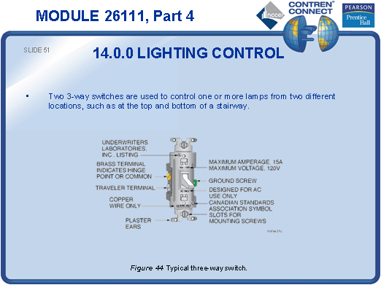
SLIDE 52
- Explain the operation and wiring of a three-way switch.
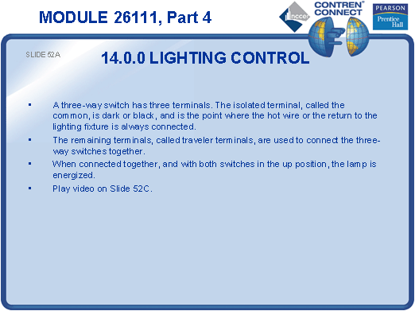
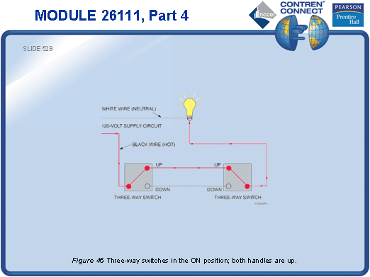

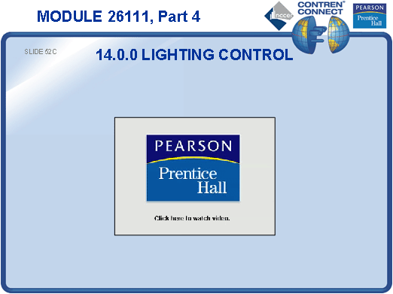
SLIDE 53
- No notes
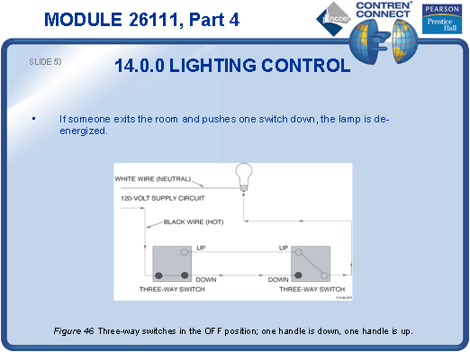
SLIDE 54
- No notes
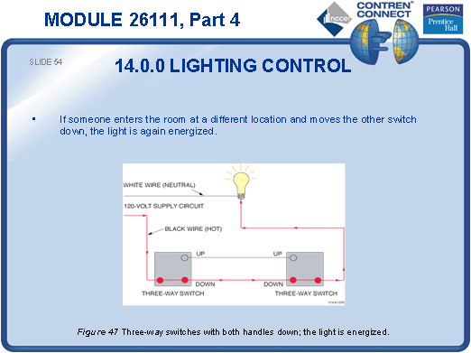
SLIDE 55
- No notes
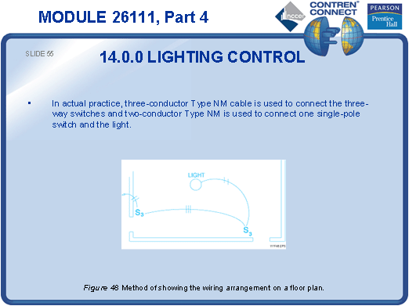

SLIDE 56
- Explain the shortcut method of wiring a three-way switch.
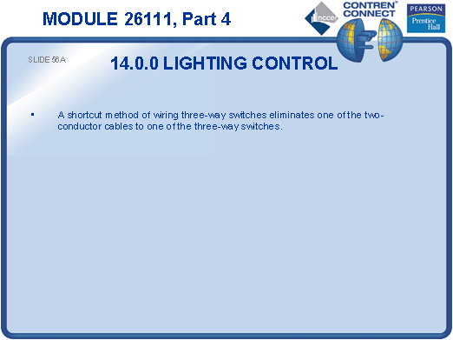
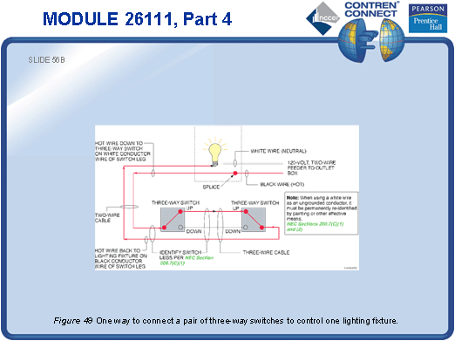
SLIDE 57
- Explain how a four-way switch combined with two three-way switches provides more flexibility in controlling a lighting fixture.
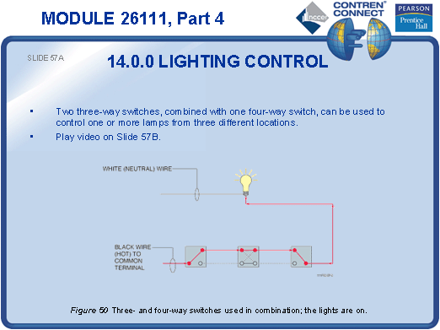

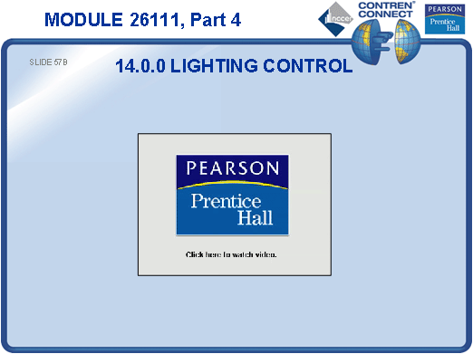
SLIDE 58
- No notes
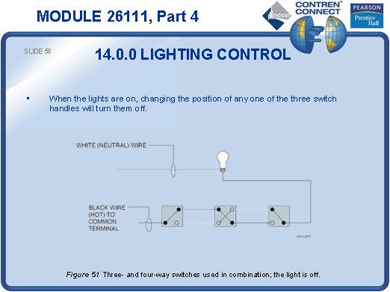
SLIDE 59
- Explain how photoelectric switches, low-voltage relays, and dimmers are used to control lighting.
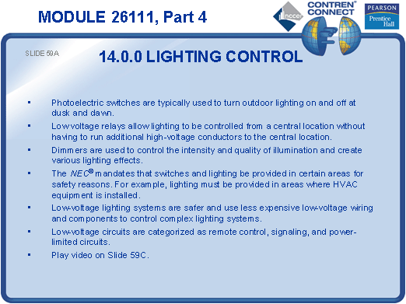
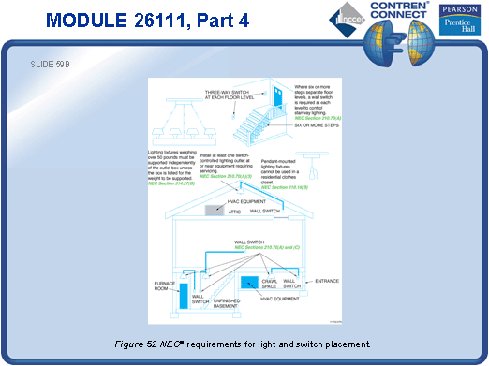
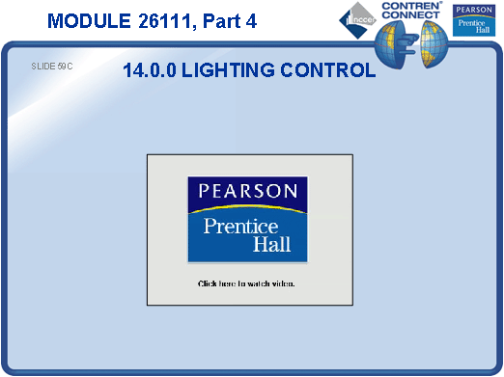
SLIDE 60
- Discuss the NEC® requirements for electric heaters.
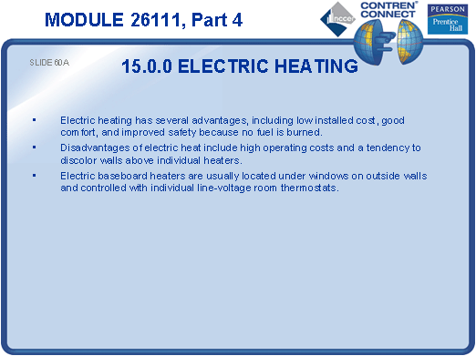
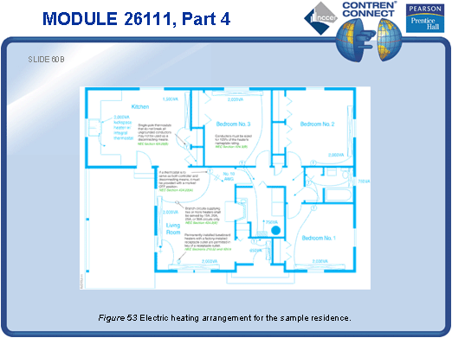
SLIDE 61
- Review the NEC® requirements for hot tubs and spas.
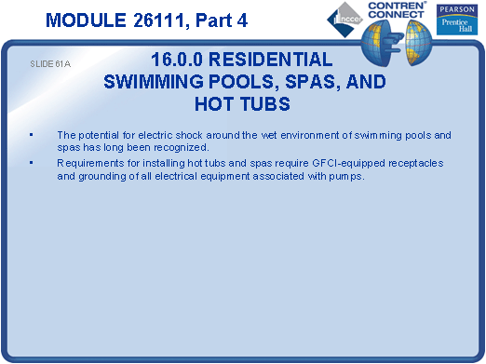
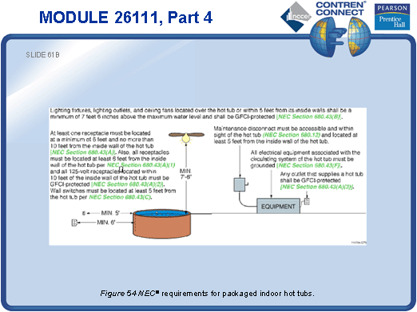
SLIDE 62
- Review the NEC® requirements for swimming pool installations.
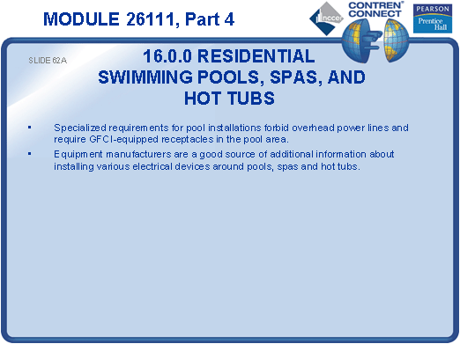
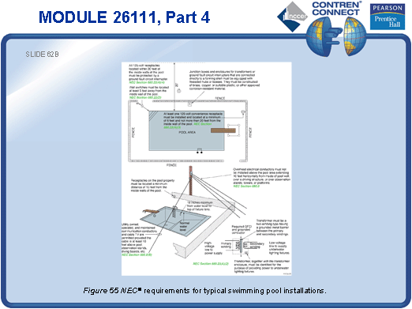
TESTING and PERFORMANCE
- Have the students complete CONTREN Connect Active Figure 40.
- Have the students complete Review Question 15 for Sections 12.0.0 – 16.0.0. Provide the correct answer and remediation at the end of the quiz.
- Have the students complete the Trade Terms Quiz.
- Students must select the proper type and size outlet box needed for a given set of wiring conditions. This can be done during the presentation of Slide 44 or at the end of the lesson. This corresponds to Performance Task 3.
- Administer the Module Exam.

