Module 26112-08
Electrical Test Equipment

Lesson 1 of 1: Electrical Test Equipment
This lesson is a classroom/lab session in which the students will learn about various types of electrical test equipment. In the lab, students will demonstrate the procedure for safely using meters.
Objectives
Upon completion of this lesson, the student should be able to:
- Explain the operation of and describe the following pieces of test equipment:
  - Voltmeter
  - Ohmmeter
  - Clamp-on ammeter
  - Multimeter
  - Megohmmeter
  - Motor and phase rotation testers
- Select the appropriate meter for a given work environment based on category ratings.
- Identify the safety hazards associated with various types of test equipment.
Performance Requirements
  - Measure the voltage in the classroom from line to neutral and line to ground. This exercise satisfies module Performance Task 1.
  - Measure the resistance of various resistors using an ohmmeter. This exercise satisfies module Performance Task 2.
Reading Assignment
  - Module 26112, Sections 1.0.0 thru 4.0.0
Slide Presentation
  - Module 26112, Slides 1 thru 18
Suggested Equipment/Materials
  - Analog multimeter
  - Voltage tester
  - Ohmmeter
  - Clamp-on ammeter
  - Digital multimeter
  - Megohmmeter
  - Motor and phase rotation testers
  - Resistors
  - Electrical Performance Project 26112-1

Suggested Student Activity
  - Lay all of the meters on a table and have the trainees identify the function and common applications of each type.
Testing
  - Module Review Questions 1 – 10
  - CONTREN Connect Active Figures 1 and 3
  - Module 26112-08 Exam
Suggested Lab Activity
  - Have each trainee demonstrate the use of a voltage tester to verify the presence or absence of voltage.
  - Students must demonstrate the use of an ohmmeter or the ohmmeter function of a VOM.
  - Students must demonstrate the use of a voltmeter or the voltmeter function of a VOM.
  - Have students demonstrate the use of a clamp-on ammeter. Use Performance Project 26112-1, Using a Clamp-on Ammeter.
Additional Resources
  - Performance Projects: Job Sheets for the Electrical Industry, Level One, New York: Prentice Hall.
  - Virtual product demos for various meters are available online from Fluke Corporation at www.fluke.com.
  - Contren Connect Electrical 1 Annotated Instructors Guide (available from NCCER).
SLIDE 1
  - Review the objectives to be covered in this module. Ask the students if they have any questions.
  - Explain that students must obtain a score of 70% on the Module Exam and perform certain tasks to the satisfaction of the instructor to receive credit for the module.
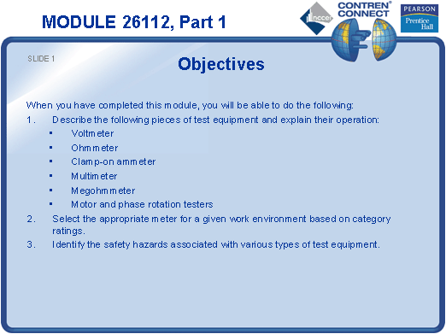
SLIDE 2
  - Describe the primary applications of electrical test equipment.
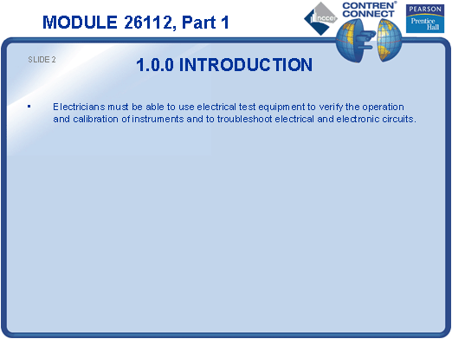
SLIDE 3
  - Describe how an analog meter movement works.
  - Point out that digital measuring instruments are rapidly replacing analog instruments.
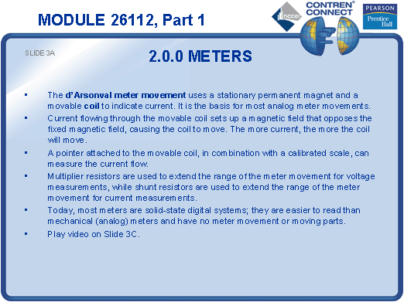
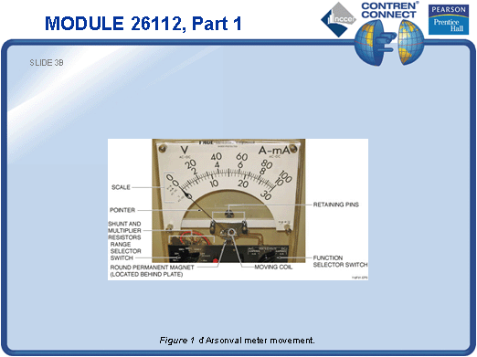
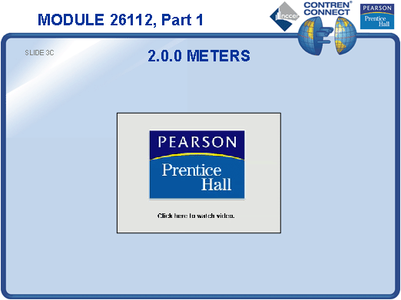
SLIDE 4
  - Demonstrate how to use a voltage tester.
  - Have each trainee demonstrate the use of a voltage tester to verify the presence or absence of voltage.
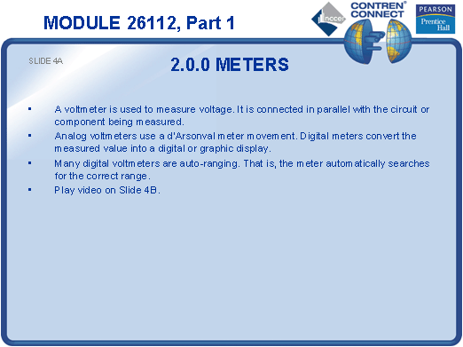
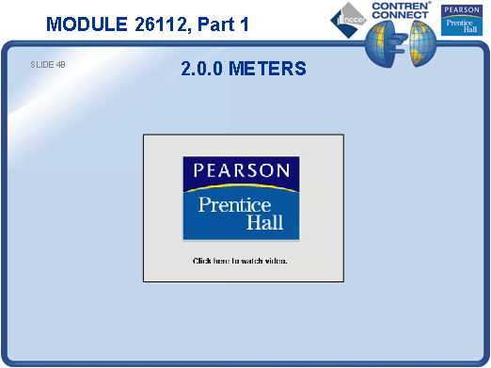
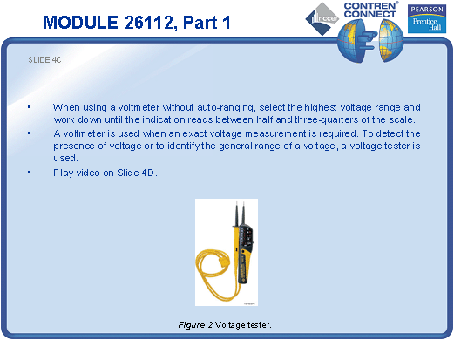
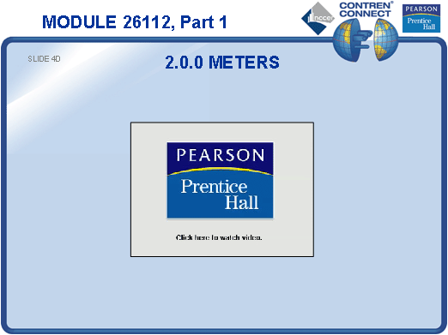
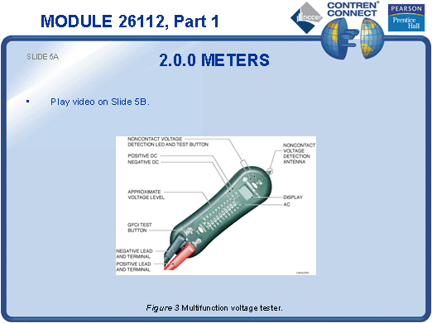
SLIDE 5
  - No notes.

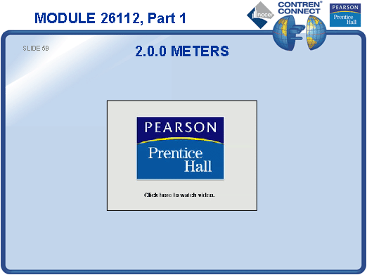
SLIDE 6
  - Demonstrate how to zero an ohmmeter.
  - Demonstrate how to isolate components from the rest of the circuit when measuring resistance with an ohmmeter.
  - Have each trainee demonstrate the use of an ohmmeter to measure the value of various resistors.
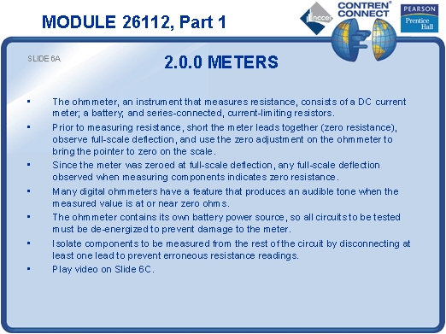
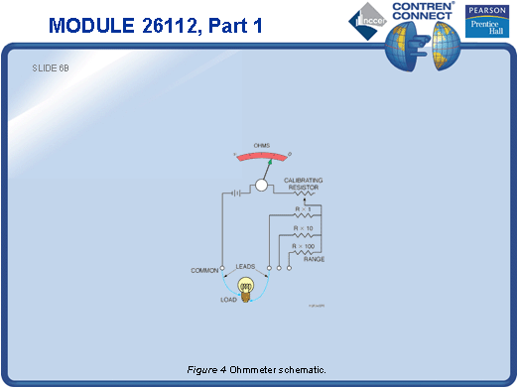
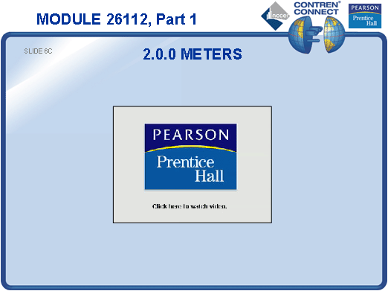
SLIDE 7
  - Describe how a clamp-on ammeter measures current.
  - Demonstrate how to use a clamp-on ammeter.
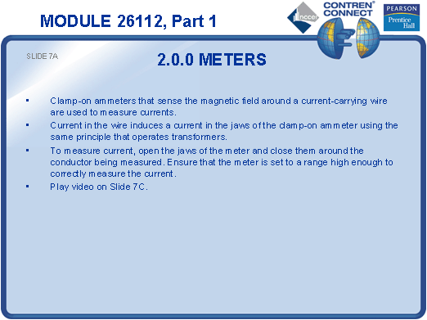
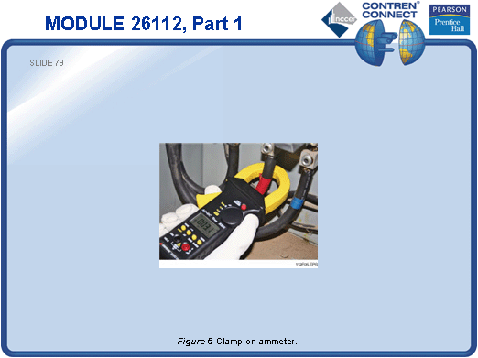
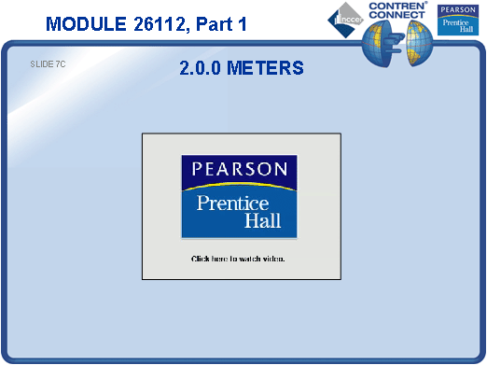
SLIDE 8
  - Demonstrate the use of an analog VOM.
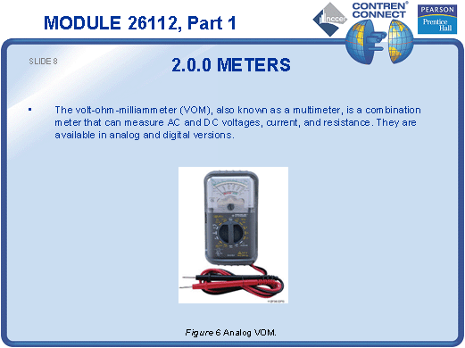
SLIDE 9
  - Demonstrate the use of a digital VOM.
  - Have each trainee demonstrate the use of a VOM to measure the voltage in the classroom from line to neutral and line to ground.
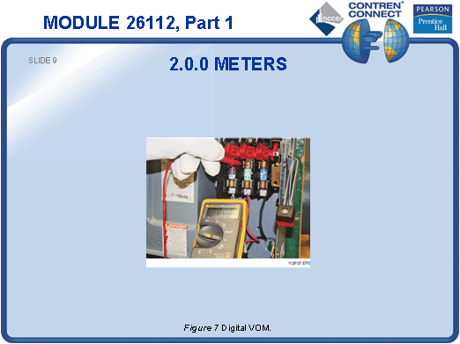
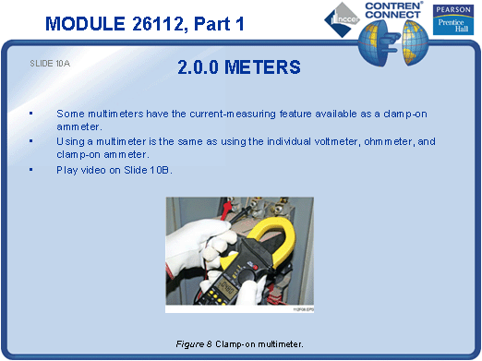
SLIDE 10
  - No notes.

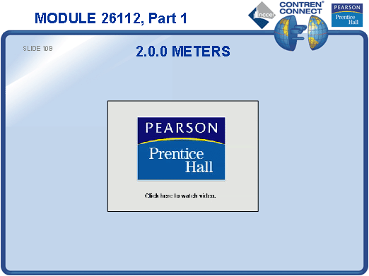
SLIDE 11
  - Emphasize the safety precautions necessary when using a megger.
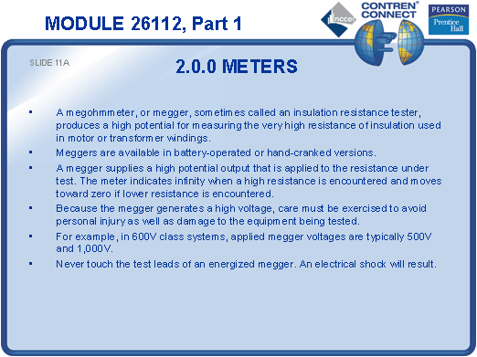
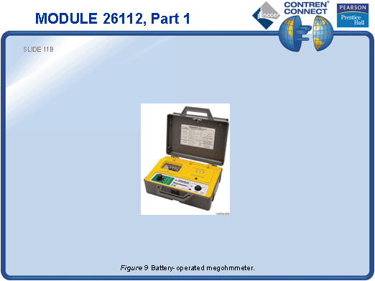
SLIDE 12
  - Demonstrate how to use a megger.
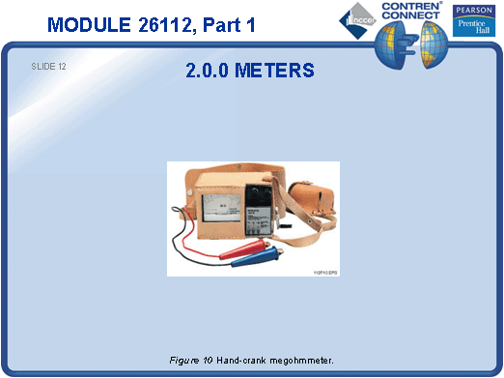
SLIDE 13
  - Explain the difference between a motor rotation tester and a phase rotation tester.
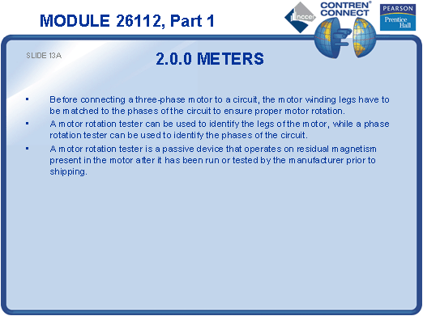
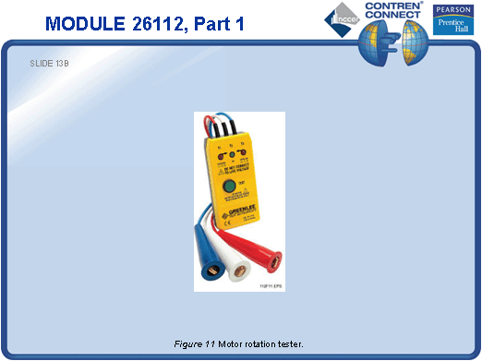
SLIDE 14
  - No notes.
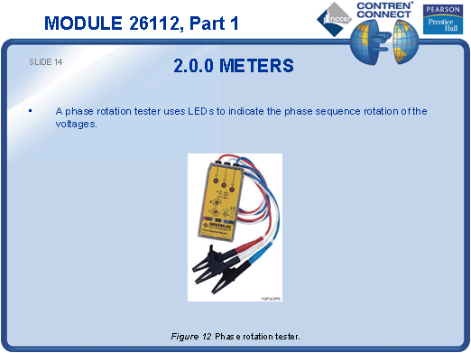
SLIDE 15
  - List the applications of recording instruments.
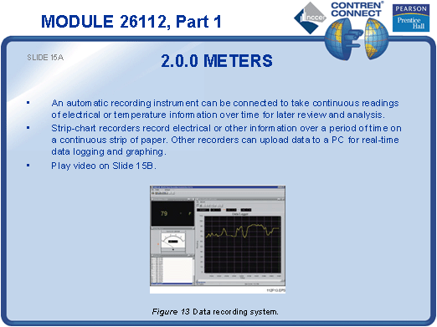
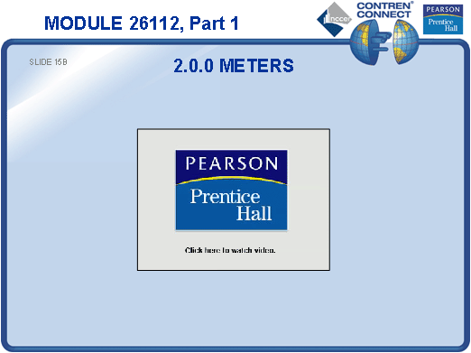
SLIDE 16
  - Discuss the category ratings shown in the table.
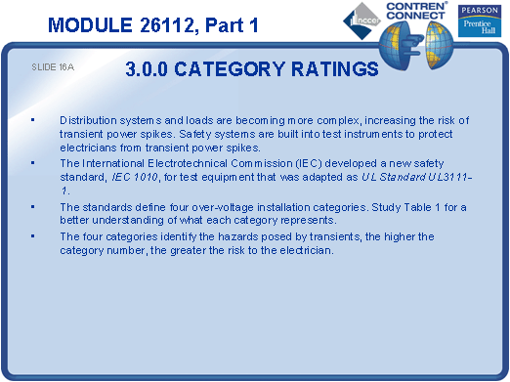
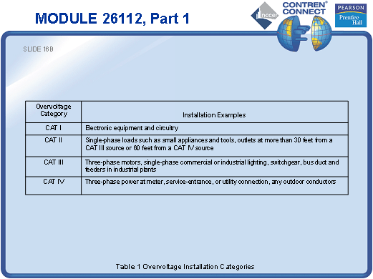
SLIDE 17
  - Point out the category ratings on the meters shown previously.
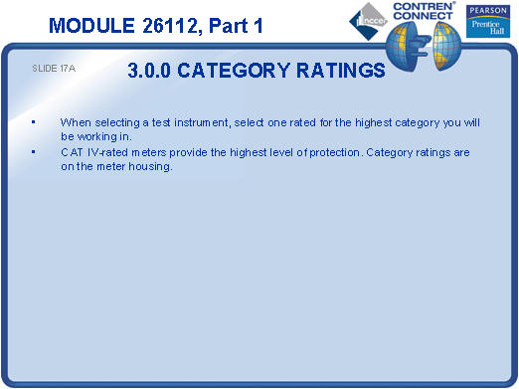
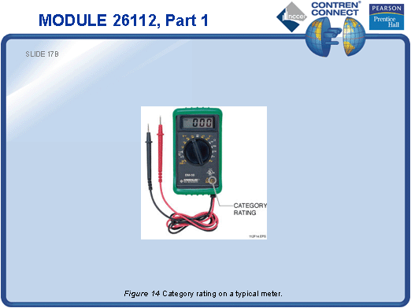
SLIDE 18
  - Explain that de-energizing main supply circuits by opening supply switches will not necessarily de-energize all circuits in a given piece of equipment.
  - Stress the importance of following logout/tagout procedures.
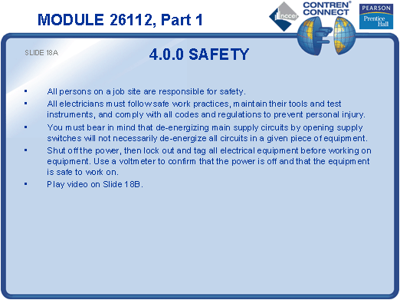
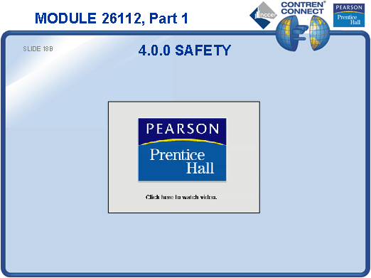
TESTING AND PERFORMANCE
- Have the students complete Active Figures 1 and 3.
- Have the students answer Review Questions 1 thru 10. Provide correct answers and remediation at the end of the quiz.
- Have the students complete the Trade Terms Quiz.
- Students must demonstrate the safe use of a voltmeter and ohmmeter. This can be done during the presentation of Slides 6 and 9 or at the end of the lesson. This satisfies Performance Tasks 1 and 2.
- Administer the Module Exam.

