Module 26104-08
Electrical Theory

Lesson 1 of 2: Applying Ohms Law to Resistive Circuits
This lesson is a classroom/lab session in which the students will learn how to calculate resistance, current, and voltage in series, parallel, and series-parallel circuits. In the lab, students will build and test basic DC circuits.
Objectives
Upon completion of this lesson, the student should be able to:
- Explain the basic characteristics of a series circuit.
- Explain the basic characteristics of a parallel circuit.
- Explain the basic characteristics of a series-parallel circuit.
- Find the total amount of resistance in a series circuit.
- Find the total amount of resistance in a parallel circuit.
- Find the total amount of resistance in a series-parallel circuit.
Performance Requirements
  - None
Reading Assignment
  - Module 26104, Sections 1.0.0 thru 2.4.3
Slide Presentation
  - Module 26104, Part 1 (Slides 1 thru 14)
Suggested Equipment/Materials
  - Calculators
  - Paper and pencils
  - VOM
  - Selected resistors
  - Breadboards
  - 6-volt batteries
  - Switches
  - 18-22 AWG wire
  - 6-volt lamps/sockets
  - Electrical schematic
Suggested Student Activity
  - Hand out copies of an electrical schematic and ask the students to identify any series or series-parallel circuits. Make sure they only select circuits with the loads connected in series or series-parallel.
Testing
  - Module Review Test Questions 1 thru 8
  - CONTREN Connect Active Figure 5
Suggested Lab Activity
  - Draw a series DC circuit and a parallel DC circuit on the board. Have the students build each of these circuits with batteries, resistors, and wire. Then have them calculate the total resistance, voltage, and current flow at different points in the circuit.
  - Build a simple circuit with a dimmer switch to demonstrate the effects of changing resistance. Use Performance Project 26104-1, Building a Dimmer Switch Lamp Circuit.
Additional Resources
  - Electronics Fundamentals: Circuits, Devices, and Applications, Thomas L. Floyd, New York: Prentice Hall.
  - Performance Projects: Job Sheets for the Electrical Industry, Level One, New York: Prentice Hall.
  - Principles of Electric Circuits, Thomas L. Floyd, New York: Prentice Hall.
  - Contren Connect Electrical 1 Annotated Instructors Guide (available from NCCER).
SLIDE 1
  - Review the objectives to be covered in this module. Ask the students if they have any questions.
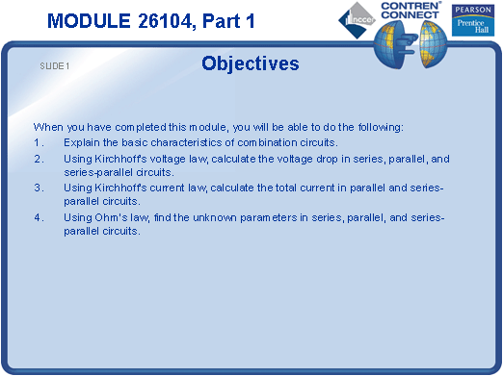
SLIDE 2
- Ask the trainees to give an example of a series circuit that might be encountered in a home or place of business.
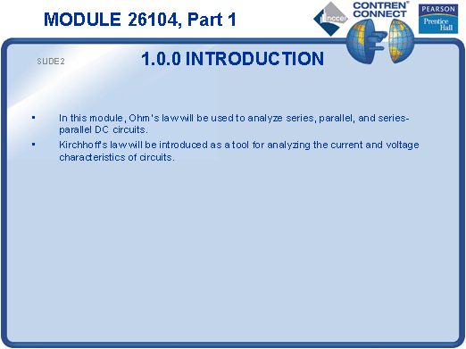
SLIDE 3
- Draw a series circuit on the board.
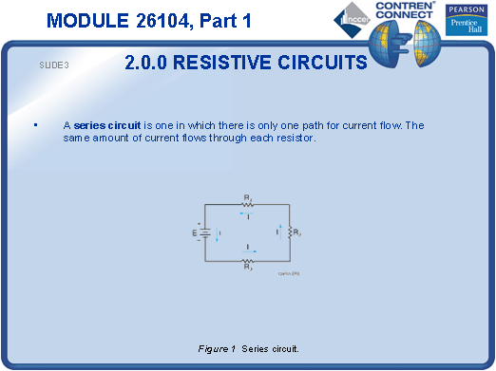
SLIDE 4
- Write the formula for the total resistance of a series circuit on the board.
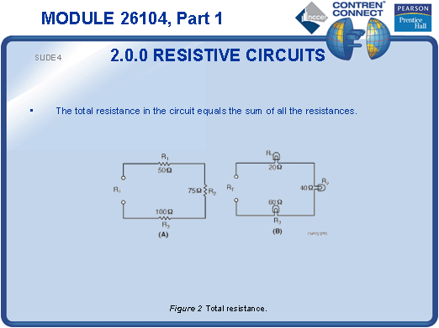
SLIDE 5
- Show an example of the reciprocal calculation for unequal resistances in parallel.
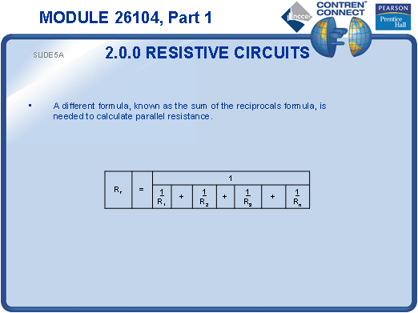
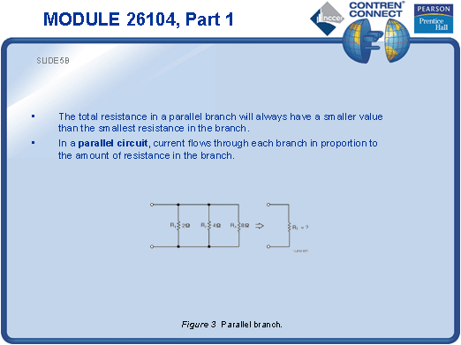
SLIDE 6
- Show the simplified formula for equal resistances in parallel.
- Show the simplified formula for two unequal resistances in parallel.
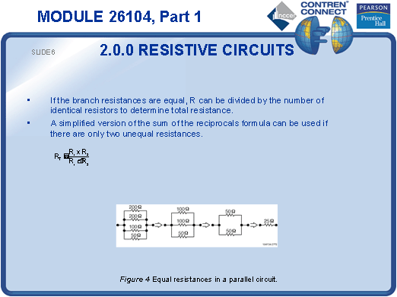
SLIDE 7
- Explain that it is unusual to find a situation outside of electronic circuitry in which loads are connected in a series-parallel arrangement.
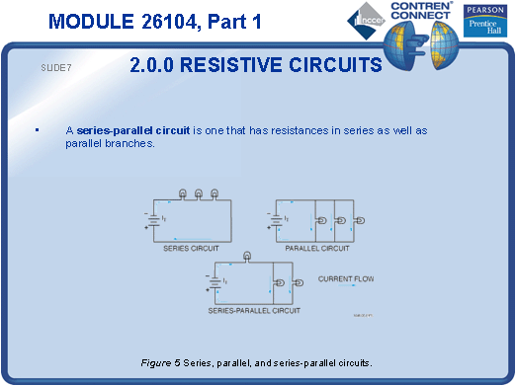
SLIDE 8
- Demonstrate how to redraw a circuit to identify the series and parallel portions.
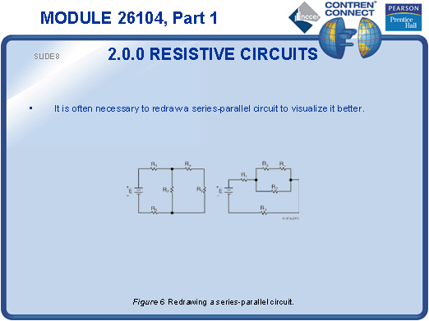
SLIDE 9
- Find the total resistance, total current, and voltage drop across each resistor for the example shown in the slide.
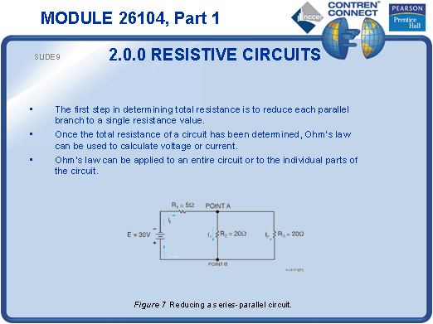
SLIDE 10
- Explain why the voltage across any branch of a parallel circuit is the same as the source voltage.
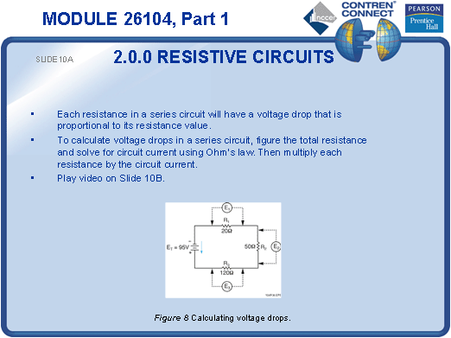
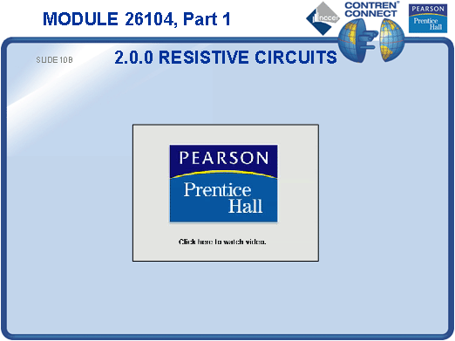
SLIDE 11
- Show the voltage drop calculations for the parallel circuit shown on the slide.
- Draw some parallel circuits on the board and have the students calculate the voltage drops.
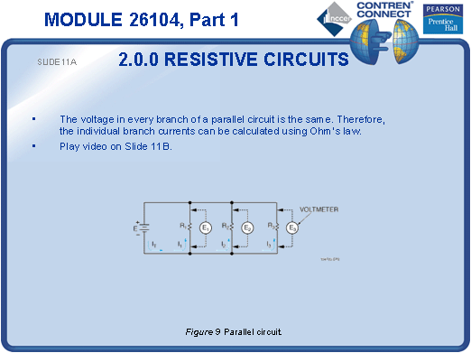
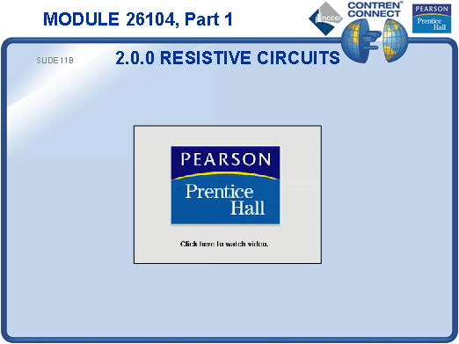
SLIDE 12
- Find the total resistance for the examples shown in the slide.
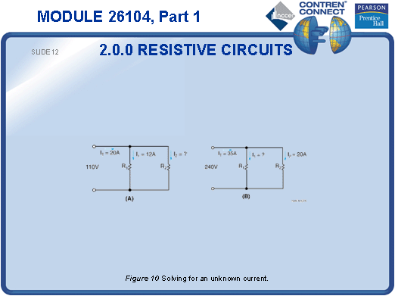
SLIDE 13
- Explain that series-parallel circuits must be simplified in order to calculate the voltage drops across individual components.
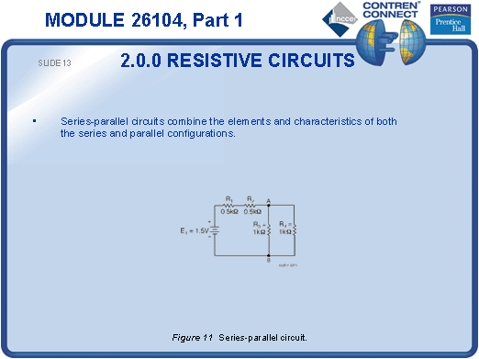
SLIDE 14
- Invite one of the students to show how to reduce the series-parallel circuit to a simple series circuit, and then calculate various values.
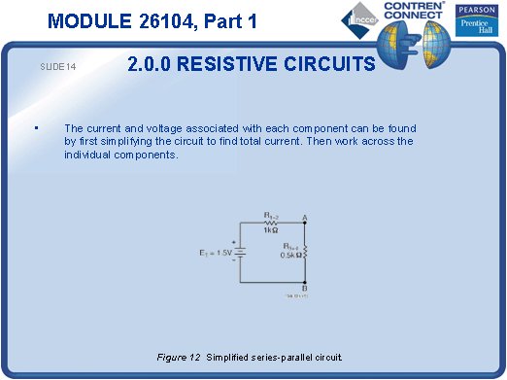
TESTING and PERFORMANCE
- Have the students complete Active Figure 5.
- Have students complete Review Questions 1 – 8 for Sections 1.0.0 – 2.4.3. Provide correct answers and remediation at the end of the quiz.

