Module 26104-08
Electrical Theory
Lesson 2 of 2: Applying Kirchoff’s Laws to Resistive Circuits
This lesson is a classroom/lab session in which the students will learn how to apply Kirchoff’s current and voltage laws for series, parallel, and series-parallel circuits.
Objectives
Upon completion of this lesson, the student should be able to:
- Calculate, using Kirchoff’s voltage law, the voltage drops in series, parallel, and series-parallel circuits.
- Calculate, using Kirchoff’s current law, the total current in series and parallel circuits.
Performance Requirements
  - None
Reading Assignment
  - Module 26104, Sections 3.0.0 thru 3.3.0
Slide Presentation
  - Module 26104, Part 2 (Slides 15 thru 19)
Suggested Equipment/Materials
  - Calculators
  - Paper and pencils
  - VOM
  - Selected resistors
  - Breadboards
  - 6-volt batteries
  - Switches
  - 18-22 AWG wire
  - 6-volt lamps/sockets
  - Electrical schematic
Suggested Student Activity
  - Have students create and solve loop equations.
Testing
  - Module Review Test Questions 9 and 10
  - CONTREN Connect Active Figure 15
  - Module 26104-08 Exam
Suggested Lab Activity
  - Draw a series DC circuit and a parallel DC circuit on the board. Have the students build each of these circuits, and calculate the voltage drops and current flows at different points in the circuit. When they are finished, show them how to use a VOM to verify the calculations.
Additional Resources
  - Electronics Fundamentals: Circuits, Devices, and Applications, Thomas L. Floyd, New York: Prentice Hall.
  - Principles of Electric Circuits, Thomas L. Floyd, New York: Prentice Hall.
  - Contren Connect Electrical 1 Annotated Instructors Guide (available from NCCER).
SLIDE 15
  - Review the objectives to be covered in this lesson. Ask the students if they have any questions.
- Define Kirchhoff’s current law.
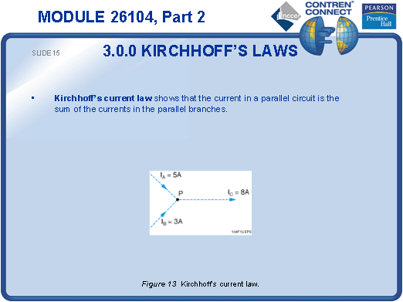
SLIDE 16
- Provide examples of Kirchhoff’s current law.
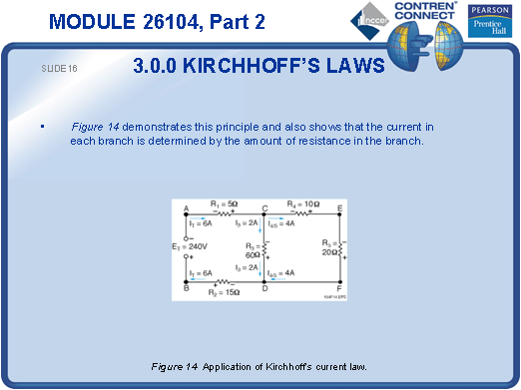
SLIDE 17
- Define Kirchhoff’s voltage law.
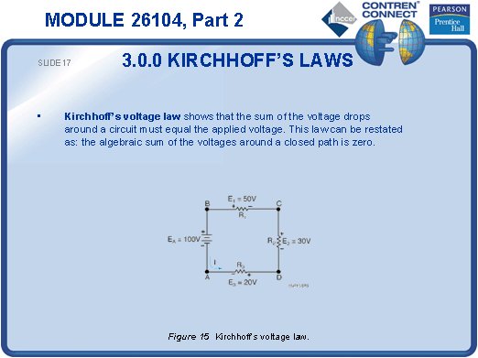
SLIDE 18
- Show the students how to work out the loop equation.
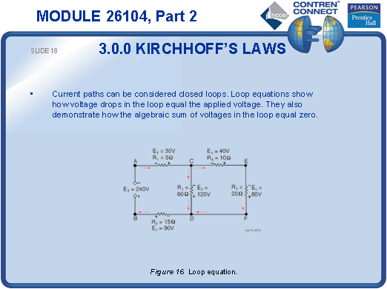
SLIDE 19
- Provide examples of Kirchhoff’s voltage law.
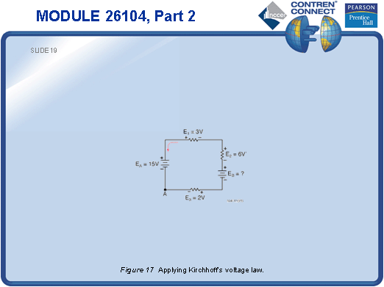
TESTING and PERFORMANCE
- Have students complete Active Figure 15.
- Have students complete Review Questions 9 and 10 for Sections 3.0.0 – 3.3.0. Provide correct answers and remediation at the end of the quiz.
- Have students complete the module Trade Terms Quiz.
- Administer the Module Exam.

