Module 26105-08
Introduction to the National Electrical Code®
Lesson 1 of 1: Layout and Navigation of the NEC®
This lesson is a classroom session in which the students will be introduced to the purpose, history, layout, and use of the National Electrical Code® (NEC®).
Objectives
Upon completion of this lesson, the student should be able to:
- Explain the purpose and history of the NEC®.
- Describe the layout of the NEC®.
- Explain how to navigate the NEC®.
- Describe the purpose of the National Electrical Manufacturers Association (NEMA) and the National Fire Protection Association (NFPA).
- Explain the role of nationally recognized testing laboratories.
Performance Requirements
  - Use NEC Article 90 to determine the scope of the NEC®. State what is covered by the NEC® and what is not.
  - Find the definition of the term feeder in the NEC®.
  - Look up the NEC® specifications that you would need to follow if you were installing an outlet near a swimming pool.
  - Find the minimum wire bending space required for two No. 1/0 AWG conductors installed in a junction box or cabinet and entering opposite the terminal.
Reading Assignment
  - Module 26105, Sections 1.0.0 thru 5.2.0
Slide Presentation
  - Module 26105 (Slides 1 thru 9)
Suggested Equipment/Materials
  - Copy of the latest edition of the National Electrical Code®
Suggested Student Activity
  - Have the students visit the Occupational Safety and Health Administration (OSHA) website at www.osha.gov and identify the organizations currently recognized by OSHA’s Nationally Recognized Testing Laboratories (NRTL) program.
  - Have students complete Performance Project 26105-1, Derating Conductor Ampacity Based on Quantity and Ambient Temperature.
Testing
  - Module Review Questions 1 – 10
  - CONTREN Connect Active Figure 3
  - Module 26105-08 Exam
Suggested Lab Activities
  - None
Additional Resources
  - National Electrical Code® Handbook, Latest Edition. Quincy, MA: National Fire Protection Association.
  - Performance Projects: Job Sheets for the Electrical Industry, Level One, New York: Prentice Hall.
  - Contren Connect Electrical 1 Annotated Instructors Guide (available from NCCER).
SLIDE 1
  - Review the objectives to be covered in this module. Ask the students if they have any questions.
  - Explain that students must obtain a score of 70% on the Module Exam and perform certain tasks to the satisfaction of the instructor to receive credit for the module.
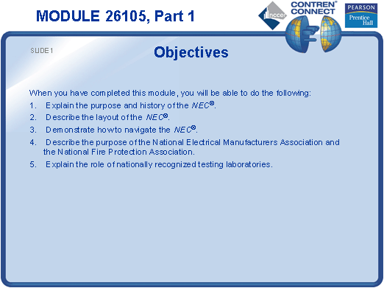
SLIDE 2
  - Describe the purpose of the NEC®.
  - Stress the importance of becoming familiar with NEC® requirements.
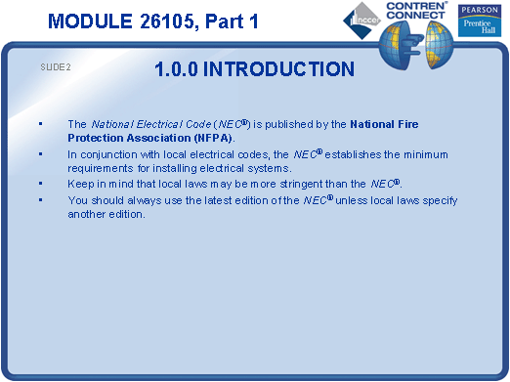
SLIDE 3
  - Discuss the history and structure of the NEC® committee.
  - Discuss the role of the National Fire Protection Association (NFPA).
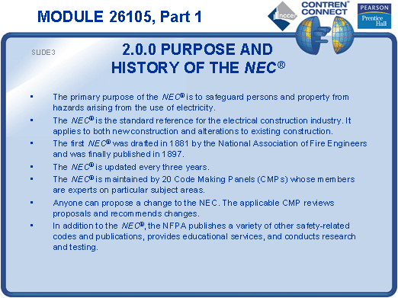
SLIDE 4
  - Discuss the layout and structure of the NEC®.
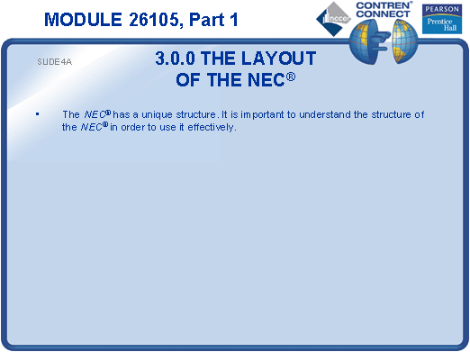
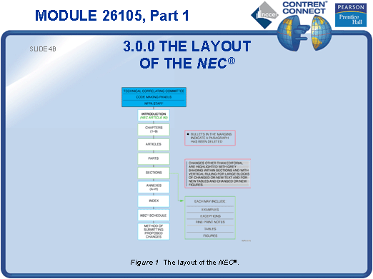
SLIDE 5
  - Describe the two basic types of rules, mandatory and permissive.
  - Review the different types of text in the NEC®.
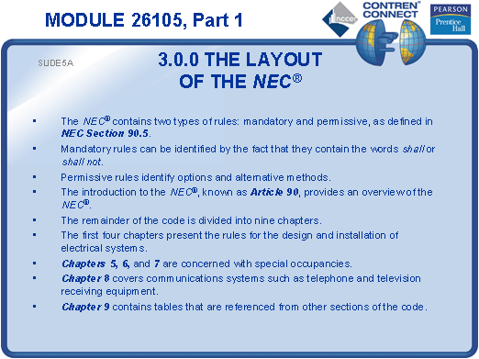
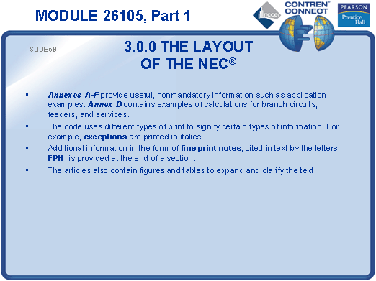
SLIDE 6
  - Discuss NEC Article 100.
  - Explain the importance of using listed equipment and devices.
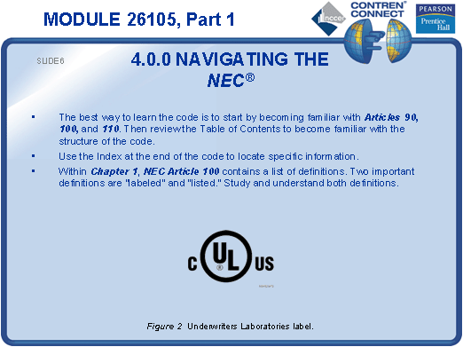
SLIDE 7
  - Discuss the chapter organization of the NEC®.
  - Demonstrate how to locate information in the NEC®.
  - Have the students practice finding specified information in the NEC®.
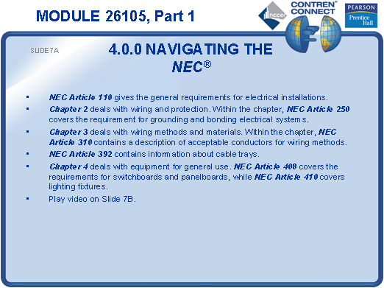
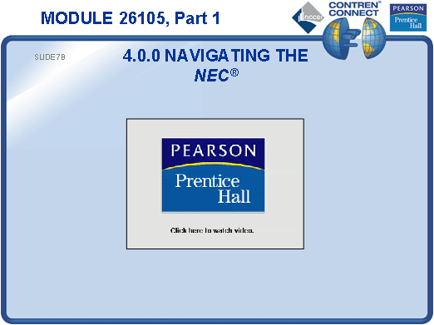
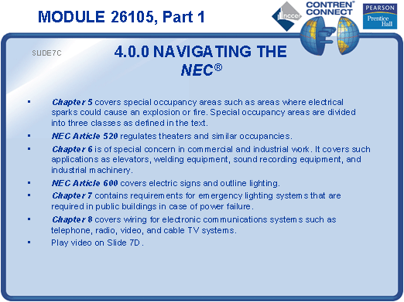
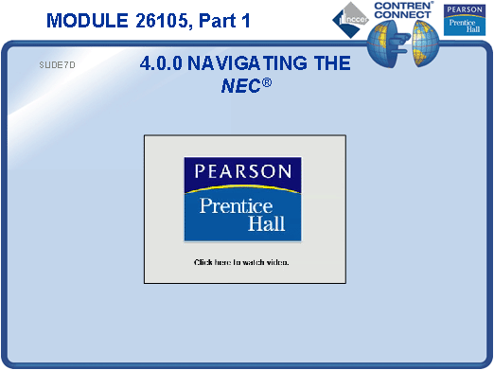
SLIDE 8
  - Demonstrate how to find the NEC® requirements for example installations.
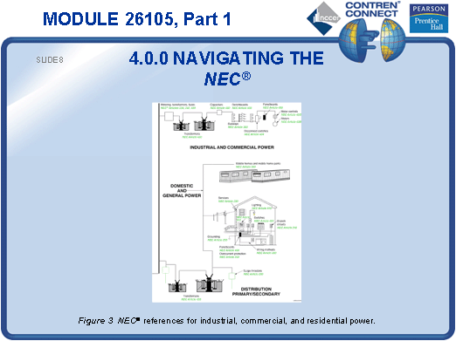
SLIDE 9
  - Discuss the roles of various testing laboratories.
  - Discuss NEMA and its role in specifying electrical equipment.
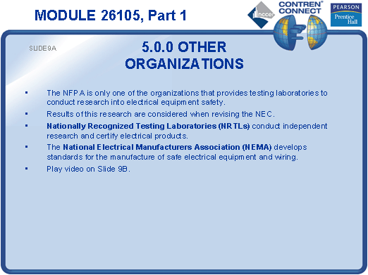
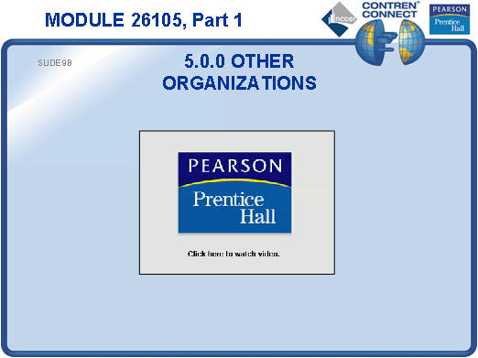
TESTING and PERFORMANCE
- Have the students complete Active Figure 3.
- Have students answer Review Questions 1 – 10 for Sections 1.0.0 – 5.2.0. Provide correct answers and remediation at the end of the quiz.
- Have the students complete the Trade Terms Quiz.
- Students must complete the following Performance Tasks:
- Use NEC Article 90 to determine the scope of the NEC®. State what is covered by the NEC® and what is not.
- Find the definition of the term feeder in the NEC®.
- Look up the NEC® specifications that you would need to follow if you were installing an outlet near a swimming pool.
- Find the minimum wire bending space required for two No. 1/0 AWG conductors installed in a junction box or cabinet and entering opposite the terminal.
  - Administer the Module Exam.

