

ACCT

PATHWAY: Construction
COURSE: Introduction to Construction
UNIT: Electrical-Hand Bending –Module 26102-05

Introduction
Annotation: This unit reviews and introduces students to the basic tools of the Electrical trade. Tools introduced in the Occupational Safety and Fundamentals course will be reviewed and used.
Occupational Safety and Fundamentals is a pre-requisite for this course
Grade(s):
 | 9th
X | 10th
X | 11th
X | 12th

Time: This unit has 3 lesson plans. Each lesson plan should be completed in 2 ½ hrs including hands-on activities.
Total time is 7.5 hours

Author: Jim Steel- Lee County 9th Grade Campus

Additional Author(s):

Students with Disabilities:
For students with disabilities, the instructor should refer to the student's IEP to be sure that the accommodations specified are being provided. Instructors should also familiarize themselves with the provisions of Behavior Intervention Plans that may be part of a student's IEP. Frequent consultation with a student's special education instructor will be beneficial in providing appropriate differentiation.

Focus Standards
GPS Focus Standards:
ACT-IC-2-Students will identify and Use the basic tools used in the four building trades
- Demonstrate knowledge of Safety as related to the basic tools of the four trade areas
- Demonstrate basic knowledge of the care and maintenance of these tools
- Demonstrate knowledge of proper application for each tool
GPS Academic Standards:
MC1P3: Students will communicate mathematically.
SSCG15: The student will explain the functions of the departments and agencies of the federal bureaucracy.
ELA9RC4: The student establishes a context for information acquired by reading across subject areas.

National / Local Standards / Industry / ISTE:
NCCER 26102-05 Hand Bending
Understandings & Goals
Enduring Understandings: Enduring understandings are statements summarizing important ideas and have lasting value beyond the classroom. They synthesize what students should understand – not just know.

This goal of this unit is to train students how to use the various tools of the four building trades. Intimate knowledge of tool use is essential for the competency of the student. Hand and eye co-ordination coupled with practical application of the principles of tool use is explored in this unit.

Essential Questions: Essential questions probe for deeper meaning and understanding while fostering the development of critical thinking and problem-solving skills. Example: Why is life-long learning important in the modern workplace?

Overall:
Why is knowledge and ability to use the tools of each trade essential for success?
How can we benefit from being able to use the tools for each trade?

Knowledge from this Unit: This unit contains four (4) parts that teach the students how to use the various tools of the trades.

Hand bending: 7.5 hours
Upon completion of this unit, the student will be able to do the following:

- Identify the methods of hand bending conduit.
- Identify the various methods used to install conduit.
- Use math formulas to determine conduit bands.
- Make 90° bend, back to back bands, offsets, kicks, and saddlebags using a hand bender.
- Cut, ream, and thread conduit.

Skills from this Unit: Performance.
Under the supervision of the instructor, the student should be able to do the following:
1. Given a piece of EMT, complete the following using a hand bender, hacksaw, and reaming tool. No couplings are allowed, and there should be no kinks in the pipe.
- Offset
- Saddle
- 90° bend
Assessment(s)
Assessment Method Type: Select one or more of the following. Please consider the type(s) of differentiated instruction you will be using in the classroom.

X | Pre-test
X | Objective assessment - multiple-choice, true- false, etc.
__ Quizzes/Tests
__ Unit test
 | Group project
X | Individual project
 | Self-assessment - May include practice quizzes, games, simulations, checklists, etc.
__ Self-check rubrics
__ Self-check during writing/planning process
__ Journal reflections on concepts, personal experiences and impact on one’s life
__ Reflect on evaluations of work from teachers, business partners, and competition judges
__ Academic prompts
__ Practice quizzes/tests
 | Subjective assessment/Informal observations
__ Essay tests
__ Observe students working with partners
__ Observe students role playing
 | Peer-assessment
__ Peer editing & commentary of products/projects/presentations using rubrics
__ Peer editing and/or critiquing
X | Dialogue and Discussion
__ Student/teacher conferences
__ Partner and small group discussions
__ Whole group discussions
__ Interaction with/feedback from community members/speakers and business partners
 | Constructed Responses
__ Chart good reading/writing/listening/speaking habits
__ Application of skills to real-life situations/scenarios
X | Post-test

Assessment(s) Title:
Electrical: See the Electrical Level One test booklet for Written and Performance Tests: 26101-05
Assessment(s) Description/Directions:
Contren provides written and performance tests for each section. See the Instructor Guides for the materials. The assessment materials should be kept under lock and key. Written tests can also be accessed through TestGen software.

Attachments for Assessment(s): See test booklets
Learning Experiences
Instructional planning: Include lessons, activities and other learning experiences in this section with a brief description of the activities to ensure student acquisition of the knowledge and skills addressed in the standards. Complete the sequence of instruction for each lesson/task in the unit.

Sequence of Instruction
Electrical: Module 26102-5 Hand Bending

Lesson 1: Introduction to Hand Bending; Gain; Back-to Back Bends
1. Identify the Standards. Standards should be posted in the classroom for each lesson.
2. Review Essential Questions.

3. Identify and review the unit vocabulary.
Offsets gains 90° bends concentric bends
Rise segment bend developed length back-to-back bend

4. Lesson 1 Content: Introduction to Hand Bending; Gain; Back-to Back Bends
a. Introduction to Hand Bending
1. Equipment
Discuss hand benders and their application. Discuss and demonstrate the various types of hand bending equipment. Demonstrate how to mock up a conduit run using a piece of solid wire. Point out the NEC® requirements pertaining to conduit bends. Explain the difference between a hand bender and a hickey.
Describe how to bend PVC using a heating unit. Discuss the precautions that must be taken when using PVC heating units.
2. Geometry required for making a Bend
Discuss geometric terms relating to:
- right triangles-
  - any triangle with a 90° Angle
  - Side directly opposite the 90° angle is the hypotenuse
  - Side on which the triangle sits is the base
  - The offset forms the hypotenuse of a right angle
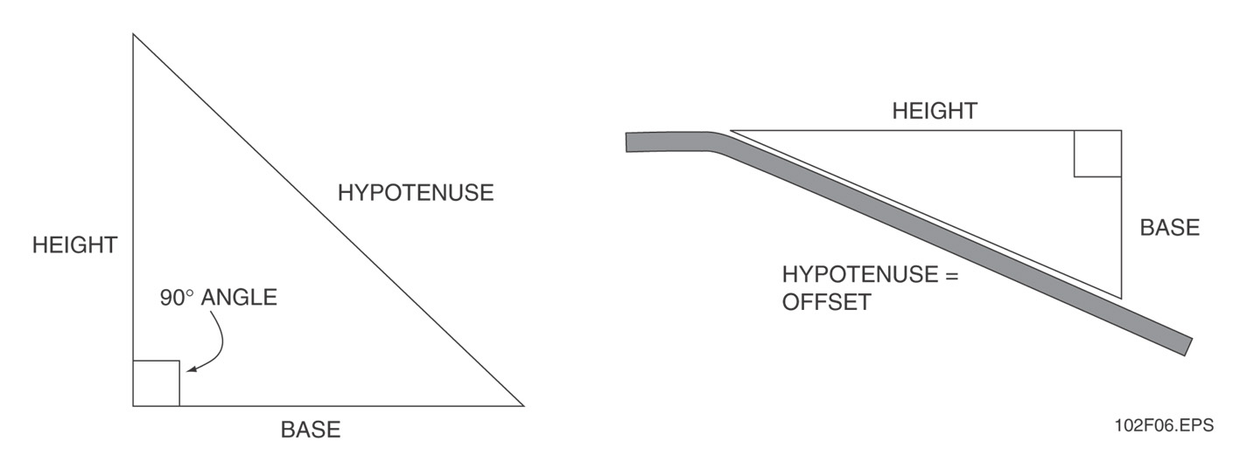
- Circles
  - Closed curved line whose points are all the same distance from its center.
  - Distance between the center point to the edge of the circle is the radius
  - Length from one edge of the circle to the other edge through the center point is the diameter.
  - Distance around the circle is the circumference
  - Can be divided into four (4) equal quadrants
  - Each quadrant accounts for 90°- total of 360°
  - A 90° bend = ¼ of the Circle
  - Concentric circles have a common center but different radii
    - Angle of each bend is 90°
  - Circumference of each circle:
    - C = π x D or C = π D
      - C = Circumference
      - D= Diameter
      - π = 3.14
    - C = 2 π R
      - R = radius or ½ the diameter
  - Arc of a Quadrant:
    - Length of the arc= (.025) 2πR = 1.57R
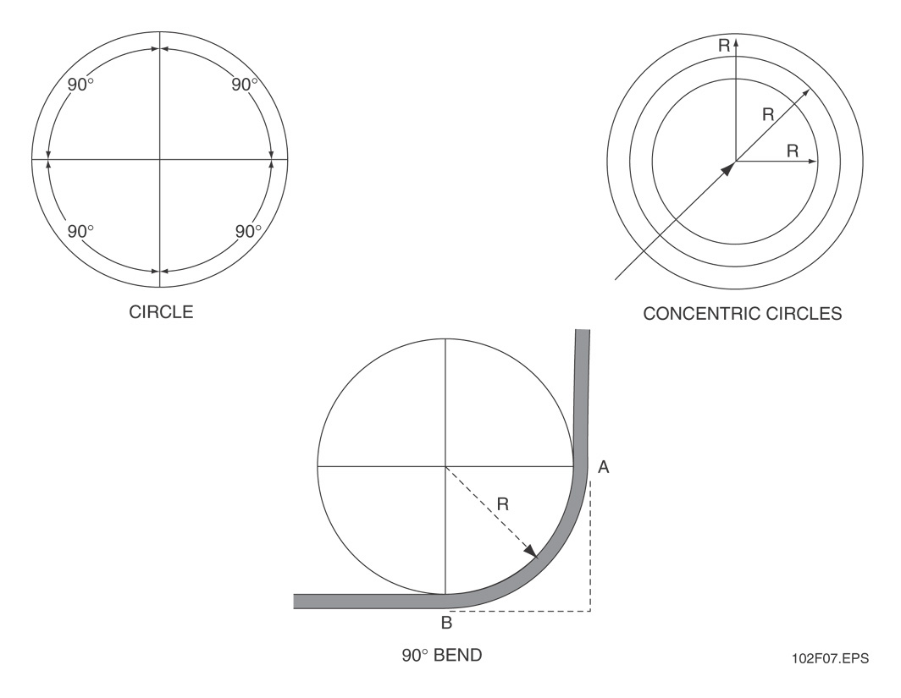
A bending radius table is located in Appendix B

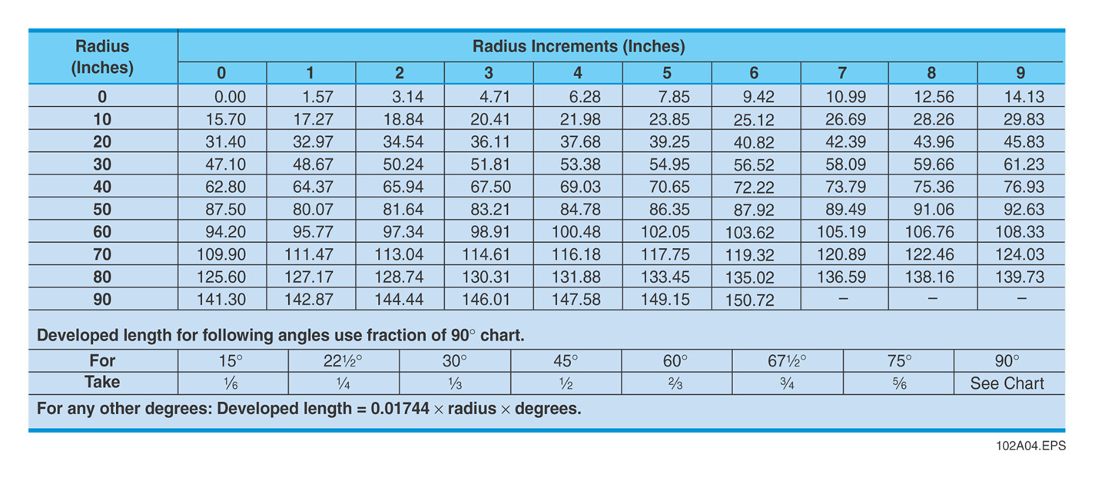
Review Appendix A at the back of the module.
Appendix A shows the students how to do basic trigonometry to determine offset angles and multipliers.
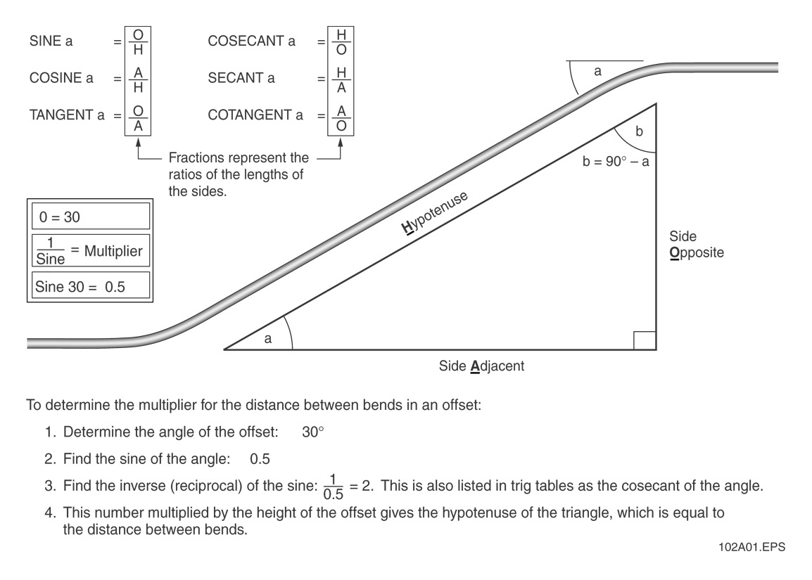
Have students practice using mathematical formulas to determine offsets.

Demonstrate how to make and check the 90° one-shot bend. Have students practice making and taking a 90° one-shot bend.
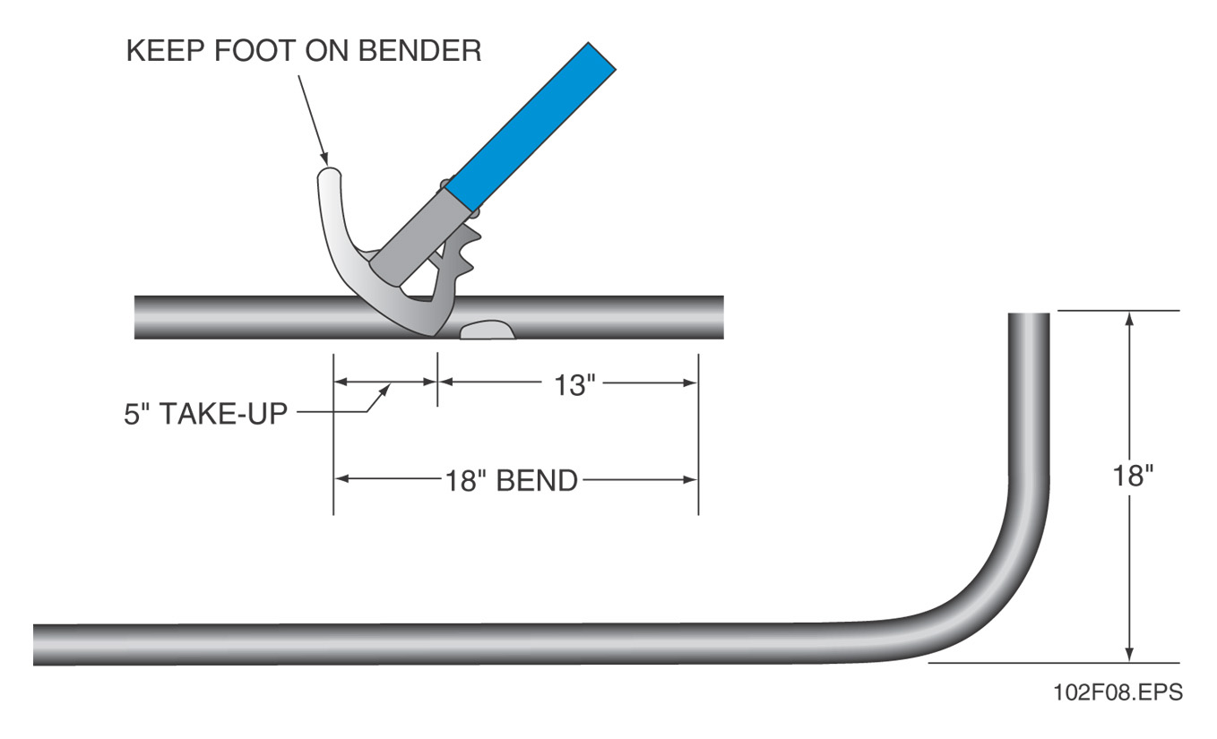
b. Gain
Discuss and explain the principle of Gain and how it applies to the correct bend required for conduit. Explain that take-up represents the length needed while the gain is the distance saved. Explain that smooth bends help to prevent conductor damage.
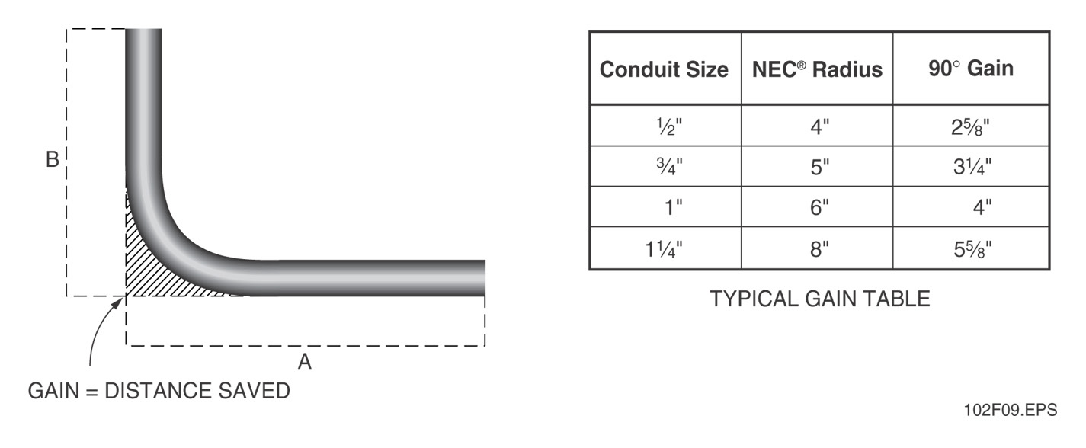

c. Back-to-Back 90° Bends
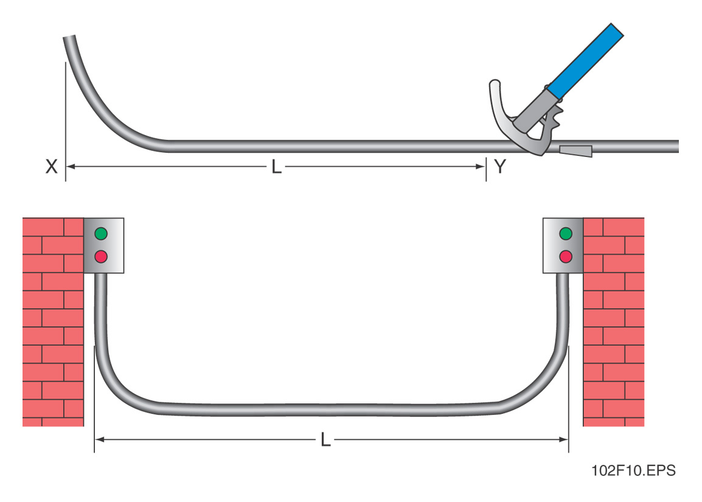
Demonstrate and have students practice making back-to-back 90° bends
At the end of this section, have the students to the Performance tasks associated with this section.

Lesson 2: Offset Bends; Saddle Bends

1. Identify the Standards. Standards should be posted in the classroom for each lesson.
2. Review Essential Questions.

3. Identify and review the unit vocabulary.

4. Lesson 2 Content: Offset Bends; Saddle Bends

a. Making an Off-set Bend
- Off-sets are needed where 2 equal bends of less than 90° are required with a specified distance apart.
- Formulas for figuring the distance between bends is:
Distance between the bends = depth of offset x multiplier
See Tables 2 & 3 on page 2.9
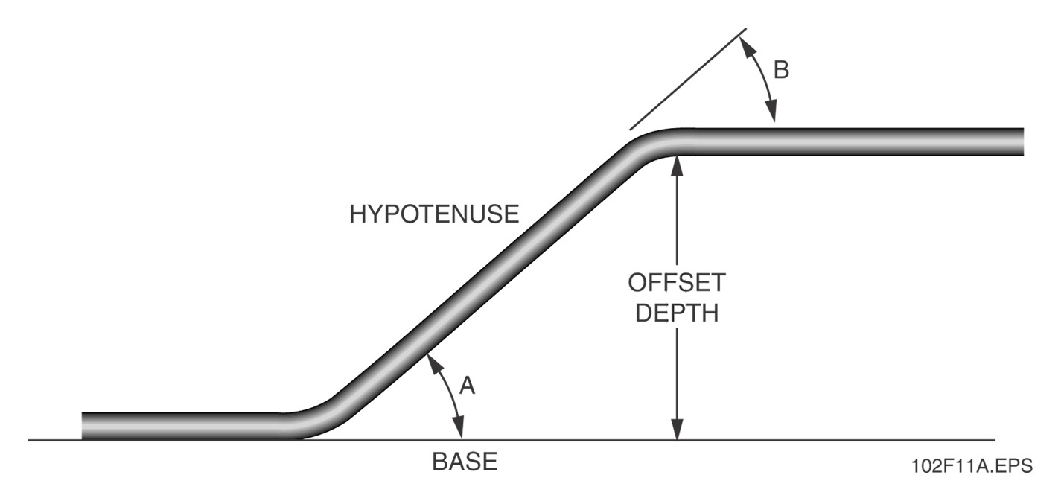
- Demonstrate how to make and offset bend.
- Have students practice making off-set bends.

b. Parallel Offsets
Parallel offsets are made when multiple pieces of conduit are needed. Care must be made to ensure that the ends do not come out uneven. See Below
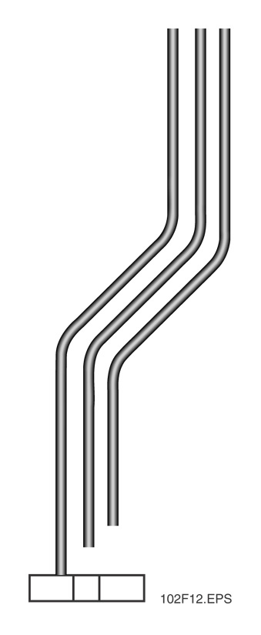
The center of the 1st bend must be found first, and then each successive centerline must be moved and adjusted. The amount to add is calculated as follows:
Amount added = center-to-center spacing x tangent (TAN) of ½ offset angle. (Tangents can be found using the trig tables in Appendix A.
Successive Centerlines
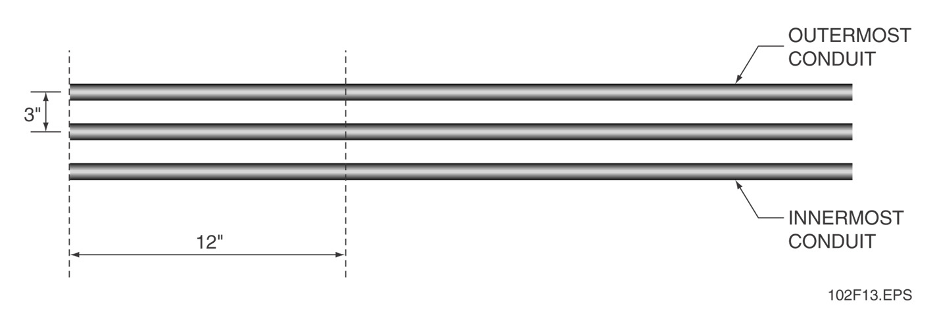

Parallel Offset pipes
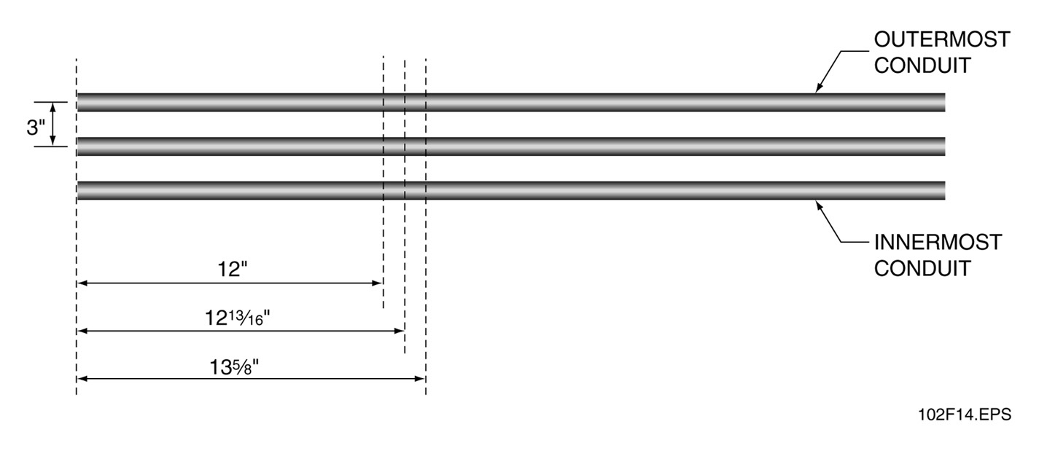
c. Saddle Bends
- Used to go around obstructions
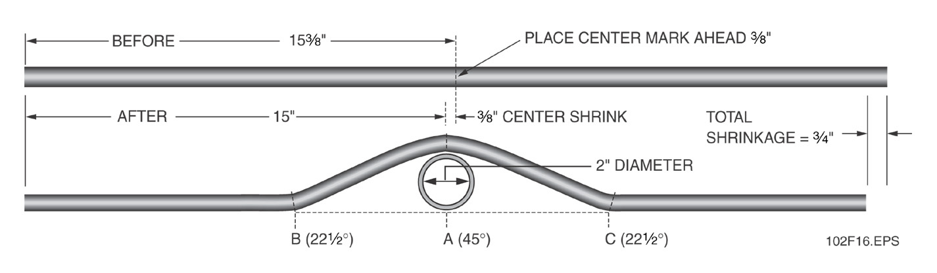
- Demonstrate how to make saddle bends
- Have students practice making saddle bends

d. Four-Bend Saddles
Location of Bends
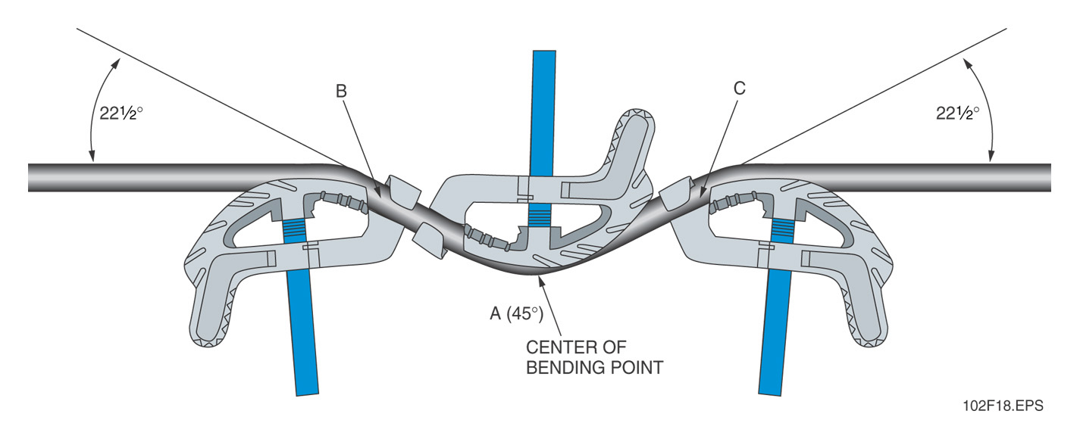
Typical four-bend saddle
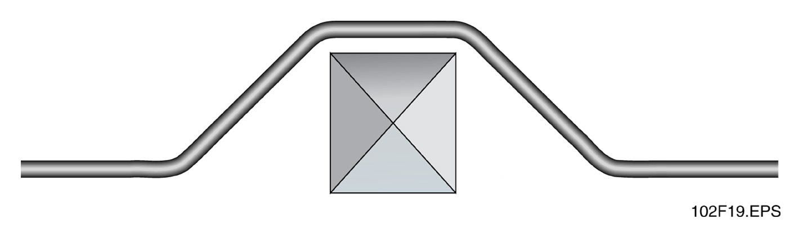
Four-bend Saddle
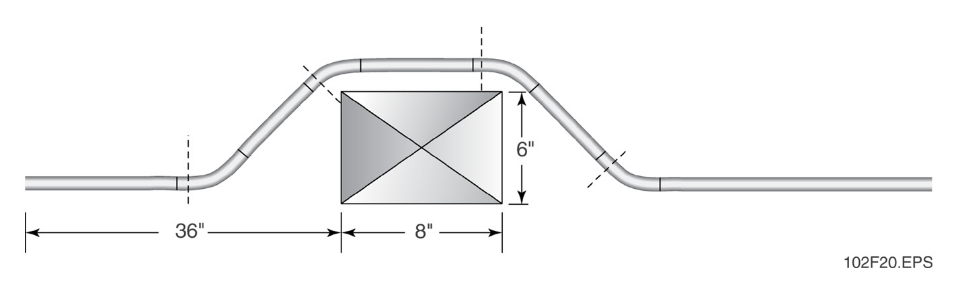

Four-bend saddle measurements
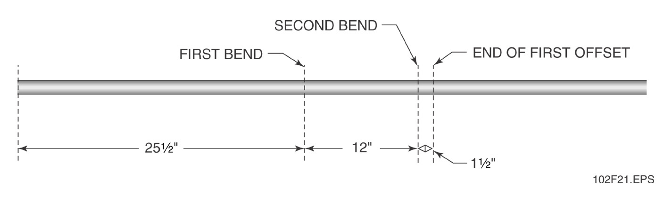
Bend and offset measurements
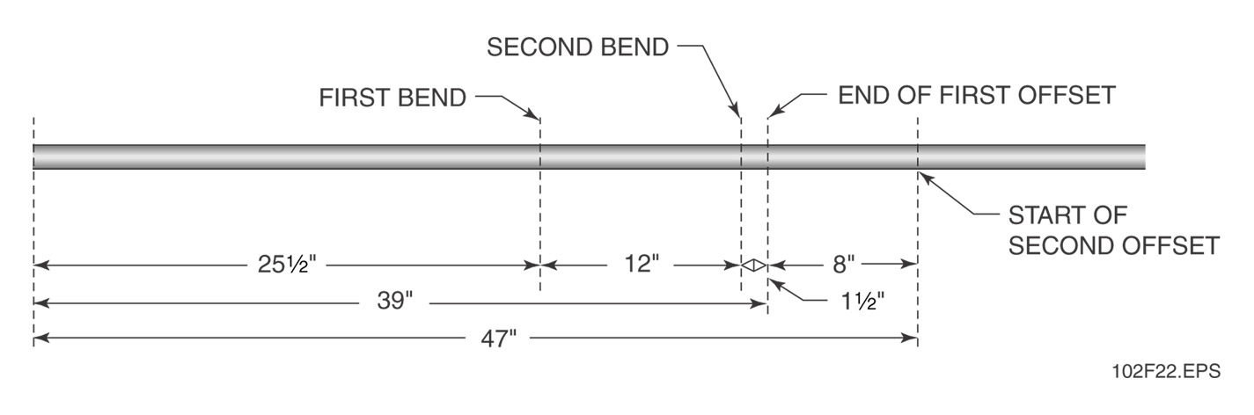
At the end of this section, have the students to the Performance tasks associated with this section.

Lesson 3: Cutting and Reaming conduit; Threading Conduit; Cutting and Joining PVC Conduit

1. Identify the Standards. Standards should be posted in the classroom for each lesson.
2. Review Essential Questions.

3. Identify and review the unit vocabulary.

4. Lesson 4 Content: Cutting and Reaming conduit; Threading Conduit; Cutting and Joining PVC Conduit
a. Cutting and Reaming Conduit

1. Using a Hacksaw
Review procedures for using a hacksaw and have students practice cutting conduit with a hacksaw
2. Using a Pipe Cutter
Review procedures for using a pipe Cutter and have students practice cutting conduit with a pipe cutter
3. Reaming Conduit
Review procedures for reaming conduit and have students practice reaming conduit.
b. Threading Conduit
Discuss and demonstrate the use of a ratchet driver.
At the end of this section, have the students to the Performance tasks associated with this section.

c. Cutting and Joining PVC Conduit
Discuss and demonstrate how to cut and Join PVC conduit. Have students practice cutting and joining PVC conduit.
At the end of this section, have the students to the Performance tasks associated with this section.

Attachments for Learning Experiences: Please list.
At the end of each module, there may be specific tips for additional questions and activities.

Notes & Reflections: May include notes to the teacher, pre-requisite knowledge & skills, suggestions, etc
Culminating Performance Task (Optional)
Culminating Unit Performance Task Title:

Culminating Unit Performance Task Description/Directions/Differentiated Instruction:

Attachments for Culminating Performance Task: Please list.

Unit Resources
Web Resources:
www.cefga.org
Additional Resources:
Benfield Conduit Bending Manual, 2nd Edition. Overland Park, KS: EC & M Books
National Electrical Code® Handbook, Latest Edition. Quincy MA: National Fire Protection Association
Tom Henry’s Conduit Bending Package (includes video, book, and bending chart). Winter Park, FL: Code Electrical Classes, Inc.
Attachment(s): Supplemental files not listed in assessment, learning experiences, and performance task.

Materials & Equipment:

Overhead projector and screen
Whiteboard/chalkboard
Appropriate personal protective equipment
Tape measure
Hickey
Hand bender
Calculator
Hacksaw
Pipe vise
Pipe cutter
Reamer
Hand-operated threader
Sandbox or drip pan
Torpedo level
Transparencies
Markers/chalk
Pencils/scratch paper
Various pieces of conduit
One piece of EMT per trainee
PVC pieces
PVC cement
Cutting oil
Shop towels
No. 10 or No. 12 solid wire
Copy of the latest edition of the National Electrical Code®
OSHA Electrical Safety Guidelines (pocket guide)
Module Examinations
Performance Profile Sheets

What 21st Century Technology was used in this unit?
Top of Form
X | Slide Show Software |  | Graphing Software |  | Audio File(s)
 | Interactive Whiteboard |  | Calculator |  | Graphic Organizer
 | Student Response System |  | Desktop Publishing |  | Image File(s)
 | Web Design Software |  | Blog |  | Video
 | Animation Software |  | Wiki |  | Electronic Game or Puzzle Maker
 | Email | X | Website
Bottom of Form

